Experiment No: 03 – Waveform generation using DAC

Marmik Moon

Roll No: 36

**Square Wave:**

#include<reg51.h> void delay_time(unsigned int time)

{ unsigned int i,j; for(i=time;i>0;i--)

{

for(j=0;j<2000;j++);

}

} void send_dac(unsigned int dat)

{

P1 = dat;

} void main(void)

{

unsigned int delay=0xFF; unsigned char state=0xFF; //send_dac(0x7F); while(1)

{

send_dac(state); delay_time(delay);

send_dac(~state);

delay_time(delay);

}

}

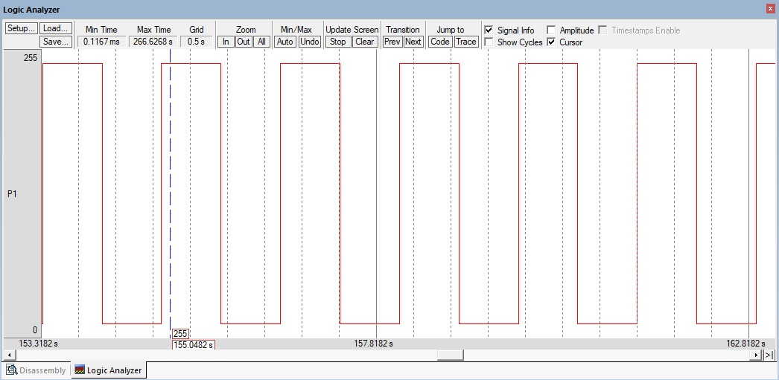

**Triangular Wave:**

#include <reg51.h> void delay_ramp(unsigned int time)

{ unsigned int i,j; for(i=time;i>0;i--)

{

for(j=0;j<10;j++);

}

}

void send_dac(unsigned int dat)

{

P1 = dat;

} void main(void)

{ unsigned int a,state=0xff; while(1)

{

// rising ramp edge for(a=0x0;a<0xFF;a++)

{

send_dac(a); delay_ramp(1);

}

// falling ramp edge for(a=0xFF;a>0;a--)

{

send_dac(a); delay_ramp(1);

}

}

}

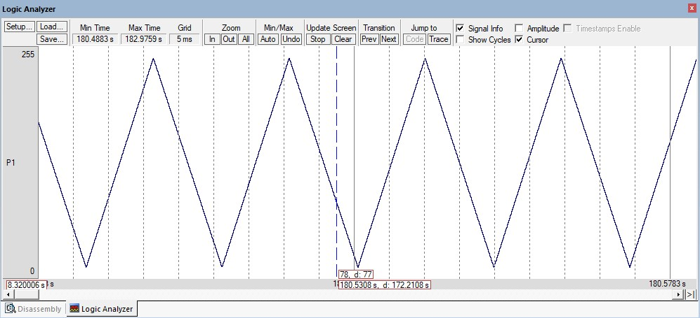

**Trapezoidal Wave:**

#include <reg51.h> void delay_time(unsigned int time)

{ unsigned int i,j; for(i=time;i>0;i--)

{

for(j=0;j<20;j++);

}

}

void delay_ramp(unsigned int time)

{ unsigned int i; for(i=time;i>=0;i--);

}

void send_dac(unsigned int dat)

{

P1 = dat;

} void main(void) { unsigned int a,state=0xFF;

while(1)

{

// rising ramp edge for(a=0;a<0xFF;a++) {

send_dac(a); // delay_ramp(0);

}

// high state send_dac(0xFF); delay_time(100); // falling ramp edge for(a=0xFF;a>0;a--)

{

send_dac(a); // delay_ramp(0);

}

// low state send_dac(0x00); delay_time(100);

}

}

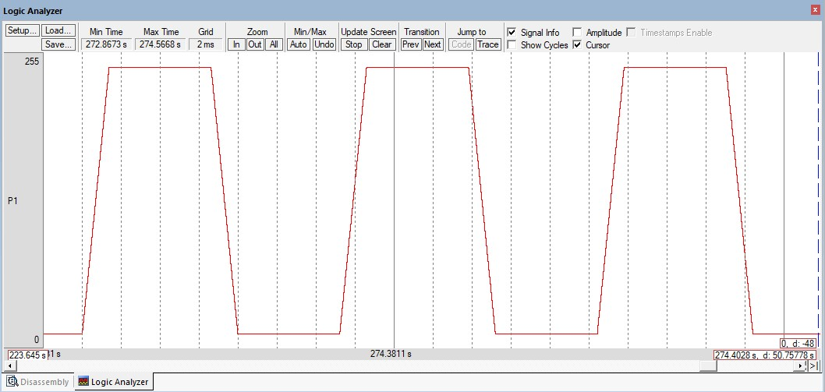

Experiment No: 04 – Microcontroller interfaced with display devices. (V-Lab)

Marmik Moon

Roll No: 36

**LED interfaced with 8051:**

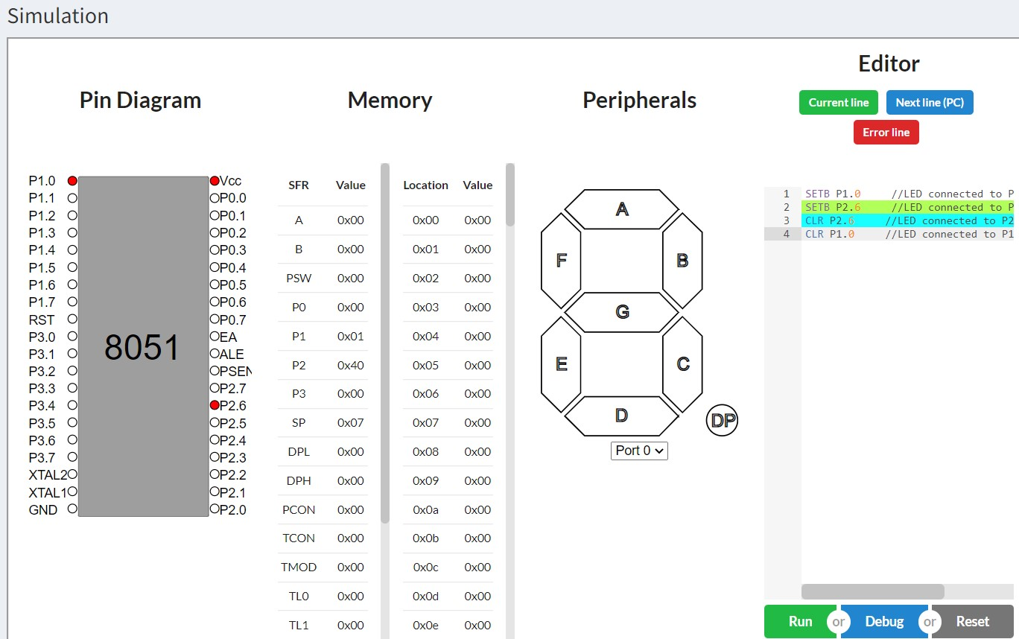

**7-Segment interfaced with 8051:**

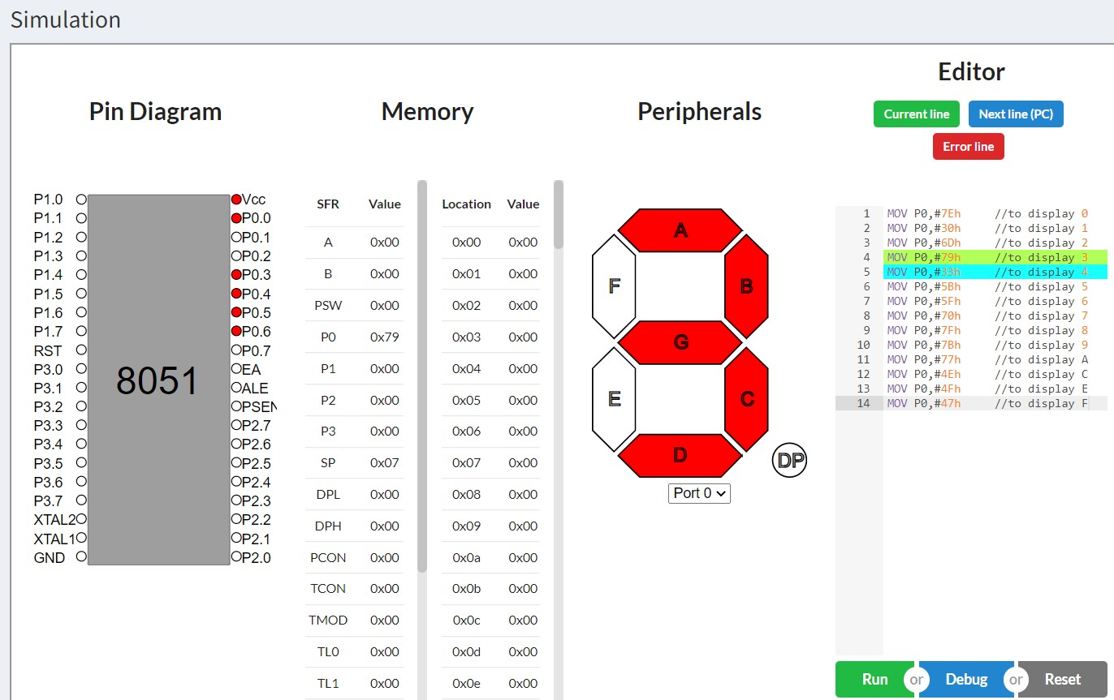

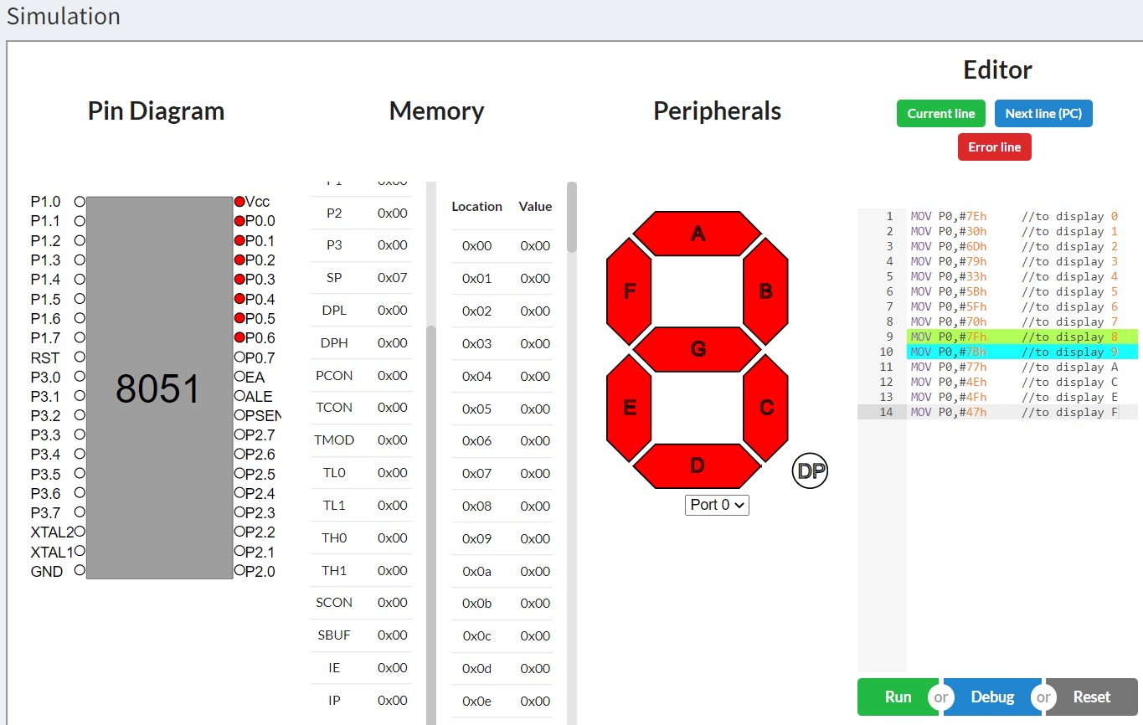

**Display number 9 using SETB and CLR:**

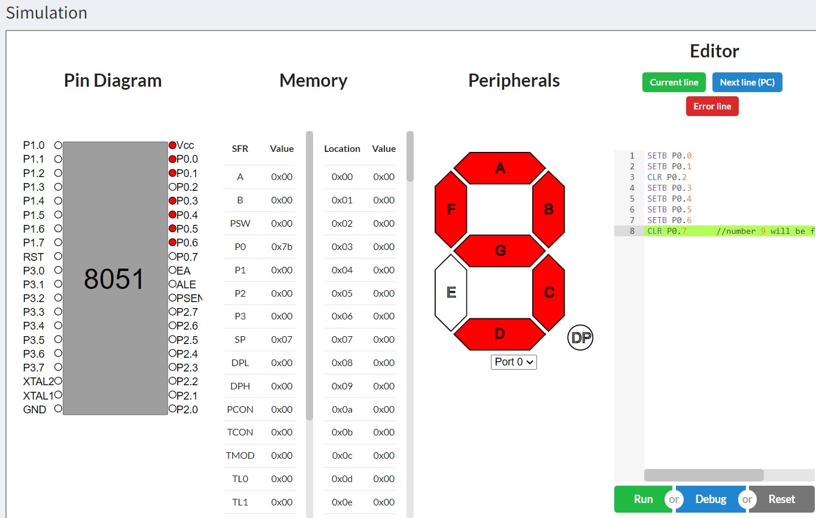

Experiment No: 05 – Microcontroller interfaced with ADC and DAC. (V-Lab)

Marmik Moon

Roll No: 36

