PHASE 1: RECONNAISSANCE
- 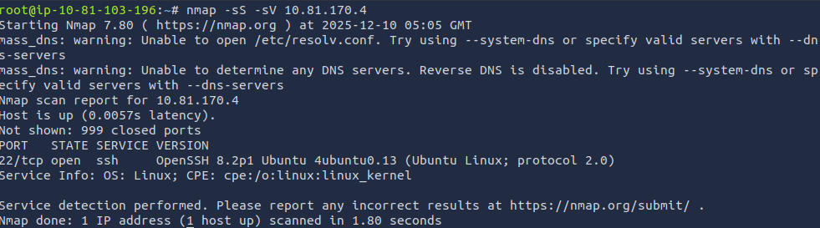 Initial nmap scan (shows SSH)
- 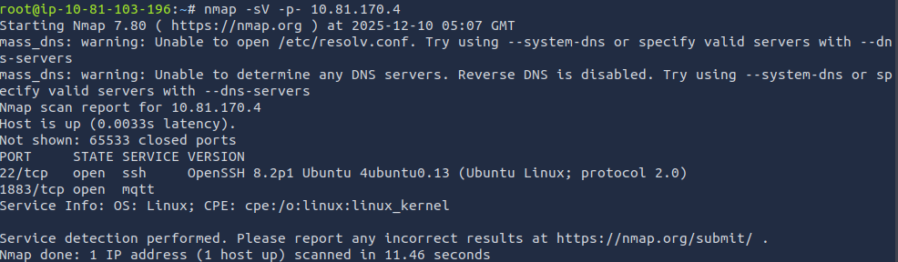Screenshot 2025-12-10 103839.png - Full nmap scan (shows MQTT port 1883)
PHASE 2: TOOL SETUP
- 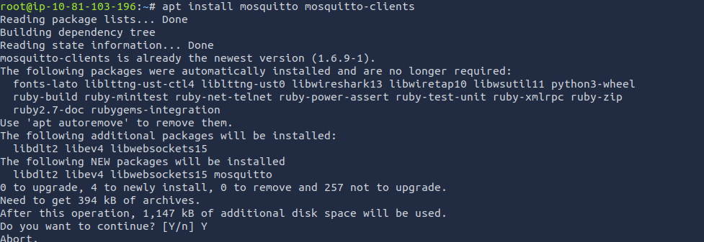 Installing mosquitto-clients
PHASE 3: ENUMERATION
- 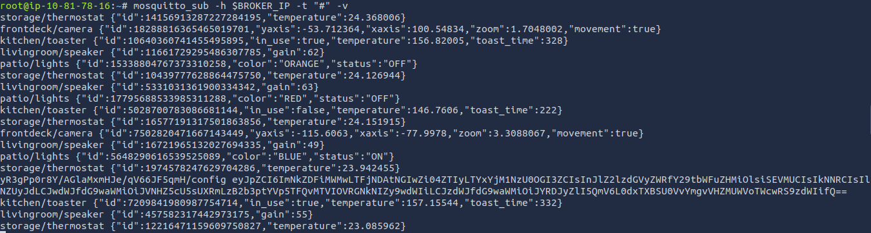 Initial MQTT traffic capture
- CRITICAL: Backdoor device discovery decoded
json
{
"id": "cdd1b1c0-1c40-4b0f-8e22-61b357548b7d",
"registered_commands": ["HELP", "CMD", "SYS"],
"pub_topic": "U4vyqNLQtf/OvozmaZyLT/1SH9TF6CHg/pub",
"sub_topic": "XD2rfR9Bez/GqMpRSEobh/TvLQehMg0E/sub"
}
PHASE 4: INITIAL TESTING & ERRORS
- 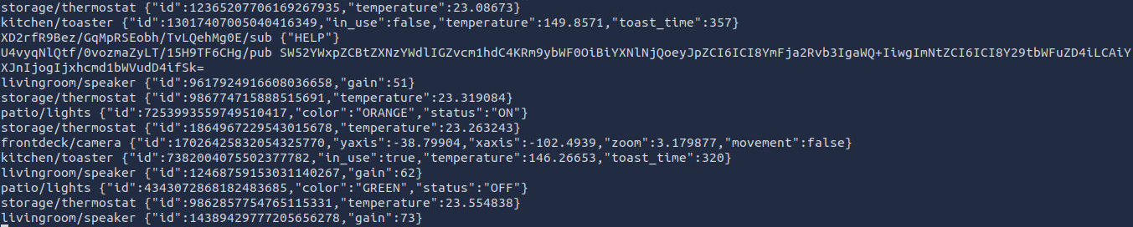 Testing HELP command
- Command sending attempt
- Screenshot 2025-12-10 124236.png - KEY ERROR: "Invalid message format. Format: base64(...)"
- More testing with JSON
- Attempting base64 encoding
PHASE 5: SUCCESSFUL EXPLOITATION
- Sending base64 encoded command
- Response traffic
- Partial response decoding
PHASE 6: COMMAND CRAFTING (CYBERCHEF)
- 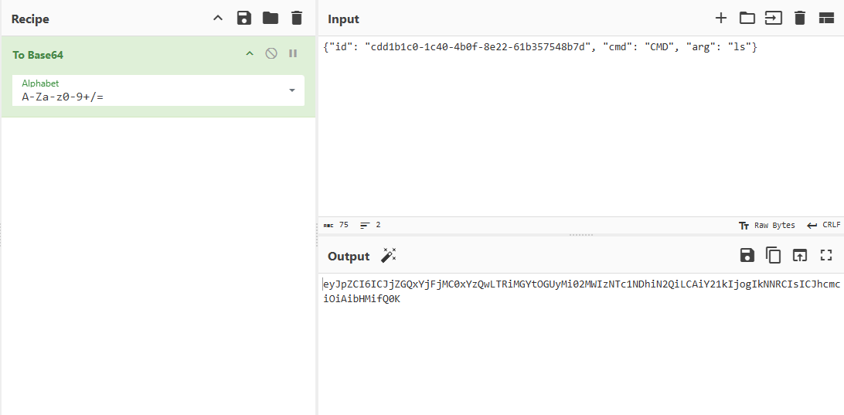CRAFTING: ls command to base64
text
Input: {"id": "cdd1b1c0-1c40-4b0f-8e22-61b357548b7d", "cmd": "CMD", "arg": "ls"}
Output: eyJpZC16ICJjZGQxYjFjMCoxYZQwLTRiMGYtOGUyMi82MMIzMTc1MDhiM2QiLCAIY21kIjogIKMNRCIsICJhcmc 101AibHWi fQgK
- 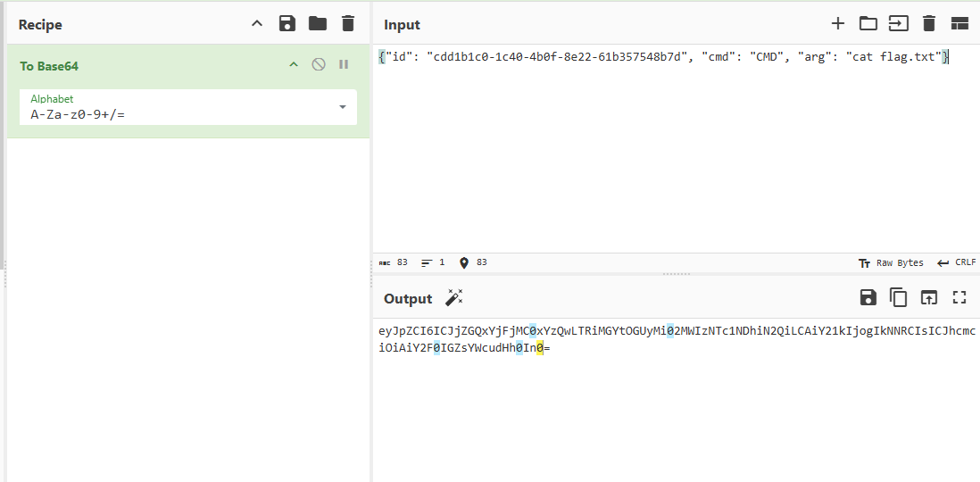CRAFTING: cat flag.txt command to base64
text
Input: "id": "cdd1b1c0-1c40-4b0f-8e22-61b357548b7d", "cmd": "CMD", "arg": "cat flag.txt"
Output: eyOpZCIGICJjZQQxYjFjMC8xYZQWLTRiMGYtOGUyMi82MMIzNTCINDbHXQjLCAiY21kIjogTkMNRCIsICJhcmc 101AiY2F6IGZsVlcudhH8In8-
PHASE 7: EXECUTION & RESPONSES
- Sending crafted command
- 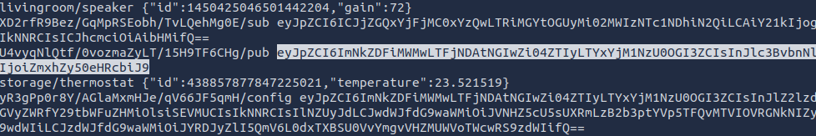Response showing base64
- Base64 response showing "flag.txt"
json
{"id":"cdd1b1c0-1c40-4b0f-8e22-61b357548b7d", "response": "flag.txt\n"}
- Another command attempt
- 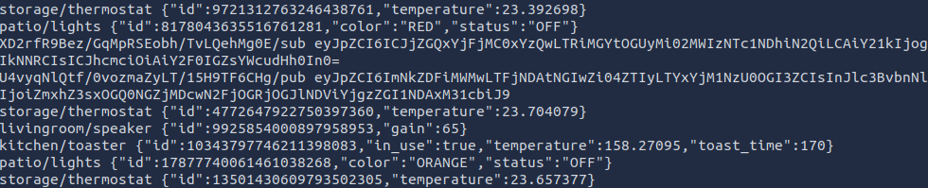Response to cat command
- FINAL FLAG DECODED:
json
{"id": "cdd1b1c0-1c40-4b0f-8e22-61b357548b7d", "response": "flag{18d44fc0707ac8dc8be45bb83db54013}\n"}

