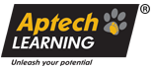

APTECH LEARNING

**CERTIFICATE OF MERIT**

This is to certify that **MR. ALI SIDDIQUE** has done his **CPISM** from **APTECH** LEARNING ­­ with the percentage of 41%

Signature of Principle

Signature of H.O.D