**THE POINT OF NO RETURN**

Ana Rita Freitas (3168833), Gaurav Talekar (3168922), Yvonne Jenniges (4526791)

Beyond Heatmaps: Data Visualization for a Warming Planet

In this course we attempted to explore new ways to visualize climate change data with the intention of making it more unders­­tandable.­ Our group focused on the concepts presented on the paper “Trajectories of the Earth System in the Anthropocene” [1]. Our plan was to investigate the concept of tipping points in order to show the impacts of biogeophysical feedbacks on the earth’s future possible pathways. The paper claims that global warming triggers biogeophysical processes on earth that affect each other leading to a higher global average temperature than expected even if emissions are reduced. When reaching a tipping point (the first is assumed to be at 1°C), the mutual reinforcement of processes reaches a climax resulting in an unexpected jump in temperature. After a tipping point is met, it is unlikely that changes can be reversed.

From the paper we collected information on the tipping intervals (1-3°C; 3-5°C; 5°C+), as well as the biogeophysical processes and their connections which we grouped according to their respective tipping interval in an Excel file. To locate the processes in time, we needed historic and projection temperature data. The historic data comes from NASA [2]. However, we came across difficulties to find projection data: First, there is no data including the tipping point theory. Second, we had accessibility problems due to format and size (12 TB of data). Therefore, we decided to use the simulation tool C-Roads [3] to generate temperature projection data for a worst-case scenario (hot house earth path) and a best-case scenario (stabilized earth path). To include the temperature jumps induced by the biogeophysical processes, we manually manipulated the data using Excel.

Our main goal was to compare the two scenarios (hot house vs. stabilized earth). To build this narrative, we chose “scrollytelling”, a web based medium. As our topic for the first presentations was on the D3.js library, we started with implementing a rough prototype/ a first idea using this tool. Afterwards, we went back to sketches on paper before moving on to building a storyboard and design with the prototyping tool Figma [4]. From there, we started the implementation. To collaborate effectively, we worked with the version control tool GitHub [5] and Google Drive.

In our final product, we start with introducing the tipping point concept and asking the question of what would happen if we take the tipping point theory into consideration. For the tone of voice of our project, we used more colloquial language to make the concept more understandable and reach the user on a personal and emotional level. To cause a greater impact, we chose to take a pessimistic approach and present the hothouse earth scenario which is supported by the rather dark look of the web application. A narrative on what would happen in the worst-scenario case is presented through animations divided by the four different temperature intervals. To conclude, the last page shows the comparison between the two possible scenarios with a highlight of the moment a tipping point might occur. To provoke thought on the user regarding Earth’s pathway, we raise the question “What will you do to change the future?”.

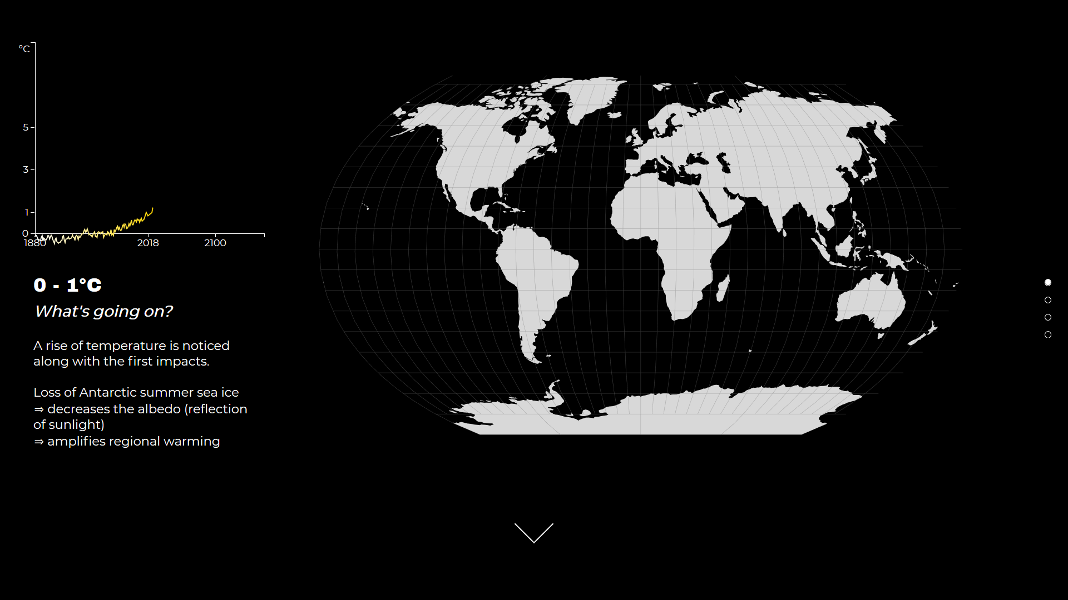

REFERENCES

[1] Trajectories of the Earth System in the Anthropocene, Article in Preceedings of the National Academy of Sciences, August 2018

URL: <https://www.researchgate.net/publication/326876618_Trajectories_of_the_Earth_System_in_the_Anthropocene>

Last access: 11.03.2019

[2] Global Temperature (data by NASA)

URL: <https://climate.nasa.gov/vital-signs/global-temperature/>

Last access: 11.03.2019

[3] C-Roads - Climate Change Policy Simulator

URL: <https://www.climateinteractive.org/tools/c-roads/>

Last access: 11.03.2019

[4] Figma URL: <https://www.figma.com/>

Figma Prototype URL: <https://www.figma.com/file/LTr2Tgiu2IqjkGzMqnKUPoA4/The-point-of-no-return?node-id=0%3A1>

Last access: 11.03.2019

[5] Github Repository

URL: <https://github.com/Meraki16/ThePointOfNoReturn>

Repository Preview

URL: <https://meraki16.github.io/ThePointOfNoReturn/Index.html>