CPE301 – SPRING 2019

Design Assignment 1A

Student Name: Meral Abu-Jaser

Student #: 5003137888

Student Email: abujaser@unlv.nevada.edu

Primary Github address: <https://github.com/MeralAbuJaser/Submission_da.git>

Directory: <https://github.com/MeralAbuJaser/Submission_da/tree/master/DA1A/Assignement1A>

1. **COMPONENTS LIST AND CONNECTION BLOCK DIAGRAM w/ PINS**

None

1. **INITIAL/MODIFIED/DEVELOPED CODE OF TASK 1/A**
2. .org 0
3. LDI R16, 0x00 ;R16 to R19 is the multiplicand
4. LDI R17, 0x10
5. LDI R18, 0x10
6. LDI R19, 0x10
7. LDI R20, 0x00 ;R20 to R23 is the multiplier
8. LDI R21, 0x01
9. LDI R22, 0x01
10. LDI R23, 0x01
11. LDI R24, 0x00 ;R24 to R31 hold the results
12. LDI R25, 0x00
13. LDI R26, 0x00
14. LDI R27, 0x00
15. LDI R28, 0x00
16. LDI R29, 0x00
17. LDI R30, 0x00
18. LDI R31, 0x00
19. SUB R31,R31 ;Clear R32 and Carry Flag
20. ADD R28,R16 ;Add Multiplicand into Answer
21. ADC R29,R17 ;
22. ADC R30,R18 ;
23. ADC R31,R19 ;
24. LOOP:
25. LSR R24 ;shifting answer to the right
26. ROR R25 ;
27. ROR R26 ;
28. ROR R27 ;
29. ROR R28 ;
30. ROR R29 ;
31. ROR R30 ;
32. ROR R31 ;
33. LSR R20 ;shift multiplier to the right
34. ROR R21 ;
35. ROR R22 ;
36. ROR R23 ;
37. BRCC COUNTER;If Carry Clear skip addition
38. BRCS ADDITION
39. ADDITION:
40. ADD R27,R19 ;add multiplicand to answer
41. ADC R26,R18 ;
42. ADC R25,R17 ;
43. ADC R24,R16 ;
44. RJMP COUNTER;jump to counter
45. COUNTER:
46. INC R0 ;increment R0
47. SBRS R0,5 ;check if counter is 32
48. BRNE LOOP ;go back to loop
49. RJMP LAST_SHIFT
50. LAST_SHIFT:
51. LSR R24 ;shift answer to the right
52. ROR R25 ;
53. ROR R26 ;
54. ROR R27 ;
55. ROR R28 ;
56. ROR R29 ;
57. ROR R30 ;
58. ROR R31 ;
59. DONE:
60. **SCREENSHOTS OF EACH TASK OUTPUT (ATMEL STUDIO OUTPUT)**

Debugging as the beginning

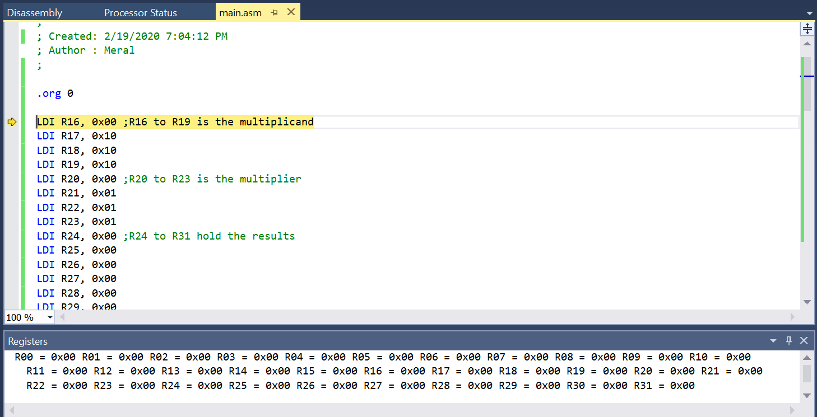

Debugging at the end

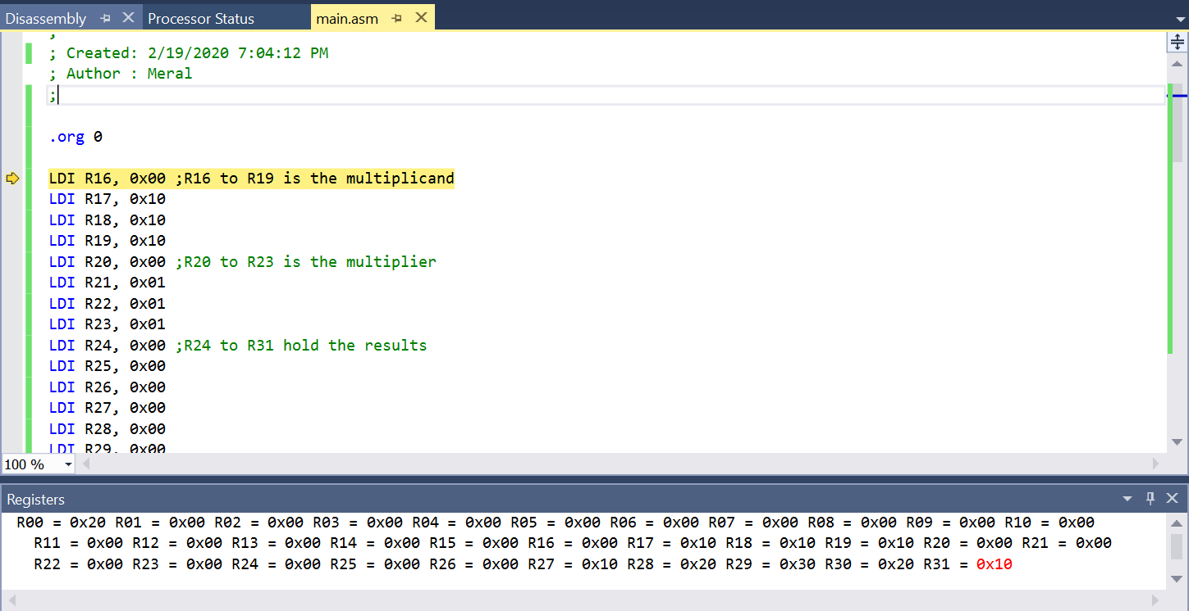



101010 * 010101 = 1020302010

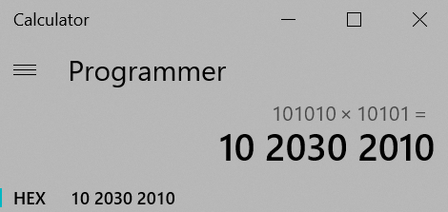

1. **GITHUB LINK OF THIS DA**

<https://github.com/MeralAbuJaser/Submission_da/tree/master/DA1A/Assignement1A>

“This assignment submission is my own, original work”.

Meral Abu-Jaser