MERAM FATIMA
SE-A
ROLL NUMBER:I263047
LAB-12
PROMPT: I need to build a 3-page website while keeping the exact same design, fonts, and colors from my Lab 11 project. My theme is cafe menu. I’ve pasted my Lab 11 code below including html and css. Could you give me ideas for what pages I should include with index.html as the home page and outline what content should go on each page? also add java script code.
RESULT: It suggested me 3 webpages and give me css html and java code.

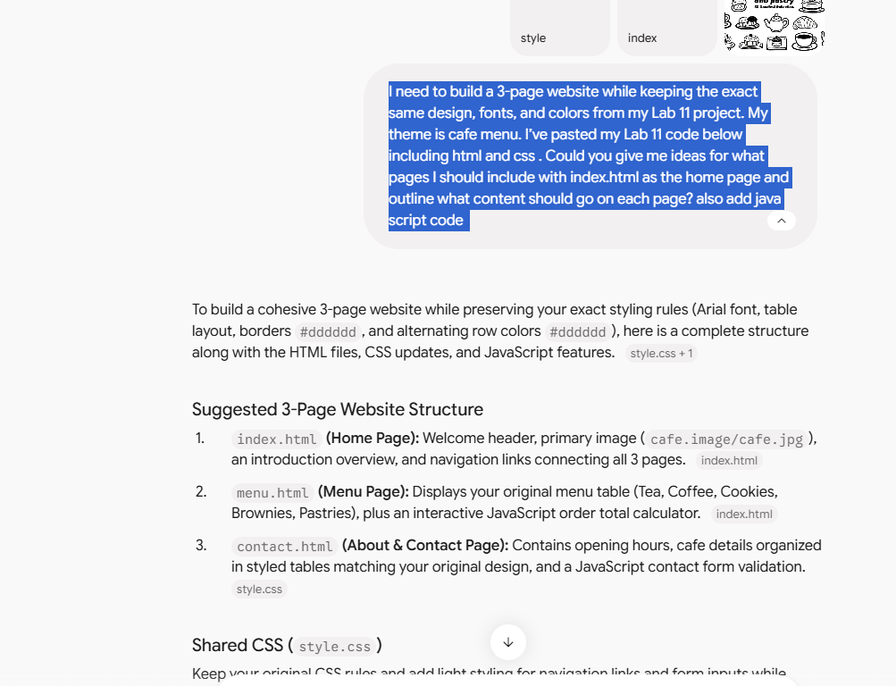
PROMPT: Add some colours and style
RESULT: 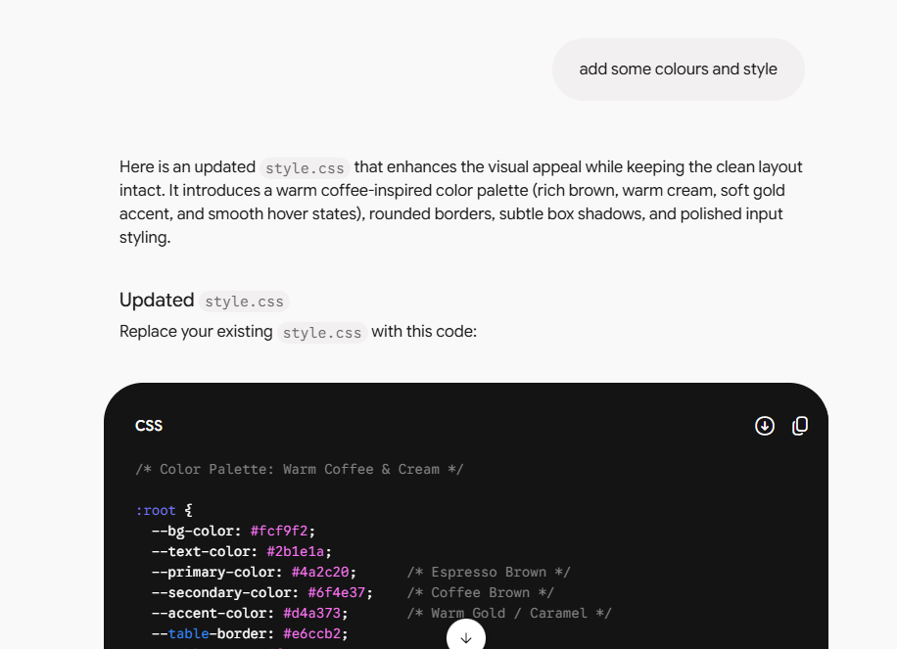
PROMPT: also add small pictures or icons before name and prices
RESULT:


