CCP Report

COMPUTER NETWORKS

Database Auditing & Security System

Submitted By:
Shah Sayed Meran -> 24-CS-087
Assam Sajjad -> 24-CS-236

Submitted to:
Sir Waqar Ismail

Department of Computer Science
HITEC University, Taxila

Introduction:
In modern enterprise software, databases face high security risks from external hacks or insider threats who bypass application frontends to access the database engine directly. Traditional relational tables compound this vulnerability because they only store the current state of data, completely lacking a historical record of past changes, who made them, or when they occurred. To solve these critical gaps, this project implements an Automated Database Auditing and Security System directly inside the database tier using T-SQL. By embedding security features like triggers and stored procedures within the database engine itself, our security controls become inescapable, independent of any frontend application, and fully capable of tracking and blocking unauthorized activity in real time.
System Features & Core Functions:
The security engine relies on four core database tables (Users, Financial_Records, Audit_Log, and Security_Alerts) managed dynamically by automated database objects:
- Automated Data Auditing (DML Triggers): Monitors the active operational tables continuously. Whenever a data modification statement (such as an UPDATE or DELETE) is targeted at protected rows, the row-level trigger instantly captures contextual system metadata (the database session user, precise timestamp, and query source) alongside immutable snapshots of the historical data states and pushes them to the central log.
- Prevention of Schema Tampering (DDL Triggers): Implements a rigorous protective boundary around the structural architecture. A database-scoped data definition language trigger monitors structural actions such as DROP_TABLE or ALTER_TABLE commands. If unauthorized session personas attempt to manipulate the structural schemas, the engine logs a high-severity alert and issues an immediate ROLLBACK TRANSACTION command, fully neutralizing the destructive action.
- Role-Based Access Control & Encapsulation (Stored Procedures): Enforces granular authorization checks. Direct text queries against structural tables are fully restricted. Users are forced to interact with database records through a strict gatekeeper Stored Procedure (sp_ExecuteTransaction). This procedure performs runtime validation checks against the system user's specific organization role and applies mandatory validation thresholds.
- Fraud & Velocity Analysis (Scalar Functions): Drives real-time anomalous tracking. A custom database function (fn_CheckUserRisk) processes the operational logging logs using windowed chronological criteria to dynamically isolate behavioral anomalies, alerting system administrators when rapid-fire data modifications are detected within narrow time intervals.
Tools & Languages Used:
- Database Server Engine: Microsoft SQL Server (Developer Edition)
- Integrated Development Environment (IDE): SQL Server Management Studio (SSMS)
- Programming Language Domain: T-SQL (Transact-SQL) — utilized for transactional logic scripting, structured exception handling, database-level trigger variables, and programmatic stored procedure execution trees.
Entity-Relationship Diagram & Cardinality:
The underlying architectural schema separates production operational data from logging history records to provide an organized relational design.
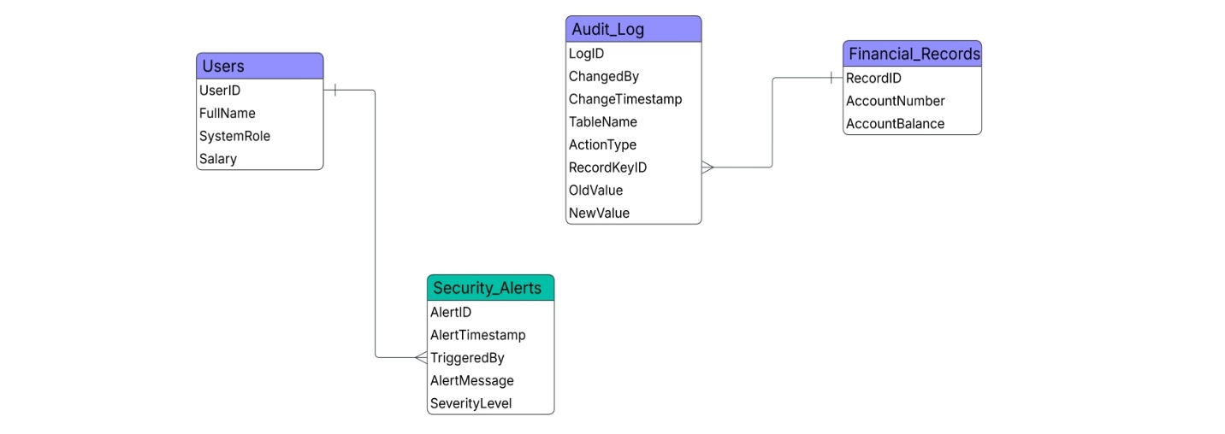
Table Schemas:
- Users Table: Holds organization profile details (UserID, FullName, SystemRole, Salary).
- Financial_Records Table: Stores critical operational assets (RecordID, AccountNumber, AccountBalance).
- Audit_Log Table: Holds the historical snapshots of modified table entries (LogID, ChangedBy, ChangeTimestamp, TableName, ActionType, RecordKeyID, OldValue, NewValue).
- Security_Alerts Table: Tracks structural attacks and procedure violations (AlertID, AlertTimestamp, TriggeredBy, AlertMessage, SeverityLevel).
Core Cardinality Rules:
- Financial_Records to Audit_Log (1:N / One-to-Many): A unique account row within the Financial_Records table may experience zero, one, or multiple operational changes across its lifecycle. Consequently, a single record points to many rows within the Audit_Log table, physically connected by routing the relationship line directly to the RecordKeyID attribute acting as the Foreign Key.
- System Sessions to Event Logging (1:N / One-to-Many): An active system session or user persona can yield multiple transactions or trigger security infractions over time. This logical relationship line runs directly into the TriggeredBy column inside the security table.

Architectural Defense: Why the Schema is Deliberately Decoupled:
An essential evaluation point in this system layout is the deliberate choice to avoid connecting all four core tables together with traditional physical Foreign Key constraints. This localized decoupling represents a deliberate engineering pattern focused on Tamper-Resistance and System Isolation:
Defense 1: Protection Against Cascading Destruction and Erasure
- The Vulnerability: In standard databases, tightly coupled tables rely on physical foreign keys to cascade deletes or enforce constraints. If a hacker breaches the operational tables and deletes user data, a tightly coupled logging system would either fail to write error logs due to constraint violations or cascade-delete the logs along with the data.
- The Solution: By removing physical keys, the Audit_Log and Security_Alerts engines remain completely permanent and untouchable, even if primary data tables are wiped out.
Defense 2: Decoupled Session Tracking via Engine Telemetry
- The Vulnerability: Relying on standard database application IDs (like UserID) to link user profiles to logs creates an unnecessary structural dependency.
- The Solution: The system extracts metadata using the built-in SQL Server variable SYSTEM_USER. This dynamically captures the authentic background server or active network account hitting the database engine at that split second. Because it reads identity straight from the engine layer, a physical database constraint to the Users table is completely redundant.
Defense 3: System Availability Under Active Compromise
- The Vulnerability: If the security alert table depended on a network of foreign keys tied to operational business modules, any logical corruption or structural table locking during an ongoing cyberattack would freeze the alert engine due to constraint validation checks.
- The Solution: Isolating the logging tables guarantees the alarm system remains functional. It ensures the database engine can successfully write alert logs and execute its automatic rollback protocols even if standard application tables are completely compromised.

Future Plans & Extensibility:
Because all verification, exception blocking, and logging logic lives natively within the SQL Server database engine, the entire backend framework remains completely decoupled from user interfaces. This gives the project immense structural flexibility, enabling it to seamlessly scale into an enterprise full-stack architecture through the following three implementation tiers:
- Backend API Tier (Java Spring Boot): A robust middleware layer can be established utilizing the Java Spring Boot framework. By leveraging Spring Data JPA or JDBC connectivity models, the API can link directly to Microsoft SQL Server. The backend middleware will serve purely as a routing gatekeeper, directly invoking the compiled database Stored Procedures (e.g., sp_ExecuteTransaction). This prevents any need to re-engineer core security logic in the application layer.
- Administrative Security Control Dashboard (React / Thymeleaf): A dynamic graphical administrative dashboard can replace manual query processing within SQL Server Management Studio (SSMS). Security administrators can view a streaming, real-time visual grid of the Audit_Log, red-flag security badges instantly updating upon DDL trigger rollbacks, and interactive transactional velocity charts mapping out real-time user anomalies.
- User-Facing Portals: Standard organizational employees can execute standard CRUD forms safely. Any data or business exception thrown by SQL Server triggers or stored procedure validation rules will be intercepted cleanly by the Spring Boot exception handler and pushed back to the UI layout as clear, user-friendly security warnings.

Conclusion:
The Automated Database Auditing & Security System successfully establishes a zero-trust protective posture centered entirely inside the database tier. By shifting security operations away from vulnerable application-level layers and embedding them directly into the database engine via T-SQL triggers, encapsulated stored procedures, and historical logging algorithms, the project removes traditional bypass avenues. The resulting architecture ensures a permanent, fully tamper-resistant historical audit trail and automated structural protections, producing a solid, production-ready security foundation that stands up to professional evaluation.

