A GPS Based Unmanned Drone Technology for Detecting Air Pollutants

# Meratun Junnut Anee, Sabahat Bushra, Amzad Hossain, Raisa Faruqui

Department of Electrical and Computer Engineering

North South University

Email:

***Abstract*—Dhaka city air pollution is getting worse every day. According to the world AQI ranking Dhaka city ranks among the worse cities. Sustainable development is needed for the protection of our environment. UAV technology because of their mobility and** **versatility, have several pronounced uses for both public and private organizations.** **When surveying landscapes highly accurate drone navigation is very crucial. Our goal is to build a drone that will detect and monitor the air quality over different landscape and capture images for the further analyzes for the improvement of the air that we breathe. It will be an affordable environmental drone that will monitor the air pollution, with low-cost sensors embedded within it. The highly acknowledgeable and progressive growths of this technology have made it a valuable research topic. Their effectiveness and convenience do get followed by some major drawbacks. Considering all the assets and liabilities we will analyze the data collected by our drone of the air pollutants for further research.**

**Index Terms— AQI; UAV technology; Environmental drone; Low cost sensors; Detection; Image capture; Image processing.**

**I. INTRODUCTION**

Unmanned Aerial Vehicles (UAV) popularly known as drones are unpiloted aerial rotorcraft. These aerial vehicles have gained a lot of acknowledgement in the research field due to its multiple usages and unique features. Drones have been used for remote sensing as well as recreational purposes. Due to its versatile aerial monitoring features UAV technology promises to be of great value in this air quality improvement research. This paper mainly focuses on the ability of our low-cost drone surveying landscapes over different heights to detect air pollutants for the improvement of the air quality. Many researches have been already done with this purpose and those proposals had their share of drawbacks. Drawbacks came by due to the fact that air pollution changes instantaneously at all heights and directions. When surveying landscapes highly accurate drone navigation is very crucial. Drones were mostly used in for military purposes because they can fly if the past few years drone has been more used for recreational purposes and commercial and motion picture filmmaking.

Our drone is a multifunctional drone which will autonomously drive along and collect data for analysis of the pollution density from certain areas of Dhaka city in Bangladesh. So this works as it navigates itself to the designated location with the help of the GPS technology equipped in it up to a different predetermined height every hour and from there detect the pollution density (the concentration of all the air pollutants present), only when the value is above the recommended threshold density . At last it flies back down to the place on the ground from where it took its flight off. Later the data collected through live data plotting (streaming) by the sensors will be stored in a application and further analyzed through image processing.

The quadcopter will also provide us with live capture from the landscape it is monitoring for structural view so that those can contribute in taking action towards lowering the risk of pollution in that area. For instance if the area monitored has a high pollution density and then from the pictures taken or the video made we can know whether that area is a busy road where we can limit the causes for increasing pollution or whether it is a quieter area where different initiative can be taken to lower the risk.

**II. RELATED WORKS AND STATE-OF-THE-ART**

1. Air pollution

It is proven that air pollution is very less in the rural areas because of the place being less polluted. Ozone is the air pollutant that significantly deters the air quality of the rural areas. Ozone levels tend to be higher in rural areas where there are fewer emissions of harmful gases to lessen any ozone layer that has been formed in the atmosphere. However, the levels of ozone are decreasing in general.

City pollution is caused by the presence of increasing amount of Carbon monoxide, Carbon dioxide and Sulphur dioxide in the air. This is present in the air in higher concentration because of there been more people and vehicles. Almost all our activities in the city contribute to little or less air pollution. The six common pollutants consistently studied and analyzed in this paper is as follows:

TABLE I

|  |  |
| --- | --- |
| **Pollutants** | **Chemical symbol** |
| Carbon Dioxide | CO2 |
| Carbon Monoxide | CO |
| Nitrogen Dioxide | NO2 |
| Sulfur Dioxide | SO2 |
| Ozone | O3 |
| Particulate Matter | PM2.5 and PM10 |

1. Low-cost sensors

TABLE II

|  |  |  |
| --- | --- | --- |
| **Chemical symbol** | **Substance** | **Sensors** |
| CO2 | Carbon Dioxide | MQ-135(gas sensor) |
| CO | Carbon Monoxide | MQ-2 (gas sensor) |
| NO2 | Nitrogen Dioxide | MQ-135(gas sensor) |
| SO2 | Sulphur Dioxide |  |
| O3 | Ozone |  |
| PM2.5 and PM10 | Particulate Matter | Dust sensors |

In the last few years sensor technology has vastly improved. Public environmental agencies alongside ordinary citizens began to own it because of its low cost. We will embed our drone with all this sensors listed above, for our drone to accomplish its purpose. For the detection of different air pollutants different high precision detectors are used.

**III. PROJECT**

1. ***Project Overview***

This project is initiated by a group of students of ECE department, North South University under the supervision of our honorable faculty Ashrafuzzaman khan. We tried to give a best & easy solution to detect pollutants and also researched about how to make it cost efficient and available for government and military and also for civilians. Our motivation to start the project was about climate changing, increasing global warming and also health issues related to the air pollutants. We tried to make a tool which can detect these toxic elements from the air. First of all, we thought in the context of Dhaka city. As the air of Dhaka is full of pollutant and we all know how many side effects it has, so our first step was to detect those pollutants from air, pollutants intensity of different area. We used GPS technology system so that our drone can perform automatically. Next step is to collect those data and analyses it. After analyzing data, we would know and compare the values where there are more pollutants which caused different hazards. We can also fly our drone from a selected area and can get back to the same place with the help of GPS technology. So that no need for manual help for this operation. It will detect pollutants within short time & will Give preliminary streaming results.it will also can take real time pictures and videos and will store it in a memory. The sensors we are using will give statistical DATA. We can also check air transparency in Dhaka city and other areas as well. Actually, we are planning to make this project for all the development countries like ours so that they also can afford this most demanding and modern device in their countries for this purpose.

1. ***Project Proposal:***

For our project we came up with a unique solution with the most popular device “DRONE”. We will follow some procedure. For this we divided the project basically in two parts. One is Hardware and another one is Data Analyzing part.

In the Hardware System first step is to make the drone, where we will use a rechargeable lipo-battery, which is eco-friendly. We will have 16 to 17 mins battery lifetime, so in this short period of time we have planned every steps of the project. Then next step is required components integration with the drone body.

**Fig: 1 Basic Work plan**



We started off with the idea of multifunctional drone that will detect the air pollutants present in a certain landscape. It will detect the pollutants that are majorly contributing in the air pollution of Dhaka city which are:

a. PM10

b. PM2.5

c. Carbon dioxide (CO2)

d. Carbon monoxide (CO)

e. Nitrogen oxides (NOX)

f. Sulfur dioxide (SO2) and

g. Ozone (O3)

We will receive the data through user interface. The objective is to contribute as little as possible, to put an end to climate change and global warming and to improve the AQI (air quality index). So, when the air quality of cities will be better, citizens would be suffering less from diseases. Our project will be beneficial for preserving the nature and for human health. It is both cost and energy efficient. It won’t even require labor force either. Our drone with GPS technology will navigate to a certain landscape detect and will record the density of air pollutants. We will receive the data through user interface. The objective is to contribute as little as possible, to put an end to climate change and global warming and to improve the AQI (air quality index). So, when the air quality of cities will be better, citizens would be suffering less from diseases. Our project will be beneficial for preserving the nature and for human health. It is both cost and energy efficient. It won’t even require labor force either. Our drone will be featured with CMOS cam that will take images and videos, and will use the gas sensor which can measure the concentration of the toxic gases. We will use a microcontroller. First, we will integrate all sensors with micro-controller and do code. This aircraft can then detect air pollutants, after detecting the pollutants it will give data to the server. As our drone can give backup 13-14 mins so readings will be taken per second. For the **Data analyzing part**, we need an internet connection. In this stage we will use a router with which will create a Wi-Fi hotspot and micro-controller will be connected to this hotspot and will be able to send its data to server. Now all the data will cast to the server and then we will read these data from a desktop client. It will work as user interface; we can choose an application or choose website to read this data. Primarily we view the preliminary streaming data with an application. Here at first sensors will detect pollutants then it will give data. It will automatically give practical data and make statistical graphs using given data.

**Fig: 2 Project Proposals**

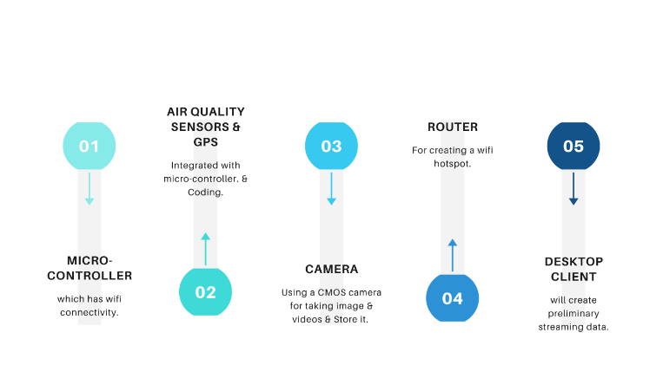

**Modelling of Drone with required Features:**

For making the drone we followed several steps and also face difficulties & challenges as well. As we are using GPS in our Drone, in our experiments we will choose path for drone, called mapping so that this drone can fly over that area and will take data for that specified area. It means before the flight of the drone area will be fixed. The vital part of the project is taking data from the air. So that stability of the DRONE really matters. What we do the programming part for our drone this is the other important part. The more features we added to our drone it will cost more. As our plan is to make it cost effective, we cut off the other features, put only the most important features to fulfill the project goal. The sensors we are using will not that costly, we are using two sensors only for detecting pollutants. but some the tools are costly such as the drone body, except this all other things we are using are cheap enough. Sometimes sensors reading can be inaccurate, for making our data more accurate, we will use a humidity sensor.

1. ***Current State:***

We can explain our total project into three stages. Such as 1) Building Drone 2) Integrating sensors and 3) Data collecting and analysis.

1. **Drone Building:**

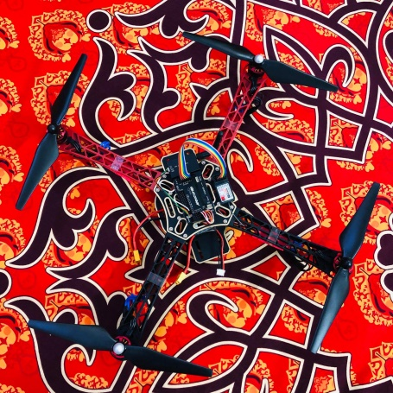

**Fig 3: Proposed Model of DRONE.**

We've done building our drone. This is the main part of the project. It will travel through a specific area, track down the specific area of the pollution and will return back to the station. As it follows the specific path so it is very easy to get all the updated condition of any specific area. It is cost effective too. Here we are using four brushless motor, Per motor draws 2A while hovering. So, 4 motor draws 8A for hovering in the air. Our selected battery is 2.2Ampere/hour. That means it cans delivery 2.2A for 1 hour (60minutes).

The calculation,

2.2A delivers 60 minutes 1A delivers 60x2.2 minutes 8A delivers (60x2.2)/12 minutes =16.5 minutes (theoretically, moderate air condition) Practically it varies from 12-14 minutes.

Theoretically, the range of our drone is 1KM, but practically it varies from 600-800 meters depending on the weather. Transmitter to the receiver has to communicate via 2.4Ghz. 6 individual channels, means 6 separate PWM values. But technically it shows some variations. Usually, we use 'mission planner' from the laptop or 'Droid planner' from mobile to select the specific path for the Drone, but in case of an error, we alternatively use a remote to control The drone. We give the input from Mobile/Laptop then it flies accordingly and returns at the same place. We use Soldering iron, Screw box, Hex screw, Double side tape as supporting tools. Still, We didn't integrate the sensor part with the drone. We are practicing over it, recording the challenges and the limitations of it.

1. **Sensor Part:**

Sensor part is our main external circuit which will be integrated with drone. The purpose of this circuit is to detect the pollutants from the air. For which we are using several gas sensors for detecting gases and PM (Particulate Matter) Sensor for detecting dust pollutants. We also use a camera for taking the structural views so that we can conclude for what reason the pollutants varies over time. We are done with making the circuit. Currently we are testing the sensitivity of the sensors (record the response of the sensors by making artificial pollutants). After that we will integrate it with the drone and will measure the data in various place of Dhaka city. We are offering a cost effective and reliable solution using low cost sensors.

1. **Analysis part:**

For analyzing data, we will take inputs as string from the sensor and read through an application. So, we can do statistical analysis and also compare the results with bar graph. Besides we are using some softwires for running the code. We will take data from a specified place for several times like, we will take data morning, noon & afternoon and can analyze the variation of density pollutants in a same place. We also will take data of different places, such as: from a crowded area and uncrowded area. Thus, we will analyze the project outcomes.

***D. Motivation:***

One of the world’s greatest issues is air pollution for which food security and people’s life both are at risk. In simpler terms our project is an environmental drone. This day’s drones are used for multifunctional purposes and we chose to do this because in context of our country as well as the whole world we should contribute in taking good care of our environment. Air pollution poses a global environmental health risk. It causes the death of billions every year and damages about billions of crops which could have been feed to the poor. The effect of air pollution on the environment and the people on this earth is extremely hazardous. Increasing level of air pollution causes damage to plants and buildings too.

An air quality index (AQI) is issued by the government of every country. It is a way of the governments of the different country to share with the citizens about the latest condition of the air pollution. It gives a measure of how polluted the air is now (through real-time technology) of a certain place in a country and it also forecasts on how polluted it may become. Poor air quality has severe effects on human health especially people working outdoor might develop lung cancer and respiratory diseases such as emphysema.

Thus, these are the thoughts that made us do this project of ours. Countries with higher AQI are at greater risk and Bangladesh ranks in at the 168th position at the Environmental Performance Index for Air Quality with a higher AQI among 179 countries. According the Department of Environment (DoE) in Bangladesh the AQI is higher because of the following pollutants: Particulate Matter (PM10), Particulate Matter (PM2.5), Nitrogen dioxide (NO2), Sulphur dioxide (SO2), Carbon Monoxide (CO) and Ozone (O3)

**IV. Future Work:**

We will very soon start with the data collection phase. We will analyze the air pollutants density from the data collected and provide reports on it by comparing the data. We will also analyze the live images captured by the drone and report on the structural views from different perspective of Dhaka city for further improvement. We will compare the data and views from different places of different time. We also want to integrate the on-spot air purification sensor, which will be an additional feature of our multifunctional drone. For this we will integrate a hepa-mini air filter in our drone which will absorb in the dust pollutants and purify the air, on the spot when the drone will be detecting that the air pollutant density is above the threshold value

**V. Conclusions:**

Air pollution in Dhaka city is of major concern. It is a global public health issue. This is because it is severely affecting the health of the citizens of our country and reduces people’s life expectancy. The rate of increasing pollution has been notably stated to be more than the statistics of the last three decades in our country Bangladesh. The air quality data provided by AQI indicates that the Dhaka city’s air quality is worsening.

Annually there is an increase of around 6.5% of NOX, 5.8% of CO, 5.6% of PM and 6% of SOX in our Dhaka city air. We intend to provide a solution as little it may contribute to minimize the effect of global warming and improved the air quality of Dhaka. This drone technology itself will provide us with the air pollutants and structural views data. Further extending our project, we will embed an air filter, a Hepa-mini air filter in our drone for the on-spot purification of the air our drone will be monitoring.

**VI. REFERENCES**