1. ***Project Overview:***

This project is initiated by a group of students of ECE department, North South University under the supervision of our honorable faculty Ashrafuzzaman khan. We tried to give a best & easy solution to detect pollutants and also researched about how to make it cost efficient and available for government and military and also for civilians. Our motivation to start the project was about climate changing, increasing global warming and also health issues related to the air pollutants. We tried to make a tool which can detect these toxic elements from the air. First of all, we thought in the context of Dhaka city. As the air of Dhaka is full of pollutant and we all know how many side effects it has, so our first step was to detect those pollutants from air, pollutants intensity of different area. We used GPS technology system so that our drone can perform automatically. Next step is to collect those data and analyses it. After analyzing data, we would know and compare the values where there are more pollutants which caused different hazards. We can also fly our drone from a selected area and can get back to the same place with the help of GPS technology. So that no need for manual help for this operation. It will detect pollutants within short time & will Give preliminary streaming results.it will also can take real time pictures and videos and will store it in a memory. The sensors we are using will give statistical DATA. We can also check air transparency in Dhaka city and other areas as well. Actually, we are planning to make this project for all the development countries like ours so that they also can afford this most demanding and modern device in their countries for this purpose.

1. ***Project Proposal:***

For our project we came up with a unique solution with the most popular device **“DRONE”**. We will follow some procedure. For this we divided the project basically in two parts. One is **Hardware** and another one is **Data Analyzing part**.

In the **Hardware System** first step is to make the drone, where we will use a rechargeable lipo-battery, which is eco-friendly. We will have 16 to 17 mins battery lifetime, so in this short period of time we have planned every steps of the project. Then next step is required components integration with the drone body.

Hardware (DRONE & other components)

Data Analyzing

Project

**Fig 1: Basic Workplan**.

We started off with the idea of multifunctional drone that will detect the air pollutants present in a certain landscape. It will detect the pollutants that are majorly contributing in the air pollution of Dhaka city which are:

1. PM10
2. PM2.5
3. Carbon dioxide (CO2)
4. Carbon monoxide (CO)
5. Nitrogen oxides (NOX)
6. Sulfur dioxide (SO2) and
7. Ozone (O3).

Our drone with GPS technology will navigate to a certain landscape detect and will record the density of air pollutants. We will receive the data through user interface. The objective is to contribute as little as possible, to put an end to climate change and global warming and to improve the AQI (air quality index). So, when the air quality of cities will be better, citizens would be suffering less from diseases. Our project will be beneficial for preserving the nature and for human health. It is both cost and energy efficient. It won’t even require labor force either. Our drone will be featured with CMOS cam that will take images and videos, and will use the gas sensor which can measure the concentration of the toxic gases. We will use a microcontroller. First, we will integrate all sensors with micro-controller and do code. This aircraft can then detect air pollutants, after detecting the pollutants it will give data to the server. As our drone can give backup 13-14 mins so readings will be taken per second. For the **Data analyzing part**, we need an internet connection. In this stage we will use a router with which will create a Wi-Fi hotspot and micro-controller will be connected to this hotspot and will be able to send its data to server. Now all the data will cast to the server and then we will read these data from a desktop client. It will work as user interface; we can choose an application or choose website to read this data. Primarily we view the preliminary streaming data with an application. Here at first sensors will detect pollutants then it will give data. It will automatically give practical data and make statistical graphs using given data.

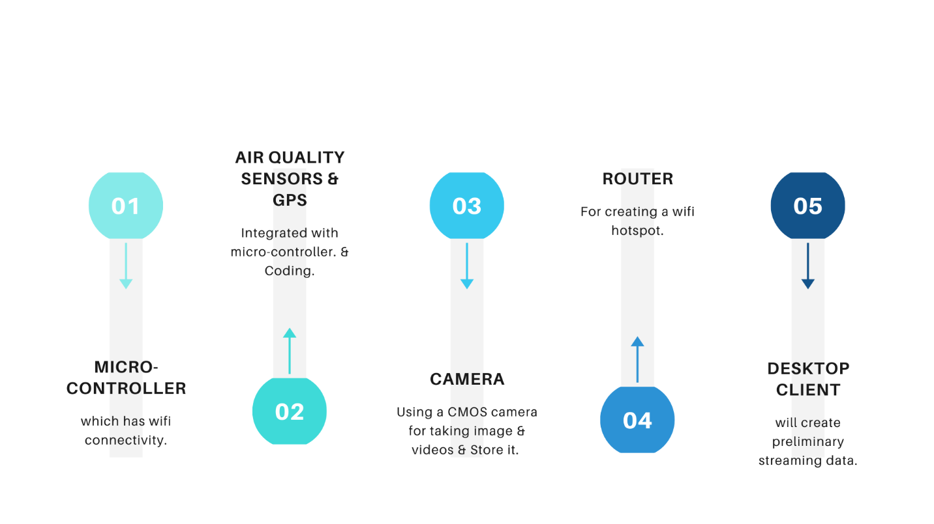

**Fig 2: Project Proposal.**

**Modelling of Drone with required Features:**

For making the drone we followed several steps and also face difficulties & challenges as well. As we are using GPS in our Drone, in our experiments we will choose path for drone, called mapping so that this drone can fly over that area and will take data for that specified area. It means before the flight of the drone area will be fixed. The vital part of the project is taking data from the air. So that stability of the DRONE really matters. What we do the programming part for our drone this is the other important part. The more features we added to our drone it will cost more. As our plan is to make it cost effective, we cut off the other features, put only the most important features to fulfill the project goal. The sensors we are using will not that costly, we are using two sensors only for detecting pollutants. but some the tools are costly such as the drone body, except this all other things we are using are cheap enough.

Sometimes sensors reading can be inaccurate, for making our data more accurate, we will use a humidity sensor.

1. ***Current State:***

We can explain our total project into three stages. Such as 1) Building Drone 2) Integrating sensors and 3) Data collecting and analysis.

1. **Drone Building:**

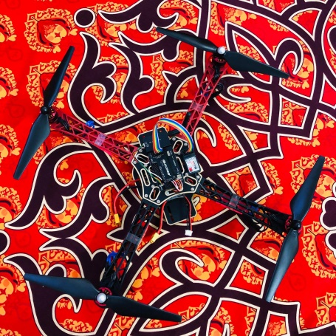

**Fig 3: Proposed Model of DRONE.**

We've done building our drone. This is the main part of the project. It will travel through a specific area, track down the specific area of the pollution and will return back to the station. As it follows the specific path so it is very easy to get all the updated condition of any specific area. It is cost effective too. Here we are using four brushless motor, Per motor draws 2A while hovering. So, 4 motor draws 8A for hovering in the air. Our selected battery is 2.2Ampere/hour. That means it cans delivery 2.2A for 1 hour (60minutes).

The calculation,

2.2A delivers 60 minutes 1A delivers 60x2.2 minutes 8A delivers (60x2.2)/12 minutes =16.5 minutes (theoretically, moderate air condition) Practically it varies from 12-14 minutes.

Theoretically, the range of our drone is 1KM, but practically it varies from 600-800 meters depending on the weather. Transmitter to the receiver has to communicate via 2.4Ghz. 6 individual channels, means 6 separate PWM values. But technically it shows some variations. Usually, we use 'mission planner' from the laptop or 'Droid planner' from mobile to select the specific path for the Drone, but in case of an error, we alternatively use a remote to control The drone. We give the input from Mobile/Laptop then it flies accordingly and returns at the same place.

We use Soldering iron, Screw box, Hex screw, Double side tape as supporting tools. Still, We didn't integrate the sensor part with the drone. We are practicing over it, recording the challenges and the limitations of it.

1. **Sensor Part:**

Sensor part is our main external circuit which will be integrated with drone. The purpose of this circuit is to detect the pollutants from the air. For which we are using several gas sensors for detecting gases and PM (Particulate Matter) Sensor for detecting dust pollutants. We also use a camera for taking the structural views so that we can conclude for what reason the pollutants varies over time. We are done with making the circuit. Currently we are testing the sensitivity of the sensors (record the response of the sensors by making artificial pollutants). After that we will integrate it with the drone and will measure the data in various place of Dhaka city. We are offering a cost effective and reliable solution using low cost sensors.

1. **Analysis part:**

For analyzing data, we will take inputs as string from the sensor and read through an application. So, we can do statistical analysis and also compare the results with bar graph. Besides we are using some softwires for running the code. We will take data from a specified place for several times like, we will take data morning, noon & afternoon and can analyze the variation of density pollutants in a same place. We also will take data of different places, such as: from a crowded area and uncrowded area. Thus, we will analyze the project outcomes.