L3 Demo and State Machine

L.O.S.T

Logically Oriented Software Technology

Rasmus Tilljander - rati10@student.bth.se

Erik Hörlin - erhd10@student.bth.se

Calle Ketola - cake10@student.bth.se

Kim Hansson - kiha10@student.bth.se

# State Machine Diagrams

Here follows three state machine diagrams describing the system. They were included already in the L2 documentation but the system has not changed from the original design in a way that would require these diagrams to be redrawn.

## Overview

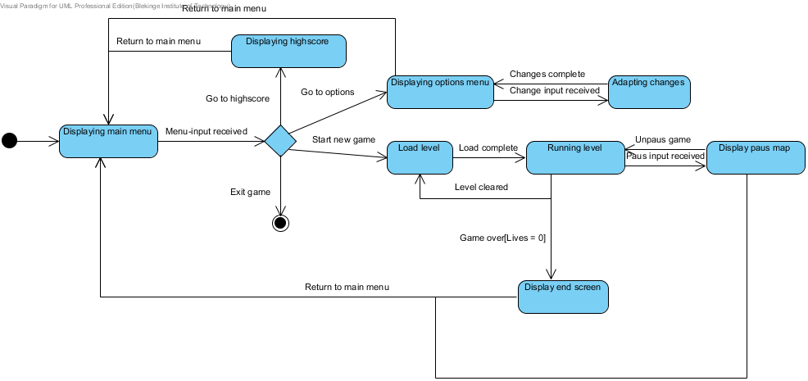

## ScreenHandler

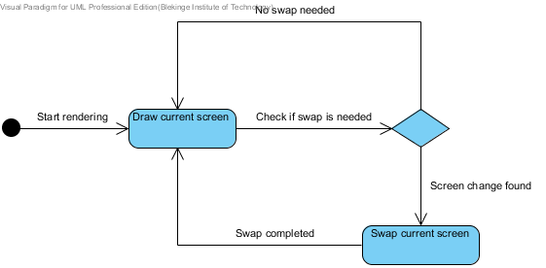

## Pacman

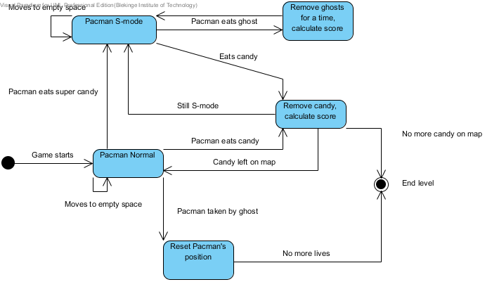

## Demo Links

Here follows two links to videos made in game from the project. We apologise in advance for the poor sound quality. Because the site had a restriction on the amount that could be uploaded per week we had to lower the quality of the video, thus making the sound lag behind the scenes and become lowered.

https://vimeo.com/41909202

https://vimeo.com/41909164