📊 AI Prediction Report
User: Merbin raj

🔹 Prediction Summary
Total Customers: 440833
Churn Customers: 249472
Connected Customers: 191361
Model Accuracy: 97.76%

Churn Prediction Graph
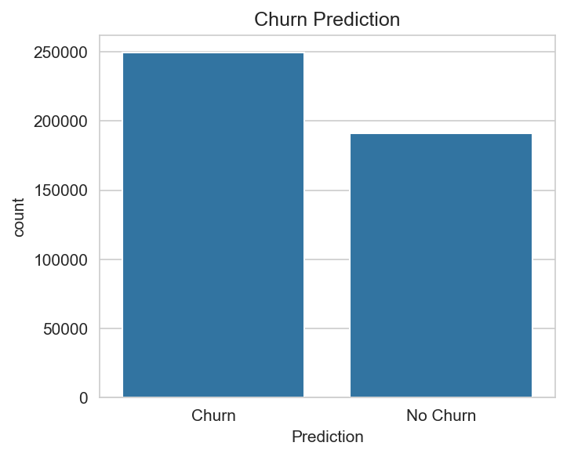

Feature Correlation Heatmap
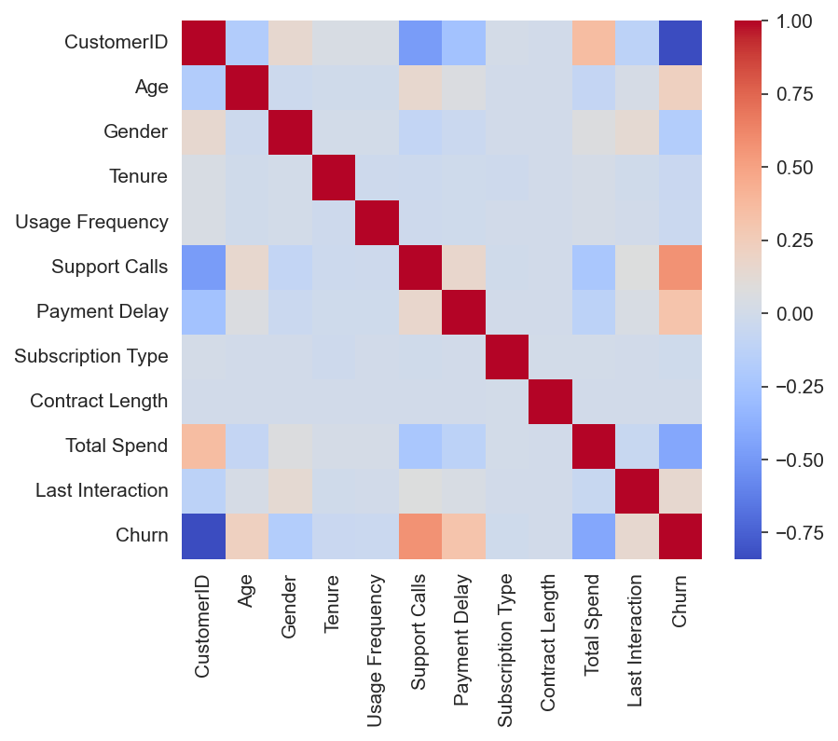

Confusion Matrix
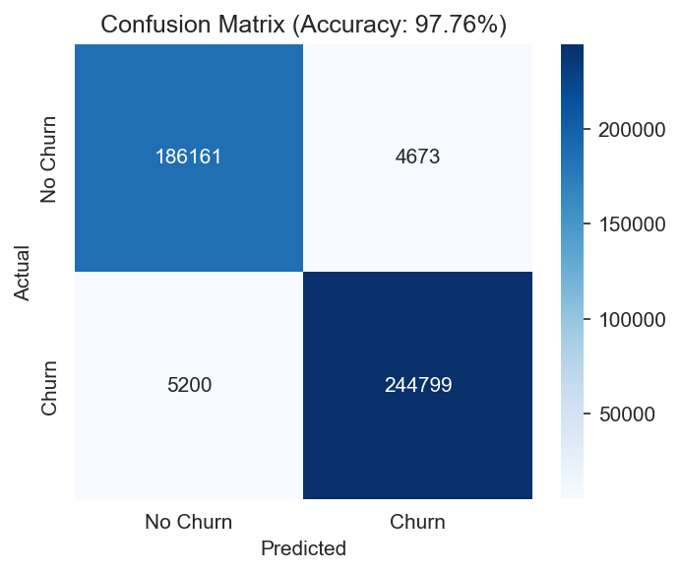

🔹 Prediction Table (Top 100 Rows)
CustomerID | Age | Gender | Tenure | Usage Frequency | Support Calls | Payment Delay | Subscription Type | Contract Length | Total Spend | Last Interaction | Churn | Prediction
2.0 | 30.0 | 0 | 39.0 | 14.0 | 5.0 | 18.0 | 2 | 0 | 932.0 | 17.0 | 1 | Churn
3.0 | 65.0 | 0 | 49.0 | 1.0 | 10.0 | 8.0 | 0 | 1 | 557.0 | 6.0 | 1 | Churn
4.0 | 55.0 | 0 | 14.0 | 4.0 | 6.0 | 18.0 | 0 | 2 | 185.0 | 3.0 | 1 | Churn
5.0 | 58.0 | 1 | 38.0 | 21.0 | 7.0 | 7.0 | 2 | 1 | 396.0 | 29.0 | 1 | Churn
6.0 | 23.0 | 1 | 32.0 | 20.0 | 5.0 | 8.0 | 0 | 1 | 617.0 | 20.0 | 1 | Churn
8.0 | 51.0 | 1 | 33.0 | 25.0 | 9.0 | 26.0 | 1 | 0 | 129.0 | 8.0 | 1 | Churn
9.0 | 58.0 | 0 | 49.0 | 12.0 | 3.0 | 16.0 | 2 | 2 | 821.0 | 24.0 | 1 | Churn
10.0 | 55.0 | 0 | 37.0 | 8.0 | 4.0 | 15.0 | 1 | 0 | 445.0 | 30.0 | 1 | Churn
11.0 | 39.0 | 1 | 12.0 | 5.0 | 7.0 | 4.0 | 2 | 2 | 969.0 | 13.0 | 1 | Churn
12.0 | 64.0 | 0 | 3.0 | 25.0 | 2.0 | 11.0 | 2 | 2 | 415.0 | 29.0 | 1 | Churn
13.0 | 29.0 | 1 | 18.0 | 9.0 | 0.0 | 30.0 | 1 | 2 | 930.0 | 18.0 | 1 | Churn
14.0 | 52.0 | 0 | 21.0 | 6.0 | 3.0 | 26.0 | 1 | 1 | 830.0 | 19.0 | 1 | Churn
15.0 | 22.0 | 1 | 41.0 | 17.0 | 10.0 | 25.0 | 0 | 2 | 265.0 | 23.0 | 1 | Churn
16.0 | 48.0 | 0 | 35.0 | 25.0 | 1.0 | 13.0 | 0 | 0 | 518.0 | 17.0 | 1 | Churn
17.0 | 24.0 | 1 | 4.0 | 9.0 | 4.0 | 22.0 | 2 | 2 | 204.0 | 4.0 | 1 | Churn
18.0 | 49.0 | 1 | 56.0 | 17.0 | 2.0 | 30.0 | 2 | 2 | 975.0 | 17.0 | 1 | Churn
19.0 | 19.0 | 0 | 38.0 | 23.0 | 7.0 | 11.0 | 0 | 2 | 978.0 | 3.0 | 1 | Churn
20.0 | 47.0 | 1 | 41.0 | 14.0 | 1.0 | 5.0 | 1 | 0 | 151.0 | 19.0 | 1 | Churn
21.0 | 24.0 | 1 | 44.0 | 13.0 | 5.0 | 4.0 | 1 | 1 | 669.0 | 13.0 | 1 | Churn
22.0 | 42.0 | 1 | 15.0 | 16.0 | 2.0 | 14.0 | 1 | 2 | 262.0 | 16.0 | 1 | Churn
23.0 | 57.0 | 0 | 55.0 | 27.0 | 3.0 | 3.0 | 0 | 0 | 212.0 | 10.0 | 1 | Churn
24.0 | 39.0 | 0 | 43.0 | 2.0 | 4.0 | 15.0 | 0 | 1 | 577.0 | 6.0 | 1 | Churn
25.0 | 27.0 | 1 | 44.0 | 28.0 | 8.0 | 18.0 | 2 | 0 | 436.0 | 30.0 | 1 | Churn
26.0 | 27.0 | 0 | 52.0 | 8.0 | 7.0 | 3.0 | 2 | 1 | 434.0 | 19.0 | 1 | Churn
27.0 | 59.0 | 1 | 26.0 | 21.0 | 0.0 | 10.0 | 1 | 1 | 822.0 | 17.0 | 1 | Churn
28.0 | 21.0 | 1 | 2.0 | 21.0 | 7.0 | 22.0 | 0 | 0 | 435.0 | 21.0 | 1 | Churn
29.0 | 60.0 | 0 | 18.0 | 16.0 | 8.0 | 28.0 | 0 | 2 | 830.0 | 22.0 | 1 | Churn
30.0 | 65.0 | 0 | 29.0 | 29.0 | 0.0 | 5.0 | 1 | 0 | 857.0 | 18.0 | 1 | Churn
31.0 | 35.0 | 0 | 38.0 | 20.0 | 6.0 | 2.0 | 1 | 0 | 574.0 | 19.0 | 1 | Churn
32.0 | 18.0 | 1 | 37.0 | 15.0 | 8.0 | 6.0 | 1 | 1 | 800.0 | 29.0 | 1 | Churn
33.0 | 56.0 | 0 | 59.0 | 5.0 | 10.0 | 27.0 | 2 | 2 | 424.0 | 2.0 | 1 | Churn
35.0 | 35.0 | 1 | 40.0 | 27.0 | 8.0 | 28.0 | 1 | 1 | 232.0 | 17.0 | 1 | Churn
36.0 | 29.0 | 1 | 43.0 | 12.0 | 2.0 | 10.0 | 1 | 0 | 289.0 | 6.0 | 1 | Churn
37.0 | 20.0 | 1 | 37.0 | 24.0 | 7.0 | 5.0 | 2 | 0 | 371.0 | 20.0 | 1 | Churn
38.0 | 63.0 | 0 | 51.0 | 3.0 | 5.0 | 12.0 | 2 | 0 | 288.0 | 15.0 | 1 | Churn
39.0 | 22.0 | 0 | 39.0 | 8.0 | 2.0 | 4.0 | 2 | 0 | 939.0 | 21.0 | 1 | Churn
40.0 | 25.0 | 0 | 53.0 | 2.0 | 10.0 | 13.0 | 0 | 2 | 336.0 | 13.0 | 1 | Churn
42.0 | 28.0 | 1 | 24.0 | 24.0 | 8.0 | 6.0 | 2 | 1 | 572.0 | 28.0 | 1 | Churn
43.0 | 51.0 | 1 | 30.0 | 4.0 | 10.0 | 29.0 | 1 | 1 | 770.0 | 23.0 | 1 | Churn
44.0 | 32.0 | 1 | 6.0 | 22.0 | 3.0 | 12.0 | 0 | 1 | 413.0 | 20.0 | 1 | Churn
45.0 | 38.0 | 0 | 28.0 | 23.0 | 6.0 | 17.0 | 0 | 2 | 993.0 | 28.0 | 1 | Churn
46.0 | 52.0 | 1 | 17.0 | 26.0 | 4.0 | 6.0 | 0 | 1 | 871.0 | 26.0 | 1 | Churn
48.0 | 37.0 | 1 | 30.0 | 30.0 | 7.0 | 13.0 | 0 | 2 | 929.0 | 13.0 | 1 | Churn
49.0 | 31.0 | 0 | 4.0 | 29.0 | 7.0 | 22.0 | 2 | 0 | 488.0 | 6.0 | 1 | Churn
50.0 | 30.0 | 1 | 24.0 | 7.0 | 6.0 | 13.0 | 2 | 0 | 874.0 | 3.0 | 1 | Churn
51.0 | 23.0 | 0 | 26.0 | 21.0 | 7.0 | 24.0 | 0 | 2 | 988.0 | 20.0 | 1 | Churn
52.0 | 35.0 | 1 | 37.0 | 11.0 | 7.0 | 13.0 | 2 | 1 | 631.0 | 7.0 | 1 | Churn
53.0 | 21.0 | 0 | 56.0 | 11.0 | 9.0 | 9.0 | 0 | 2 | 626.0 | 1.0 | 1 | Churn
54.0 | 56.0 | 0 | 44.0 | 11.0 | 2.0 | 11.0 | 2 | 0 | 583.0 | 9.0 | 1 | Churn
55.0 | 53.0 | 0 | 18.0 | 21.0 | 1.0 | 23.0 | 0 | 2 | 717.0 | 15.0 | 1 | Churn
56.0 | 41.0 | 0 | 18.0 | 27.0 | 10.0 | 3.0 | 0 | 1 | 111.0 | 19.0 | 1 | Churn
57.0 | 33.0 | 1 | 6.0 | 12.0 | 7.0 | 29.0 | 2 | 2 | 869.0 | 10.0 | 1 | Churn
58.0 | 18.0 | 1 | 55.0 | 29.0 | 9.0 | 21.0 | 2 | 2 | 296.0 | 22.0 | 1 | Churn
59.0 | 26.0 | 1 | 60.0 | 9.0 | 10.0 | 1.0 | 2 | 1 | 643.0 | 2.0 | 1 | Churn
60.0 | 42.0 | 0 | 7.0 | 9.0 | 1.0 | 11.0 | 0 | 0 | 196.0 | 18.0 | 1 | Churn
61.0 | 36.0 | 1 | 2.0 | 15.0 | 3.0 | 29.0 | 1 | 1 | 501.0 | 4.0 | 1 | Churn
62.0 | 22.0 | 0 | 43.0 | 16.0 | 8.0 | 21.0 | 2 | 1 | 966.0 | 30.0 | 1 | Churn
63.0 | 47.0 | 1 | 59.0 | 24.0 | 6.0 | 26.0 | 1 | 0 | 288.0 | 26.0 | 1 | Churn
64.0 | 30.0 | 1 | 52.0 | 23.0 | 1.0 | 27.0 | 0 | 0 | 400.0 | 20.0 | 1 | Churn
66.0 | 21.0 | 0 | 51.0 | 1.0 | 8.0 | 6.0 | 1 | 0 | 618.0 | 13.0 | 1 | Churn
67.0 | 27.0 | 0 | 40.0 | 17.0 | 3.0 | 1.0 | 0 | 0 | 999.0 | 17.0 | 1 | Churn
68.0 | 27.0 | 1 | 34.0 | 13.0 | 4.0 | 26.0 | 0 | 2 | 214.0 | 6.0 | 1 | Churn
69.0 | 32.0 | 1 | 3.0 | 5.0 | 1.0 | 6.0 | 2 | 0 | 282.0 | 20.0 | 1 | Churn
70.0 | 44.0 | 0 | 43.0 | 1.0 | 8.0 | 28.0 | 2 | 1 | 548.0 | 28.0 | 1 | Churn
71.0 | 38.0 | 1 | 10.0 | 9.0 | 6.0 | 5.0 | 1 | 0 | 820.0 | 18.0 | 1 | Churn
72.0 | 34.0 | 0 | 5.0 | 18.0 | 3.0 | 29.0 | 1 | 2 | 575.0 | 10.0 | 1 | Churn
73.0 | 42.0 | 1 | 29.0 | 23.0 | 0.0 | 6.0 | 1 | 1 | 736.0 | 5.0 | 1 | Churn
74.0 | 61.0 | 1 | 41.0 | 4.0 | 7.0 | 23.0 | 0 | 2 | 753.0 | 23.0 | 1 | Churn
75.0 | 22.0 | 1 | 45.0 | 13.0 | 5.0 | 16.0 | 0 | 2 | 538.0 | 26.0 | 1 | Churn
76.0 | 59.0 | 0 | 53.0 | 13.0 | 0.0 | 4.0 | 2 | 2 | 688.0 | 14.0 | 1 | Churn
77.0 | 53.0 | 1 | 54.0 | 18.0 | 10.0 | 0.0 | 0 | 1 | 679.0 | 1.0 | 1 | Churn
78.0 | 37.0 | 1 | 17.0 | 23.0 | 9.0 | 23.0 | 1 | 2 | 530.0 | 19.0 | 1 | Churn
79.0 | 65.0 | 0 | 33.0 | 28.0 | 9.0 | 22.0 | 1 | 1 | 383.0 | 17.0 | 1 | Churn
80.0 | 61.0 | 0 | 6.0 | 7.0 | 4.0 | 26.0 | 2 | 0 | 369.0 | 20.0 | 1 | Churn
81.0 | 40.0 | 0 | 58.0 | 8.0 | 2.0 | 10.0 | 0 | 1 | 760.0 | 28.0 | 1 | Churn
82.0 | 63.0 | 0 | 38.0 | 19.0 | 7.0 | 21.0 | 2 | 2 | 768.0 | 7.0 | 1 | Churn
83.0 | 19.0 | 1 | 53.0 | 3.0 | 6.0 | 17.0 | 2 | 1 | 808.0 | 19.0 | 1 | Churn
84.0 | 45.0 | 0 | 25.0 | 4.0 | 8.0 | 13.0 | 1 | 2 | 681.0 | 26.0 | 1 | Churn
85.0 | 59.0 | 1 | 17.0 | 21.0 | 1.0 | 24.0 | 2 | 2 | 858.0 | 2.0 | 1 | Churn
86.0 | 55.0 | 0 | 54.0 | 2.0 | 5.0 | 0.0 | 2 | 1 | 159.0 | 29.0 | 1 | Churn
87.0 | 44.0 | 1 | 13.0 | 12.0 | 7.0 | 7.0 | 2 | 1 | 624.0 | 15.0 | 1 | Churn
88.0 | 61.0 | 1 | 7.0 | 12.0 | 7.0 | 2.0 | 1 | 0 | 925.0 | 9.0 | 1 | Churn
89.0 | 46.0 | 1 | 41.0 | 12.0 | 3.0 | 25.0 | 1 | 0 | 531.0 | 11.0 | 1 | Churn
90.0 | 22.0 | 1 | 45.0 | 17.0 | 3.0 | 28.0 | 0 | 2 | 769.0 | 3.0 | 1 | Churn
92.0 | 46.0 | 0 | 47.0 | 4.0 | 5.0 | 10.0 | 2 | 0 | 299.0 | 5.0 | 1 | Churn
93.0 | 64.0 | 1 | 31.0 | 20.0 | 9.0 | 24.0 | 1 | 2 | 785.0 | 16.0 | 1 | Churn
94.0 | 28.0 | 0 | 22.0 | 16.0 | 1.0 | 7.0 | 2 | 1 | 389.0 | 16.0 | 1 | Churn
95.0 | 35.0 | 0 | 19.0 | 28.0 | 4.0 | 28.0 | 0 | 2 | 507.0 | 5.0 | 1 | Churn
96.0 | 55.0 | 0 | 34.0 | 6.0 | 2.0 | 7.0 | 0 | 0 | 392.0 | 5.0 | 1 | Churn
97.0 | 35.0 | 1 | 3.0 | 17.0 | 6.0 | 23.0 | 0 | 0 | 392.0 | 7.0 | 1 | Churn
98.0 | 45.0 | 0 | 23.0 | 4.0 | 5.0 | 1.0 | 1 | 2 | 699.0 | 12.0 | 1 | Churn
99.0 | 24.0 | 1 | 1.0 | 20.0 | 0.0 | 17.0 | 0 | 2 | 268.0 | 4.0 | 1 | Churn
100.0 | 44.0 | 0 | 8.0 | 11.0 | 7.0 | 26.0 | 1 | 1 | 139.0 | 3.0 | 1 | Churn
102.0 | 60.0 | 1 | 55.0 | 7.0 | 3.0 | 18.0 | 2 | 1 | 871.0 | 4.0 | 1 | Churn
103.0 | 40.0 | 0 | 46.0 | 24.0 | 3.0 | 1.0 | 0 | 1 | 404.0 | 28.0 | 1 | Churn
104.0 | 26.0 | 1 | 15.0 | 11.0 | 0.0 | 20.0 | 0 | 0 | 269.0 | 1.0 | 1 | Churn
105.0 | 58.0 | 0 | 28.0 | 17.0 | 0.0 | 24.0 | 1 | 2 | 820.0 | 29.0 | 1 | Churn
106.0 | 56.0 | 0 | 16.0 | 11.0 | 5.0 | 18.0 | 1 | 1 | 590.0 | 27.0 | 1 | Churn
107.0 | 42.0 | 0 | 12.0 | 6.0 | 8.0 | 25.0 | 0 | 1 | 566.0 | 11.0 | 1 | Churn
108.0 | 52.0 | 1 | 29.0 | 2.0 | 2.0 | 4.0 | 0 | 0 | 435.0 | 27.0 | 1 | Churn
Generated on: 2026-04-10 19:43:26

