GE01 Agile Teams, Python and Version Control

**Goals:**

* Communicate effectively in a variety of professional contexts within a team, doing oral or written presentations, and creating technical documents.
* Function effectively as a member/leader of a team engaged in retrospectives and scrums while participating in different roles
* Apply various tools and agile principles utilizing concepts (scrum, behavior-driven development, pair programming , version control

**Effort:** Collaborative Assignment (see [CS Academic Integrity](https://docs.google.com/document/d/1vfCpxFGn-7Ru5fplmD7lK1n_cSFvhtMtsVQg4SCs2OU/edit) )

**Points:** 40 (see rubric in canvas)

**Deliverables:** Upload this document with your answers. If you are a Scrum Coach or Tech Lead also submit that separate assignment on canvas.

**Due Date:** See Canvas

**Description:** Learning how to learn new technologies. This is not about getting everything working perfectly the first time but collaborating, communicating, finding resources and problem solving on your own and in a team. Remember you are all honing your skills to work together and lead. Be professional and responsible. Most of all do not panic if you run into issues. Note the issues and how you resolved them. Think about what information is helpful to have for the next time you do this.

Order of getting assistance for this GE but make sure you include a link to your resources or the person outside your group that assisted.

1. Team
2. Online resources or AI tools
3. In class server in python or git/github discussion areas
4. Deb

|  |  |
| --- | --- |
| Brief description | Resource |
|  |  |
|  |  |
|  |  |

**Communication and explaining in writing.** Explanations provide elaboration of the concepts using supporting evidence and vocabulary.

1 Team Information

2 Python Introduction

3 Version Control

4 Agile Team Member Roles Only Need to Complete

# 1 Team Information

Team name:

Team members and roles

|  |  |
| --- | --- |
| **Roles and Responsibilities** | **Names** |
| **Scrum Coach**  - see [Team Scrum Coach Role](https://docs.google.com/document/d/1GR04En225yi5699ZT5YfhHyLCjrdrBgr/edit) assignment on canvas.  - submit this and the scrum coach assignment | Jon Gurnik |
| Tech Lead Git/Github  - see[Team Technical Lead Role](https://docs.google.com/document/d/1Xx4bqHQNuvfuxozaaf5tZc7bhP_dUdlc/edit#heading=h.86wae0otsxbo) assignment on canvas.  - submit this and the scrum coach assignment  -technical documentation can be stored in the team github | Mercury Goodwin |
| Tech Lead Python  - see[Team Technical Lead Role](https://docs.google.com/document/d/1Xx4bqHQNuvfuxozaaf5tZc7bhP_dUdlc/edit#heading=h.86wae0otsxbo) assignment on canvas.  - submit this and the scrum coach assignment | Noah Holt |
| Team Member  - Participates in team meetings  - Help with technical documentation  - Help with troubleshooting issues and understanding concepts | Gunnar Anderson |
| Team Member  - Participates in team meetings  - Help with technical documentation  - Help with troubleshooting issues and understanding concepts |  |

# 2 Python Introduction

Explain the following python concepts and include examples. Think about what you want to include in your technical documentation for python.

|  |
| --- |
| Virtual Environment  With python, you have the ability to control the version of python you are using for particular projects. These are referred to as virtual environments.  Say you were writing a program to exploit a problem in python but a patch fixes it, you can continue by creating an environment for that instance of python to continue testing. |
| Classes and Objects  Classes are a blueprint where an object was built using said blueprint  Dog is an animal, So using the general layout of an animal you can create a dog. |
| Dictionaries  They are an array but instead of being in numerical order, you give them a “key” or way to access  Phone Ex: [“josepie”: 719-123-4567] now you can access the phone number by asking which number belongs to josepie |
| Regular Expressions: A way to set up guidelines to compare inputs to that except. Using pattern Characters such as the * for anything, ? for single any character or exact matches.  “ [*@*.com](mailto:*@*.com) “ could be used for email matching. |

# 3 Version Control

For this activity you need to coordinate with your team. **You will be using command line to work with your local repository and github updates**

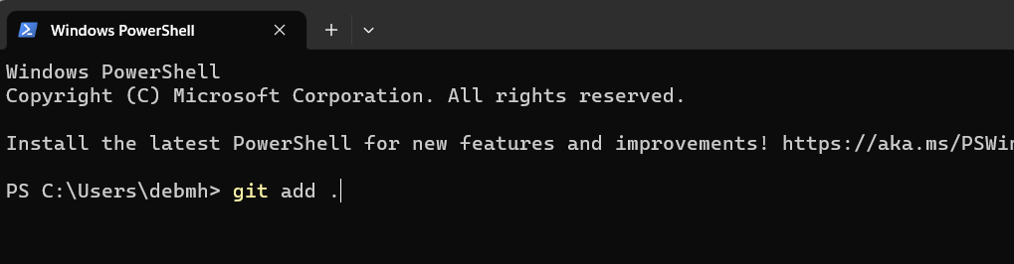

1. Scrum Coach
   1. Creates agenda and updates agenda
   2. Encourages collaboration
   3. Communicates through discord but
2. Tech lead creates
   1. a shared repository cs3300[team name] that is public
   2. Contains gitignore for python <https://github.com/github/gitignore/blob/main/Python.gitignore>
   3. contains your team as collaborators
   4. Adds a simple python file that displays the team name
   5. Create branch called iteration01

|  |
| --- |
| Put a link to the team github repository. |

1. Each team member should clone the repository into their local environment.

|  |
| --- |
| Paste the command you used to clone the remote repository to your local repository. |

1. Each team member should be working on the iteration01 branch

|  |
| --- |
| Paste the commands to change branches |

1. Each person adds code to display their name after the team name. Then take turns having 2 people version it in the local docker repository and update the remote server. Then have one person work with the other person on one computer to do the merging and commit the merged information. See example merge issue below. Take a screenshot of each merge that is completed and put the screenshot of your merge below. Complete this until each person has added their information. The example below is not a python example.

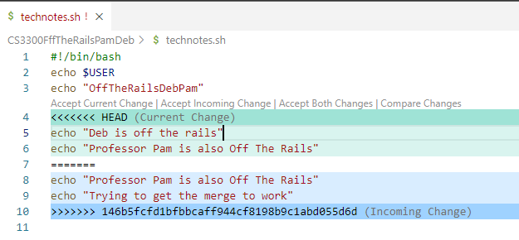

|  |
| --- |
| 5.1: List and explain the commands needed to merge and a screenshot of the file like the one above for your merge you did with someone else in your group. |

1. After all the introduction updates are complete the tech lead will merge to the main branch. Do not delete the PracticeMerge branch. Then tag the code as release 1.0

Version Control Concepts

As you answer each question in your own words, **include any resources you used to help you. You can use AI to help you understand but answer in your own words.**

3.1 Explain software version control. Address in your description branches, commits, merges, tags.

|  |
| --- |
|  |

3.2 Research what Git is and what its relationship is to software version control. Include how GitHub integrates with git.

|  |
| --- |
|  |

3.2 Explain the following commands and include examples: commit, pull, push, add, clone, status, log, checkout

|  |
| --- |
|  |

3.3 Describe at least three benefits of a version control system and include an example for each that would be related to industry.

|  |
| --- |
|  |

# 4 Agile Team Member Roles Only Need to Complete

**Team Member:**

Share how you contributed to the team

|  |
| --- |
|  |

Explain how it went for you being the team member. What was one of your strengths in this role and would be a growth area for you?

|  |
| --- |
|  |

Summarize any issues and resolutions encountered by the team.

|  |
| --- |
|  |