DOCUMENTATION

ASSIGNMENT ASSIGNMENT_3

STUDENT NAME: …Mercean Dragos
GROUP: ……….30424

CONTENTS

1. Assignment Objective 3
2. Problem Analysis, Modeling, Scenarios, Use Cases 3
3. Design 3
4. Implementation 3
5. Results 3
6. Conclusions 3
7. Bibliography 3

Assignment Objective
- Main objective: Implement an application for interacting with a relational database that stores a warehouses orders.
- Sub-objectives:
  - Implement immutable classes for modeling table objects.
  - Implement a layered architecture through Business-logic layer classes and Data access object classes for each table
  - Define a relational database schema..
  - Build a GUI
  - Test

Problem Analysis, Modeling, Scenarios, Use Cases
Functional Requirements:
- “SELECT *”,
- “SELECT WHERE id = ?”,
- “INSERT”,
- “UPDATE”,
- “DELETE” operations
Use cases :
-managing warehouse orders and bills

Design
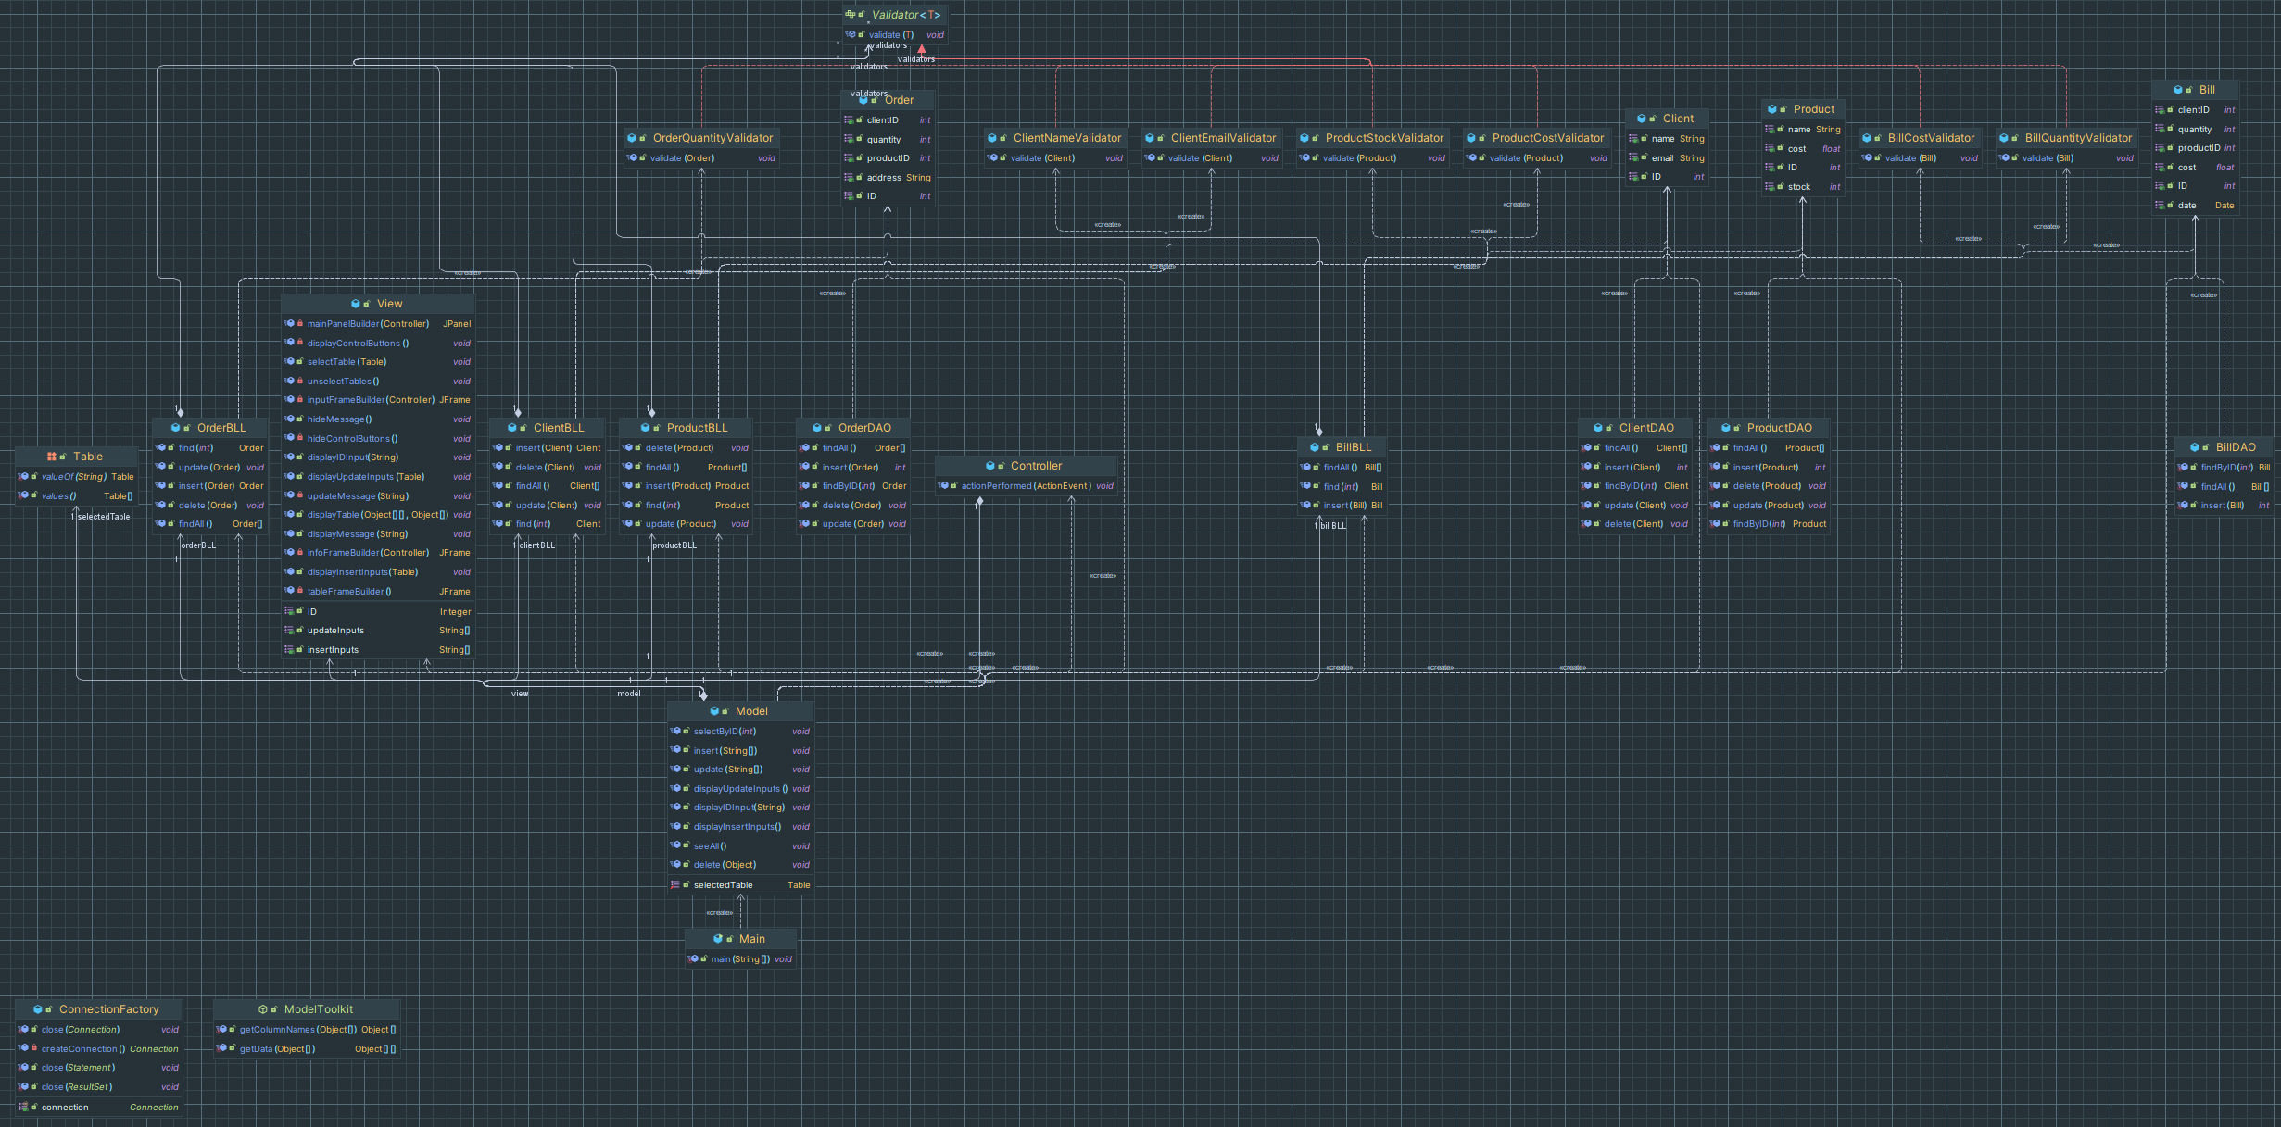

The application implements multiple software design patterns, such as a Model-View-Controller GUI design pattern, a Singleton ConnectionFactory class and a layered architecture.

Implementation
Models package:

The models package contains all the Model object (or Table object) classes, namely Client, Product, Order and Bill. These classes are immutable and serve to model the rows of the tables inside the database.
The models package also contains the Validators package which will be described next…

Validators package:

The validators package contains all classes that implement the Validator interface. Instances of these classes are used to validate the data that the user is attempting to insert into the tables. As such, they appear in the Business-logic layer classes.

DAO package:

The DAO package contains Data access object for each table in the database. These object implement the five types of operations required for interacting with a database. Using PreparedStatements, DAOs can prepare the database for the imminent query or update, thus speeding up the interaction.

BLLs package:

The BLL package contains the Business-logic layer classes for each table. These layers impose quality on the data that is inserted into the database. They also help with SQL error interpretation.

ConnectionFactory class:

This class is a Singleton class, that assures that only one instance of this class is created. It also manages the connection between the application and the database, as well as the objects needed for using said connection. These objects include ResultSets, ResultSetMetaData objects and PreparedStatements.

Presentation package:
The presentation package contains the three Model-View-Controller classes that implement the GUI for the application. The user interacts with the application through the controller, which manipulates the model ,which updates the view, which in turn informs the user.

Results
Main frame
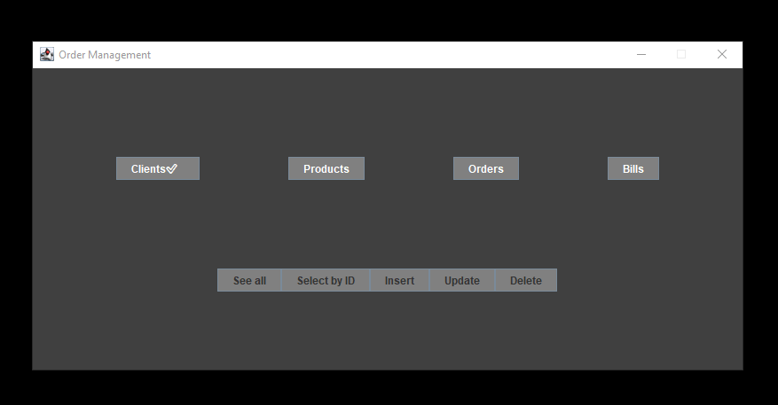

Input frame
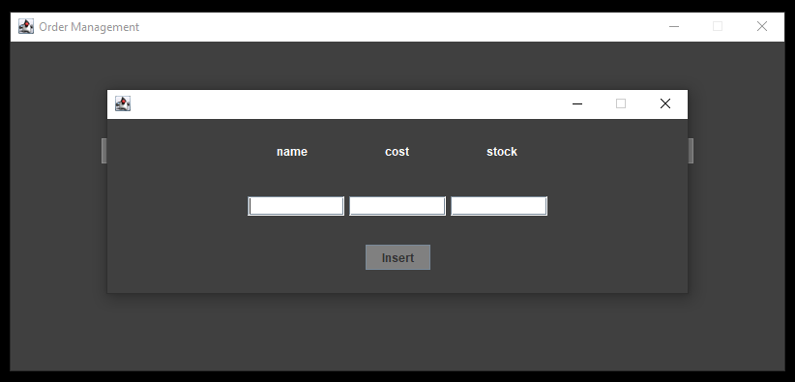

Message frame
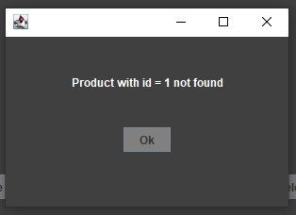

Table frame
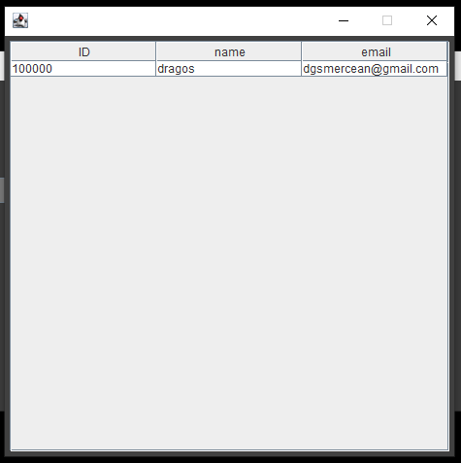

Conclusions
What have I learned:
- Improved my understanding of the Model-View-Controller design pattern
- Familiarized myself with Layered architectures
- Bettered my database management system knowledge
- Exercised my GUI building skills

Bibliography
- Oracle Java documentation https://docs.oracle.com/en/java/
- Various StackOverflow questions https://stackoverflow.com/

