DOCUMENTATION

ASSIGNMENT 1

STUDENT NAME: Mercean Dragos
GROUP: 30424

CONTENTS

1. Assignment Objective 3
2. Problem Analysis, Modeling, Scenarios, Use Cases 3
3. Design 3
4. Implementation 3
5. Results 3
6. Conclusions 3
7. Bibliography 3

Assignment Objective
The following should be presented: (i) main objective of the assignment (1 phrase), and (ii) the sub-objectives in a table/list. The sub-objectives represent the steps required to follow for achieving the main objective. Each sub-objective will be described and the section in which it will be addressed should be mentioned.
- Main objective
Implementing a calculator for operations on polynomials
- Sub-objectives
- implementing a Polynomial class and methods for manipulating its objects (Section.4)
- implementing an abstract class for operations on polynomial objects (Addition, Subtraction, Multiplication, Division, Differentiation and Integration) (Section.4)
- building a GUI (Section.4)
- testing (Section.5)

Problem Analysis, Modeling, Scenarios, Use Cases
The functional requirements should be presented together with the use cases (use case diagrams and use case description). The use cases’ descriptions can be done as a flow-chart or as a list containing the execution steps of each use case.
Use Cases:
- solving systems of linear or non-linear equations
Functional requirement: correct and efficient implementations of operations on polynomials
- rewriting of polynomials in a more readable manner
Functional requirement: I/O methods for converting to and from internal representations of polynomials
- working with large systems of equations and/or polynomials of larger orders
Functional requirement: efficient storage of polynomials
- educational assistance
Functional requirement: intuitive GUI

Scenarios:
Implementing a step by step visualization of Gaussian elimination algorithm for solving systems of linear equations
Step 1. Importing Polynomial.java and PolynomialOperations.java classes
Step 2. Implementing the algorithm using PolynomialOperations.add() and PolynomialOperations.multiply() methods
Step 3. Outputting each step using Polynomial.print() method

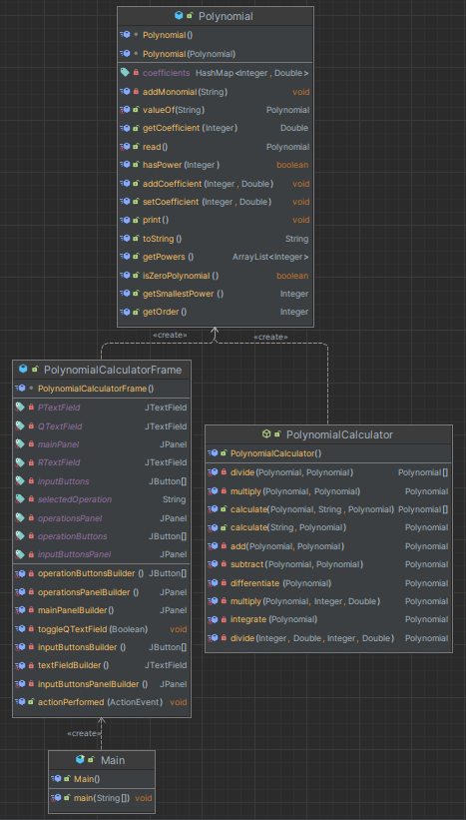
Design
The following should be presented: OOP design of the application, UML package and class diagrams, used data structures, defined interfaces and used algorithms (if it is the case).

The project is split into 3 main classes:
- Polynomial
- PolynomialCalculator
- PolynomialCalculatorFrame

Data structures:
- HashMap<>

Implementation
Each class will be described (fields, important methods). Also, the implementation of the graphical user interface will be described.
Polynomial class

The implementation makes use of the HashMap data structure provided by the JDK. This approach leads to a more efficient storing method of the polynomials, having only non-zero entries that can also be quicly accessed. The class contains methods for manipulating, reading and printing Polynomial objects, making it reusable.

PolynomialCalculator class

An abstract class that implements operations on polynomials, namely addition, subtraction, multiplication, division, differentiation and integration. It takes inspiration from the factory class design method, by having two calculate methods that provide a more unified and friendly method for using its methods. These functions adapt to the needs of the return value of the performed operation. Because the division operation needs to return a quotient as well as the rest, all operation results are wrapped inside a adequately sized Polynomial array. An addition will return an array of size 1 and a division will return an array of size 2.

PolynomialCalculatorFrame class

This class provides a GUI for a more user-friendly interaction with the program. It extends the JFrame class provided by the Java Swing toolkit and implements the ActionListener Interface also provided by the AWT package. This means that this class represents the controller of the model-view-controller architectural pattern.

The GUI consists of a main panel that contains all of the components. The SpringLayout layout manager allows for great flexibility and adaptability and was chosen for this reason. There are 5 main components: PTextField, QTextField, RTextField, operationsPanel and inputsPanel.

PTextField allows the input of the first polynomial operand as a string.
QTextField allows the input of the second polynomial operand as a string.
RTextField outputs the result of the operation.
The operationsPanel provides a selection method for operation that the user wants performed on the operands.
The inputPanel provides the needed characters or functions for inputting polynomials and executing operations.

QTextField will update to reflect the needed number of text fields according to the selected operation.

Results

Conclusions
The following should be presented: conclusions, what you have learned from the assignment, future developments.
What I have learned:
- The advantages of using the HashMap data structure
- How to use the GrigBagLayout layout manager
- Problem solving skills
- Factory class design pattern

Improvements:
    - The result text field is not editable, making it impossible to copy results from it
    - Faster multiplication implementation using Fast Fourier Transform algorithm
    - Using the enter key on the keyboard to perform the selected operation

Bibliography
Oracle documentation for the JDK docs.oracle.com
Various questions on StackOverflow stackoverflow.com

