Dog Food
Pantry Management & Recipe Application
Final Report
Document Author: Zachary Amith
Code Author: Zachary Amith & Claude Opus 4.7 (comments, git commit messages)
Course: Data Structures (Java)
Project: Pantry Management & Recipe Application

Program Overview

What the program does
Dog Food is a Java console application that manages a kitchen pantry and helps the user decide what to cook. The user can add, view, and remove ingredients; browse a built-in recipe book; find recipes they can make based on the current pantry; sort recipes by how close they are to being makeable; search recipes by name; generate shopping lists for recipes they want to make; cook a recipe (which deducts the required quantities automatically); and undo any pantry change.

Why it is useful
The program addresses a common kitchen problem: owning ingredients but lacking the creativity to combine them into meals. By cross-referencing what the user has against a recipe library, Dog Food reduces food waste, helps the user avoid buying ingredients they already own, and turns a stocked kitchen into a list of concrete cooking options.

Algorithms

1. Match Scoring

Steps
- Take a recipe and the pantry as input
- For each ingredient in the recipe's required array, look it up in the pantry hash table
- Count how many are present and divide by the total required
- Multiply by 100 and round to an integer percentage

Explanation
Match scoring asks “how close am I to making this recipe?” without caring about exact quantity. It is used to rank and filter recipes for display.

Big-O
O(M) per recipe, where M is the number of required ingredients. O(N · M) for the full recipe book.

2. Inventory Deduction

Steps
- Take a recipe as input
- Snapshot the pre-cook state of every required ingredient and push it onto the undo stack as a single composite action
- For each required ingredient, subtract the required quantity from the owned quantity
- If the resulting quantity is zero or below, remove the ingredient from the pantry entirely

Explanation
When the user cooks a recipe, the pantry needs to update. The snapshot-and-push step makes the entire cook a single undoable action so one undo restores all affected ingredients at once.

Big-O
O(M) per cook.

3. Merge Sort

Steps
- Copy the recipe linked list into an array of size N
- Compute each recipe's match score once and store in a parallel integer array
- Recursively split the array in half and sort each half
- Merge two sorted halves by walking both with two pointers and writing the higher-scoring recipe at each position

Explanation
Used to display recipes in descending order of match score so the user sees the best matches first. Merge sort was chosen over quicksort because its worst-case time is also O(N log N), giving predictable performance regardless of input order. Scores are computed up front to avoid recomputing them in every comparison.

Big-O
O(N log N) time, O(N) extra space for merging.

4. Linear Search

Steps
- Lowercase the user's query
- Walk the recipe linked list from the head
- For each recipe, lowercase its name and check whether it contains the query as a substring
- Append matches to a result string

Explanation
Used to find recipes by partial name. A linear walk is appropriate because the recipe book is small and unsorted; a binary search would require maintaining sorted order on every insert.

Big-O
O(N · L) where N is the recipe count and L is the average name length.

Data Structures

Hash Table — Pantry
Stores: the user's current ingredient inventory, keyed by ingredient name.
Why chosen: match scoring queries the pantry once per ingredient per recipe. With N recipes and M ingredients each, a list-backed pantry would cost O(N · M · P) where P is pantry size. A hash table reduces that to O(N · M) on average. Implemented from scratch with separate chaining and 16 buckets.
Used in: Pantry.put, get, contains, remove, deduct.

Linked List — LinkedList<T>
Stores: dynamic collections of the recipe book and the shopping list.
Why chosen: both collections are highly dynamic. Recipes are added and (in a future version) removed; shopping items are added as the user browses recipes and removed one by one as they shop. A linked list handles those operations without shifting elements like an array would. Implemented from scratch as a generic LinkedList<T> and reused by both RecipeBook and ShoppingList.
Used in: RecipeBook.recipes, ShoppingList.items.

Stack — Stack<T>
Stores: the pantry's undo history as PantryAction objects.
Why chosen: undo is naturally LIFO (last in first out), the most recent action is the first to be reversed. Implemented from scratch as a generic linked stack so it grows without an upper bound and without resize cost.
Used in: Pantry.history (every put, remove, and deduct pushes; undo pops).

Array — inside Recipe
Stores: the fixed list of required ingredients for a recipe.
Why chosen: a recipe's required ingredients don't change after the recipe is defined. An array is the honest choice: fixed size, O(1) indexed access for the match-scoring loop, no list overhead.
Used in: Recipe.required.

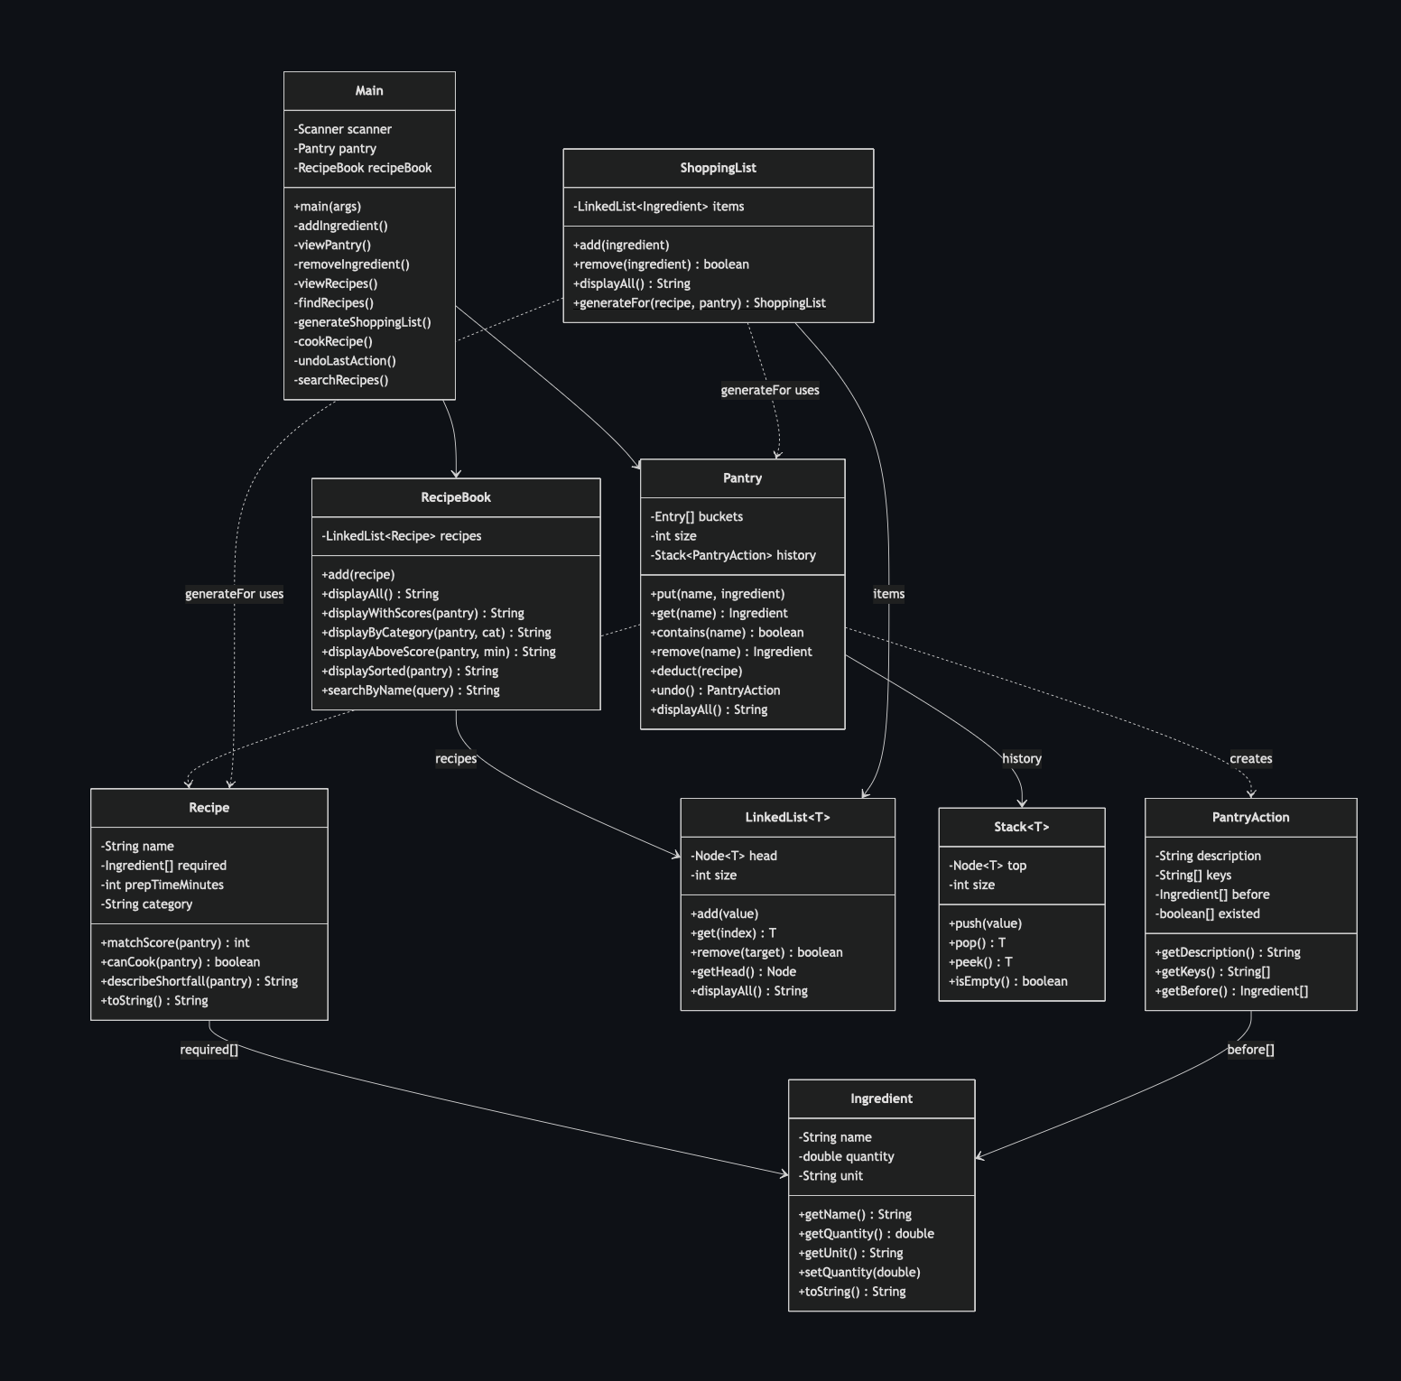

Development Reflection

One problem I encountered and solved
Early in Phase 4 I designed PantryAction to store before-snapshots of affected ingredients but didn't include the ingredient names explicitly. This worked for remove (where the ingredient existed beforehand and the snapshot wasn't null), but broke when undoing a put on a brand-new key the snapshot was null, so there was no way to know which key to remove on undo. I caught this mid-commit when writing the undo logic and reshaped PantryAction to include a parallel keys array. The fix took about ten minutes once I understood the issue, but the deeper lesson was that snapshot-based undo needs the identifier even when the prior value is absent.

One design improvement I discovered
When implementing merge sort, my first pass recomputed each recipe's match score inside every comparison in the merge step. For five recipes that didn't matter, but I realized that matchScore itself is O(M), so the sort would have been O(N · M · log N) instead of O(N log N). The fix was to compute all N scores once before sorting and carry them in a parallel integer array. The lesson: avoid doing expensive work in the inner loop of a recursive algorithm.

What I would add in version 2
- Persistent storage so the pantry and recipe book survive between sessions (currently both reset on every run)
- User-defined recipes: currently the book is hardcoded with five starter recipes; users should be able to add their own through the menu
- Smarter unit handling: the pantry currently can't tell that “1 cup of flour” and “120 grams of flour” refer to the same thing
- Redo to complement the undo stack
- Recipe tags beyond a single category, so a recipe can be both “vegan” and “quick”

