
International School
Capstone Project 2
CMU-SE 451
C2SE.05
Project Proposal
Version 1.3
Date: September 29, 2026
CASTRAVISION
Submitted by:
Tri, Tran Thanh
Phuc, Dinh Van
Minh,Tran Quoc
Dat, Le Thanh
Approved by PhD Sanh,Tran Kim
Proposal Review Panel Representative:
Name Signature Date

Capstone Project 1- Mentor:
Name PhD Sanh,Tran Kim Signature Date
PROJECT INFORMATION
Project acronym | CASTRAVISION
Project tiltle | Automated Strategy Assistant for Advertising and Marketing Campaigns.
Start date | 27 Aug 2026 | End Date | 27 August 2026
Lead Instution | International School, Duy Tan University
Project mentor | PhD Sanh,Tran Kim
Scrum master/ project leader & contact details | Dat, Le Thanh  Scrum Master  Gmail: lthanhdat85@gmail.com  Tel: 0353846505
Partner organization | Duy Tan University
Team members | Name | Email | Tel
28210234461 | Tri, Tran Thanh | Tritran0932523321@gmail.com | 0932523321
28211106860 | Phuc, Dinh Van | VanPhucDinh.2004@gmail.com | 0934987967
28211101651 | Minh,Tran Quoc | mtranquoc77@gmail.com | 0766709535
28211100334 | Dat, Le Thanh | lthanhdat85@gmail.com | 0353846505
DOCUMENT APPROVALS
The following signatures are required for approval of this document.
Dat, Le Thanh  28211100334  Scrum Master | Signature | Date
Tri, Tran Thanh  28210234461  Team Member | Signature | Date
Minh,Tran Quoc  28211101651  Team Member | Signature | Date
Phuc, Dinh Van  28211106860  Team Member | Signature | Date

REVISION HISTORY
Version | Date | Comment | Author
v1.0 | 27 Aug 2026 | Draft | Tri, Tran Thanh
1.2 | 29/09/2026 | Aligned Sprint 1 implementation and FR01 contract. | Project Team
1.3 | 29/09/2026 | Expanded Section 12 with System Context, C&C, Module, and Allocation views. | Project Team

TABLE OF CONTENT
1. Project Title..............................................................6
2. Team Members...............................................................6
3. Supervisor(s)..............................................................7
4. Problem Statement..........................................................7
5. Survey / Existing Solutions................................................8
6. Objectives and Scope.......................................................9
7. Key Features & Requirements................................................10
7.1 Non-Functional Requirements............................................22
8. Constraints and Assumptions................................................24
9. Target Users / Stakeholders................................................25
10. Technology Stack..........................................................26
11. Methodology & Development Plan............................................27
11.1 Team Role Assignment..................................................29
12. System Architecture Overview..............................................30
12.1 System Context View...................................................30
12.2 Component and Connector View..........................................31
12.3 Module View...........................................................32
12.4 Allocation View.......................................................33
14. Potential Risks and Mitigation Strategies.................................34
15. Expected Outcomes / Deliverables..........................................34
17. References................................................................35

1. Project Title
CastraVision – Automated Strategy Assistant for Advertising and Marketing Campaigns.

2. Team Members
Table 1: Project Team Members and Role Assignment
No  . | Full Name | Student ID | Contact Email | Phone | Primary Role | Key Responsibilities
1 | Dat, Le Thanh | 28211100334 | lthanhdat85@gmail.com | 0353846505 | Scrum Master | Sprint facilitation and overall coordination; leads the AI Strategy & Competitor Insight modules (FR01, FR09).
2 | Minh,Tran Quoc | 28211101651 | mtranquoc77@gmail.com | 0766709535 | Team Member | AI Content Generation and Budget Optimization modules (FR02, FR03).
3 | Tri, Tran Thanh | 28210234461 | Tritran0932523321@gmail.com | 0932523321 | Team Member | Platform & workflow modules: Approval Workflow, Workspace/RBAC, Notification Center, Audit Log (FR04, FR06, FR10, FR11).
4 | Phuc, Dinh Van | 28211106860 | VanPhucDinh.2004@gmail.com | 0934987967 | Team Member | Data & reporting modules: Performance Dashboard, Report Export, Campaign Data Import, Account & Profile Management (FR05, FR07, FR08, FR12).

3. Supervisor(s)
The CastraVision project is supervised by academic faculty from the International School, Duy Tan University.
Table 2: Capstone Project Supervisor Information
Full Name | Academic Title / Degree | Department / Division | Institution/ Affiliation | Contact Email
Tran Kim Sanh | PhD |  | International School, Duy Tan University

Supervisory Guidance: PhD Sanh,Tran Kim meets with the team every two weeks to review sprint progress, give advice on system architecture, review grading rules, and ensure the project meets university curriculum standards. Because CastraVision is an educational software project built for university courses, an outside enterprise supervisor is not required.

4. Problem Statement
Currently, most small and medium-sized enterprises (SMEs), as well as their in-house marketing teams, face significant challenges in designing and executing effective advertising campaigns: a lack of personnel with deep expertise in communication strategy, limited advertising budgets, and difficulties in analyzing customer data and measuring campaign performance in real time. The process of planning, selecting channels, allocating budgets, and optimizing advertising content still largely relies on personal experience, leading to budget wastage, low conversion rates, and difficulty competing with larger enterprises that boast professional marketing teams.
The impact of this issue is clearly evident in the steadily rising Customer Acquisition Cost (CAC) amid a lack of corresponding improvement in campaign effectiveness—especially as advertising platforms (Facebook Ads, Google Ads, TikTok Ads, etc.) continuously update their distribution algorithms. CastraVision was developed to address this challenge by leveraging artificial intelligence (AI) to automatically analyze data, recommend strategies, generate content, and optimize advertising budgets, enabling businesses to make faster, more accurate decisions while reducing the operational costs associated with maintaining a dedicated marketing team.

5. Survey / Existing Solutions
The issue of automating marketing with AI has been approached by numerous international platforms from various perspectives. The table below summarizes several representative solutions and compares them against the approach adopted by CastraVision.:
Table 1: Comparative Analysis
Product/System | How to solve a problem | Constraint
HubSpot Marketing Hub | Automate email marketing, manage leads, and generate campaign performance reports. | High costs, focus on inbound marketing, and lack of capability to automate paid advertising strategies.
Jasper AI | Generate advertising content and marketing articles using AI based on user prompts. | Supports content creation only; lacks the capability to develop overall strategies or analyze campaign performance.
AdCreative.ai | Generate ad creatives and predict performance using AI. | Focuses on visuals/creative; lacks modules for strategic planning or multi-channel budget allocation.
Meta Advantage+ / Google Performance Max | Automatically optimize ad delivery and budgets within the platform's own ecosystem. | Operating solely within a closed advertising platform, lacking a multi-channel strategic perspective, and failing to customize to the business's specific characteristics.

The distinctive feature of CastraVision: Integrating three distinct functional domains—where previous solutions often operated in isolation: (1) data analysis and development of comprehensive strategies, (2) creation of targeted advertising content tailored to specific customer segments, and (3) optimal allocation of multi-channel budgets based on real-world performance data—into a unified system designed for small and medium-sized enterprises at an affordable cost.

6. Objectives and Scope
Overall Objective: Develop an AI assistant system capable of automatically supporting businesses in formulating strategies, creating content, and optimizing budgets for advertising and marketing campaigns, based on real-world data.
Specific objectives (SMART):
- Develop an object-analyzing module and propose a marketing strategy within the first 8 weeks of the project, achieving a minimum customer segmentation accuracy of 80% on the test dataset.
- Develop an automated content creation module (ad copy, suggested images) for at least three channels (Facebook, Google, TikTok) by the 12th week.
- Developing an optimal budget allocation module based on performance data helps reduce the cost per conversion (CPA) by at least 15% compared to manual allocation in the experimental scenario.
- Complete a dashboard for monitoring and reporting campaign performance in real time before the project concludes.

Scope:
Within the scope: Analyzes customer and campaign data, proposes marketing strategies, generates advertising content using AI, optimizes budget allocation, and provides a performance monitoring dashboard; target users include SME business owners and marketing staff/management personnel.
Outside the scope: The system does not support direct payment or third-party advertising purchases on external platforms; it does not handle corporate accounting or financial transactions; and in the initial phase, it does not support any languages other than Vietnamese and English.

7. Key Features & Requirements
The CastraVision system focuses on core feature groups designed to automate the analysis, development, and management of advertising campaigns:
- Analyze target audiences and customer behavior based on previous campaign data.
- Propose an overall marketing strategy (channels, messaging, and preliminary budget) aligned with business objectives.
- Automatically generate advertising content (headlines, descriptions, and image suggestions) personalized for each customer segment.
- The approval and refinement process (Human-in-the-loop) allows users to edit, regenerate, or approve content and budget proposals before they are applied.
- Optimize multi-channel budget allocation based on real-time performance data.
- Provide a dashboard for monitoring and visually reporting KPIs (CTR, CPA, ROAS, etc.) and support periodic report exports in PDF/CSV format.
- Analyze competitors and market trends.
- Manage workspaces and role-based access control (RBAC).
- Record activity logs (Audit Log) and maintain the version history of content.
- Import and normalize historical campaign data (CSV/Excel import or Mock Ads API synchronization).
- Provide in-app and email notifications for important events.
- Manage user accounts and business profiles.

Group A — Core Functions (AI Engine)

FR01 — Customer Analysis & Marketing Strategy Recommendation Module
Field | Content
Primary Actor | Business Owner / Marketing Manager
Description | The user enters business information and campaign objectives; the system uses AI to analyze them and return an overall strategy recommendation.
Input | Industry, business size, campaign objective (brand awareness/conversion/increase sales), planned budget, and historical campaign data (if available, from FR08)
Output | Recommended channels (with preliminary allocation percentages), key message, target customer segments, and rationale (brief AI explanation)
Main Flow | 1. The user fills in the business information form.  2. The system calls the AI Service (RAG + LLM) with context from the business profile and historical data.  3. The AI returns a structured strategy recommendation (JSON).  4. The system displays the result in the UI.  5. The user can request a "Re-analyze" using adjusted inputs.
Preconditions | The user has created a Workspace (FR06) and has a business profile (FR12).
Exceptions | LLM API timeout/error → display an error message and Retry button (per NFR04); missing required input fields → validate before submission.
Priority | High (Must-have)

FR02 — AI-Powered Multi-Channel Advertising Content Generation Module
Field | Content
Primary Actor | Marketing Specialist / Content Creator
Description | From an existing strategy (FR01) or a manually entered brief, the system generates advertising content (headline, description, CTA, and image suggestions) for each channel and customer segment.
Input | Source strategy (from FR01) or manually entered brief, target channel (FB/Google/TikTok), customer segment, and brand tone of voice
Output | A list of content sets (one set per channel: headline, description, CTA, and image suggestion as a text prompt), with multiple variants possible
Main Flow | 1. The user selects the source strategy and target channels.  2. The system calls the AI Service to generate content using channel-specific templates.  3. Results are displayed as cards with "Regenerate" and "Edit" buttons.  4. The user selects the preferred option and moves it to the approval workflow (FR04).
Preconditions | At least one strategy (FR01) or a valid brief exists.
Exceptions | Generated content violates the prohibited-keyword filter (as specified in the constraints) → block display and require regeneration; LLM timeout → Retry/Fallback (NFR04).
Priority | High (Must-have)

FR03 — Performance-Based Budget Allocation Optimization Tool
Field | Content
Primary Actor | Business Owner / Marketing Manager
Description | Periodically (or on demand), the system analyzes performance data (CTR/CPA/ROAS) and recommends reallocating the budget across channels/campaigns.
Input | Performance data by channel/campaign (from FR08 or Mock API), current total budget, and constraints (minimum/maximum budget per channel, if any)
Output | Recommended new budget by channel, percentage change from the current allocation, and estimated CPA after application
Main Flow | 1. The system (cron job/Celery task) or user triggers the calculation.  2. Retrieve the latest performance data.  3. Run the optimization algorithm (rule-based or AI-assisted).  4. Generate the recommendation.  5. Send it to the approval workflow (FR04) and send a notification (FR10).
Preconditions | At least one performance-data cycle is available for comparison.
Exceptions | Insufficient historical data → display "insufficient data for optimization" and do not generate a recommendation.
Priority | High (Must-have)

FR09 — Competitor Analysis & Market Trends Module
Field | Content
Primary Actor | Business Owner / Marketing Specialist
Description | The user enters a competitor name or industry keyword; the system summarizes content trends and estimated advertising activity as additional context for FR01.
Input | Competitor name or industry keyword, and period of interest
Output | Summary of popular content trends, estimated advertising spend/frequency (simulated data during development), and suggestions for differentiation.
Main Flow | 1. The user enters a competitor/keyword.  2. The system queries a data source (web search or simulated dataset).  3. The AI summarizes and structures the results.  4. The results are displayed, with an option to "Use as context" when creating a strategy in FR01.
Preconditions | Optional; an independent supporting function.
Exceptions | No competitor data found → display a clear notification rather than leaving the screen blank.
Priority | Medium (Should-have)

Group B — Platform & Operational Functions

FR04 — Content/Budget Approval & Editing Workflow (Human-in-the-loop)
Field | Content
Primary Actor | Manager / Admin (approver, editor, rejector). Member only creates the original proposals in FR02/FR03 and cannot directly operate the approval screen.
Description | A centralized interface for viewing, editing, requesting AI regeneration, or approving/rejecting content and budget proposals before they are officially recorded.
Input | Proposals from FR02/FR03 in "Pending" status
Output | The proposal's new status (Approved/Rejected/Edited) and a change-history record (sent to FR11)
Main Flow | 1. A new proposal appears in the Pending Queue.  2. The Manager reviews the details.  3a. Approve → update the official status.  3b. Reject → require a reason.  3c. Edit → save the revision, then approve it or send it back for review.  4. Record the action in the Audit Log (FR11) and notify relevant users (FR10).
Preconditions | The user performing Approve/Reject/Edit must have the Manager or Admin role in the Workspace (FR06); Members are not granted access to the approval screen.
Exceptions | Two users approve the same proposal simultaneously (race condition) → lock the record while it is being processed (optimistic/pessimistic lock).
Priority | High (Must-have)

FR06 — Workspace Management & Role-Based Access Control (Workspace & RBAC)
Field | Content
Primary Actor | Admin
Description | Create/manage multiple Workspaces, invite members, and assign Admin/Manager/Member roles with different permissions in each Workspace.
Input | Workspace name, invitee email, and assigned role
Output | The user's Workspace list, member list with roles, and applicable permission matrix
Main Flow | 1. The Admin creates a new Workspace.  2. Members are invited by email (an invite token is generated).  3. A member receives the invitation and accepts assignment to the Workspace with the corresponding role.  4. The Admin can change roles or remove members at any time.
Preconditions | The user has an account (FR12).
Exceptions | Inviting an email without an account → send a registration link with the invite; removing the last Admin from a Workspace → block the operation (at least one Admin must always remain).
Priority | High (Must-have)

FR10 — Notification Center
Field | Content
Primary Actor | All registered users
Description | Send in-app and email notifications for events requiring attention, such as new proposals awaiting approval, budgets approaching limits, and abnormal campaign metrics.
Input | System events generated by other modules (FR03, FR04, etc.)
Output | In-app notifications (badge/list) and email (depending on user settings)
Main Flow | 1. A source module generates an event (e.g., FR03 creates a new proposal).  2. The Notification Service receives the event through a queue (Celery/Redis).  3. Recipients are determined by role/Workspace.  4. The notification is stored in the database and pushed in real time (WebSocket/polling).  5. Email is sent if the user enables the option.
Preconditions | The user has configured notification channels (default: in-app enabled, email disabled).
Exceptions | Email delivery failure → log the error without blocking the main flow; excessive duplicate notifications → batch them by event type.
Priority | Medium (Should-have)

FR11 — Audit Log & Version History
Field | Content
Primary Actor | Admin (log viewer), system (automatic log writer)
Description | Record all important changes (who changed what, when, and before/after values) and allow users to review content/budget version history.
Input | Change events from other modules (FR02, FR03, FR04, FR06, etc.)
Output | A log list filterable by user/time/action type, with detailed diffs between versions
Main Flow | 1. Each important data write/edit triggers a log entry (through middleware/decorator at the service layer).  2. The log stores the actor, action, entity, before/after values, and timestamp.  3. The Admin opens the Audit Log screen, filters entries, and views details.
Preconditions | None; runs automatically in the background alongside other modules.
Exceptions | Logs may become large over time → an archiving/pagination strategy is required (outside the MVP scope and noted for future work).
Priority | Medium (Should-have)

Group C — Data & Reporting Functions

FR05 — Real-Time Campaign Performance Monitoring Dashboard
Field | Content
Primary Actor | Business Owner / Marketing Manager
Description | Display visual charts (line/bar/pie) for CTR, CPA, ROAS, and Impressions by channel/campaign/time period, with filters.
Input | Normalized performance data (from FR08) and user-selected filters (Workspace, time, channel)
Output | Charts and summarized data tables (KPI cards + charts)
Main Flow | 1. The user opens the Dashboard and selects filters.  2. The backend queries/aggregates data (Redis caching may be used to reduce load).  3. The aggregated data is returned.  4. The frontend renders the charts (real-time or periodic polling).
Preconditions | The Workspace contains campaign data (through FR08 or generated by FR02/FR03).
Exceptions | No data → display an empty state with import guidance (pointing to FR08).
Priority | High (Must-have)

FR07 — Periodic Report Export in PDF/CSV Format
Field | Content
Primary Actor | Business Owner / Marketing Manager
Description | Allow users to select the time period, campaigns, and metrics to export; the system generates a PDF file (with charts) or CSV (raw data).
Input | Time period, campaign/channel list, and export format (PDF/CSV)
Output | PDF/CSV file available for download or sent by email
Main Flow | 1. The user selects report export parameters.  2. The backend creates a Celery task to generate the file (avoiding request blocking).  3. When the task is complete, the file is temporarily stored and a notification (FR10) with a download link is sent.  4. The user downloads the file within X hours before it is deleted.
Preconditions | Data exists within the selected period.
Exceptions | No data in the selected period → report an error before creating the task; PDF generation failure → retry once, then report the error to the user.
Priority | Medium (Should-have)

FR08 — Campaign Data Import & Normalization
Field | Content
Primary Actor | Marketing Specialist / Admin
Description | Allow historical campaign data to be imported through CSV/Excel files or synchronized through a Mock Ads API; normalize the data into a common metric structure before passing it to other modules.
Input | CSV/Excel file uploaded by the user, or response from the Mock Ads API
Output | Normalized campaign data stored in the database, with a report of successfully imported and failed rows
Main Flow | 1. The user uploads a file or selects "Sync from platform" (mock).  2. The system parses and validates each row (correct format and required fields present).  3. Map source data columns to the internal standard schema (CTR/CPA/ROAS/Impression).  4. Store the data in the database and display the import result report (X successful rows, Y failed rows with reasons).
Preconditions | The file uses a supported format (CSV/XLSX according to the specified template).
Exceptions | Invalid file format/missing required columns → reject the entire file or import valid rows and report detailed row-level errors.
Priority | High (Must-have — other modules depend on this data).

FR12 — User Account & Business Profile Management
Field | Content
Primary Actor | All users
Description | Register/login, manage the business profile (industry, business size, target customers) used as input for FR01, and manage personal information.
Input | Registration information (email/password) and business profile information
Output | Created account, JWT session token, and business profile stored in the database
Main Flow | 1. Registration: enter email/password → email verification (optional for MVP).  2. Login: authenticate and issue JWT (access + refresh token).  3. After the first login: complete the business profile (onboarding).  4. The profile and password can be updated at any time.
Preconditions | None (initial system function).
Exceptions | Email already exists → show a registration error; multiple incorrect password attempts → temporarily lock the account (rate limit according to NFR03).
Priority | High (Must-have)

7.1 Non-Functional Requirements
In addition to the functional requirements (FR01–FR12) above, the system must satisfy the following quality attributes. Numeric thresholds are indicative targets to be validated with real benchmark results during integration and system testing.
Table: Non-Functional Requirements Specification (NFR01–NFR06)
NFR ID | Quality Area | Requirement & Acceptance Standard | Technical Approach
NFR01 | Performance | AI-generated strategy suggestions (FR01) return within an acceptable time budget (target: p95 ≤ 8s under normal load); dashboard queries (FR05) return within 2s for datasets within the Sprint 3 scope. | Asynchronous processing (Celery/Redis) for long-running AI/report tasks; caching for frequent dashboard queries.
NFR02 | Usability | In a usability test with at least 5 representative users, at least 80% shall complete the core flow (create strategy → generate content → submit for approval) without facilitator intervention. | Responsive React form, consistent custom CSS components, semantic labels, clear loading/error states, and inline browser/API validation.
NFR03 | Security | All API endpoints require JWT authentication; role-based authorization (RBAC) is enforced for every Workspace-scoped action; passwords are hashed; repeated failed login attempts are rate-limited (see FR12). | JWT + RBAC middleware, password hashing (bcrypt), login rate limiting.
NFR04 | Reliability & Error Handling | A failed or timed-out call to an external AI/Ads API shall not corrupt existing data; the system shall display a clear error state and allow the user one controlled retry (Retry button, see FR01/FR02) before falling back gracefully. | Try/catch with retry logic, circuit-breaker/fallback pattern, Celery task status tracking.
NFR05 | Maintainability | Frontend, Backend and AI Service layers remain logically separated with documented API contracts; critical service logic is covered by unit tests. | Modular Django services, typed Pydantic request/response schemas, a documented JSON contract, Django tests, frontend lint/build checks, and CI validation.
NFR06 | Deployment & Portability | The full development environment (frontend, backend, database, Redis, worker) shall start from a single docker-compose command on a fresh machine. | Docker & docker-compose configuration, .env.example template.

8. Constraints and Assumptions
Constraints:
- The project implementation period is limited to one semester (approximately 14–16 weeks).
- The budget for using AI APIs (e.g., large language models) is limited by trial/free-plan quotas, requiring strict control of call frequency (Rate Limit) and token usage.
- Initial training and testing data consist primarily of simulated or publicly available data; large-scale real-world enterprise data is not yet available.
- Due to barriers in verifying actual business accounts on advertising platforms (Meta, Google), API integration during development will use a Sandbox/Test Accounts environment or a Mock API set.
- AI-generated content must comply with basic keyword filtering rules to avoid violating advertising network content policies.
- The development team has a limited number of members and works in parallel with the academic curriculum.
Assumptions:
- Users have a stable Internet connection and use modern devices (computers or smartphones with a standard web browser).
- Businesses have existing advertising campaign data available or are willing to enter data manually during the initial setup phase.
- Third-party advertising APIs (Facebook Ads API, Google Ads API, etc.) remain stable throughout the development period.
- Cross-platform reporting data can be standardized into a common measurement structure (CTR, CPA, ROAS, Impression) before being processed by the model.

9. Target Users / Stakeholders
The primary users of CastraVision include small and medium-sized enterprise (SME) owners, marketing staff/managers in organizations without highly specialized marketing departments, and small freelancer or agency teams that need tools for rapid multi-account planning.
User Personas by Role:
- SME Business Owner / Marketing Manager (Decision Maker): Needs an overview of investment effectiveness, budget control, monitoring of key conversion metrics (ROAS, CPA), and approval of communication plans recommended by the system.
- Marketing Specialist / Content Creator (Operator): Directly uses the tool to quickly generate ideas, create multi-channel advertising content (Facebook, Google, TikTok), refine messages by segment, and monitor actual campaign responses.
- Freelancer / Small Agency (Multi-account Manager): Needs to manage multiple workspaces for different clients simultaneously, optimize planning time, and quickly generate performance reports.
Stakeholders:
- Project Team: Responsible for requirements analysis, architecture design, software development, AI integration, and full-system testing.
- Supervisors & Reviewers: Monitor project progress and assess technical feasibility, software architecture quality, and project deliverables.
- System Administrator: Monitors system stability, manages resources, tracks AI API call traffic, and ensures data security and protection.
Benefits Provided by the System:
- Save campaign planning time through automated AI-generated strategic recommendations.
- Reduce operating costs and optimize marketing budgets through data-driven decisions.
- Maintain human control over AI-generated proposals through a transparent editing and approval workflow.
- Visually monitor multi-channel performance through a centralized real-time interface.

10. Technology Stack
Component | Recommended Technology
Frontend | React 19 + Vite 8, responsive custom CSS
Backend | Python 3.13 + Django 6; Celery 5 worker
Database | PostgreSQL 16 + pgvector; Redis 7 broker/cache
AI/ML | OpenAI Responses API and embeddings; pgvector RAG; deterministic local fallback for development and AI failures
Third-Party Integrations | Planned mock/sandbox adapters for Meta, Google Ads, TikTok, and related platforms
Infrastructure & Deployment | Docker Desktop / WSL 2, Docker Compose, GitHub Actions CI
Other Supporting Tools | Figma (UI/UX design), Postman (API testing), Jira/Trello (task management), Draw.io (diagrams), Postman Agent (API testing)

11. Methodology & Development Plan
The project is implemented using an Agile/Scrum methodology with two-week sprints, allowing the team to continuously adjust requirements and prioritize features based on feedback throughout development. The overall weekly plan is summarized below:
Phase | Timeline | Main Content
Sprint 1 – Platform & Core AI | Weeks 1–5 | • Weeks 1–2: Conduct surveys and gather detailed requirements; design the system architecture (Client, API Gateway, AI Service, Data Layer, External Integration); select React/Vite with responsive CSS, Python/Django, PostgreSQL/pgvector, and Redis/Celery; design the database schema for FR12 and FR08.  • Weeks 3–5: Develop FR12 – User Account & Business Profile Management; FR08 – Campaign Data Import & Normalization; FR01 – Customer Analysis & Strategy Recommendation; FR02 – Multi-Channel Advertising Content Generation.  • Result: The workflow for entering business information → receiving strategy recommendations → generating content → importing historical data is operational.
Sprint 2 – Optimization Workflow & Platform | Weeks 6–10 | • Weeks 6–7: Develop FR03 – Budget Allocation Optimization; FR04 – Approval & Editing Workflow; FR06 – Workspace Management & RBAC.  • Weeks 8–10: Develop FR10 – Notification System; FR11 – Audit Log & Version History; implement basic integration with Facebook Ads Mock API and Google Ads Mock API.  • Result: Complete the FR02 → FR03 → FR04 → FR11 → FR10 workflow, supporting multiple Workspaces and RBAC.
Sprint 3 – Completion & Reporting | Weeks 11–14 | • Weeks 11–12: Develop FR05 – Performance Monitoring Dashboard; FR07 – PDF/CSV Report Export; FR09 – Competitor Analysis & Market Trends (Should-have, if time permits).  • Weeks 13–14: Conduct full-system integration testing; optimize performance with Redis; complete documentation, API specification, user guide, and test reports; create the demo video; prepare presentation slides and defense rehearsal.  • Result: Complete all Must-have features (FR01–FR06, FR08, FR12); implement additional Should-have features if time permits (FR07, FR09, FR10, FR11), ready for demonstration and defense.

11.1 Team Role Assignment
To ensure each of the four team members owns a technically substantial, independently defensible part of the system (rather than only supporting UI work around the AI modules), responsibilities are split across the four functional groups below, consistent with the Sprint plan above.
Table: Team Role Assignment by FR Module
Team Member | Role | Primary Modules (FR) | Key Deliverables
Dat, Le Thanh | Scrum Master | FR01, FR09 | Strategy recommendation engine (RAG + LLM); competitor & market trend insight module; sprint facilitation and progress tracking.
Minh, Tran Quoc | Team Member | FR02, FR03 | Multi-channel AI content generator; budget reallocation/optimization engine.
Tri, Tran Thanh | Team Member | FR04, FR06, FR10, FR11 | Human-in-the-loop approval workflow; Workspace & RBAC management; notification center; audit log & version history.
Phuc, Dinh Van | Team Member | FR05, FR07, FR08, FR12 | Performance dashboard; PDF/CSV report export; campaign data import & normalization; account & business profile management.

12. System Architecture Overview
CastraVision is implemented as a modular client-server system for Sprint 1. The architecture separates the React/Vite presentation layer, Django API and application logic, AI-assisted retrieval and strategy generation, and the supporting PostgreSQL/pgvector and Redis infrastructure. The following views describe the same system from four complementary perspectives: its external environment, runtime collaboration, source-code decomposition, and deployment allocation.

12.1 System Context View
The system boundary contains the CastraVision web application and its strategy-generation capabilities. SME business owners and marketing staff submit a business profile, campaign objective, budget, preferred channels, and optional historical data, then review the structured recommendation returned by the system. Administrators configure and operate the application. OpenAI supplies hosted language-model and embedding capabilities when credentials are available, while enterprise documents and campaign history provide retrieval context. Meta, Google Ads, and TikTok are planned integration endpoints and are not active Sprint 1 dependencies.
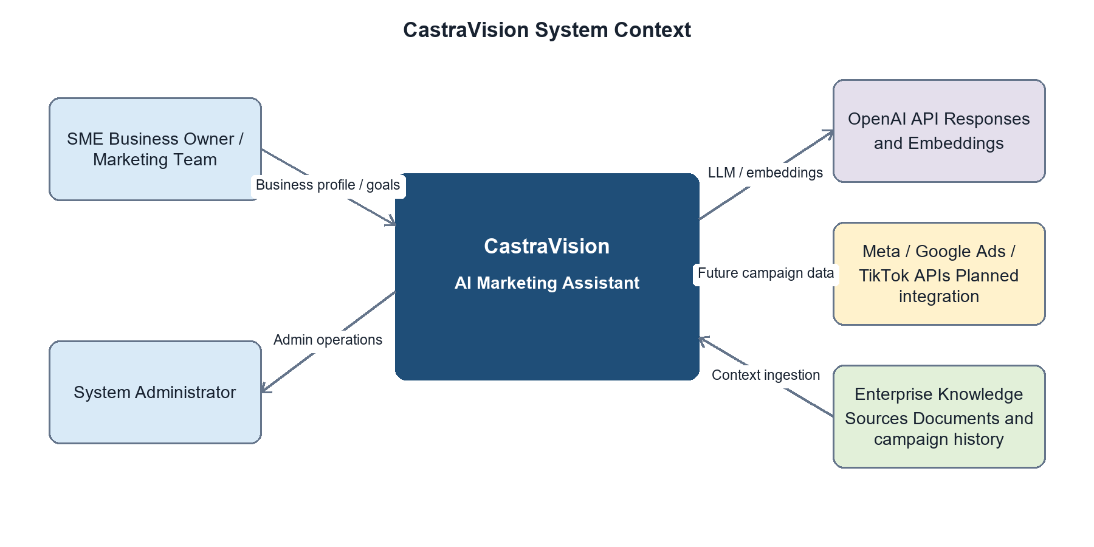
Figure 1. CastraVision System Context View

12.2 Component and Connector View
At runtime, the browser exchanges JSON over the strategy API with Django. The API view validates the request through typed Pydantic schemas and invokes the strategy orchestrator. The orchestrator retrieves top-k enterprise context from PostgreSQL/pgvector, builds the prompt, and requests a structured recommendation from the configured LLM provider. OpenAI calls use bounded retry logic; if the provider is unavailable and fallback is enabled, a deterministic local strategy is returned. Knowledge ingestion is separated as a background path that can run through a management command or Celery worker with Redis as the broker.
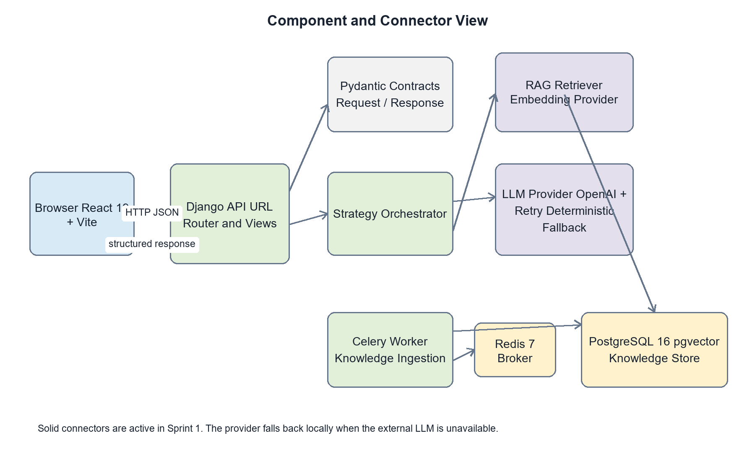
Figure 2. CastraVision Component and Connector View
Runtime component | Responsibility and connectors
React/Vite client | Collects the business profile, calls the Django REST endpoint, and renders loading, error, fallback, and recommendation states.
Django API | Routes /api requests, enforces HTTP constraints, validates JSON payloads, and serializes structured responses.
Strategy orchestrator | Coordinates retrieval, prompt construction, provider selection, retries, fallback behavior, and response assembly.
RAG subsystem | Chunks source material, creates embeddings, performs top-k similarity search, and returns traceable context sources.
PostgreSQL/pgvector | Persists knowledge chunks, metadata, vector embeddings, and application data using relational transactions.
Redis and Celery | Broker background ingestion or processing tasks without blocking synchronous API requests.
OpenAI provider | Supplies structured strategy generation and embeddings through outbound HTTPS when configured.

12.3 Module View
The implementation uses a modular monolith rather than independently deployed microservices in Sprint 1. CastraView contains the presentation code. The CastraVision package owns project configuration, root routing, and runtime entry points. CastraServices owns the public API, typed contracts, strategy workflow, prompts, retrieval logic, persistence models, migrations, tests, and ingestion tasks. Dependency direction remains inward from delivery modules to application and data modules, which keeps the AI workflow testable and allows later service extraction without changing the public JSON contract.
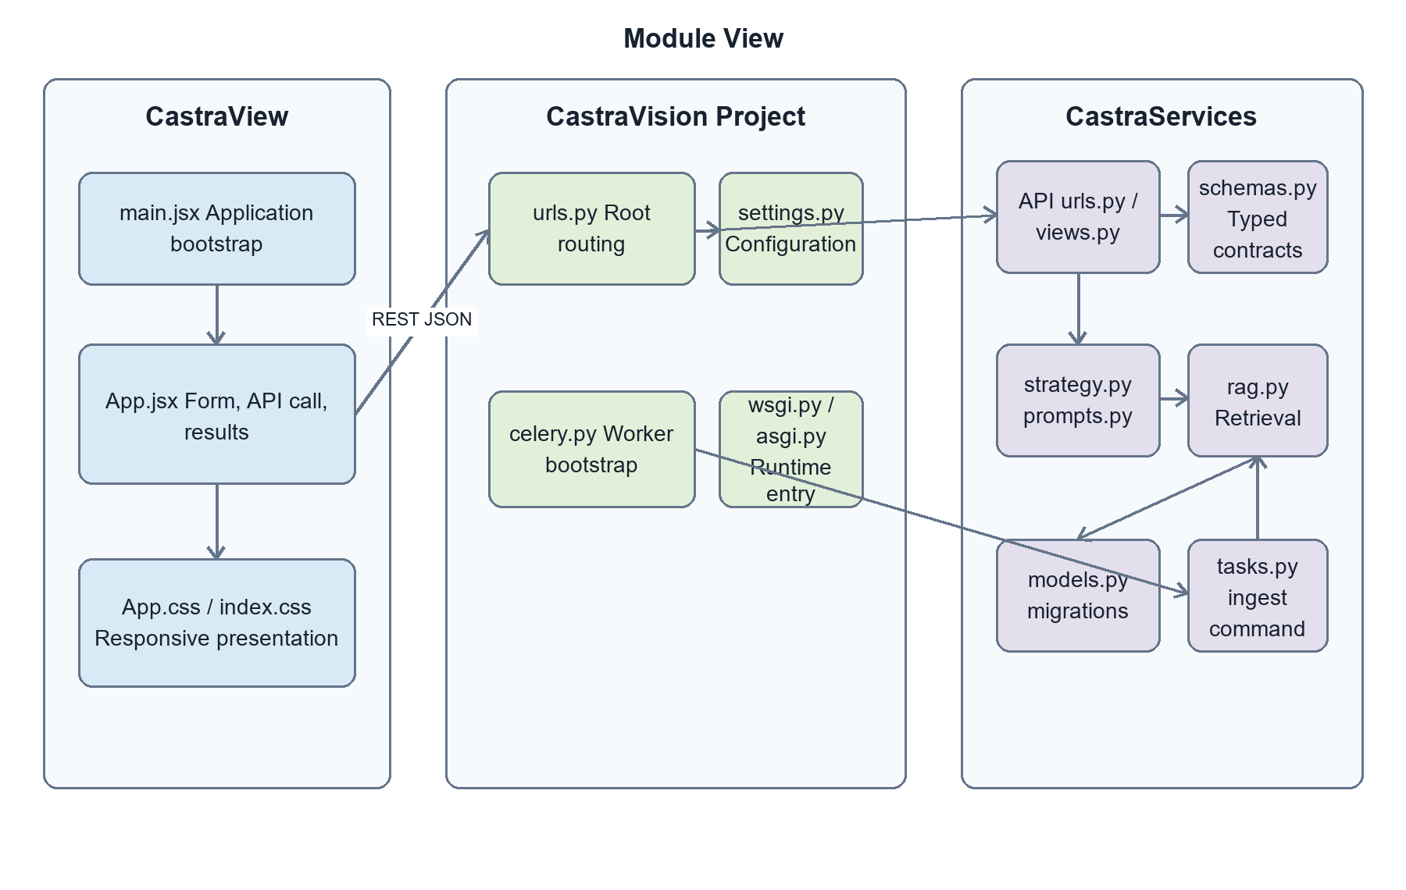
Figure 3. CastraVision Module View
Module group | Key contents and dependency rule
CastraView | React entry point, strategy form, result presentation, and responsive styles. It depends only on the documented HTTP contract.
CastraVision | Django settings, root URLs, Celery bootstrap, ASGI, and WSGI entry points. It composes infrastructure and application modules.
API and schemas | urls.py and views.py expose endpoints; schemas.py defines validated request and response contracts.
Strategy and prompts | strategy.py and prompts.py implement orchestration and prompt construction without UI concerns.
Retrieval and persistence | rag.py, models.py, and migrations implement ingestion, vector search, and database storage.
Background processing | tasks.py and ingest_knowledge.py invoke ingestion logic through Celery or administrative commands.

12.4 Allocation View
The Sprint 1 deployment baseline uses Docker Compose on one development host. The browser accesses the frontend on port 5173; the frontend calls the Django backend on port 8000. The backend and Celery worker share the same application image and configuration but run as separate processes. PostgreSQL with the pgvector extension stores durable data on a named volume, while Redis provides the Celery broker and result backend on a separate volume. Outbound HTTPS connects the backend to OpenAI. Advertising-platform connectors remain a planned extension and are shown as a future allocation rather than a deployed dependency.
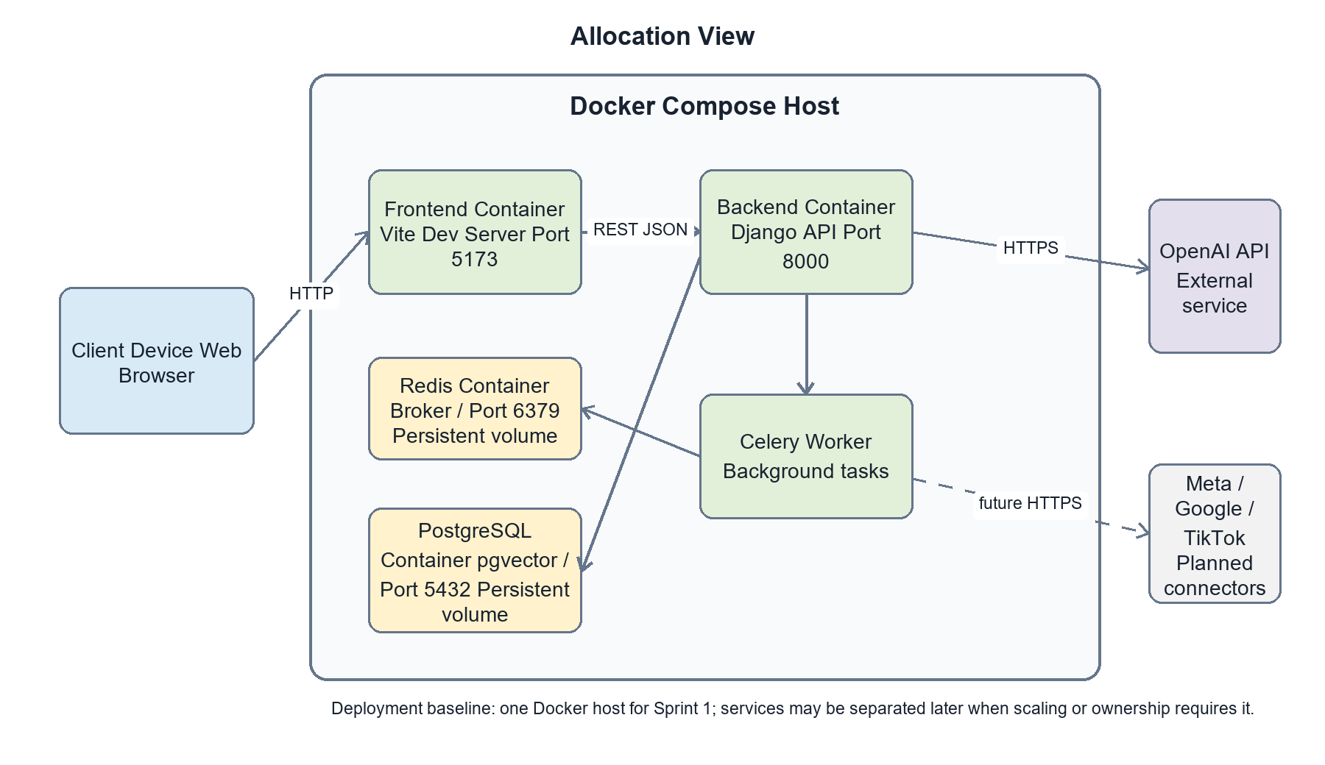
Figure 4. CastraVision Allocation View
Node or execution unit | Allocated artifacts and communication
Client device | A standards-compliant browser renders the React application and sends JSON requests to the backend.
Frontend container | Runs the Vite development server on port 5173 and reads VITE_API_URL for backend addressing.
Backend container | Runs Django migrations and the HTTP server on port 8000; connects to PostgreSQL, Redis, and external AI APIs.
Celery worker | Runs asynchronous jobs from the same backend codebase and consumes tasks through Redis.
PostgreSQL container | Runs PostgreSQL 16 with pgvector on port 5432 and stores durable data in the pgdata volume.
Redis container | Runs Redis 7 on port 6379 and stores broker/result data in the redisdata volume.
External AI service | OpenAI endpoints are reached over HTTPS; secrets and model choices are supplied through environment variables.
This allocation is intentionally simple for a four-person capstone team. The logical module boundaries preserve a migration path to independently deployed services if a future workload requires separate scaling, stronger fault isolation, or independent ownership.

14. Potential Risks and Mitigation Strategies
Risk | Impact | Mitigation Strategy
Lack of real-world data for training/testing AI models | Low accuracy of strategy recommendations | Use publicly available and simulated data combined with data augmentation techniques; collaborate with volunteer enterprises to collect experimental data.
Changes/limitations in third-party APIs (Facebook, Google Ads) | Interruption of data integration functionality | Design a separate, easily replaceable adapter layer; regularly monitor API documentation.
Project delays due to complex AI workload | Failure to complete the final report on time | Apply Scrum with regular sprint reviews, prioritize the MVP (Minimum Viable Product) first, and implement advanced features later.
Corporate/customer data security risks | Loss of user trust and violation of data protection regulations | Apply data encryption and role-based access control (RBAC), and follow fundamental security principles in system design.

15. Expected Outcomes / Deliverables
- A complete CastraVision web application with modules for strategic analysis, advertising content generation, budget optimization, and performance monitoring.
- Complete source code with installation and deployment documentation.
- Technical documentation: system design documents, requirements specification, and test documentation.
- A demo video showcasing the system's features and usage flows.
- A complete Graduation Project Report.

17. References
- Chaffey, D., & Ellis-Chadwick, F. (2022). Digital Marketing: Strategy, Implementation and Practice (8th ed.). Pearson.
- Kietzmann, J., Paschen, J., & Treen, E. (2018). Artificial intelligence in advertising: How marketers can leverage artificial intelligence along the consumer journey. Journal of Advertising Research, 58(3), 263–267.
- HubSpot. (2025). Marketing Hub – Product Documentation. Retrieved from https://www.hubspot.com/products/marketing
- Jasper AI. (2025). Jasper for Marketing Teams. Retrieved from https://www.jasper.ai
- Meta for Business. (2025). Advantage+ Campaigns Documentation. Retrieved from https://www.facebook.com/business/ads
- Google Ads Help. (2025). Performance Max Campaigns. Retrieved from https://support.google.com/google-ads

