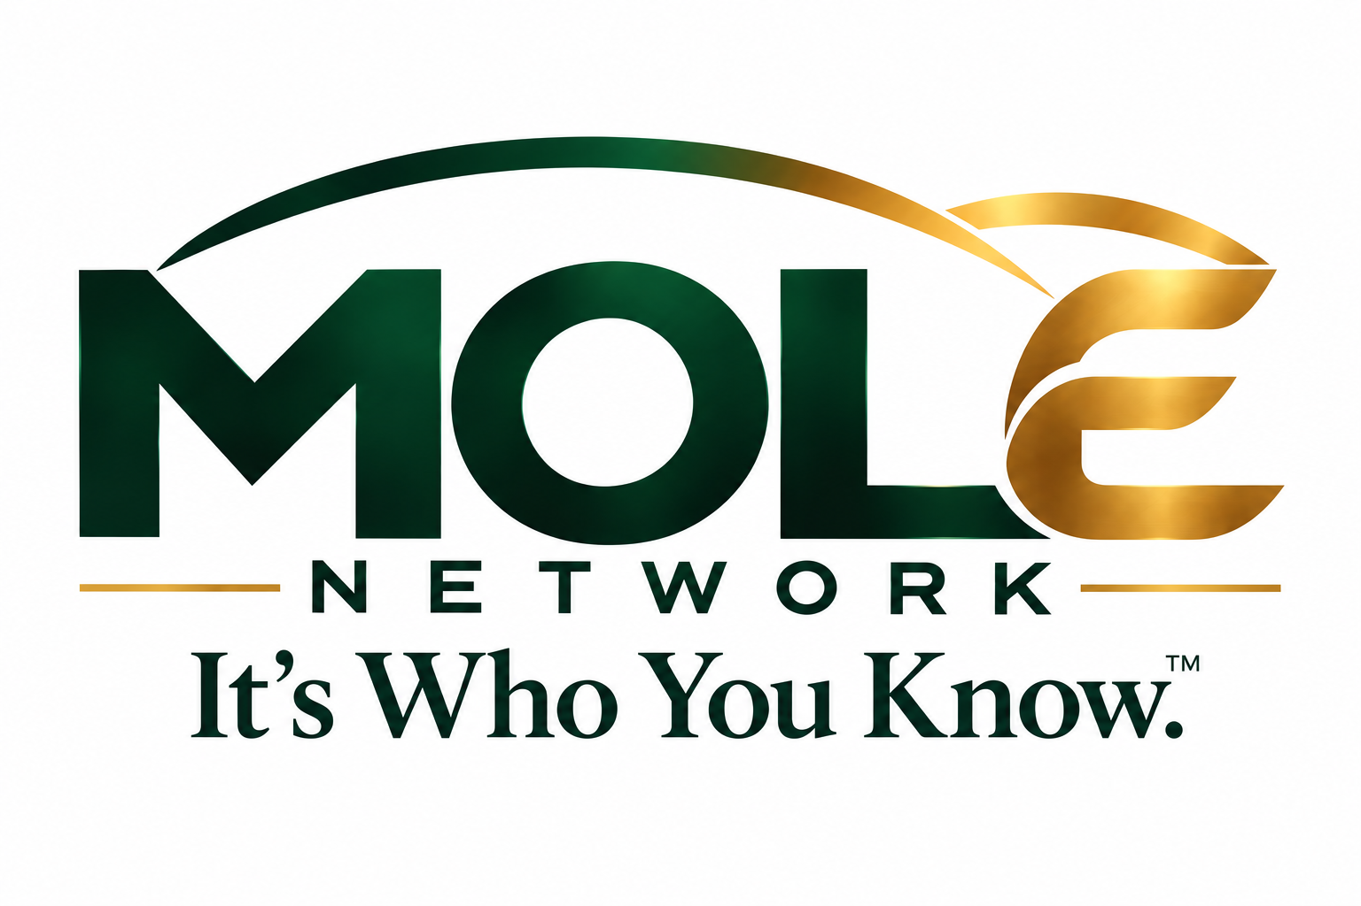
MOLE REFERRAL REVENUE PROGRAM
Program Design, Fee Schedule, and Operating Rules
Draft v1.1 | October 2026 | For internal planning and attorney review
Program at a Glance
Who pays: Participating businesses fund referral rewards. Members and customers never pay to join.
What earns: Verified results only: a qualifying sale, a qualified lead, or a completed sign-up or appointment.
How MOLE earns: A disclosed platform fee taken from each verified reward. Standard split is 80% member / 20% MOLE, with a $1.00 minimum fee and lower rates on larger rewards.
What never earns: Recruiting. Members are paid only for their own direct referrals, never for activity by people they invited.
Business cost: Free listing. Businesses pay only when a referral is verified.

1. Program Purpose
The MOLE Referral Revenue Program turns the MOLE Network’s marketplace into a pay-for-results customer acquisition channel. Businesses post offers with a referral reward. Members share those offers through the social platforms they already use. When a referral produces a verified result, the business funds the reward, the member receives most of it, and MOLE keeps a disclosed platform fee.
This program puts the revenue model from the MOLE Network Program Summary into operation. It sets the fee schedule, how businesses fund rewards, how referrals are attributed and verified, how payouts work, and which rules protect members, businesses, and customers.
Core principle: MOLE earns only when a business gets a measurable result. No result, no fee.

2. Program Participants
Participant | Role in the program | Cost to participate
Individual Member | Shares business offers using a personal referral link and earns rewards on verified results | Free
Business Member | Lists products or services, sets referral rewards, funds a Reward Wallet, and verifies results | Free listing; pays only verified rewards
Customer | Clicks a referral link, makes an inquiry or purchase; no account required | Free
MOLE Network | Hosts the marketplace, tracks referrals, holds reward funds, pays members, and enforces rules | Earns the platform fee

3. Referral Reward Types
Each business chooses one reward type per offer. The reward amount is the business’s total referral budget for that result. The member payout and MOLE fee both come out of it, so the business never pays more than the posted amount.
Reward type | How it is earned | Wireframe example
Fixed per sale | A referred customer completes a qualifying purchase | HavSum Brownies: $2 per sale
Percentage of sale | A set percentage of the eligible sale amount (excluding tax, shipping, and refunds) | Parker Consulting: 10% per sale
Per qualified lead | A referred customer submits an inquiry that meets the business’s posted lead criteria | CleanTech Services: $25 per lead
Per sign-up or appointment | A referred customer enrolls, books, or attends a scheduled visit | FitLife Wellness: $15 per sign-up

Lead criteria must be posted. For lead-based offers, the business states in advance what counts as a qualified lead (for example: “homeowner within 25 miles who requests a quote”). Leads that meet the posted criteria cannot be rejected after the fact.

4. MOLE Platform Fee Schedule
MOLE’s fee is a disclosed percentage of each verified reward, subject to a $1.00 minimum. The rate decreases as the reward size grows, which keeps MOLE competitive for high-value offers such as service contracts and professional engagements.
Reward size (per verified result) | MOLE fee | Member share | Minimum MOLE fee
Up to $100.00 | 20% | 80% | $1.00
$100.01 to $500.00 | 15% | 85% | $1.00
Over $500.00 | 10% | 90% | $1.00

How the fee is calculated: MOLE fee = the greater of (reward × tier rate) or $1.00. The tier rate applies to the whole reward. The member receives the reward minus the MOLE fee.

Worked Examples
Offer | Reward | MOLE fee | Member gets | Business pays
Standard purchase reward | $20.00 | $4.00 (20%) | $16.00 | $20.00
CleanTech Services lead | $25.00 | $5.00 (20%) | $20.00 | $25.00
FitLife Wellness sign-up | $15.00 | $3.00 (20%) | $12.00 | $15.00
Parker Consulting, 10% of $2,500 | $250.00 | $37.50 (15%) | $212.50 | $250.00
Contract referral reward | $800.00 | $80.00 (10%) | $720.00 | $800.00
HavSum Brownies sale | $2.00 | $1.00 (minimum) | $1.00 | $2.00

Small-reward note
With a $1.00 minimum fee, any reward under $5.00 gives the member less than 80%. On the $2.00 HavSum offer, the member and MOLE each receive $1.00.
Recommended rule: set a $5.00 minimum reward per offer, or let small-ticket businesses bundle (for example, $5 per referred customer’s first three orders). See Section 15.

5. How Businesses Fund Rewards: The Reward Wallet
Businesses prepay referral rewards into a MOLE Reward Wallet. This protects members from unpaid rewards and lets MOLE pay out on schedule.
- Business creates an offer and sets the reward type, amount, and monthly reward cap.
- Business funds the Reward Wallet. The recommended minimum deposit equals five rewards or $50, whichever is greater.
- When a referral is verified, the full reward amount moves from the wallet into a holding account.
- After the holding period, MOLE releases the member share to the member and keeps the platform fee.
- When the wallet balance falls below one reward, the offer pauses automatically and the business is notified to top up.
Monthly cap. Each business sets a maximum number of rewards or maximum dollar spend per month, so the business is never billed beyond its budget.
Unused funds. Wallet balances not tied to a pending reward can be withdrawn by the business, less payment-processing costs.

6. Referral Lifecycle
# | Stage | What happens
1 | Share | Member picks an offer and shares a personal link (mole.network/name) to Facebook, Instagram, WhatsApp, text, or email.
2 | Click | Customer opens the link. MOLE records a validated visit and sets a referral window.
3 | Action | Customer buys, submits a lead, or books within the referral window.
4 | Report | Business confirms the result in its dashboard, or it is confirmed automatically through a tracked checkout or promo code.
5 | Verify | Business has 7 days to approve or dispute. Results not disputed in 7 days are approved automatically.
6 | Hold | Approved rewards sit in Pending status for the holding period to cover refunds and cancellations.
7 | Pay | Rewards move to Approved, then Paid in the next scheduled payout.

7. Attribution Rules
- Referral window: 30 days from the customer’s click for sales and sign-ups; 7 days for leads.
- One referrer per result: Credit goes to the last member link the customer used before the qualifying action.
- Promo-code backup: Each member also receives a personal code for in-person or phone sales where a link cannot be tracked.
- No self-referrals: Members cannot earn on their own purchases or on purchases by the business owner or its employees.
- New customers only (business option): A business may limit rewards to first-time customers. This must be shown on the offer.
- Refunds and cancellations: A reward is reversed if the sale is refunded or cancelled during the holding period.

8. Member Payouts
Item | Program rule
Holding period | 30 days after approval for sales and sign-ups; 14 days for leads
Payout schedule | Monthly, on the 15th, for all rewards that cleared the hold by the end of the prior month
Minimum payout | $25.00. Balances under $25 roll forward to the next month
Payout methods | Direct deposit (ACH) or digital wallet through MOLE’s payment processor
Tax information | Members provide a W-9 before their first payout. MOLE issues IRS information returns (Form 1099) when federal reporting thresholds are met
Earnings statuses | Pending (in hold), Approved (cleared), Paid (sent), matching the My Earnings screen

9. My Network and My Team: Tracking Only
Members can see who joined through their invitation (Direct Connections) and the wider network connected through those invitations (Extended Network). These views help members understand their reach and stay in touch with their connections.
No team or override earnings
Members earn only on their own direct referrals to participating businesses.
No member earns any commission, bonus, or override from the referrals, purchases, or sign-ups of people they invited.
No reward is paid for inviting a member, and no purchase is required to participate.
This keeps MOLE a referral marketplace, clearly separate from multi-level marketing, consistent with Section 9 of the Program Summary.

10. MOLE Revenue Streams

Primary: Referral Platform Fees
MOLE’s core income is the platform fee on every verified reward, per the schedule in Section 4. Listing is free and there is no business subscription at launch.

Secondary: Optional Business Add-Ons (Phase 4)
Introduced after the referral model is validated. None are required to list or run offers.
- Featured listing: Placement at the top of a marketplace category.
- Sponsored offer: Offer promoted to members in the Share & Earn feed.
- Advanced analytics: Deeper reporting on ad views, link clicks, leads, and cost per customer.
Pricing for add-ons will be set after Phase 3 results are available.

11. Illustrative Revenue Model
The figures below show how MOLE fee income scales with verified activity. They are planning illustrations, not forecasts, and assume an average reward of $20 at the standard 20% rate ($4.00 MOLE fee per verified result).
Stage | Active businesses | Verified results / month | MOLE fee income / month
Pilot | 10 | 100 | $400
Local launch | 50 | 750 | $3,000
Metro growth | 200 | 4,000 | $16,000
Regional | 1,000 | 25,000 | $100,000

Key drivers: number of active offers, member share rate, link click-to-result conversion, and average reward size. Payment-processing costs (typically a few percent of each transaction) come out of MOLE’s fee and should be modeled before final pricing.

12. Program Integrity and Compliance

Disclosure
- Every shared offer includes a built-in disclosure tag (for example, “#ad – I may earn a reward”) so members meet endorsement disclosure requirements.
- Members must be honest in their recommendations and may not make claims the business has not approved.

Restricted Categories
Referral rewards are disabled for real estate, insurance, lending, legal, medical, and other licensed or regulated services until an attorney confirms the arrangement is permitted. Businesses in these categories may still list in the marketplace without a referral reward.

Fraud Prevention
- Duplicate, bot, and repeated-click detection on referral links.
- Self-referral and household-match checks.
- Reward reversals for refunds, chargebacks, and fake leads.
- Account suspension and forfeiture of unpaid rewards for confirmed fraud.

Disputes
Members may dispute a rejected reward within 30 days. MOLE reviews the business’s posted criteria, tracking records, and any supporting evidence, and issues a final decision within 14 days.

Privacy
MOLE does not access private friend lists or treat follower counts as ad views. Customer contact details are shared with a business only when the customer submits an inquiry or purchase.

13. Launch Plan
Phase | Program activity | Success measure
1. Pilot setup | Recruit 10 pilot businesses (HavSum Brownies first). Set offers, fund wallets, onboard first members | 10 funded offers live
2. Tracking test | Run referral links and promo codes; verify results manually; no cash payouts yet (test credits) | Attribution matches business records in 95%+ of cases
3. Paid rewards | Turn on Reward Wallets, platform fees, and monthly payouts after compliance review | First payout cycle completed with no unresolved disputes
4. Expand | Add categories, featured listings, and analytics; grow member base | Repeat business funding month over month

14. Member Growth & Experience Design
Because MOLE pays only for direct referral results and never for recruiting, the app cannot attract members with “build a team” messaging. Instead, the design must show people, quickly and honestly, that they can earn by recommending businesses they already trust. Every design choice below supports one of four goals: attract, first earning, trust, and repeat activity.

Design Principles
- Show the money first. Real offers and real member earnings appear before sign-up, not after.
- Show net, not gross. Every offer displays what the member actually receives after the MOLE fee.
- Customer first, member second. Invitations lead people to an offer they might want; membership follows naturally.
- Make progress visible. Members always know where each referral stands and when they will be paid.
- No income hype. No average-earnings or income claims anywhere in the app or marketing. Show actual offer amounts and the member’s own history only.

Growth Loops (No Recruiting Compensation)
Loop | How it works | Why it grows MOLE
Customer-to-member | After a referred purchase, the confirmation page says: “Love HavSum? Recommend it and earn $X.” One tap creates a member account with that offer ready to share. | Every verified sale produces a likely new member who already trusts the business
Offer-based invites | Invite links open a specific offer, not a sign-up form. Friends arrive as customers first. | Invites create sales activity immediately, not empty accounts
Business-driven supply | Each new business brings its own customers and fans into the marketplace as members. | More and better offers are the main reason members stay active
Social proof circle | My Circle shows which offers connections are sharing (never their earnings). | Members see what works among people they know and copy it

First-Earning Onboarding Flow
- Join with Google, Facebook, Apple, or email (one screen).
- Answer one question: “What do your friends ask you about?” (Food, Home Services, Fitness, Beauty, Business Help, etc.).
- See three matching local offers, each showing the member’s net earning.
- Tap Share on one offer. A pre-written post with the disclosure tag is ready to send to Facebook, Instagram, WhatsApp, or text.
- A progress strip tracks the milestones: Joined → First Share → First Click → First Verified Earning.
Target: a new member completes a first share within two minutes of joining.

Screen-by-Screen Design Updates (12-Screen Wireframe)
Screen | Current wireframe | Recommended update
1. Welcome | Logo, group photo, Join Now and Sign In; small Browse link | Headline: “No fees. No inventory. No recruiting. Get paid when your recommendation becomes a customer.” Show 3–4 live local offers with net earnings. Make Browse the Marketplace a primary button.
2. Join / Login | Name, email, password, social sign-in | Keep it to one screen. Add one line: “Free forever for members.” If the user came from an offer link, show that offer at the top.
3. My Profile | Personal info, interests, social links, business (optional) | Move My Interests to onboarding step 2. Add payout setup (W-9 and bank) here, with a note that it is needed only before the first payout.
4. Dashboard | Connections, offers shared, qualified leads, pending earnings | Lead with earnings and the first-earning progress strip. Add a “Recommended for you” offer card. Replace the Connections count with Offers Shared and Verified Results.
5. My Network | My Connections and My Team tabs | Rename My Team to My Circle. Show offers your connections are sharing (never their earnings). Add a clear note: “You earn only on your own referrals.”
6. Marketplace | Search, categories, featured businesses with “Earn $X” | Show net earnings (“You earn $16”). Add “Top-paying this week” and “New near you” sections. Show a business’s verification badge and payout reliability.
7. Business Profile | About, Products, Offers tabs; Earn per Sale card | Show offer terms clearly: what qualifies, referral window, holding period, and first-time-customer limits.
8. Post an Ad | 3-step: Details, Offer, Review | In the Offer step, show the business the split preview (member gets $X, MOLE fee $Y, you pay $Z) and enforce the $5 minimum reward if adopted.
9. Share & Earn | Offer, referral link, share buttons | Add 2–3 pre-written post options with the disclosure tag built in, plus the member’s personal promo code for in-person sales.
10. Referral Tracking | Clicks, leads, verified sales, earnings, recent activity | Show each referral’s stage (Clicked → Action → Verified → Hold → Paid) with dates, so members never wonder what happened.
11. My Earnings | Total, pending, approved, paid; history | Show the expected payout date on every item (“Approved · pays Nov 15”) and progress toward the $25 minimum payout.
12. Business Dashboard | Ad views, link clicks, leads, sales, rewards paid, MOLE fee | Add cost per customer and Reward Wallet balance with a top-up alert. Show which offers convert best so businesses raise rewards on what works.

Customer Purchase Confirmation (New Screen)
A short confirmation page shown to customers after a referred purchase or inquiry. It thanks them, confirms who referred them (with permission), and invites them to recommend the same business and earn. This is the main customer-to-member conversion point and should be added to the wireframe as screen 13.

Messaging Guide
Use | Avoid
“Get paid when your recommendation becomes a customer.” | “Build your team” or “Grow your downline”
“You earn $16 when your friend books.” | “Earn up to $500 a month!” or any income claim
“Share businesses you already trust.” | “Passive income” or “Financial freedom”
“Free to join. No fees, ever.” | “Get in early” or other urgency hype

Member Growth Measures
- Activation: percentage of new members who share an offer within 24 hours.
- First earning: percentage of members with a verified result within 30 days.
- Customer-to-member conversion: percentage of referred customers who become members.
- Active sharers: members who shared at least once in the last 30 days.
- Offer depth: number of live funded offers per category and area.

15. Decisions to Confirm
These items are proposed in this draft and should be confirmed before launch:
- Tier thresholds and rates in Section 4 (20% / 15% / 10% at $100 and $500).
- Whether to require a $5.00 minimum reward per offer to protect the 80% member share.
- Holding periods (30 days for sales, 14 days for leads) and the 7-day auto-approval window.
- $25.00 minimum payout and monthly payout date.
- Reward Wallet minimum deposit ($50 or five rewards).
- Payment processor selection and who absorbs processing fees.
- Adding screen 13 (Customer Purchase Confirmation) and renaming My Team to My Circle in the wireframe.
- Attorney review of the program terms, disclosure language, and restricted categories in Georgia and each launch state.
MOLE Network™ | It’s Who You Know.
Connect people. Create opportunities. Share in the value.
This draft is for planning purposes and is not legal, tax, or financial advice. All fees and earnings shown are illustrative.

