July, 2013

**ABSTRACT:**

Use of electric vehicles (EVs) has been viewed by many as a way to significantly reduce US oil dependence, operate vehicles more efficiently, and reduce carbon emissions. Due to the potential benefits of EVs, the federal and local governments have allocated considerable funding and taken a number of legislative and regulatory steps to promote EV deployment and adoption. With this momentum, it is not difficult to see that in the near future EVs will gain a significant market penetration, particularly in densely populated urban areas with systemic air quality problems. We will soon face one of the biggest challenges: How to improve efficiency for the entire EV system? This research takes the first step in tackling this challenge by addressing a fundamental issue, how to measure and estimate EVs’ energy consumption. In detail, this paper first presents a system which can collect in-use EV data from both the battery system, including battery state of charge, pack current, pack voltage, pack power and vehicle driving data including velocity, acceleration, and vehicle position (latitude, longitude, and elevation). Then this system has been installed in an EV conversion vehicle built for this research. Approximately five months of EV data have been collected and these data have been used to analyze both EV performance and driver behaviors. The analysis shows that the EV is more efficient when driving on incity routes than driving on freeway routes. This has become one of the major reasons that EV driver prefers in-city routes over freeway routes. This research further analyzes the relationships among the EV’s power use, the vehicle’s velocity, acceleration, and the roadway grade. This is done by categorizing data according to the specific ranges of velocity, acceleration, and roadway grade. In addition, through statistical analysis, we determined that the EV’s power within a specific range of velocity, acceleration, and grade could be described as a normal distribution. Based on the analysis presented, this paper further proposes an analytical EV power estimation model using the fundamental theory of vehicle dynamics and basic relationships among power, force, torque, voltage, and current. This model has been evaluated using the test vehicle. The results show that this model can successfully estimate EV’s instantaneous power and trip energy consumption. Future research will focus on applying the proposed EV power estimation model to improve EVs’ energy efficiency.

## 1. INTRODUCTION

The transportation system is fundamental to the health of the nation’s economic growth. However, the current transportation system is overwhelmingly powered by internal combustion engines (ICE) fueled by petroleum. This not only causes the nation be dependent on the whims of the global oil market[15]; but more importantly, has made the transportation sector the economy’s largest source of greenhouse gas (GHG) emissions[9]. Because of projected shortage of crude oil and the urgent need of reducing GHG emissions, more and more national talents and resources are now focusing on shaping a sustainable transportation system that can address the climate change challenge as well as reduce oil dependence[22]. Among many innovative technologies, electrification of passenger vehicles is viewed by many as one that could significantly reduce US oil dependence, operate vehicles more efficiently, and reduce carbon emissions.

Electric vehicles (EVs) include both plug-in hybrid (PHEVs) and battery-powered electric vehicles (BEVs). PHEVs usually have a moderately sized energy storage system and an internal combustion engine to ensure most miles are electrified while retaining the range capability of today’s ICE vehicles. BEVs are entirely battery dependent and provide complete petroleum displacement for certain vehicle sectors. This research mainly focuses on BEV (simplified as EV for the rest of the paper). EV adoption could play a significant role in addressing both energy and environmental crises brought by the current transportation system. First, electricity will help meet future U.S. transportation needs. Since the vast majority of electric generation resources are domestic, electric vehicles are viewed as an excellent way to diversify transportation fuels. Although some challenges remain in regard to cost and battery technology, the availability of domestic electricity is not an issue so long as vehicles are charged at night, when excess electric generating capacity is available[15]. In addition, fueling EVs is far less expensive than fueling ICE vehicles. With the national average price of residential electricity at approximately 11.5 cents per kilowatt hour, a vehicle that runs only on electricity can travel approximately 30 miles on about 80 cents of electricity - almost one fourth of the cost of driving a similarly equipped ICE vehicle at $3 a gallon for gasoline[1]. Second, electricity has a strong potential for GHG reduction. Electric vehicles themselves have zero emissions, although generating the electricity to power the vehicle is likely to create air pollution. If electricity is generated from the current U.S. average generation mix, EVs can reduce GHG emissions by about 33 percent, compared to today’s ICE powered vehicles[22]. If we assume 56 percent light duty vehicle (LDV) penetration by 2050, this could provide a total reduction in transportation emissions of 26 to 30 percent[22].

The huge potential benefits of EVs have already generated significant interest and investment in EV technology. Since late 2010, more than 20 automakers have introduced BEVs or PHEVs. Within the United States, the government allocated considerable stimulus funding to promote the use of alternative fuels[18]. The American Recovery and Reinvestment Act (ARRA) of 2009 provided over $2 billion for electric vehicle and battery technologies, geared toward achieving a goal of one million electric vehicles on U.S. roads by 2015[3]. Many states also have committed themselves to promoting EVs. For example, California has taken a number of legislative and regulatory steps to promote electric vehicle deployment and adoption, such as the Zero Emission Vehicle and Low Carbon Fuel Standard regulatory programs and rebates for purchasing electric vehicles[6]. These actions demonstrate the state’s commitment to promote electric vehicles. With this momentum, it is not difficult to see that in the near future EVs may gain significant market penetration, particularly in densely populated urban areas with systemic air quality problems. We will soon face one of the biggest challenges: How to improve efficiency for the whole EV system?

The majority of current EV research is focused on how to overcome technical barriers such as battery technology limitations[2] and charging infrastructure problems[13]. Extensive research efforts and investments have been given to address these barriers[5,7,10,11,14,17,19,20]. However, very little research has been focused on how to improve the efficiency of the EV system. People have yet to realize the importance of this question, partly because they haven’t foreseen the oncoming growth worldwide for EVs; but more importantly, due to lack of knowledge of electric vehicle performance and drivers’ behaviors. We have yet to identify the unique features of both EVs and EV drivers that control energy consumption and efficiency. These unique features could fundamentally change our understanding of people’s travel and driving behaviors and further impact the transportation system, our environment, and our society. This research begins to explore these features starting by investigating EVs’ energy usage measurement and estimation.

Measuring and estimating EVs’ electricity usage is the foundation for the future improvement of energy efficiency of the EV system. One of the most advanced features of an EV, compared to conventional ICE vehicles, is its ability to capture and store energy through the regenerative braking system (RBS)[4,23,24]. RBS uses the electric motor to recharge the battery by applying negative torque to the drive wheels and converting kinetic energy to electrical energy. The use of RBS in EVs’ fundamentally changes their energy consumption characteristics compared to ICE vehicles. For example, EVs are much more efficient when driving on interrupted urban routes than uninterrupted freeway[12]. This is in contrast to conventional ICE vehicles, which require much more energy in urban driving because of braking and thermal losses[8,16]. This characteristic could significantly change driving behaviors and travel behaviors in order to save energy. The unique characteristics of EVs needs to be carefully investigated; and the first requirement of this investigation is the ability to measure and estimate EVs’ energy usage, which, as will be demonstrated in the paper, is a function of vehicle’s velocity, acceleration, and roadway grade.

This research is a critical first step in developing a sustainable EV system. This paper first describes an EV data collection system which can collect both in-use EV data from both the battery system, including battery state of charge, pack current, pack voltage, pack power and vehicle driving data including velocity, acceleration, and vehicle position (latitude, longitude, and elevation). This system has been installed in an EV conversion vehicle built for this research and collected approximately five months of data. Based on these data, we have completed a comprehensive analysis of the EV performance and driver behaviors. In particular, this analysis explored the relationships among EVs energy consumption, vehicle velocity, acceleration, and roadway grade. The derived relationships provide us an empirical foundation to create the EV energy consumption and estimation model proposed in this paper.

The paper is organized as follows. We first introduce the EV data collection system, which is able to collect both in-use EV data and driving information in Section 2. Section 3 provides detailed explanation of data analysis, followed by an EV energy consumption estimation model in Section 4. Finally, we conclude this paper with a number of perspectives for future research.

## 2. AN EV DATA COLLECTION SYSTEM

The EV data collection system developed in this research collects both in-use EV data and driving information. The data collection system has been installed in an EV conversion vehicle built to support this research. The data collection system has been collecting data from the test vehicle for approximately 5 months. This section explains the details of the EV conversion vehicle and the data collection system.

### **2.1 EV Conversion Vehicle**

To support this research, an EV conversion vehicle was built. This EV is converted from a 1987 Nissan D-21 pickup (see Fig.1). The system currently consists of a 50 HP, 120v AC motor, with a Curtis controller. The battery pack consists of 36, 3.2v, 180aH LiPo batteries connected in series to form a single 115v, 180 aH battery. An elithion® battery management system is used to monitor the voltage and temperature of each cell and to control charging of the system. A 2000w Elcon charger is installed onboard the EV. There are two data busses on board, one for the battery management system (BMS) and one for the motor controller. The BMS bus operates as a controller area network (CAN) bus and uses an on-board diagnostic (OBD-II) system data standard. The OBD-II provides information such as individual cell voltage, temperature and resistance; pack voltage, current, and power; and numerous diagnostic and control parameters. This vehicle serves as a test bed for this research.

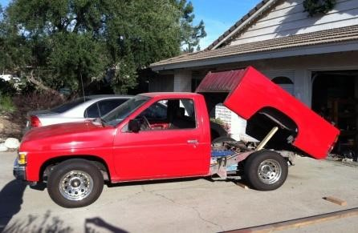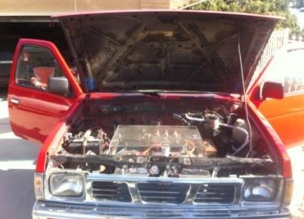

### FIG.1 EV conversion vehicle & batteries

#### 2.2 Data Collection System

A data collection system has been developed to collect in-use EV data and vehicles’ driving information. In-use EV data includes battery usage, battery state of charge, current, pack voltage, off-vehicle charging event time, duration, location, power level and charger type, etc. Vehicles’ driving information includes velocity, acceleration/deceleration, and vehicle position (latitude, longitude, and elevation). Data collection serves as the foundation for this research. The architecture of the data collection system is presented in Fig.2. It consists of four parts. First, a CAN bus data logger (through BMS) is used to collect in-use vehicle data; the data then are sent to a Smartphone (or tablet) through Bluetooth. At the same time, the global positioning system (GPS) in a Smartphone collects vehicle location data and generates trip trajectories. The trajectory data is then synchronized with vehicle in-use data using an application installed in the Smartphone. The synchronized data then are transmitted to a database through WiFi or cellular networks. A web application has been further developed to publish some useful information derived from raw data to users or managers.

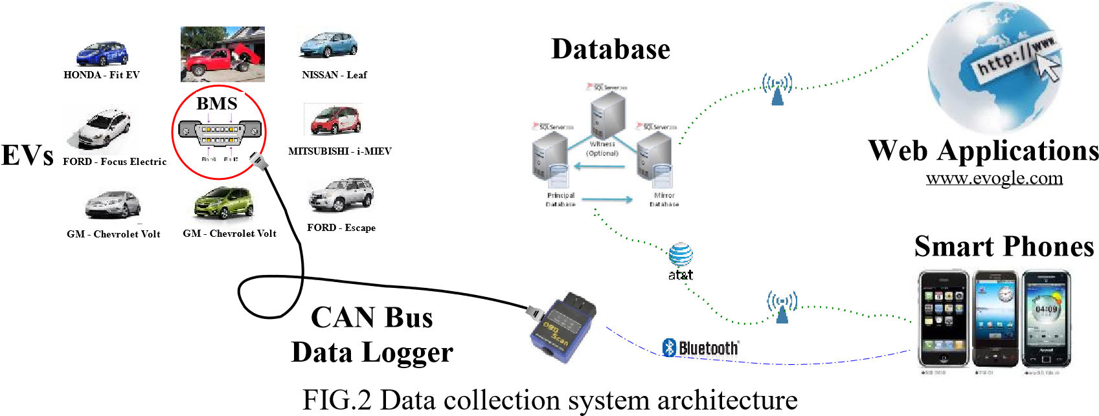

The data collection system has been successfully tested using the EV conversion vehicle. A data sample is presented in Fig.3. As shown in the figure, Columns A and B record GPS time and device (tablet in this research) time; Columns C and D record longitude and latitude; Column E is the vehicle speed measured by GPS (in meter/second); Columns M – P are the acceleration information recorded by the accelerometer in the tablet; and Columns Q – T are the energy usage related information including pack current (in ampere), pack total voltage (in voltage), pack power (in kilowatt), and state of charge(SOC, in %).

Although this data collection system has been tested in only our test car, the concept of this system is general and should be able to apply to any other EVs.

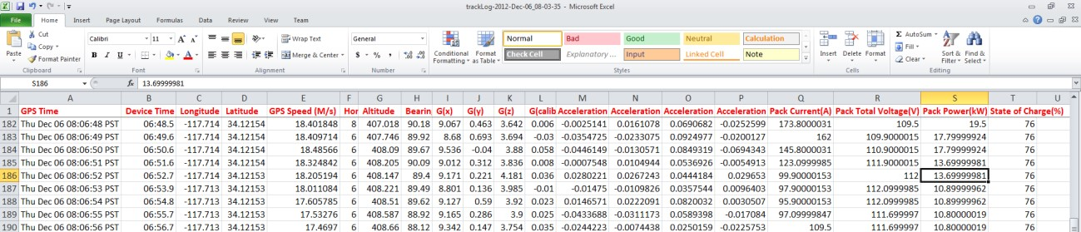

FIG.3 Data sample

## 3. DATA ANALYSIS

The test vehicle has been used by a faculty member at Cal Poly Pomona for his daily commute since Nov. 2012. About 5 months of data (Nov. 2012, Dec. 2012, Jan. 2013, Apr. 2013, and May 2013) has been collected. These data include 169 trips. For each trip, the information including in-use EV data and driving information has been collected. A comprehensive analysis of these data is presented in this section.

### **3.1 Driver’s Behaviors**

To study EV driver’s behaviors, we first categorize all 169 trips into the categories of Home-to-Work (H2W) trips, Home-to-Other (H2O) trips, Work-to-Home (W2H) trips, Work-to-Other (W2O) trips, Other-to-Home (O2H) trips, Other-to-Work (O2W) trips, and Other-to-Other (O2O) trips. The table in Fig.4 shows the details about these types of trips. We are most interested in daily commute trips, i.e. H2W and W2H, because these trips are important for studying drivers’ travel behaviors. Among the 169 recorded trips, 67 are completed commute trips (26 of H2W and 41 of W2H). Many other commute trips in the data base include stops by the driver which split a H2W or W2H trip into 2 trips (for example, a H2W trip becomes H2O and O2W trips). Examination of these data identifies some interesting phenomena which could be very helpful for understanding EV drivers’ behaviors.

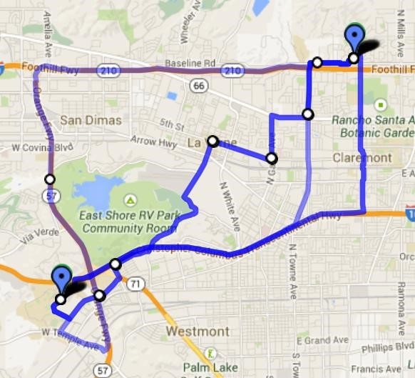

2

10

13

1

12

2

27

0

0

5

10

15

20

25

30

Route 1

Route 2

Route 3

Route 4

Home2Work (H2W)

Work2Home (W2H)

**Trips**

**& Routes**

**# of Trips**

Route 1

Route

2

Route

3

Route

4

O-D

**Home**

**Work**

**Other**

**Total**

**Home**

-

26

44

70

**Work**

41

-

6

47

**Other**

25

21

6

52

**Total**

66

47

56

169

### FIG.4 Trips & routes

**EV Driver’s Route Choice**: The first observation is about this particular EV user’s route choice. From this participant’s home to his work place, the Google map suggests three possible routes: Route 1, Route 2, and Route 4 (see Fig.4). But from the data we collected, we found out the participant also uses Route 3 very often (see Fig.4). Four similar routes have been identified for the trips from work to home. Note although this EV user has been informed about our data collection, he makes his own route choice decisions. Among all these 4 routes, Route 4 mostly is on freeway, so it is a freeway-driving route; Route 3 is on urban arterials, so we call it an in-city driving route, and Routes 1 & 2 are half freeway driving and half in-city driving. Interestingly, among total 67 commute trips, the participant chose Route 3, the in-city driving route, for 40 times (13 of H2W trips and 27 of W2H trips); but only selected Route 4, the freeway driving route, for one time. So it is clear that this participant is in favor of in-city driving.

To better understand why this driver favored in-city routes over freeway routes, we summarize some important factors which we think could impact a driver’s route choice. These factors include the total travel time (in min), total travel distance (in miles), average travel speed (in mph), total energy usage (in kilowatt-hour), and average energy efficiency (in kilowatt-hour per 100 miles). Fig.5 presents the mean values of these measurements for four routes shown in Fig.4 for both H2W and W2H trips. From Fig.5a, we can see that the possible reason why the driver chose Route 3, the in-city driving route, instead of Route 4, the freeway driving route. Route 4 provides a small travel time saving (1.3 min) at the cost of significantly higher energy consumption (3.0 kWH) compared to Route 3. Routes 2 and 3 for H2W trips have no significant difference in either travel time or energy consumption. That’s why the user chose Routes 2 & 3 much more often than using other routes when he travels from home to work (see Fig.4).

When traveling from work to home, the participant chooses Route 3, the in-city driving route, for most of the time (27 times over total 41 trips, see Fig.4). However, Route 3 is not the best choice based our data analysis. As shown in Fig.5b, Route 1 requires less travel time (23.6 min vs. 24.9 min) and slightly less energy consumption (3.4 kWH vs. 3.5 kWH). Route 2 actually has the highest energy efficiency (31.1 kWH/100-mile). However the accuracy of the route 2 data is questionable since the sample size is only two. So overall this driver indeed made a good route choice decision in terms of energy and travel time saving.

Based on our data analysis, it is clear that for EV users, travel time is not the only factor which they will consider when they make a route choice decision. While many other factors may impact the driver’s route choices, EVs’ energy consumption has played a significant role in this driver’s route selection. It seems that the EV user tries to balance the trade-off between travel time and energy consumption. This is different from traditional ICE vehicle drivers. For these drivers, travel time is the dominant factor in determining their selection.

27.0

9.4

20.9

1.8

19.4

22.1

9.4

25.8

1.8

18.8

23.9

9.3

23.5

1.7

18.7

22.6

15.3

40.8

4.7

30.4

0.0

5.0

10.0

15.0

20.0

25.0

30.0

35.0

40.0

45.0

Total TT (min)

Total Distance (mile)

Average Speed (mile/hr)

Total Energy (KWH)

Energy Efficiency

(

KWH/100mile

)

Route 1

Route 2

Route 3

Route 4

**a**

**)**

**(**

**Home2Work (H2W) Trip**

**Information (on average)**

23.6

9.6

25.2

3.4

35.6

28.2

10.4

22.0

3.2

31.1

24.9

9.8

24.0

3.5

35.9

0.0

5.0

10.0

15.0

20.0

25.0

30.0

35.0

40.0

Total TT (min)

Total Distance (mile)

Average Speed (mile/hr)

Total Energy (KWH)

Energy Efficiency

(

KWH/100mile

)

Route 1

Route 2

Route 3

Route 4

**b) Work2Home (W2H) Trip**

**(**

**Information (on average)**

### FIG.5 Work2Home & Home2Work trip information (on average)

**Energy Efficiency on In-city Driving vs. Freeway Driving**: Interestingly, similar behavior (i.e. favoring in-city driving) of EV drivers has been observed in other research[12]. The reason, as mentioned in other research, is that EVs are much more energy efficient when driving on interrupted urban routes than uninterrupted freeway routes. To verify this point of view, we separate all our data (167 trips) into two categories: in-city driving and freeway driving; and calculate their energy efficiency using total consumed energy divided by total travel distance. The division of travel into in-city versus highway driving was done manually. Our data support the same conclusion that driving on urban city streets is more efficient than driving on freeways. In this study, the energy efficiency is 26.97 kWH/100-mile for in-city driving and 27.94 kWH/100-mile for freeway driving (see Fig.6). The difference between these two numbers is relatively small. The major reason is that most of trips from our data is in-city driving. The total travel distance for in-city driving is 529 miles, while for freeway driving the total travel distance is only 110 miles. Also, many of these in-city trips are on uphill routes. We believe with more freeway-driving data, the difference between the energy efficiency of in-city driving and freeway-driving would increase.

**26.97**

**27.94**

20.00

21.00

22.00

23.00

24.00

25.00

26.00

27.00

28.00

29.00

30.00

In-city Driving

Freeway Driving

**Energy Efficiency:**

**In**

**-**

**city Driving vs. Freeway Driving**

kWH/100

-

mile

### FIG.6 Energy efficiency for in-city driving vs. freeway driving

**Day-to-Day Energy Efficiency:** Another interesting observation we would like to report concerns the change of energy efficiency over 5 months’ driving. Since we define an EV’s energy efficiency as the required kilowatt-hours for traveling 100 miles, i.e. kWH/100-mile, a higher number indicates worse efficiency. From the data, we found out that for several routes, the EV user has traveled over 10 times during the data collection period. We identify three typical routes here: one H2O route (18 times), one O2H route (10 times), and one W2H route (Route 3 in Fig.4, 27 times), and present the energy efficiency changes over 5 months in Fig.7. Note due to some technical issues, the data in Feb. 2013 and Mar. 213 have not been collected. But from the data collected, we can clearly see that the energy efficiency is gradually improving over time. Through interviews with this participant we learned that he began to adjust his driving behaviors in order to save once he was able to easily see the energy used during his commutes. In particular, he identified (and avoided) routes and segments which required exceptionally high energy consumption and adjusted his driving behaviors in order to drive more efficiently. The driver made these choices without and guidance or direction from the research team. These choices were made simply changes based on the data provided by the collection system. This finding is encouraging since it indicates that by providing information or feedback on EVs’ energy consumption, EV users may consciously adjust their driving behaviors in order to improve energy efficiency. This further shows the importance of developing an EV performance system which can provide such feedback to EV users. Further investigation of this topic would be much desired.

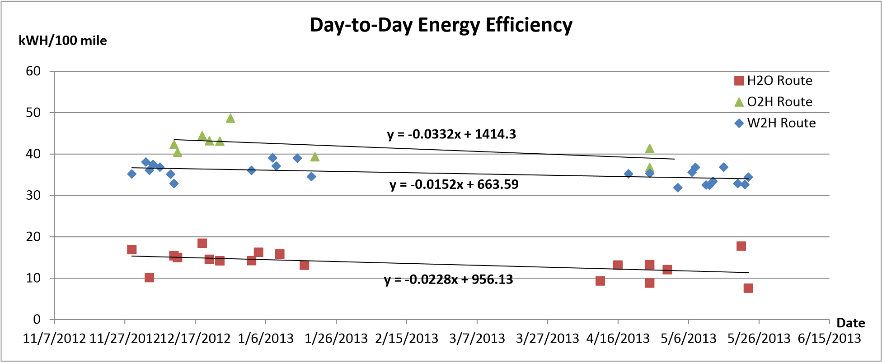

### FIG.7 Day-to-day energy efficiency three routes

#### 3.2 EV Performance

To understand EVs’ energy consumption, one valuable research perspective is to investigate the relationships among power, velocity, acceleration, and roadway grade. Realizing that EVs’ characteristics would be different when driving on urban streets and freeways, we first separated data into in-city and freeway segments, and then analyzed each category separately.

**Power vs. Velocity:** Fig.8a) shows the relationship between EV’s energy usage (in kW) and velocity (in mph) for in-city driving and freeway driving. Clearly, as shown in the figure, driving at higher speed required more power. But interestingly, the required power decreased noticeably and reaches a local minimum when the EV drives at a speed around 55mph in both in-city and highway driving. The figure also shows that to maintain a similar speed, driving on freeway requires a little bit higher power compared to driving on urban streets, although the difference is not significant based on our data.

**Power vs. Acceleration:** It is well known that an EV is consuming energy when accelerating but regenerating electricity when decelerating. Data shown in Fig.8b) confirms this conclusion. When acceleration is negative (i.e. decelerating), the power is negative indicating that the EV is generating energy; and when acceleration is positive, the power is positive indicating that the EV is consuming energy. From the figure, we can see that when the acceleration is between -5 to 5 ft/sec2, the power is proportional to the acceleration. However, when the acceleration is lower than -5 ft/sec2 or higher than 5 ft/sec2, the power keeps almost the same and does not change with the acceleration. This is especially clear form the power vs. acceleration plot derived from the in-city driving data. The upper bound of the required power is about 20 kW and the lower bound is about -5 kW. A similar trend has is seen in the data for freeway driving. The lower bound during regeneration is limited by the battery pack’s ability to accept a charge and is controlled by the vehicles battery management system. The upper bound is significantly less than the maximum power the vehicle can deliver and may be due to driver behavior. More research is needed in this area.

**Power vs. Grade:** Roadway grade will have significant impact on EVs’ energy consumption so it is important to investigate this relationship. Fig.8c) shows the relationship between EV power and roadway grade. As mentioned before, our data collection device, which uses GPS, has difficulties to provide accurate altitude; so we manually collected the elevation and grade information from Google earth along the driven routes. Interestingly, the relationships between power and grade derived from in-city driving data and freeway driving data are significantly different. The possible reason could be that the freeway driving data is limited. From the power vs. grade plot for in-city driving data, the power consumption is small when driving on downhill. This is reasonable since the driver will often be using the vehicles regenerative braking capability. But it is interesting that when the vehicle drives on uphill with high grades, the energy consumption is also low. The possible reason is that the velocity of the vehicle could be low. To provide more detailed explanation, we need to analyze EV’s energy consumption within a specific range of vehicle’s velocity, acceleration, and roadway grade as presented in the following section.

|  |  |  |
| --- | --- | --- |
| kW **Power vs. Velocity: In-City Driving** | **Power vs. Acceleration: In-City Driving**  **-10**  **-5**  **0**  **5**  **10**  **15**  **20**  **25**  **30**  **-25**  **-15**  **-5**  **5**  **15**  **25**  **Power**  kW  ft/sec^2  b  ) | **Power vs. Grade: In-City Driving**  **0**  **4**  **8**  **12**  **16**  **-12**  **-8**  **-4**  **0**  **4**  **8**  **12**  **Power**  kW  %  c  ) |
| kW **Power vs. Velocity: Freeway Driving** | **Power vs. Acceleration: Freeway Driving**  **-10**  **-5**  **0**  **5**  **10**  **15**  **20**  **25**  **30**  **-25**  **-15**  **-5**  **5**  **15**  **25**  **Power**  kW  ft/sec^2 | **Power vs. Grade: Freeway Driving**  **0**  **4**  **8**  **12**  **16**  **-12**  **-8**  **-4**  **0**  **4**  **8**  **12**  **Power**  kW  % |

### FIG.8 a) Power vs. velocity; b) Power vs. Acceleration; and c) Power vs. Grade

**Distribution of EV’s Power Usage:** The above sections provide some general explanation of the relationships between EV power and velocity, acceleration, and roadway power. However, each point in Fig.8 represents an average value of EV power under many different conditions. For example, a point in the figure of power vs. velocity indicates the average power value corresponding to a specific velocity but with all possible accelerations and roadway grades. Therefore, the relationships presented in Fig.8 are only approximate. To better understand EVs’ energy consumption, we further subdivided the data into specific ranges of velocity, acceleration, and roadway grade. With the subdivided data, we were able to more precisely describe the relationships between EV power and velocity, acceleration, and grade. More importantly, the subdivided data also provided opportunities for us to statistically analyze the power data of a specific subgroup.

Fig.9 presents three examples of this analysis. Fig.9a) shows the relationship between EV power and velocity under the condition that vehicle’s acceleration is within the range of 0 – 2 ft/sec2 and roadway grade changes from 0 to 2%. So each point in this figure represents an average power value for the condition that the EV drives at a specific speed with the acceleration between 0 – 2 ft/sec2 and grade between 0 – 2%. Similarly, Fig.9b) shows the relationship between EV power and acceleration for the condition that vehicle’s velocity is within the range of 5 – 10 mph and roadway grade changes from 0 to

2%; and Fig.9c) shows the relationship of EV power vs. roadway grade for the condition that vehicle’s velocity is between 0 – 5 mph and acceleration is within the range of 0 – 2 ft/sec2. Note these ranges could be smaller which would provide more precise description of these relationships if more data was available.

We then statistically analyzed the EV’s power data for each point in Fig.9 which indicates a specific range of velocity, acceleration, and grade. The histograms in the figure suggest that the EV’s power within a specific range of velocity, acceleration, and grade could be described as a normal or log-normal distribution. For different categories, the mean and variance values of distributions are different. As shown in Fig.9, each red point indicates the mean value of the distribution for the data corresponding to a specific range of speed, acceleration and grade, and two bars for each red point indicate the upper and lower bounds of the data, which is calculated based on standard deviation. Note there are many plots which are similar to those shown in Fig.9 which describe the relationships between power, velocity, acceleration, and grade in different subdivisions. Due to space limit, we only present three represented examples.

Describing the power data corresponding to a specific range is very important for EVs’ energy consumption estimation. Fig.9 essentially presents a data-driven method to estimate EVs’ power, which can be used to directly calculate EVs’ energy consumption. From the figure, we can directly read the power value and its variance based on the distribution derived from the power data corresponding to a specific range of EV’s speed, acceleration and grade. But this method requires a large amount of EV data in order to find accurate relationship between EV’s power and velocity, acceleration, and grade. So it would be time-consuming and computationally expensive to pursue this method. To overcome these disadvantages, we propose an analytical EV power estimation model as described in the following section.

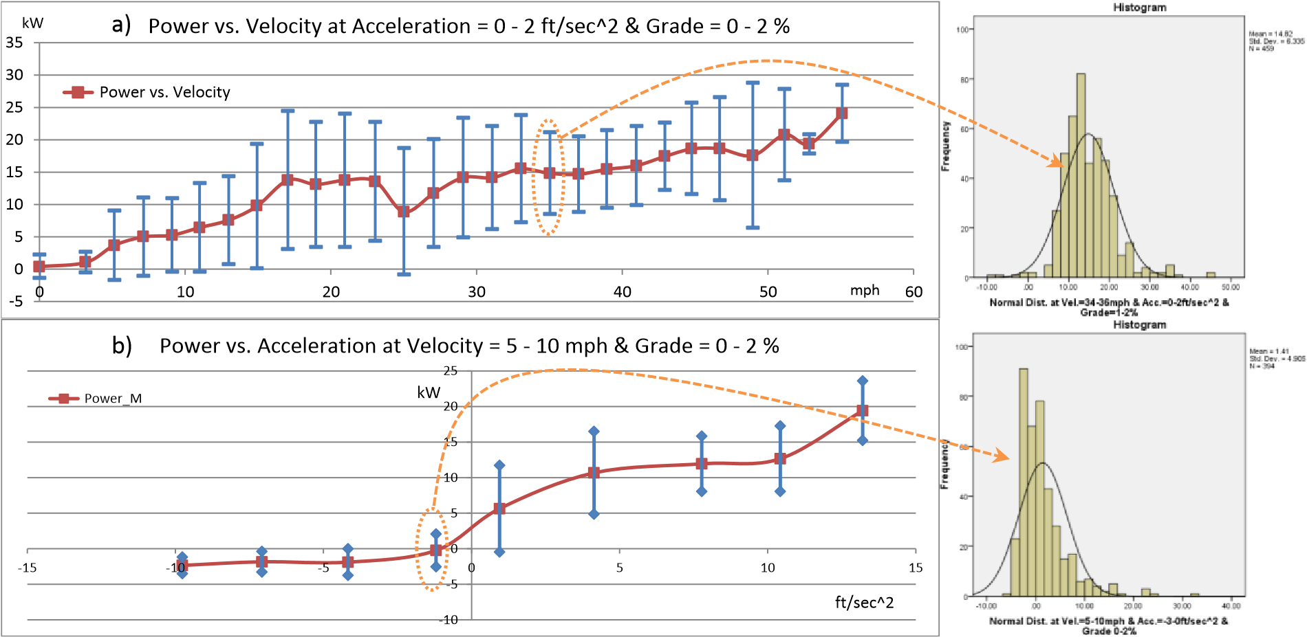

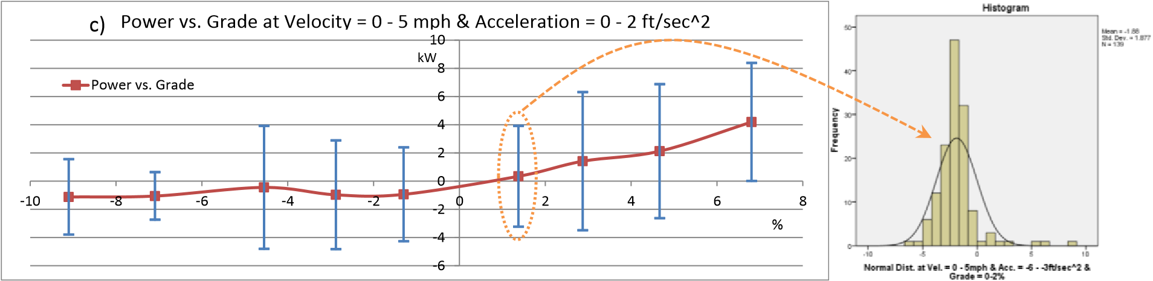

FIG.9 Mean power distribution with a fixed acceleration and grade

## 4. AN ENERGY CONSUMPTION ESTIMATION MODEL FOR ELECTRIC VEHICLES

As discussed above, using distributions of the power to estimate energy consumption is feasible but difficult partly because these distributions have relatively large variance which generate large estimation errors, and partly because this method requires a large amount of effort to collect and analyze data. Therefore, we propose using a physical model, which provides more accurate power estimation for EVs. According to our data analysis, we know that the required power for an EV depends on its travel velocity and acceleration as well as roadway grade. So the proposed model essentially is an analytical description of the relationship between EVs’ power and velocity, acceleration, and grade.

### **4.1 Power Estimation Model**

The proposed model is based on the fundamental theory of vehicle dynamics. Because EVs have very small losses (compared to ICE vehicles), the electrical power used is equal to the power to produce tractive effort (ignoring energy used for climate control and vehicle accessories). The tractive effort is described in the following equation:

 (1)

where is tractive effort (in  or); is vehicle mass (in kg or slug); and  are aerodynamic, rolling, and grade resistances respectively (in  or).

For a vehicle to travelling with a velocity ) and acceleration ),  can be calculated by the following equation:

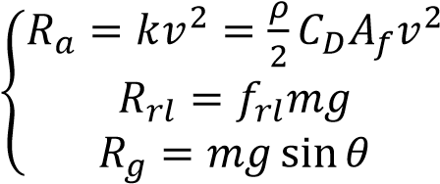 (2)

where *k* is aerodynamic resistance constant, which is determined by air density ), frontal area of the vehicle ), and coefficient of drag  (no unit);  is rolling resistance constant,  is gravity acceleration (, and  is the road grade (in degree).

Combining Eqs.1 and 2, we can get:

 (3)

To generate above tractive force, the required power () for a vehicle traveling at  can be estimated using the following equation:

 (4)

 actually is the output power, which is provided by the input power () generated by a motor. Because of some electrical power losses for an electric motor, the input power and output power have the following relationship:

 (5)

where  is motor efficiency.

The electrical power loss could be copper loss for the high-current region (for a DC motor) or iron loss (for an AC motor). Equivalently, the power losses could be described as a product of the square of the current and the resistance of the conductor[21]. Therefore, the motor efficiency can be calculated by:

 (6)

where  represents the current, and  represents the resistance of the conductor.

From Eqs.3 5, we will have the following equation to estimate vehicle power:

 (7)

On the other hand, the force, , is generated by the torque of the motor, which can be simplified as a product of the armature constant, magnetic flux, and current:

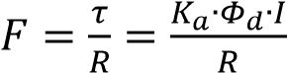 (8)

where  is the torque;  is the radius of the tire;  is the armature

constant;  is the magnetic flux; and  is the current. Note for DC and AC motors, 

is different. For a DC motor,  is the direct-axis air-gap flux per pole; and for an AC motor,  is the rms value of the direct-axis air-gap flux per pole.

To simplify Eq.8, we assume:

 (9)

Therefore, we have:

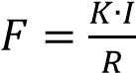 (10)

Finally, combining Eqs.3, 7, and 10, an EV’s instantaneous power can be estimated by:

  (11)

Eq.11 can be simplified as the following equation:

 (12)

where:  is the power losses by the motor;

 is the power losses because of travel resistance; and

 is the possible gained energy from acceleration (or deceleration)

### **4.2 Model Evaluation**

The above model has been evaluated using our test vehicle. We have specifically focused on the following two questions: 1) can the model accurately estimate instantaneous power and 2) can the model accurately estimate the energy consumption of a trip?

To apply the model, we first need to determine the values of the parameters in Eq.11 including vehicle weight (m), rolling resistance coefficient, aerodynamic resistance coefficient (), product of armature constant and magnetic flux (), equivalent resistance of motor (), radius of tire (), and transmission efficiency (η). Most of these parameters including vehicle weight, armature constant, magnetic flux, motor resistance, and radius of tire were directly measured from the vehicle. Other parameters such as rolling resistance coefficient, aerodynamic resistance coefficient, and transmission efficiency are difficult to measure were estimated based on other related research. Table 1 provides the values used for the model.

Table 1: EV’s Parameters to Calculate the Power Consumption Profile

|  |  |  |
| --- | --- | --- |
| Parameters |  | Values |
| Vehicle weight (including driver),  [kg] |  | 1266 |
| Rolling resistance coefficient, |  | 0.006 |
| Aerodynamic resistance coefficient,  [kg/m] |  |  |
| Product of armature constant and magnetic flux, | [V∙s] |
| Resistance of motor (in general),  [Ω] |  |
| Radius of tire,  [m] |  | 0.50 |
| Transmission efficiency, η [%] |  | 95 |

Based on the values in Table 1, we use Eq.11 to calculate instantaneous power. The control variables are EV’s velocity, acceleration, and roadway grade. Vehicle velocity and acceleration time histories were taken directly from the data collection system. Elevation and grade information was manually collected from Google earth. With these input values as a function of time, we calculated EV power using Eq.11. We then compare this calculated power with the measured power. Fig.10 presents an example based on a trip on Dec. 03, 2012. As we can see from the figure, the purple line, which represents estimated EV power, closely follows the green line, which is the measured EV power. This shows the accuracy of our simple estimation model. We also include vehicle velocity and acceleration information indicated by light pink and light blue lines respectively as shown in the figure. Interestingly, we can see that the changes of power follow the trend of the change of acceleration closely.

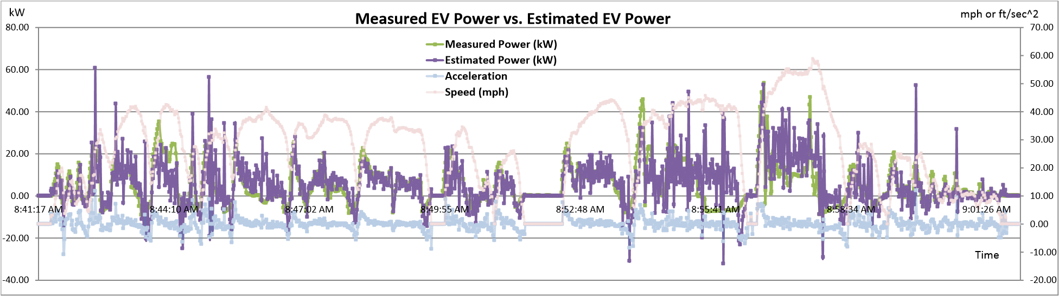

### FIG.10 Measured power vs. estimated power

More importantly, we are interested if the developed model can accurately estimate the energy consumption for a trip. The energy consumed over a trip is computed by integrating the power over the time of the trip. Using this integral we computed both the measured and estimated energy usage for over 40 trips completed during May, 2013. Fig.11 compares the measured and estimated energy for each of the trips. It is clear that the estimation model successfully estimate trip energy usage. We also calculated mean absolute error (MAE). The average MAE for all trips shown in Fig.11 is 15.6%. We believe further calibration of the parameters presented in Table 1 could significantly improve the accuracy for our model.

1 2 3 4 5 6 7 8 9 10 11 12 13 14 15 16 17 18 19 20 21 22 23 24 25 26 27 28 29 30 31 32 33 34 35 36 37 38 39 40 41

0

1

2

3

4

5

Measured EV Energy Usage

Estimated EV Energy Usage

**EV**

**Energy Consumption: Measured vs. Estimated**

kWH

Trip #

FIG.11 Estimated EV energy consumption vs. measured EV energy consumption for 41 trips

## 5. CONCLUDING REMARKS

This paper first presented a system which can collect in-use EV data from both the battery system, including battery state of charge, pack current, pack voltage, pack power and vehicle driving data including velocity, acceleration, and vehicle position (latitude, longitude, and elevation). This system then has been installed in an EV conversion vehicle built for this research. Approximately five months of EV data has been collected and have been used to analyze both EV’s performance and EV driver’s behaviors. The analysis indicates that EV is more efficient when driving on urban streets than driving on freeways. As a result, this particular EV driver prefers in-city routes over freeway routes. This result is consistent with other research showing a preference for in-city driving over freeway driving for EV users. Another important finding was that providing the driver timely information on energy usage encouraged the driver to adjust his driving behavior to reduce energy consumption. Specifically the driver selected more energy efficient routes and modified his driving behavior to improve efficiency over time. This could be an indication of information-induced behavior for EV drivers.

To understand EV’s energy consumption, we also analyzed the relationships between EV’s power and vehicle’s velocity, acceleration, and roadway grade. The relationship of power vs. velocity shows that driving at higher speed required more power, and the relationship of power vs. acceleration confirms that an EV is consuming energy when accelerating but re-generating electricity when decelerating. However, the relationship between power and roadway grade is not clear. The data shows that the EV requires less power when driving on downhill, which is reasonable due to EV’s energy re-generation; but it is interesting that the data shows when the vehicle drives on uphill with high grade, the energy consumption is also low. Further research is needed to understand this apparent discrepancy. We further subdivided the data into specific ranges of velocity, acceleration, and roadway grade. By statistically analyzing the subdivided data, we determined that the EV’s power within a specific range of velocity, acceleration, and grade could be described as a normal or log-normal distribution; and for different ranges of velocity, acceleration, and grade, the mean and variance values of these distributions are different. Knowing the power data corresponding to a specific range is very important for estimating EV energy consumption. Using these data, the paper presents an empirical method to estimate EVs’ power. Using this method, the mean and variance of the EV power usage can be estimated for specific speed, acceleration and grade values.

However the empirical method is both time-consuming and computationally expensive. Therefore a second analytical EV power estimation model was proposed. The model is based on the fundamental theory of vehicle dynamics and the basic relationships among power, force, torque, voltage, and current.

This model was evaluated using our test vehicle. The results indicate that this model can successfully estimate EV’s instantaneous power and trip energy consumption.

This research provides a comprehensive review of EV energy use. It demonstrates the feasibility of collecting such data and the potential insights that can be gained from analysis of the data. The energy estimation model presented appears to work well and has potential as both a research tool and resource for EV users. However, the data set is limited since it contains data from only one driver, one vehicle, and includes limited freeway driving. This research should be expanded to other vehicles and drivers to gain the data needed to improve the estimation model and validate the preliminary conclusions present in this paper.

**ACKNOWLEDGEMENT:** This research is partially supported by the President’s Research, Scholarship, and Creative Activity Award (#060660) funded by the California State Polytechnic University Pomona (CPP). The authors would also like to thank Prof. Gerald Herder from the Electronics and Computer Engineering Technology (ECET) Department at CPP and Dr. Tim Lin from the Electrical and Computer Engineering (ECE) Department at CPP for their help on the development of EV energy consumption estimation model and Mr. Johnny Truong for his help on elevation data collection.

## REFENRENCES

1. Andersen, G. (2012). Volatile oil prices and new technologies are helping the effort to diversify transportation fuels, National Conference of State Legislatures**,** [http://www.ncsl.org/issuesresearch/energyhome/fueling-the-future.aspx](http://www.ncsl.org/issues-research/energyhome/fueling-the-future.aspx) (Accessed April 22, 2013)
2. Axsen, J., Kurani, K.S., Burke, A. (2010). Are Batteries Ready for Plug-in Hybrid Buyers? Transport Policy 17,173–182
3. Canis, B. (2011). Battery Manufacturing for Hybrid and Electric Vehicles: Policy Issues.

Congressional Research Service

[http://nepinstitute.org/get/CRS_Reports/CRS_Energy/Energy_Efficiency_and_Conservation/Batterie s_for_Hybrid_and_Elec_Vehicles.pdf](http://nepinstitute.org/get/CRS_Reports/CRS_Energy/Energy_Efficiency_and_Conservation/Batteries_for_Hybrid_and_Elec_Vehicles.pdf) (Accessed April 10, 2013).

1. Clegg, S.J. (1996) A Review of Regenerative Braking Systems. Institute of Transport Studies,

University of Leeds, Working Paper 471.

<http://eprints.whiterose.ac.uk/2118/1/ITS105_WP471_uploadable.pdf>(Accessed April 15, 2013)

1. Deutsche Bank (2009). Autos & Auto Parts Electric Cars: Plugged in 2 [www.fullermoney.com/content/2009-11-03/ElectricCarsPluggedIn2.pdf](http://www.fullermoney.com/content/2009-11-03/ElectricCarsPluggedIn2.pdf) (Accessed April 15, 2013)
2. Elkind, E.N. (2012). Electric Drive by ’25: How California Can Catalyze Mass Adoption of Electric Vehicles by 2025, workshop by UCLA Law \ Berkeley Law, <http://www.law.berkeley.edu/files/ccelp/Electric_Drive_by_25-2.pdf>(Accessed April 22, 2013).
3. Frade, I., Ribeiro, A., Goncalves, G., Antunes, A.P. (2010). An Optimization Model for Locating Electric Vehicle Charging Stations in Central Urban Areas. In: Proceeding of the Transportation Research Board 90th Annual Meeting, Transportation Research Board. Washington, D.C.
4. Gao, Y.M., Chen, L.P.,Ehsani, M. (1999). Investigation of the Effectiveness of Regenerative Braking for EV and HEV, SAE Trans, 108, 3184–3190.
5. Greene, D.L., Schafer, A. (2003). Reducing Greenhouse Gas Emissions: From U.S. Transportation,

Pew Center on Global Climate Change, Arlington, VA 22201

1. He, F., Wu, D., Yin, Y., & Guan, Y. (2013). Optimal Deployment of Public Charging Stations for Plug-in Hybrid Electric Vehicles, Transportation Research Part B 47 87–101
2. Ip, A., Fong, S., Liu, E. (2010).Optimization for Allocating BEV Recharging Stations in Urban Areas by Using Hierarchical Clustering. In: Proceedings of the 2nd International Conference on Data Mining and Intelligent Information Technology Applications (ICMIA 2010), Seoul, Korea, 27262730.
3. Knowles, M., Scott, H., Baglee, D. (2012). The Effect of Driving Style on Electric Vehicle Performance, Economy and Perception. Int. J. Electric and Hybrid Vehicles, 4(3), 228-247
4. Morrowa, K., Karnerb, D., Francfortc, J. (2008). U.S. Department of Energy Vehicle Technologies Program - Advanced Vehicle Testing Activity Plug-in Hybrid Electric Vehicle: Charging Infrastructure Review, Final Report: INL/EXT-08-15058, Battelle Energy Alliance, Contract No. 58517
5. Pan, F., Bent, R., Berscheid, A., Izraelevitz, D. (2010). Locating PHEV Exchange Stations in V2G. In: Proceedings of 1st IEEE International Conference on SmartGrid Communications (SmartGridComm), 173–178.
6. Pound, W.T. (2012). Transportation Energy for the Future: A Guide for Policymakers, Washington, D.C. 20001
7. Rajashekara, K. (2004) Power Conversion and Control Strategies for Fuel Cell Vehicles. In Proceedings of the 29thAnnual Conference of the IEEE Industrial Electronics Society, Roanoke, VA, USA, 3, 2865–2870.
8. Sioshansi, R. (2012). Modeling the Impacts of Electricity Tariffs on Plug-in Hybrid Electric Vehicle Charging, Costs, and Emissions. Operations Research 60(3) 506-516.
9. Skerlos, S.J., Winebrake, J.J. (2010). Targeting Plug-in Hybrid Electric Vehicle Policies to Increase Social Benefits. Energy Policy 38 (2), 705–708
10. Sovacool, B.K., Hirsh, R.F. (2009). Beyond Batteries: An Examination of the Benefits and Barriers to Plug-in Hybrid Electric Vehicles (PHEVs) and a Vehicle-to-Grid (V2G) Transition. Energy Policy 37 (3), 1095–1103.
11. Sweda, T., Klabjan, D. (2011). An Agent-Based Decision Support System for Electric Vehicle Charging Infrastructure Deployment. In: Proceeding of 7thIEEE Vehicle Power and Propulsion Conference, Chicago, Illinois.
12. Tanaka, D., Ashida, T., & Minami, S. (2008). An Analytical Method of EV Velocity Profile Determination from the Power Consumption of Electric Vehicles, IEEE Vehicle Power and Propulsion Conference (VPPC), Harbin, China
13. US DOT (2010). Transportation’s Role in Reducing U.S. Greenhouse Gas Emissions Volume 1: Synthesis Report, Report to Congress, U.S. Department of Transportation
14. Xu, G., Li, W., Xu, K., Song, Z. (2011). An Intelligent Regenerative Braking Strategy for Electric Vehicles,Energies 4, 1461-1477
15. Zhang, J., Lu, X., Xue, J., Li, B. (2008). Regenerative Braking System for Series Hybrid Electric City Bus, The World Electric Vehicle Journal, 2 (4), 128-134