**中国科学技术大学计算机学院**

**《数字电路实验》报告**



**实验题目：_综合实验-“猜学号”shell _**

**学生姓名：___宋玮_____**

**学生学号：_PB20151793_**

**完成日期：__2021.12.22_**

计算机实验教学中心制

【实验题目】

**综合实验-“猜学号”shell**

【实验目的】

熟练掌握前面实验中的所有知识点

熟悉几种常用通信接口的工作原理及使用

独立完成具有一定规模的功能电路设计

【实验环境】

VLAB：vlab.ustc.edu.cn

FPGAOL: fpgaol.ustc.edu.cn

Vivado

【实验过程】

***实验概述：*首先，在 FPGAOL 平台上，利用串口终端等外设，实现一个可以简单读写的shell。然后，在此功能之上，再加入判断（judge）功能，即判断写入的八位是否为本人学号（20151793），若是，则输出congrats，否则输出E！**

**注意，在输入命令时须符合如下规范，否则，也将输出E！**

|  |  |  |  |  |
| --- | --- | --- | --- | --- |
| **命令** | **格式** | **范围** | **示例** | **说明** |
| **Write** | **w addr data** | **1<=addr<=4**  **00<data<ff** | **>w 1 ff** | **向地址1写入ff** |
| **Read** | **r addr** | **1<=addr<=4** | **>r 1** | **读地址1中的数据并将其打印** |
| **Judge** | **j** |  | **>j** | **判断写入的是否为本人的八位学号** |
| **Else** |  |  |  | **输出为E！** |

**地址1：数码管 1~0 位所表示的字节数据**

**地址2：数码管 3~2 位所表示的字节数据**

**地址3：数码管 5~4 位所表示的字节数据**

**地址4：数码管 7~6 位所表示的字节数据**

**七段数码管(led[7:0])在写入的八位为本人学号时显示1，其他时候均显示0**

**示例：**

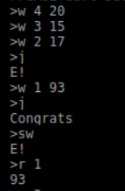

**step1程序**

**（1）首先是主体部分。**

总共包含8个状态：

C_CMD_CO 判断正确阶段，即发送”Congrats”

C_IDLE 空闲状态，接收到串口数据后跳转到下一状态C_CMD_DC

C_CMD_DC 解码命令状态，解析缓冲区中的命令类型，如写字节、读字节等

C_CMD_WB 写数据阶段，根据命令内容，将数据写入对应地址

C_CMD_RB 读数据阶段，根据命令内容，读取对应地址的数据

C_CMD_ERR 错误状态，上位机发送的命令格式有误时进入此状态，向上位机发送"E！"

C_TXFIFO_WR 等待阶段，将数据或返回信息以ASCII码格式存入发送缓冲区

C_TXFIFO_WAIT 发送等待阶段，将发送缓冲区中的数据依次以ASCII码格式从串口发出

根据不同的情况，状态在这八个当中跳转，并在特定状态完成相应的特定操作。

**主体design代码如下：**

module lab10(

input clk,rst,

input rx,

output tx,

output reg [7:0] led,

output wire [2:0] hex_seg_an,

output reg [3:0] hex_seg_data

);

wire tx_ready;

wire [7:0] tx_data;

wire [7:0] rx_data;

reg [3:0] curr_state;

reg [3:0] next_state;

wire is_wb_cmd;

wire is_rb_cmd;

wire is_judge;

reg [3:0] tx_byte_cnt;

reg [3:0] rx_byte_cnt;

reg [7:0] rx_byte_buff_0;

reg [7:0] rx_byte_buff_1;

reg [7:0] rx_byte_buff_2;

reg [7:0] rx_byte_buff_3;

reg [7:0] rx_byte_buff_4;

reg [7:0] rx_byte_buff_5;

reg [7:0] rx_byte_buff_6;

reg [7:0] rx_byte_buff_7;

reg [7:0] tx_byte_buff_0;

reg [7:0] tx_byte_buff_1;

reg [7:0] tx_byte_buff_2;

reg [7:0] tx_byte_buff_3;

reg [7:0] tx_byte_buff_4;

reg [7:0] tx_byte_buff_5;

reg [7:0] tx_byte_buff_6;

reg [7:0] tx_byte_buff_7;

reg [7:0] tx_byte_buff_8;

reg rx_fifo_en;

wire [7:0] rx_fifo_data;

wire rx_fifo_empty;

reg wr_en;

reg [3:0] wr_addr;

reg [7:0] wr_data;

reg rd_en;

reg [3:0] rd_addr;

reg [7:0] rd_data;

reg [7:0] tx_fifo_din;

reg tx_fifo_wr_en;

wire tx_fifo_full;

wire tx_fifo_empty;

reg [18:0] hex_seg_scan;

reg [31:0] hex_seg_buff;

parameter C_IDLE = 4'b0000;

parameter C_CMD_DC = 4'b0010;

parameter C_CMD_WB = 4'b0011;

parameter C_CMD_RB = 4'b0100;

parameter C_CMD_ERR = 4'b0111;

parameter C_TXFIFO_WR = 4'b0101;

parameter C_TXFIFO_WAIT = 4'b0110;

parameter C_CMD_CO = 4'b1000;

always@(posedge clk or posedge rst)

begin

if(rst)

begin

tx_fifo_wr_en <= 1'b0;

tx_fifo_din <= 8'h0;

end

else if(curr_state==C_TXFIFO_WR)

begin

tx_fifo_wr_en <= 1'b1;

case(tx_byte_cnt)

4'h8: tx_fifo_din <= tx_byte_buff_8;

4'h7: tx_fifo_din <= tx_byte_buff_7;

4'h6: tx_fifo_din <= tx_byte_buff_6;

4'h5: tx_fifo_din <= tx_byte_buff_5;

4'h4: tx_fifo_din <= tx_byte_buff_4;

4'h3: tx_fifo_din <= tx_byte_buff_3;

4'h2: tx_fifo_din <= tx_byte_buff_2;

4'h1: tx_fifo_din <= tx_byte_buff_1;

4'h0: tx_fifo_din <= tx_byte_buff_0;

default:tx_fifo_din <= 8'h0;

endcase

end

else

begin

tx_fifo_wr_en <= 1'b0;

tx_fifo_din <= 8'h0;

end

end

always@(posedge clk or posedge rst)

begin

if(rst)

begin

rd_en <= 1'b0;

rd_addr[3:0] <= 4'h0;

end

else if(curr_state==C_CMD_RB)

begin

rd_en <= 1'b1;

if((rx_byte_buff_2>="0")&&(rx_byte_buff_2<="9"))

rd_addr[3:0] <= rx_byte_buff_2[3:0];

else

rd_addr[3:0] <= rx_byte_buff_2[3:0]+ 4'h9;

end

else

begin

rd_en <= 1'b0;

rd_addr[3:0] <= 4'h0;

end

end

always@(posedge clk or posedge rst)

begin

if(rst)

tx_byte_cnt <= 4'h0;

else if(curr_state==C_IDLE)

tx_byte_cnt <= 4'h0;

else if(curr_state==C_CMD_RB)

tx_byte_cnt <= 4'h2;

else if(curr_state==C_CMD_ERR)

tx_byte_cnt <= 4'h2;

else if(curr_state==C_CMD_CO)

tx_byte_cnt <= 4'h8;

else if(curr_state==C_TXFIFO_WR)

begin

if(tx_byte_cnt!=4'h0)

tx_byte_cnt <= tx_byte_cnt - 4'h1;

end

end

always@(posedge clk or posedge rst)

begin

if(rst)

begin

tx_byte_buff_0 <= 8'h0;

tx_byte_buff_1 <= 8'h0;

tx_byte_buff_2 <= 8'h0;

tx_byte_buff_3 <= 8'h0;

tx_byte_buff_4 <= 8'h0;

tx_byte_buff_5 <= 8'h0;

tx_byte_buff_6 <= 8'h0;

tx_byte_buff_7 <= 8'h0;

tx_byte_buff_8 <= 8'h0;

end

else if(curr_state==C_IDLE)

begin

tx_byte_buff_0 <= 8'h0;

tx_byte_buff_1 <= 8'h0;

tx_byte_buff_2 <= 8'h0;

tx_byte_buff_3 <= 8'h0;

tx_byte_buff_4 <= 8'h0;

tx_byte_buff_5 <= 8'h0;

tx_byte_buff_6 <= 8'h0;

tx_byte_buff_7 <= 8'h0;

tx_byte_buff_8 <= 8'h0;

end

else if(curr_state==C_CMD_RB)

begin

tx_byte_buff_0 <= "\n";

if(rd_data[7:4]<=4'h9)//0~9

tx_byte_buff_2 <= {4'h3,rd_data[7:4]};

else

tx_byte_buff_2 <= rd_data[7:4] - 4'ha + "a";

if(rd_data[3:0]<=4'h9)//0~9

tx_byte_buff_1 <= {4'h3,rd_data[3:0]};

else

tx_byte_buff_1 <= rd_data[3:0] - 4'ha + "a";

end

else if(curr_state==C_CMD_ERR)

begin

tx_byte_buff_2 <= "E";

tx_byte_buff_1 <= "!";

tx_byte_buff_0 <= "\n";

end

else if(curr_state==C_CMD_CO)

begin

tx_byte_buff_8 <= "C";

tx_byte_buff_7 <= "o";

tx_byte_buff_6 <= "n";

tx_byte_buff_5 <= "g";

tx_byte_buff_4 <= "r";

tx_byte_buff_3 <= "a";

tx_byte_buff_2 <= "t";

tx_byte_buff_1 <= "s";

tx_byte_buff_0 <= "\n";

end

end

always@(posedge clk or posedge rst)

begin

if(rst)

curr_state <= C_IDLE;

else

curr_state <= next_state;

end

always@(*)

begin

case(curr_state)

C_IDLE:

if((rx_vld==1'b1)&&(rx_data==8'h0a))

next_state = C_CMD_DC;

else

next_state = C_IDLE;

C_CMD_DC:

if(rx_fifo_empty)

begin

if(is_wb_cmd)

next_state = C_CMD_WB;

else if(is_rb_cmd)

next_state = C_CMD_RB;

else if(is_judge)

next_state = C_CMD_CO;

else

next_state = C_CMD_ERR;

end

else

next_state = C_CMD_DC;

C_CMD_WB:

next_state = C_IDLE;

C_CMD_RB:

if(rd_en==1'b1)

next_state = C_TXFIFO_WR;

else

next_state = C_CMD_RB;

C_CMD_ERR:

next_state = C_TXFIFO_WR;

C_CMD_CO:

next_state = C_TXFIFO_WR;

C_TXFIFO_WR:

if(tx_byte_cnt==4'h0)

next_state = C_TXFIFO_WAIT;

else

next_state = C_TXFIFO_WR;

C_TXFIFO_WAIT:

if(tx_fifo_empty)

next_state = C_IDLE;

else

next_state = C_TXFIFO_WAIT;

default:

next_state = C_IDLE;

endcase

end

always@(posedge clk or posedge rst)

begin

if(rst)

rx_fifo_en <= 1'b0;

else if(curr_state==C_CMD_DC)

rx_fifo_en <= 1'b1;

else

rx_fifo_en <= 1'b0;

end

always@(posedge clk or posedge rst)

begin

if(rst)

rx_byte_cnt <= 4'h0;

else if(curr_state==C_CMD_DC)

begin

if((rx_fifo_en)&&(rx_fifo_empty==1'b0)&&(rx_byte_cnt<4'hf))

rx_byte_cnt <= rx_byte_cnt + 4'b1;

end

else

rx_byte_cnt <= 4'h0;

end

always@(posedge clk or posedge rst)

begin

if(rst)

begin

rx_byte_buff_0 <= 8'h0;

rx_byte_buff_1 <= 8'h0;

rx_byte_buff_2 <= 8'h0;

rx_byte_buff_3 <= 8'h0;

rx_byte_buff_4 <= 8'h0;

rx_byte_buff_5 <= 8'h0;

rx_byte_buff_6 <= 8'h0;

rx_byte_buff_7 <= 8'h0;

end

else if(curr_state==C_IDLE)

begin

rx_byte_buff_0 <= 8'h0;

rx_byte_buff_1 <= 8'h0;

rx_byte_buff_2 <= 8'h0;

rx_byte_buff_3 <= 8'h0;

rx_byte_buff_4 <= 8'h0;

rx_byte_buff_5 <= 8'h0;

rx_byte_buff_6 <= 8'h0;

rx_byte_buff_7 <= 8'h0;

end

else if(curr_state==C_CMD_DC)

begin

case(rx_byte_cnt)

4'h0: rx_byte_buff_0 <= rx_fifo_data;

4'h1: rx_byte_buff_1 <= rx_fifo_data;

4'h2: rx_byte_buff_2 <= rx_fifo_data;

4'h3: rx_byte_buff_3 <= rx_fifo_data;

4'h4: rx_byte_buff_4 <= rx_fifo_data;

4'h5: rx_byte_buff_5 <= rx_fifo_data;

4'h6: rx_byte_buff_6 <= rx_fifo_data;

4'h7: rx_byte_buff_7 <= rx_fifo_data;

endcase

end

end

assign is_wb_cmd = (curr_state==C_CMD_DC)

&&(rx_byte_buff_0=="w")

&&(rx_byte_buff_1==" ")&&(rx_byte_buff_3==" ")

&&(((rx_byte_buff_2>="0")&&(rx_byte_buff_2<="9"))||((rx_byte_buff_2>="a")&&(rx_byte_buff_2<="f")))

&&(((rx_byte_buff_4>="0")&&(rx_byte_buff_4<="9"))||((rx_byte_buff_4>="a")&&(rx_byte_buff_4<="f")))

&&(((rx_byte_buff_5>="0")&&(rx_byte_buff_5<="9"))||((rx_byte_buff_5>="a")&&(rx_byte_buff_5<="f")));

assign is_rb_cmd = (curr_state==C_CMD_DC)

&&(rx_byte_buff_0=="r")

&&(rx_byte_buff_1==" ")

&&(((rx_byte_buff_2>="0")&&(rx_byte_buff_2<="9"))||((rx_byte_buff_2>="a")&&(rx_byte_buff_2<="f")));

assign is_judge = (curr_state==C_CMD_DC)

&&(rx_byte_buff_0=="j")

&&(hex_seg_buff==32'h20151793);

always@(posedge clk or posedge rst)

begin

if(rst)

begin

wr_en <= 1'b0;

wr_addr[3:0] <= 4'h0;

wr_data[7:4] <= 4'h0;

wr_data[3:0] <= 4'h0;

end

else if(curr_state == C_CMD_WB)

begin

wr_en <= 1'b1;

if((rx_byte_buff_2>="0")&&(rx_byte_buff_2<="9"))

wr_addr[3:0] <= rx_byte_buff_2[3:0];

else

wr_addr[3:0] <= rx_byte_buff_2[2:0] + 4'h9;

if((rx_byte_buff_4>="0")&&(rx_byte_buff_4<="9"))

wr_data[7:4] <= rx_byte_buff_4[3:0];

else

wr_data[7:4] <= rx_byte_buff_4[2:0] + 4'h9;

if((rx_byte_buff_5>="0")&&(rx_byte_buff_5<="9"))

wr_data[3:0] <= rx_byte_buff_5[3:0];

else

wr_data[3:0] <= rx_byte_buff_5[2:0] + 4'h9;

end

else

begin

wr_en <= 1'b0;

wr_addr[3:0] <= 4'h0;

wr_data[7:4] <= 4'h0;

wr_data[3:0] <= 4'h0;

end

end

rx rx_inst(

.clk (clk),

.rst (rst),

.rx (rx),

.rx_vld (rx_vld),

.rx_data (rx_data)

);

tx tx_inst(

.clk (clk),

.rst (rst),

.tx (tx ),

.tx_ready (~tx_fifo_empty),

.tx_rd (tx_rd),

.tx_data (tx_data)

);

fifo_32x8bit_0 rx_fifo(

.clk (clk),

.srst (rst),

.din (rx_data),

.wr_en (rx_vld),

.rd_en (rx_fifo_en),

.dout (rx_fifo_data),

.full (),

.empty (rx_fifo_empty)

);

fifo_32x8bit_0 tx_fifo(

.clk (clk),

.srst (rst),

.din (tx_fifo_din),

.wr_en (tx_fifo_wr_en),

.rd_en (tx_rd),

.dout (tx_data),

.full (tx_fifo_full),

.empty (tx_fifo_empty)

);

always@(posedge clk or posedge rst)

begin

if(rst)

hex_seg_scan <= 19'h0;

else

hex_seg_scan <= hex_seg_scan + 1'b1;

end

assign hex_seg_an = hex_seg_scan[18:16];

always@(*)

begin

case(hex_seg_an)

3'h0: hex_seg_data = hex_seg_buff[3:0];

3'h1: hex_seg_data = hex_seg_buff[7:4];

3'h2: hex_seg_data = hex_seg_buff[11:8];

3'h3: hex_seg_data = hex_seg_buff[15:12];

3'h4: hex_seg_data = hex_seg_buff[19:16];

3'h5: hex_seg_data = hex_seg_buff[23:20];

3'h6: hex_seg_data = hex_seg_buff[27:24];

3'h7: hex_seg_data = hex_seg_buff[31:28];

endcase

end

always@(*)

begin

if(rd_en)

begin

case(rd_addr)

4'h1: rd_data = hex_seg_buff[7:0];

4'h2: rd_data = hex_seg_buff[15:8];

4'h3: rd_data = hex_seg_buff[23:16];

4'h4: rd_data = hex_seg_buff[31:24];

default:rd_data = 4'h0;

endcase

end

else

rd_data = 8'h0;

end

always@(posedge clk or posedge rst)

begin

if(rst)

begin

hex_seg_buff <= 32'h0;

end

else if(wr_en)

begin

case(wr_addr)

4'h1: hex_seg_buff[7:0] <= wr_data;

4'h2: hex_seg_buff[15:8] <= wr_data;

4'h3: hex_seg_buff[23:16] <= wr_data;

4'h4: hex_seg_buff[31:24] <= wr_data;

endcase

end

end

always@(*)

begin

if(hex_seg_buff==32'h20151793) led<=8'h06;

else led<=8'h3f;

end

endmodule

**（2）其他部分。**

**①rx**

**代码如下：**

module rx(

input clk,rst,

input rx,

output reg rx_vld,

output reg [7:0] rx_data

);

parameter DIV_CNT = 10'd867;

parameter HDIV_CNT = 10'd433;

parameter RX_CNT = 4'h8;

parameter C_IDLE = 1'b0;

parameter C_RX = 1'b1;

reg curr_state;

reg next_state;

reg [9:0] div_cnt;

reg [3:0] rx_cnt;

reg rx_reg_0,rx_reg_1,rx_reg_2,rx_reg_3,rx_reg_4,rx_reg_5,rx_reg_6,rx_reg_7;

wire rx_pulse;

always@(posedge clk or posedge rst)

begin

if(rst)

curr_state <= C_IDLE;

else

curr_state <= next_state;

end

always@(*)

begin

case(curr_state)

C_IDLE:

if(div_cnt==HDIV_CNT)

next_state = C_RX;

else

next_state = C_IDLE;

C_RX:

if((div_cnt==DIV_CNT)&&(rx_cnt>=RX_CNT))

next_state = C_IDLE;

else

next_state = C_RX;

endcase

end

always@(posedge clk or posedge rst)

begin

if(rst)

div_cnt <= 10'h0;

else if(curr_state == C_IDLE)

begin

if(rx==1'b1)

div_cnt <= 10'h0;

else if(div_cnt < HDIV_CNT)

div_cnt <= div_cnt + 10'h1;

else

div_cnt <= 10'h0;

end

else if(curr_state == C_RX)

begin

if(div_cnt >= DIV_CNT)

div_cnt <= 10'h0;

else

div_cnt <= div_cnt + 10'h1;

end

end

always@(posedge clk or posedge rst)

begin

if(rst)

rx_cnt <= 4'h0;

else if(curr_state == C_IDLE)

rx_cnt <= 4'h0;

else if((div_cnt == DIV_CNT)&&(rx_cnt<4'hF))

rx_cnt <= rx_cnt + 1'b1;

end

assign rx_pulse = (curr_state==C_RX)&&(div_cnt==DIV_CNT);

always@(posedge clk)

begin

if(rx_pulse)

begin

case(rx_cnt)

4'h0: rx_reg_0 <= rx;

4'h1: rx_reg_1 <= rx;

4'h2: rx_reg_2 <= rx;

4'h3: rx_reg_3 <= rx;

4'h4: rx_reg_4 <= rx;

4'h5: rx_reg_5 <= rx;

4'h6: rx_reg_6 <= rx;

4'h7: rx_reg_7 <= rx;

endcase

end

end

always@(posedge clk or posedge rst)

begin

if(rst)

begin

rx_vld <= 1'b0;

rx_data <= 8'h55;

end

else if((curr_state==C_RX)&&(next_state==C_IDLE))

begin

rx_vld <= 1'b1;

rx_data <= {rx_reg_7,rx_reg_6,rx_reg_5,rx_reg_4,rx_reg_3,rx_reg_2,rx_reg_1,rx_reg_0};

end

else

rx_vld <= 1'b0;

end

endmodule

**②tx**

**代码如下：**

module tx(

input clk,rst,

output reg tx,

input tx_ready,

output reg tx_rd,

input [7:0] tx_data

);

parameter DIV_CNT = 10'd867;

parameter HDIV_CNT = 10'd433;

parameter TX_CNT = 4'h9;

parameter C_IDLE = 1'b0;

parameter C_TX = 1'b1;

reg curr_state,next_state;

reg [9:0] div_cnt;

reg [4:0] tx_cnt;

reg [7:0] tx_reg;

always@(posedge clk or posedge rst)

begin

if(rst)

curr_state <= C_IDLE;

else

curr_state <= next_state;

end

always@(*)

begin

case(curr_state)

C_IDLE:

if(tx_ready==1'b1)

next_state = C_TX;

else

next_state = C_IDLE;

C_TX:

if((div_cnt==DIV_CNT)&&(tx_cnt>=TX_CNT))

next_state = C_IDLE;

else

next_state = C_TX;

endcase

end

always@(posedge clk or posedge rst)

begin

if(rst)

div_cnt <= 10'h0;

else if(curr_state==C_TX)

begin

if(div_cnt>=DIV_CNT)

div_cnt <= 10'h0;

else

div_cnt <= div_cnt + 10'h1;

end

else

div_cnt <= 10'h0;

end

always@(posedge clk or posedge rst)

begin

if(rst)

tx_cnt <= 4'h0;

else if(curr_state==C_TX)

begin

if(div_cnt==DIV_CNT)

tx_cnt <= tx_cnt + 1'b1;

end

else

tx_cnt <= 4'h0;

end

always@(posedge clk or posedge rst)

begin

if(rst)

tx_rd <= 1'b0;

else if((curr_state==C_IDLE)&&(tx_ready==1'b1))

tx_rd <= 1'b1;

else

tx_rd <= 1'b0;

end

always@(posedge clk or posedge rst)

begin

if(rst)

tx_reg <= 8'b0;

else if((curr_state==C_IDLE)&&(tx_ready==1'b1))

tx_reg <= tx_data;

end

always@(posedge clk or posedge rst)

begin

if(rst)

tx <= 1'b1;

else if(curr_state==C_IDLE)

tx <= 1'b1;

else if(div_cnt==10'h0)

begin

case(tx_cnt)

4'h0: tx <= 1'b0;

4'h1: tx <= tx_reg[0];

4'h2: tx <= tx_reg[1];

4'h3: tx <= tx_reg[2];

4'h4: tx <= tx_reg[3];

4'h5: tx <= tx_reg[4];

4'h6: tx <= tx_reg[5];

4'h7: tx <= tx_reg[6];

4'h8: tx <= tx_reg[7];

4'h9: tx <= 1'b1;

endcase

end

end

endmodule

**③ip核-FIFO**

用以临时存储数据，起到缓冲作用.

大小是32×8 bit.

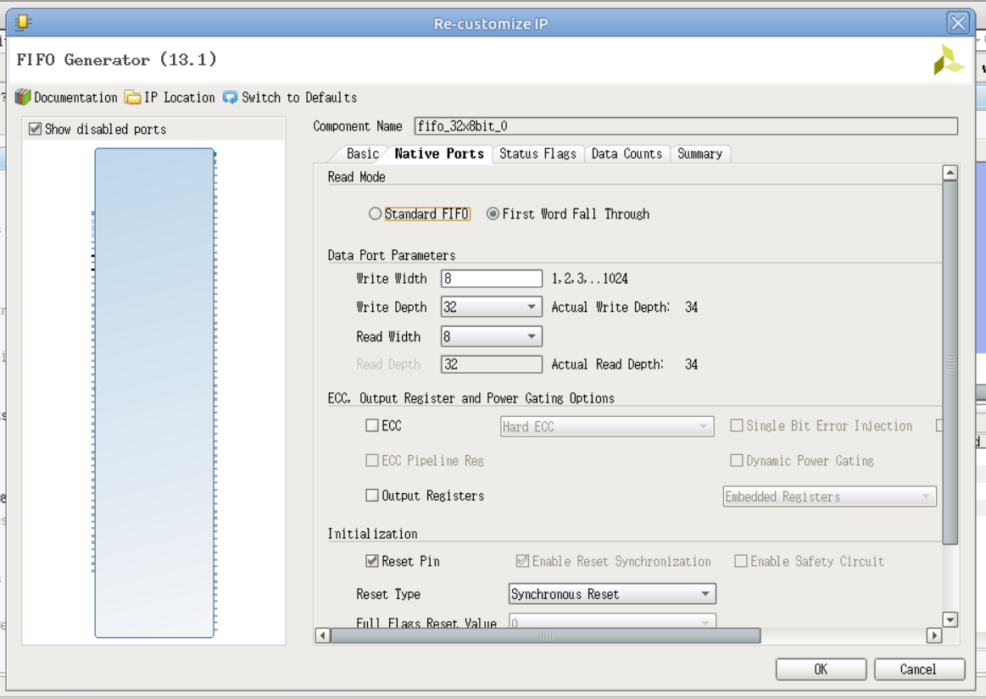

**step2测试**

（1）>w 4 20

>w 3 15

地址4写入20，地址3写入15.

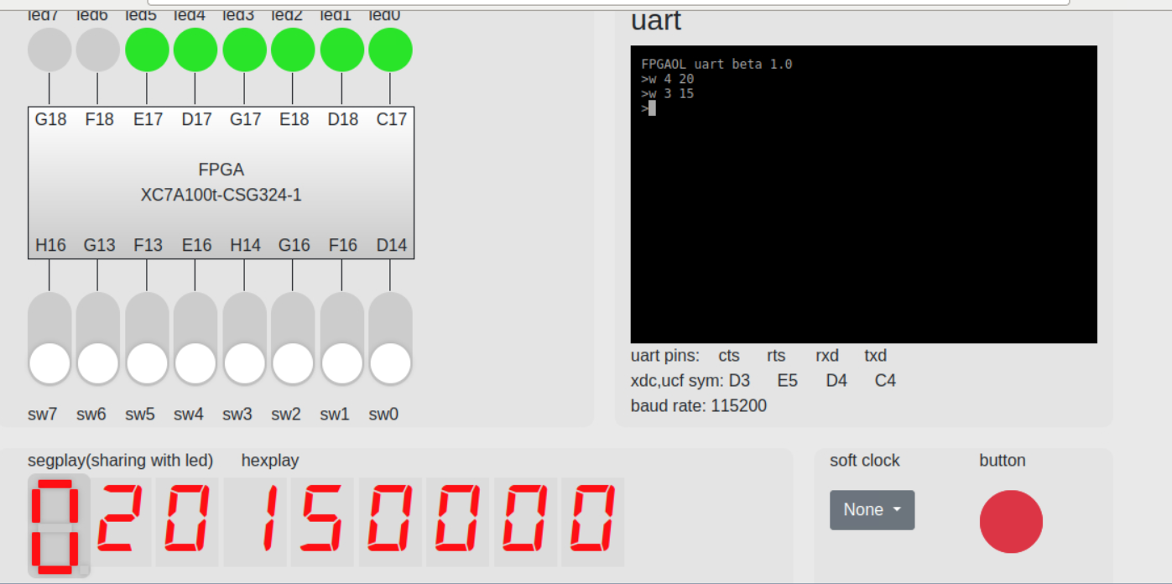

（2）>w 2 17

地址2写入17.

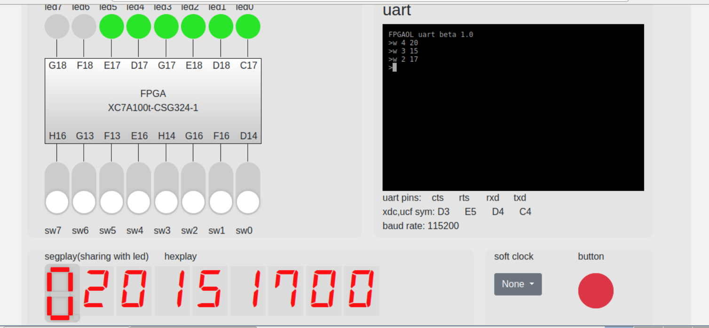

（3）>j

判断

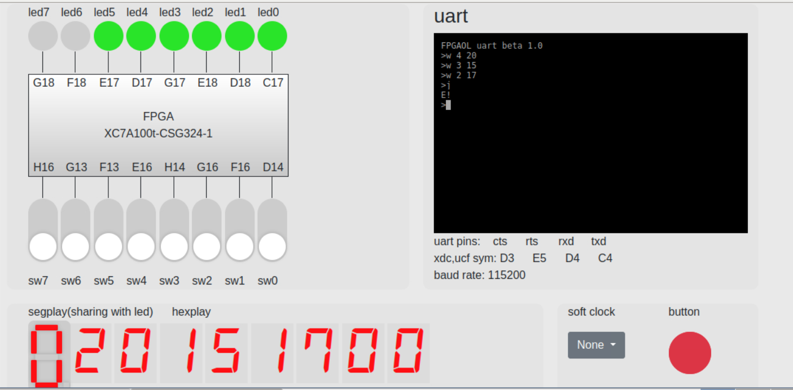

输出E！表明当前八位不是本人学号

（4）>w 1 93

地址1写入93

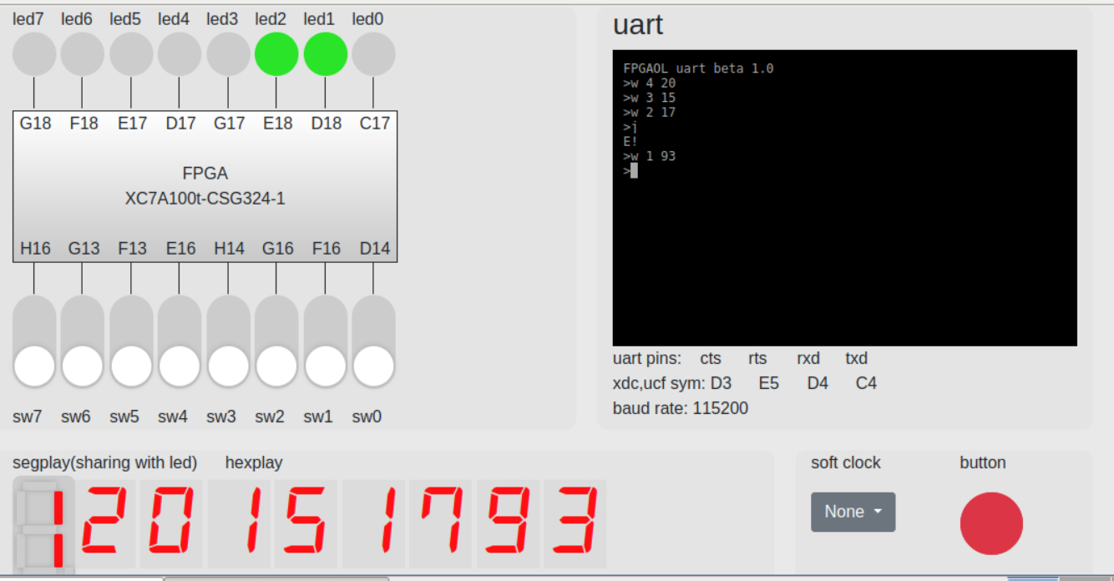

此时七段数码管变为1，表明当前八位为学号.

（5）>j

判断

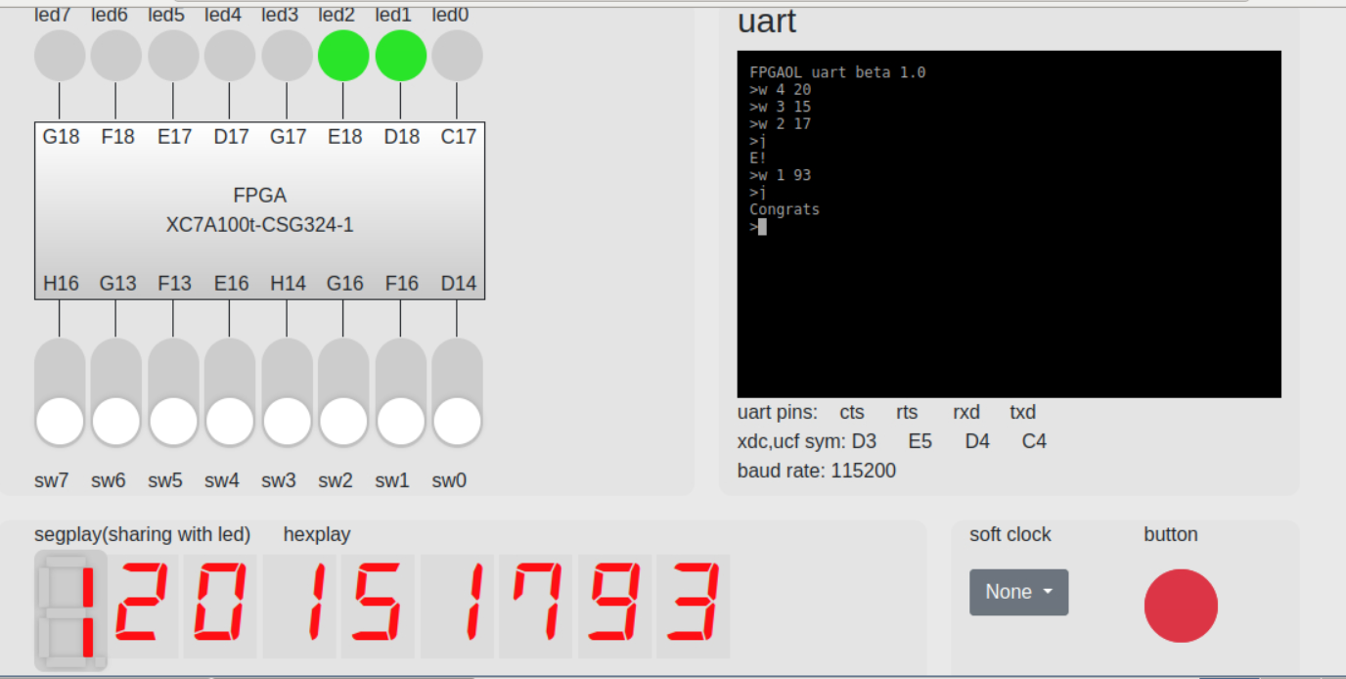

输出congrats，恭喜“猜”对学号，当前写入的八位为本人学号。

（6）>sw

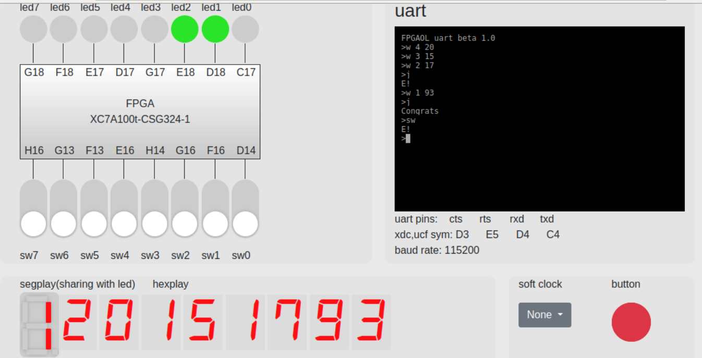

输出E！ 表示当前为错误输入.

（7）>r 1

>r 2

读地址1和2的数据

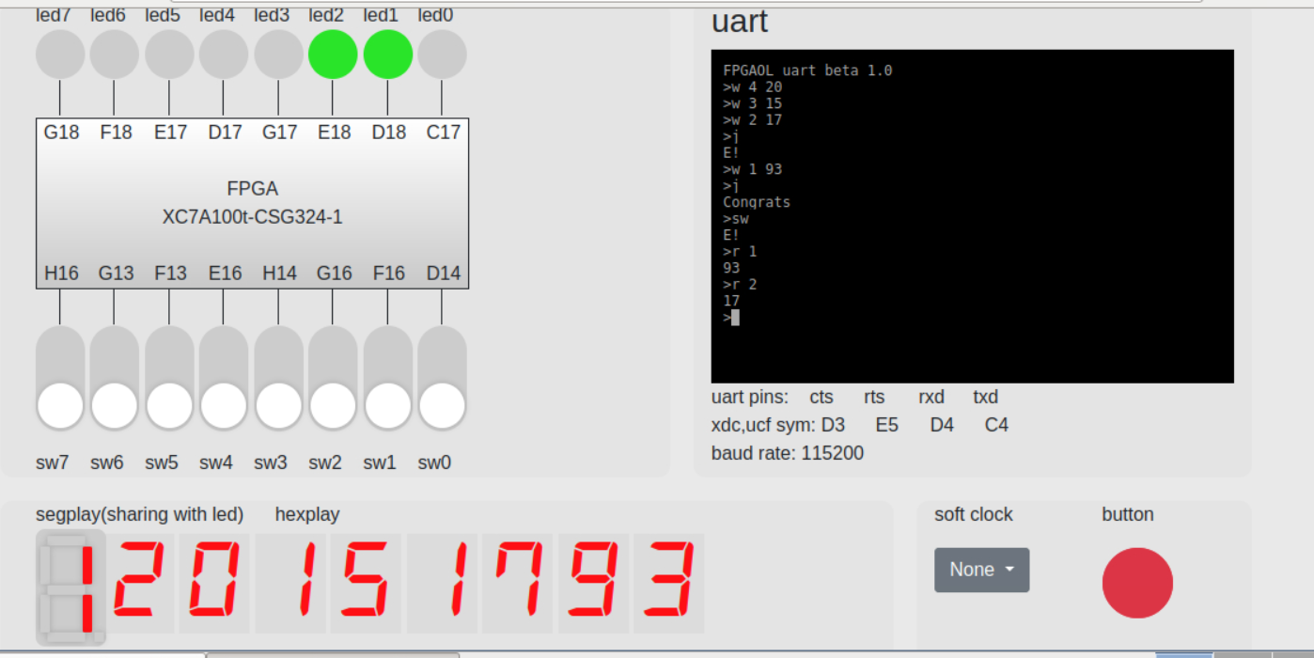

输出分别为93和17.

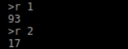

（8）>w 4 00

>j

地址4写入00

并判断

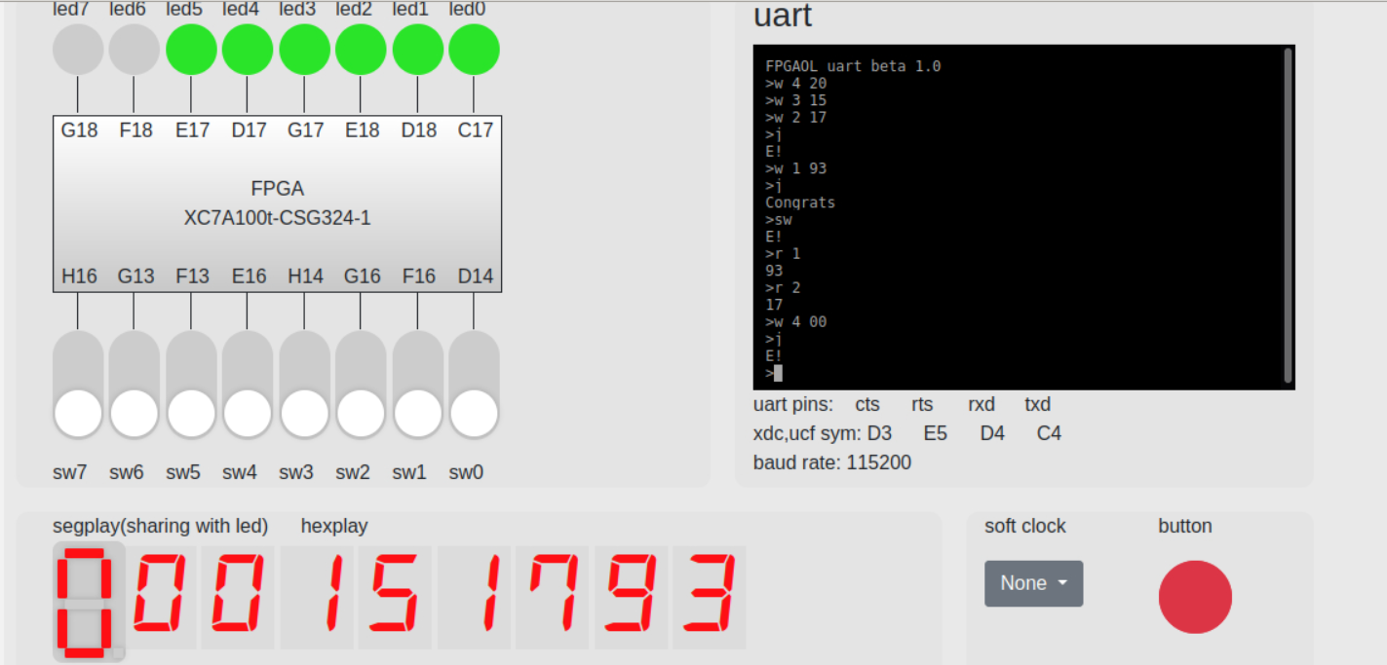

七段数码管显示0. 输出E！

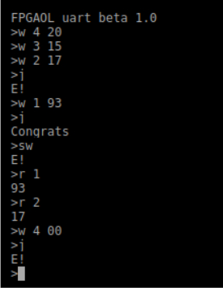

【总结与思考】

本次实验是建立在“串口测试说明文档”基础之上，经过改写，添加等，最终实现的。起初在fifo参数设置以及串口（tx，rx）的连接上出现了一些问题，不过最后在助教和老师的帮助下，解决了这些问题。此次实验由于逻辑较复杂，实现步骤繁多，因此花费了不少时间。难度较前8次实验有明显的增大。也让我站在一个新的高度，体验了实现复杂功能的代码的编写。此次综合实验——“猜学号”shell让我尝试了新的思考，新的创意。

最后，感谢一直为我提供帮助的助教，老师以及同学们！