Larry Gates & Aaron Mercier

CSSE463

Lab 3

**Lab 3: Edge Features**

1. **Type these (2 choices for multiplication) in and explain the answers you get:**

Using the * symbol produces dot product of rows and columns

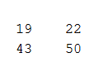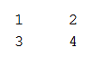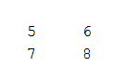

* =

The $.*$ does scalar multiplication

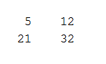

* =

1. **Submit the 5x5 matrix what you used as a filter. Then explain any differences between it and the “true” Gaussian.**

Our approximation:

$$\left[\begin{matrix}\frac{1}{74} & \begin{matrix}\frac{2}{74} & \frac{3}{74} & \frac{2}{74}\end{matrix} & \frac{1}{74} \\ \begin{matrix}\frac{2}{74} \\ \frac{3}{74} \\ \frac{2}{74}\end{matrix} & \begin{matrix}\begin{matrix}\frac{4}{74} & \frac{5}{74} & \frac{4}{74}\end{matrix} \\ \begin{matrix}\frac{5}{74} & \frac{6}{74} & \frac{5}{74}\end{matrix} \\ \begin{matrix}\frac{4}{74} & \frac{5}{74} & \frac{4}{74}\end{matrix}\end{matrix} & \begin{matrix}\frac{2}{74} \\ \frac{3}{74} \\ \frac{2}{74}\end{matrix} \\ \frac{1}{74} & \begin{matrix}\frac{2}{74} & \frac{3}{74} & \frac{2}{74}\end{matrix} & \frac{1}{74}\end{matrix}\right]$$

Correct results:

$$\left[\begin{matrix}0 & \begin{matrix}0 & .0002 & 0\end{matrix} & 0 \\ \begin{matrix}0 \\ .0002 \\ 0\end{matrix} & \begin{matrix}\begin{matrix}.0113 & .0837 & .0113\end{matrix} \\ \begin{matrix}.0837 & .6187 & .0837\end{matrix} \\ \begin{matrix}.0113 & .0837 & .0113\end{matrix}\end{matrix} & \begin{matrix}0 \\ .0002 \\ 0\end{matrix} \\ 0 & \begin{matrix}0 & .0002 & 0\end{matrix} & 0\end{matrix}\right]$$

Explain Differences:

Our 5x5 matrix didn’t rely on exponential change. The correct Gaussian filter weighted the center extremely heavily, more than ½, and weighed the edges lowly. Anything that is not on the same row or column as the center was 0 or very close to zero, excluding the immediate corners. Since the neighbor corners of the center are still closer than the far edges, they have some impact.

1. **Sobel Images**
2. **Original**

Image from the site: <https://ironyisapoormaster.wordpress.com/2016/06/23/return-0-person-of-interest-review-season-5-episode-13/>

Image Link: <https://ironyisapoormaster.files.wordpress.com/2016/06/person-of-interest-reese-jim-finch-root-finale-return-0.jpg>

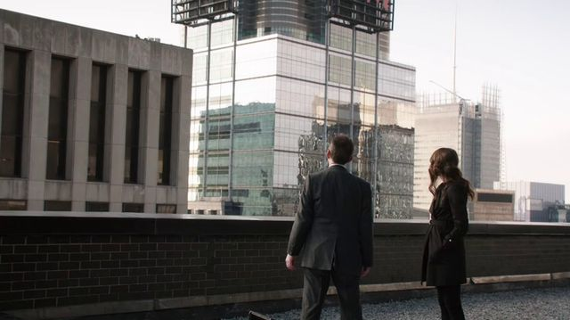

1. **Horizontal Edges**

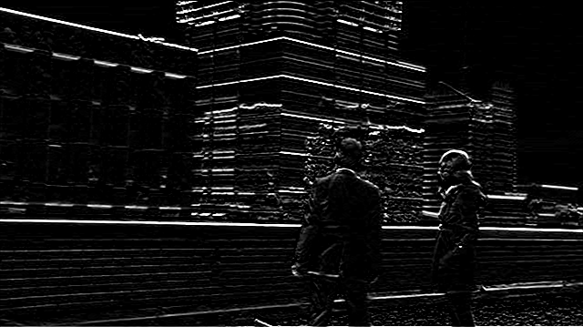

1. **Vertical Edges**

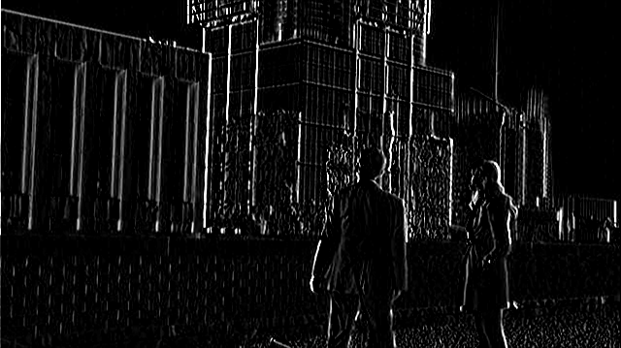

1. **Sum of (b) and (c)**

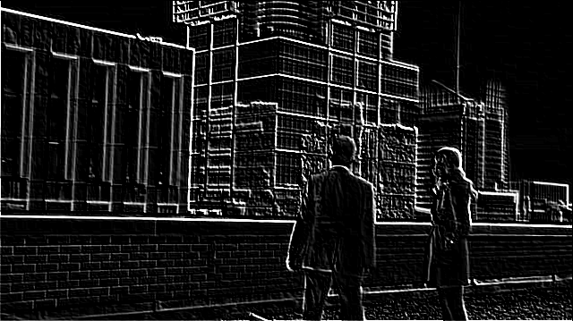

1. **Magnitude of the gradient**

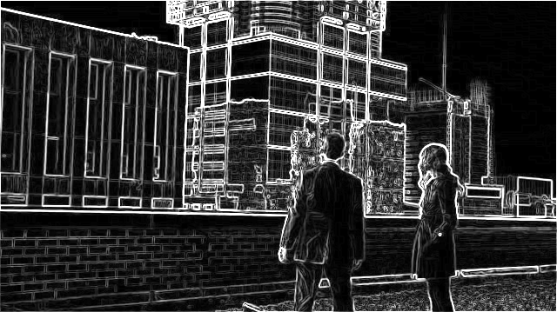

1. **Direction of the gradient**

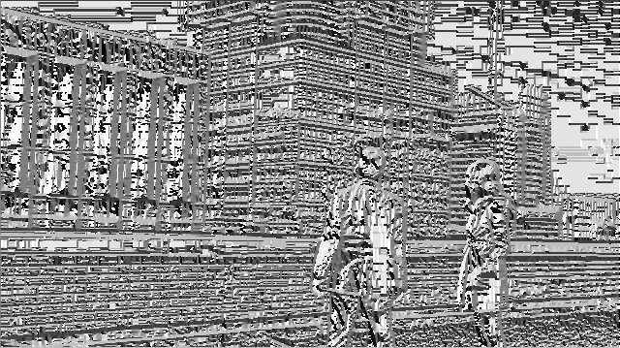

1. **Directions and Magnitude**

