Larry Gates, Aaron Mercier

CM1004

CSSE463

**Lab 6: K-Means Cluster**

**Original Image:**

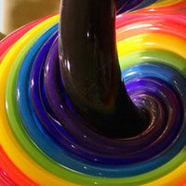We used this image because of the multitude of colors available in the image. Since we could choose a larger number of clusters, this would make it easier to see how the mean was successful.

**K=3 Clustering (Iterations = 10):**



**K=3 Clustering (Iterations = 20):**

TODO

**K=10 Clustering (Iterations = 10):**

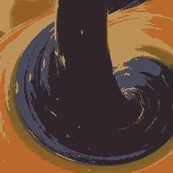TODO

**K=20 Clustering (Iterations = 10):**

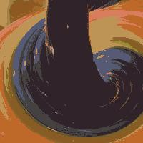TODO

**K-40 Clustering (Iterations = 10):**

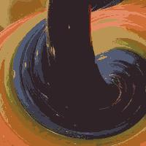TODO