Larry Gates & Aaron Mercier

CM1004

CSSE463

**Lab 7: PCA**

We used 82 week image set, using the G from Gates.

Correct top 10 Eigenvalues:

8.2858 \* 1.0e+07

0.1152 \* 1.0e+07

0.0819 \* 1.0e+07

0.0602 \* 1.0e+07

0.0454 \* 1.0e+07

0.0173 \* 1.0e+07

0.0110 \* 1.0e+07

0.0099 \* 1.0e+07

0.0086 \* 1.0e+07

0.0055\* 1.0e+07

Using the method described in the slides for day 21, slide 3, we were able to calculate the covariance matrix a much simpler way programmatically. We were slightly concerned at first when we didn’t get a 2x2 matrix, however we were sure about the matrix multiplication.

Correct 3 Eigen-images:

The images were reduced by a fourth. The images will appear smaller.

Image 1:

C:\Users\gateslm\OneDrive\Winter Classes 1617\CSSE463\MATLAB\Github\Image_recognition\Lab7\results\v1Norm.png

Image 2:

C:\Users\gateslm\OneDrive\Winter Classes 1617\CSSE463\MATLAB\Github\Image_recognition\Lab7\results\v2Norm.png

Image 3:

C:\Users\gateslm\OneDrive\Winter Classes 1617\CSSE463\MATLAB\Github\Image_recognition\Lab7\results\v3Norm.png

Correct 2 Approximation Images:

Image 1:

*Original Image*

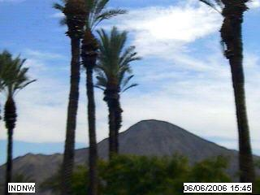

*Image Approximation*

C:\Users\gateslm\OneDrive\Winter Classes 1617\CSSE463\MATLAB\Github\Image_recognition\Lab7\results\Image1approx.png

C1: 5941.4

C2: 1600.3

C3: 2479.4

Image 2:

*Original Image:*

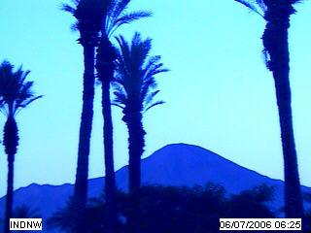

*Image Approximation:*

C:\Users\gateslm\OneDrive\Winter Classes 1617\CSSE463\MATLAB\Github\Image_recognition\Lab7\results\image2approx.png

C1: 6147.7

C2: -977.1

C3: -7525.1

C1 Plot:

