Pruritus Frequency by Treatment Group

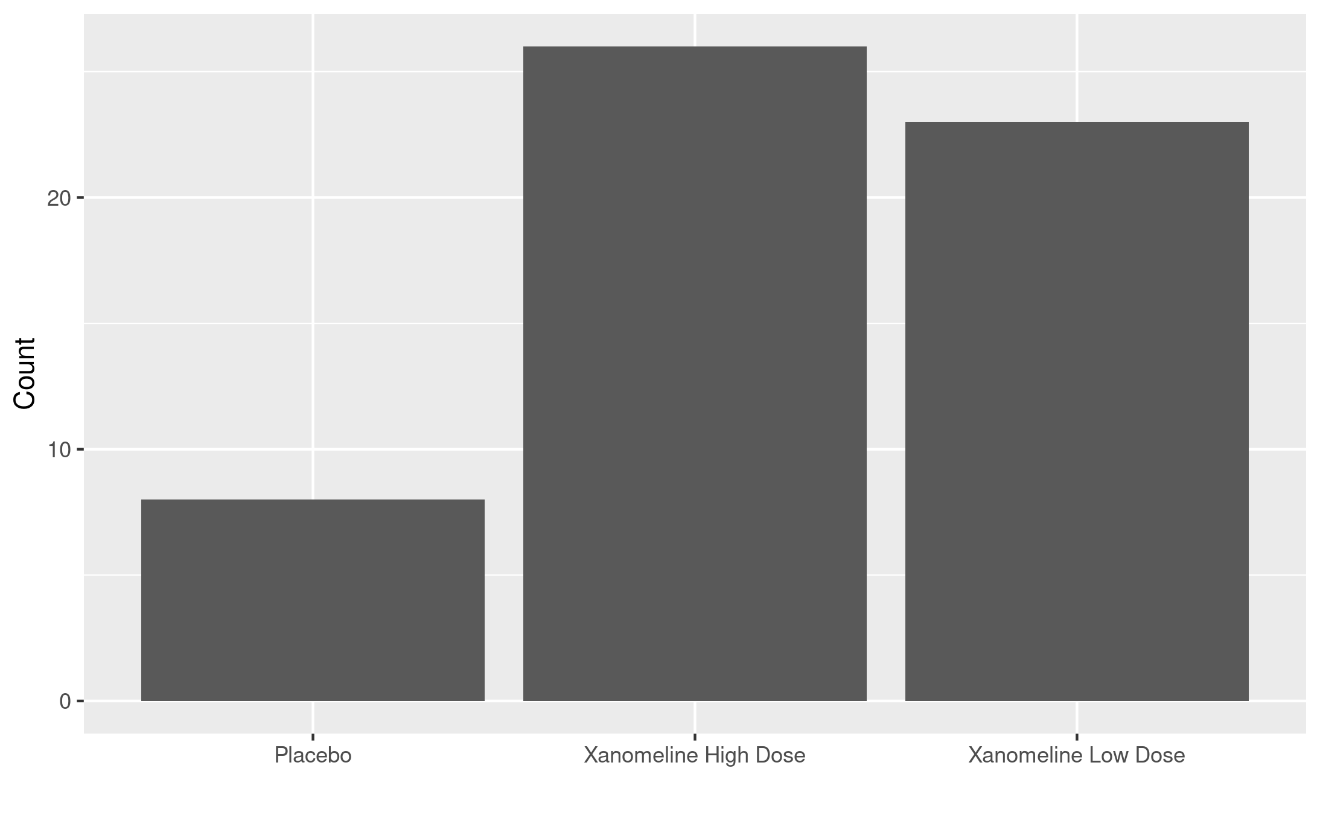

footnote here

[datasource: adam-adae]