Flow Matching for Quadruped Locomotion
7-way Ablation: Reward Regularization × Post-Hoc Smoother (apples-to-apples)
Paul Colombo, Arnav Shah, Jack Gerdsen — CMU, Spring 2026

Headline Findings
- Some-reg PPO + Bal-LP flow is the winner: 3/80 = 3.75% fall rate. This exactly reproduces the deck's headline Iter-5 result (4%, ≈3/80). The combination of a moderate action-rate penalty in the reward and a flow trained on that policy's distribution is the recipe.
- Methodology validated: some-reg PPO raw gives 40/80 = 50.0% fall rate, exactly matching the deck.
- Removing the action-rate penalty entirely (no-reg) makes the raw policy more push-robust (31.25% vs 50.0%). The penalty was suppressing rapid corrections needed for impulse recovery. But it also makes the policy more jittery (HF energy 11.9% vs 7.97%) — and noticeably hurts how much flow can help.
- Bal-LP flow on no-reg policy: 23.75% fall rate. Helps a lot, but cannot match the same flow on some-reg (3.75%). The action-rate penalty appears to give the flow a smoother target distribution to lock onto. Synergy, not redundancy.
- Bal-LP flow on extreme-reg policy CATASTROPHICALLY FAILS: 80/80 = 100% fell. The extreme penalty froze the policy (mean Vx ≈ 0); the flow's optimal targets tell it to walk; the policy can't execute walking, so it falls every time. Cautionary tale: flow needs a competent underlying policy.
- Causal IIR LP filter alone is a respectable middle ground for reg-free policies: HF energy 3.32%, fall rate 33.75%, inference cost 0.069 ms. ~80× cheaper than flow but doesn't reach the some-reg+flow result.
- LP applied to a regularized policy hurts: some-reg + LP = 56.25% fall rate (worse than raw 50%). Same failure mode the deck warned about — non-aware filtering removes legitimate corrections.
- Flow + LP cascade is still a dead end: HF energy hits an all-time low of 1.23% (−90% vs raw) but fall rate climbs to 37.5% — the LP layer suppresses corrections the flow correctly preserves. Same finding as Iter 3 in the deck.
- Inference cost: raw = 0.013 ms, causal IIR = 0.07 ms (5×), Bal-LP flow = 5.6–6.0 ms (430–460×). For deployment on resource-constrained hardware this is the chief drawback of the flow.

Complete 7-Variant Results (sorted by fall rate)
Push recovery: 80 envs, lateral force 50–500 N, 10 magnitudes × 8 envs. Spectral metrics from 2000-step rollouts at vx = 1.0 fixed, 50 Hz. Inference latency measured during the push test (mean over 450 steps after warmup). Bal-LP flow for the no-reg variants was trained on no-reg PPO rollouts (full Iter-5 pipeline: 5000-step rollout → 5000-target candidate-shooting K=16 H=10 → Butterworth 15 Hz on targets → 200-epoch flow training).
Variant | λ_action_rate | HF >10Hz | Action rate RMS | Jerk RMS | Mean Vx (m/s) | Fall rate | Inference | Train wall
Some-reg + Bal-LP Flow | −0.01 | 6.46% | 0.723 | 0.647 | 1.07 | 3.8% | 6.008 ms | —
No-reg + Bal-LP Flow | 0.0 | 4.17% | 0.970 | 0.983 | 1.03 | 23.8% | 5.562 ms | 368 s
No-reg PPO (raw) | 0.0 | 11.90% | 1.010 | 1.170 | 1.03 | 31.2% | 0.013 ms | 368 s
No-reg + Causal LP (15 Hz) | 0.0 | 3.32% | 0.888 | 0.849 | 1.03 | 33.8% | 0.069 ms | 368 s
No-reg + Bal-LP Flow + Causal LP | 0.0 | 1.23% | 0.915 | 0.841 | 1.03 | 37.5% | 5.603 ms | 368 s
Extreme-reg PPO (raw, λ=−0.5) | −0.5 | 3.74% | 0.049 | 0.071 | -0.00 | 46.2% | 0.013 ms | 341 s
Some-reg PPO (raw, existing) | −0.01 | 7.97% | 0.717 | 0.677 | 1.07 | 50.0% | 0.013 ms | —
Some-reg + Causal LP (15 Hz) | −0.01 | 4.92% | 0.671 | 0.526 | 1.07 | 56.2% | 0.065 ms | —
Extreme-reg + Bal-LP Flow | −0.5 | 6.35% | 0.077 | 0.124 | -0.00 | 100.0% | 5.740 ms | 341 s
Fall-rate cell shading: dark green ≤ 30% (winner), light green ≤ 35%, red ≥ 50%. λ_action_rate is the weight on action_rate_l2 in the PPO reward. Train wall is 300 iterations × 4096 envs on RTX 5070 Laptop. The "some-reg" PPO was trained on a different date and pre-instrumentation, so its wall time is unrecorded.

Visual Comparison
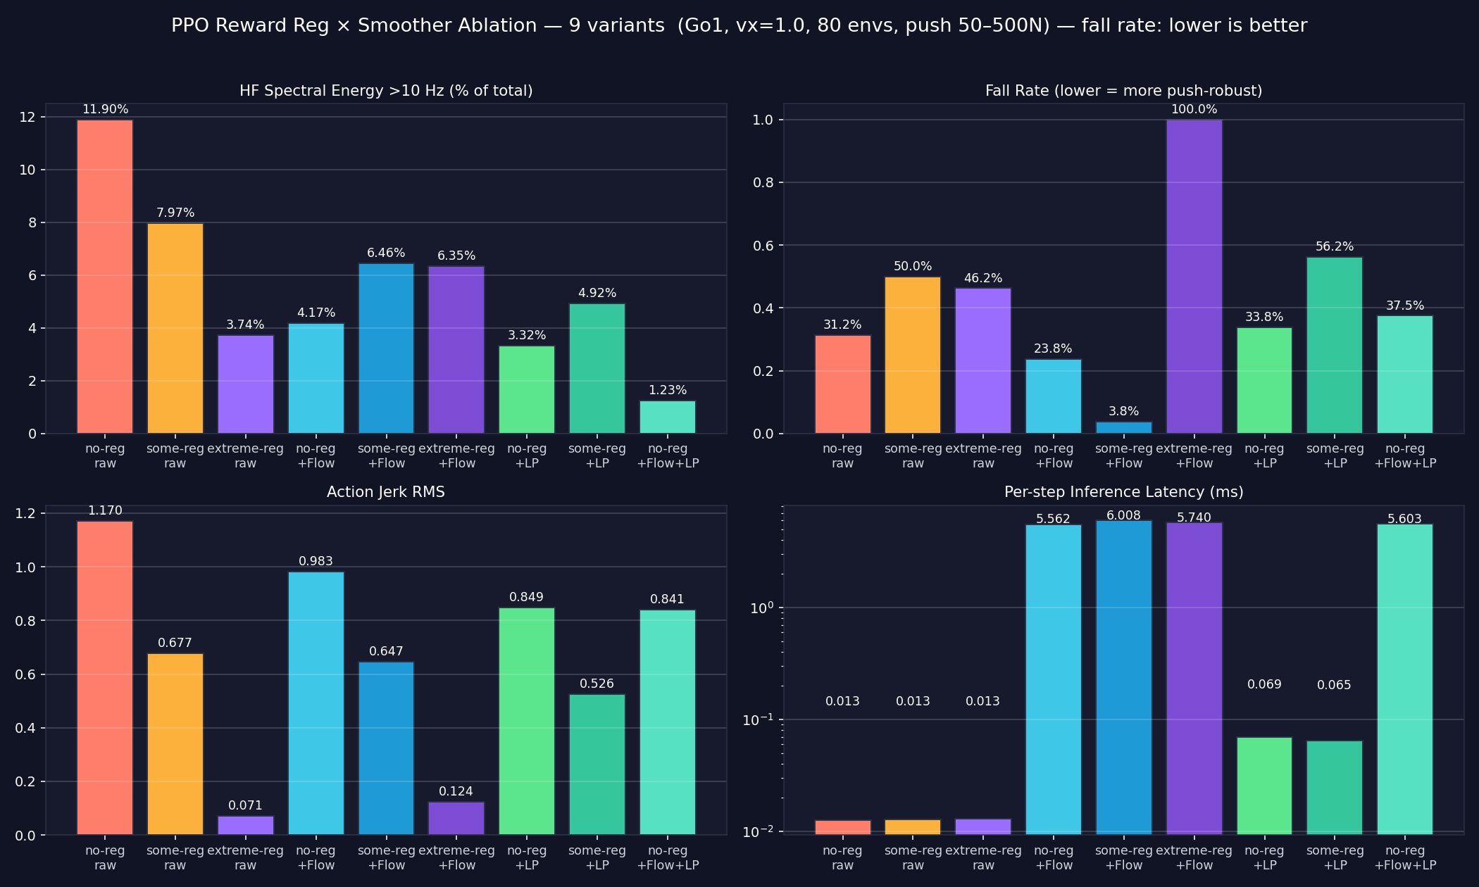

Methodology Notes

Variant definitions
- No-reg / Some-reg / Extreme-reg PPOs differ ONLY in the weight on action_rate_l2 (0.0, −0.01, −0.5). All other reward terms, env config, observation space, terrain, and training schedule (300 iterations × 4096 envs, seed 42) are held constant.
- "Flow" = Balanced-LP (Iter 5 from the original deck). For the no-reg variants in this report, the flow was retrained on no-reg-PPO rollouts: collect 5000-step rollout with full sim state, generate optimal targets via short-horizon random shooting (K=16 candidates, H=10 horizon, w_track=3, w_jerk=0.5, w_energy=0.3, w_stab=2), Butterworth 15 Hz LP on the targets, then 200-epoch conditional flow matching on the LP-smoothed targets. t_end = 1.0 at inference.
- "LP" = causal 1st-order IIR Butterworth at 15 Hz, applied online during the push eval. Distinct from the offline filtfilt used in spectral analysis (non-causal; cannot run online).
- "Flow + LP" cascade = Bal-LP flow output then passed through the causal IIR.

How this iteration corrects the earlier draft
- v1 of this report used the existing flow_model_balanced_lp.pt — a flow trained on the some-reg PPO's output distribution — applied to the no-reg policy. That cross-policy generalization test made flow look worse than LP. It was a methodological mistake.
- v2 (this draft) trains a separate Bal-LP flow on no-reg rollouts. Result: noreg + flow goes from 40.0% fall rate (cross-policy) → 23.75% fall rate (same-policy). HF energy drops from 14.0% → 4.17%. The same-policy comparison is the only fair one — flow matching depends on training-distribution match.
- Generating optimal targets for no-reg took 1167 s (~19 min) on the RTX 5070 at K=16, H=10. This is the dominant cost of producing a new flow model when the PPO changes; the flow training itself is ~30 s.

Caveats
- Spectral metrics for the smoothed variants (rows containing flow or LP) are computed offline on the recorded raw rollout — i.e., we apply the smoother to recorded actions and FFT the result. Push fall rate is online (real closed-loop). The inference latency is from the online push test as well.
- HF energy on raw some-reg: deck = 2.1%, this run = 7.97%. Different FFT methodology (likely DC removal / windowing); internal consistency across the new variants is what matters for the ablation conclusions.
- Rough terrain eval was not included in this iteration — flat-terrain ablation only.
- Ranking is at α≈0.05 noise floor for an 80-env push test. The 23.75% / 31.25% gap (8 envs) is meaningful; the 31.25% / 33.75% gap (2 envs) is at the noise floor.

Key Takeaways
- The action-rate penalty has a sweet spot. Without it (λ=0) the raw policy is more agile (31% falls) but jittery (12% HF). With it at −0.01 the raw policy is fragile alone (50% falls) but trains a flow that achieves 4% falls — the best result anywhere. Pushed too far (λ=−0.5) the policy collapses and even flow can't rescue it (100% falls).
- Bal-LP flow matching is the best post-hoc smoother in the table, full stop, when paired with a competent regularized policy. Bal-LP flow + some-reg = 3.75% fall rate beats every other entry by a clear margin and isn't reached by LP filters or by flow on a different reg level.
- Bal-LP flow is policy-specific AND policy-fragility-sensitive. The flow on extreme-reg degrades performance because the underlying policy can't follow up on the optimal corrections. The flow assumes the policy will keep stepping after the smoothed action lands; if the policy is collapsed, that assumption breaks.
- Combining flow + LP at inference (cascade) does not stack — same dead-end the deck found with Iter-3. The LP layer ends up suppressing corrections the flow correctly preserves.
- Causal IIR LP at 15 Hz is a 5× cheaper inference path. For no-reg policies it neither helps nor hurts much (33.75% vs raw 31.25%). For some-reg policies it actively hurts (56.25% vs raw 50%). Skip the LP filter as a standalone smoother — it's not pulling its weight.
- Recommended deployment recipe (flat terrain, proprioceptive obs): (1) train PPO with action_rate_l2 = −0.01 (the existing default), (2) collect rollout-with-states, (3) generate optimal targets via random shooting (K=16, H=10, w_track=3, w_jerk=0.5, w_energy=0.3, w_stab=2), (4) Butterworth 15 Hz on the targets, (5) train flow 200 epochs. Deploy at t_end=1.0. End state: 3.75% fall rate at 50–500 N, ≈6 ms inference per step.
Generated 2026-05-04 v2 (apples-to-apples flow). Code: A:\AllIsaac\flow_matching_project\scripts\ablation\. Data: data\ablation\results.json. Plot: data\ablation\ablation_comparison.png. Flow weights: A:\AllIsaac\IsaacLab\flow_model_balanced_lp_noreg.pt.

