**Building a Map of Businesses Serviced by Mercy Corps Northwest.**

**Data Extract and Cleaning**.

First, business addresses are pulled from Vistashare with a simple filter on the ‘Role’ field. We get the columns containing the records full address and system ID for all records with Role = ‘Clients Business’. See Vistashare for the queries used to produce this data.

The second step is to clean the address fields. Many of them include addresses whose exact latitude longitude coordinates cannot be determined or give errors when ArcGIS attempts to geocode them. These included addresses with PO Box numbers, apartment numbers, suite numbers, and various other nuisances. A messy regex-based method in R --Outlined **link**here**link**-- is used to clean the address field in preparation for geocoding in ArcGIS.

**Geocoding in ArcGis:**

This process is a bit messy, but the general steps are:

1. Import the data frame with cleaned addresses into an ArcGIS map.
2. Geocode the addresses using the built-in ArcGIS tool.
3. Export geocoded data as an excel/.csv file.

There are many messy intermediate steps, please see **link** for a specific walkthrough.

The result is a .csv file with latitude-longitude coordinates, business names, and a unique ID for that particular business. We want to get various metadata about the businesses, such as what type (IDA, loan, class participant, etc.)* they are. There are multiple ways to accomplish this, but I simply queried Vistashare for all records for individuals with these* roles. Included in this query, was the *related* ID field, which connects each of these records to a business, if it exists.

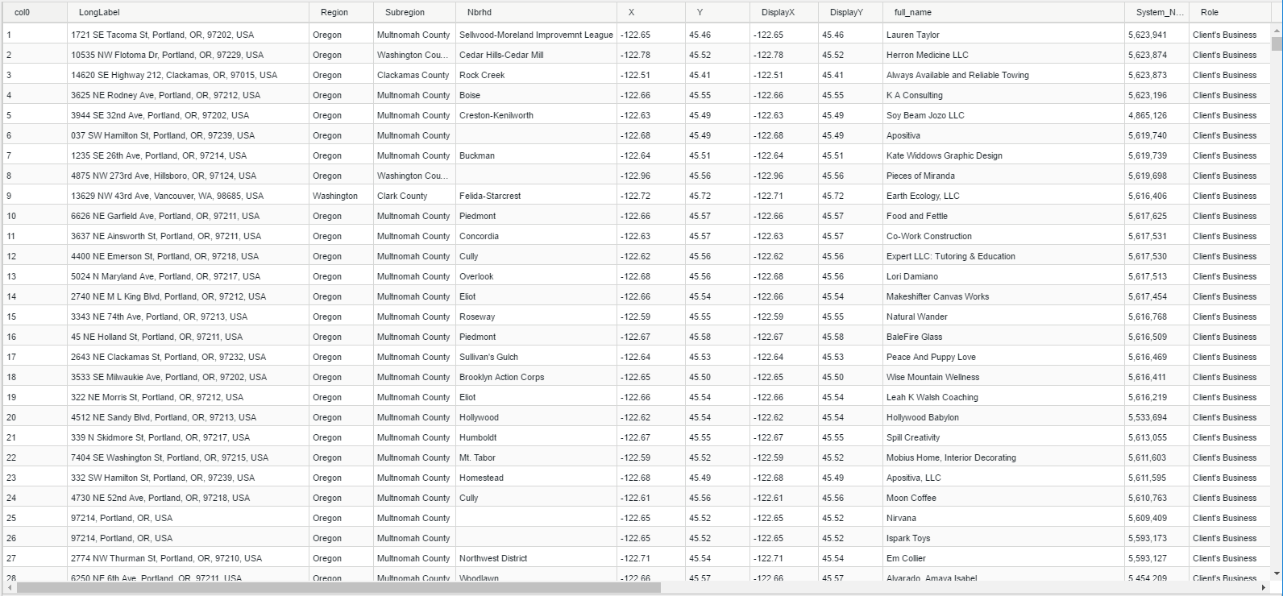

Table output from ArcGIS geocoding. The DisplayX and DisplayY are the coordinates used to visualize the data.

Since the structure of Vistashare may be different from the time this document was written, I should explain that the basic idea is to find a field that relates any record with its associated business (not all persons/records will have an associated business). In my case, it was the ‘Related System Name ID’ field in Vistashare.

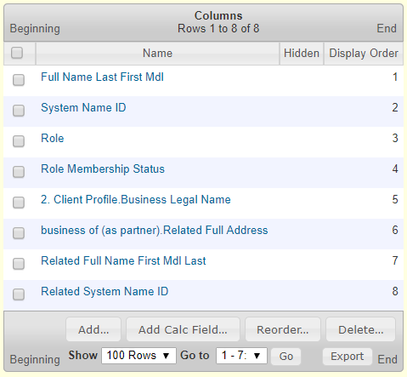

Example query with Related System Name ID field

**Visualization in PowerBI/ArcGIS**

I explored creating a publishable web-app in both PowerBI/ArcGIS. A quick summary is that PowerBI is easier to use for this purpose, and is generally cheaper. Using ArcGIS has the advantage of keeping the geocoding and web publishing tasks within one software suite and options for some fancier mapping options.

**Power BI:**

The general process for visualizing the data in PowerBI are as follows:

1. Set up a data import from:
2. A .csv file that includes the business coordinates and relevant metadata.
3. A .csv file that has information about role membership, ethnicity, or any fields you are interested in AND the ‘Related System Name ID’ field that links each record to the businesses in a.
4. OR a single table which is the result of a. and b. joined by System Name ID -> Related System Name ID.
5. Create a map (not the filled one) visualization. Put the ‘DisplayX’ field in the longitude bin and ‘DisplayY’ field in the latitude bin.
6. Color and filter the data using the metadata in the imported tables.
7. Publish the map to web. PowerBI provides html code to embed the map in a website as well as a link to share the map with anyone.

See **this video** for a detailed overview of how I designed my version of the map.

**ArcGIS:**

Mapping and web publishing with ArcGIS is done through their online service. The general steps ***that I used*** are:

1. Create a feature layer that includes all relevant metadata and upload it to ArcGIS Online ***as a service***. This will create a feature layer in your online content that can be used to create a map.
2. Create a map in ArcGIS online using the feature layer created above and add relevant dynamic filters for any variables you are interested in.
3. Create an interactive web app using the Filter app template.

These steps are the ones used to create a map similar to the one in PowerBI – that is, a map with interactive filters.

See **this video** for a detailed overview of how to publish and get an interactive map working in ArcGIS online.

**Overview and Final Thoughts**

The process I have used for creating this map is nontrivial. It includes using *four* interfaces (Vistashare, R, ArcGIS, PowerBI) to go from raw data to a published visualization. ArcGIS is an impressive, but somewhat clunky interface. Its visualization capabilities are also somewhat limited, though it does produce a serviceable end product.

One is faced with the choice of either wasting ArcGIS’s power and using it only for geocoding for the convenience of doing visualization in PowerBI, OR foregoing use of PowerBI and dealing with the quirks of ArcGIS in the visualization/publishing process.