Question 1:

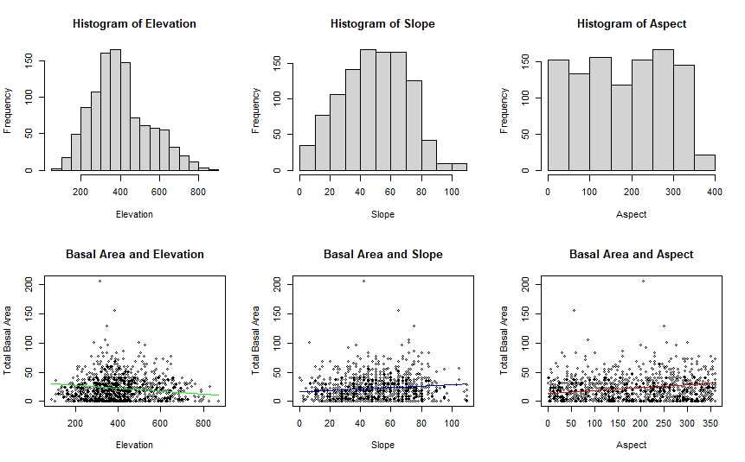

Question 2:



Since birds are found at different elevations, a large range of elevations were surveyed for this study. The most common elevation was between 350-450m, but sites were also sampled above and below this range (ranging from 50-900m). Since 350-450m is in the lower half of the range (450m being the middle value of the entire range), we can notice that more lower-elevation sites were sampled than upper-elevation sites. This is likely due to easier accessibility to lower elevations as higher elevations would typically require more uphill hiking. Overall we can see from the shape of the figure that there is a pretty even distribution of sampled elevations, but there is a slight skew towards lower elevation sampling sites.

Question 3:

Slope is reported as % slope, ranging between 0% and 110%.

Question 4:



The slope of the sampling sites was very evenly distributed with the most common slope being around 50% (which was also the middle value of the range of slopes surveyed). Since the middle value of the range was also the most common, the data looks like a pyramid with fewer datapoints as you get further from 50% in both directions. In this way, the least common slopes were the lowest slopes (0-10%) and the steepest slopes (90-110%). Despite the otherwise even distribution, there were slightly fewer samples taken from sites on very steep slopes than were taken on low slopes. This is likely due to the logistical difficulty of accessing and sampling on very steep slopes.

Question 5:

Aspect is the direction in which a slope is facing, in this case being reported in degrees, with 0 and 360 degrees both being the same direction (reported on a circular scale). For example, if North is 0 degrees (and therefore also 360 degrees), East would be 90 degrees, South would be 180 degrees, and West would be 270 degrees.

Question 6:



Aspect (the cardinal direction the survey sites are facing) was equally distributed throughout all 4 directions. Aspect itself ranges from 0 to 360 degrees with a different cardinal direction being placed every 90 degrees. Since cardinal degrees are arranged in a circular fashion, 0 degrees and 360 degrees are at facing the same direction (typically north). The other directions would therefore follow suit with East being 90 degrees, South being 180 degrees, and West being 270 degrees.

There were slightly fewer surveys sites that faced south (180 degrees) than north (0/360 degrees), but there were just as many sites facing East as were facing West. Looking at the figure, the bar between 350-400 looks disproportionately small, but this is simply due to the range of values being from 0 to 360 (and therefore not having any values between 360-400). Overall, all cardinal directions were represented in the survey sites at pretty much equal amounts.

Question 7: (Put all 6 plots into one figure and then cropped down to just scatterplots for this question)



All Plots:



Question 8:

Elevation- Elevation seems to be normally distributed with the most points being found around 350-450m and fewer points being found on either end of the range. Because of this, the data does not follow a linear pattern and a linear model does not accurately fit the data. Instead, a bell-shaped curve could be fitted with the peak of the curve being placed around 400m.

Slope- There seems to be a mild association between slope and basal area (slight positive correlation), but the data is mostly scattered. Similar to elevation, the data is more normally-distributed than linear and would benefit from a bell-shaped curve line rather than a linear model.

Aspect- No associations can be found in the aspect scatterplot, whether linear or otherwise. All points seem extremely scattered and evenly distributed along the x-axis. A linear model is not a good fit for this data.