ECO634- Lab 3

Question 1: What is basal area, and how is it measured?

Basal area is the total area of trees within a plot of land. In this case, basal area is measured in square meters per hectare of land surveyed.

Question 2: Include a figure of your terrain/basal area pairplots.

Question 3: Consider the first bird species you chose to examine in the walkthrough: Include a figure of your logistic function plot. Your figure must include the name of the bird species, appropriate title, axes, etc.

Question 4:  Qualitatively describe the bird’s presence/absence patterns in terms of basal area.

Song sparrows appear to prefer more open habitat that is almost devoid of tree coverage. As basal area increases, song sparrow abundance seems to decrease, as shown in the left-ward skew of the points with a value of 1. The logistic model fits this data well, but it is important to note that fewer sites were surveyed with high tree coverage than were sampled with low tree coverage (i.e. the points aren’t distributed equally along the x-axis).

Question 5: Consider the second bird species you chose to examine in the walkthrough: Include a figure of your logistic function plot. Your figure must include the name of the bird species, appropriate title, axes, etc.

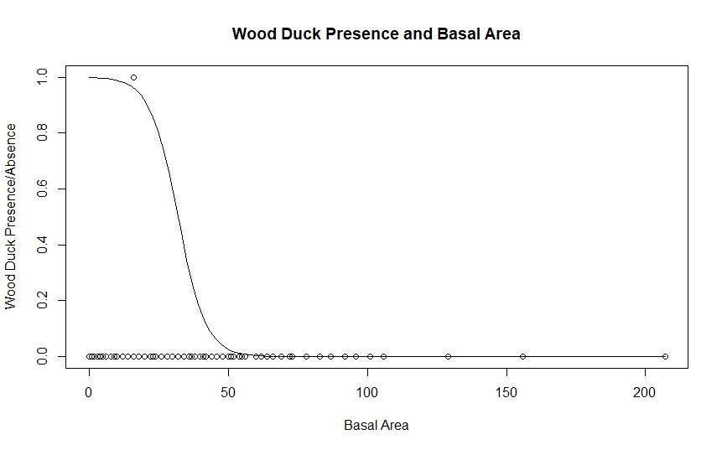

Question 6: Qualitatively describe the bird’s presence/absence patterns in terms of basal area.

Wood ducks seem to prefer lower tree cover, but trends in the data are difficult to detect due to the scarcity of datapoints. Since there was only 1 wood duck detected, the fit of the model is also questionable because there is no variability in the data. Using only the single datapoint, this logistic curve seems to fit the data best, but adding more data would help to verify the model’s fit and possibly suggest alternative models.

Question 7: How many **total number of Gray Jays** were observed in all of the sampling sites.

181 Gray Jays were detected among all of the sample sites.

Question 8:  Include the R code you used to perform the calculation in question 7.

GrayJay<- dat_all$GRJA

sum(GrayJay)

Question 9: Calculate the **total number of sampling sites** in which Gray Jays were observed.

Gray Jays were detected at 110 sampling sites.

Question 10:  Include the R code you used to perform the presence/absence calculation.

GrayJay<- dat_all$GRJA

GJ<- as.numeric(GrayJay > 0)

sum(GJ)