OneDrive with “hello_world” OneNote document:

Azure Virtual Desktop:

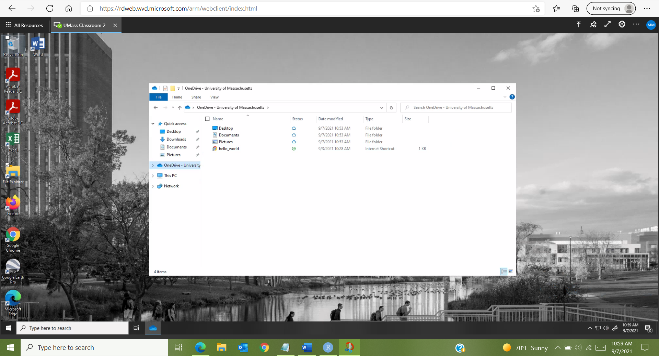

RStudio session with “hello_world” message in console:

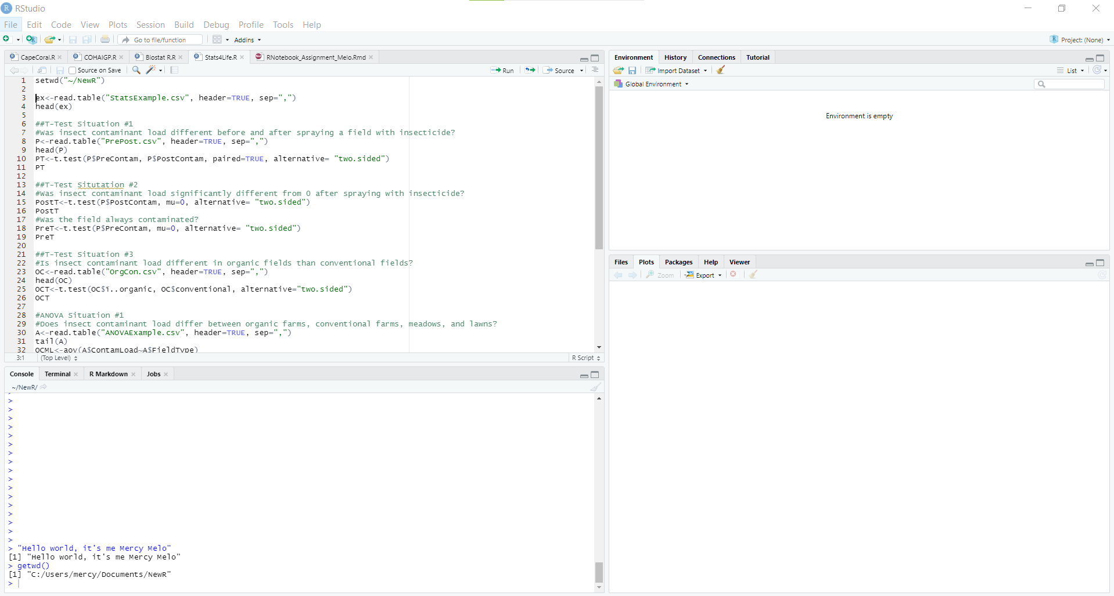

Course folder:

RProject with correct options selected:

