**Remote Learning Group- Chloe and Mercy**

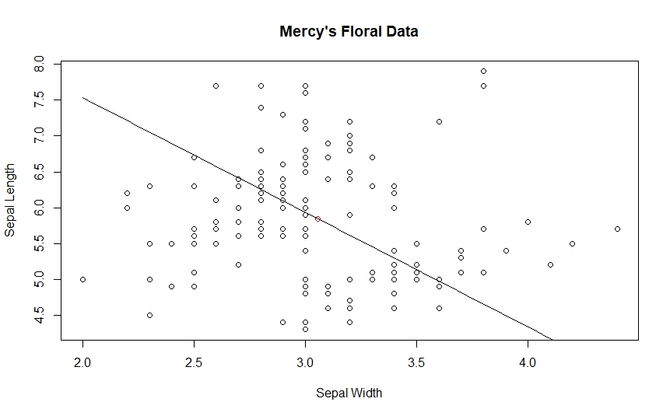

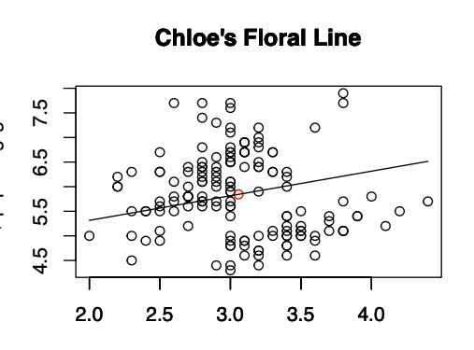

How far did your group go?

We were able to complete our plot including a plotted line and red data point. We were also able to complete making titles for our plots.

What parts of the exercise were difficult, or too easy?

Some difficulty occurred trying to create axis labels. I had difficulty figuring out how to create new axis labels but also deleting the original labels that were there. With Mercy’s help, I was able to trouble shoot and learn how to fix my code to fix this problem. -Chloe

I thought this was a great introduction to data exploration and plotting in R. I use R often in my work to create plots (and therefore had a good deal of background knowledge) but could see this as a fantastic way to introduce folks to R and get them thinking about how we can visually represent data. -Mercy