**VISVESVARAYA TECHNOLOGICAL UNIVERSITY**

BELGAUM – 590014



WEB TECHNOLOGY(17CSL78) PROJECT ON

“BOAT RESERVATION SYSTEM”

***Submitted in partial fulfillment of the requirement of 7th semester***

**BACHELOR OF ENGINEERING**

**IN**

**COMPUTER SCIENCE AND ENGINEERING**

**BY**

**ROSHINI P 1KN17CS070**

**MERCY RABECAL P 1KN17CS052**

**NAKUM MAMATHA M 1KN17CS059**

***UNDER THE GUIDANCE OF***

**Mr. Syed Zabiulla**

Asst. Prof, Dept of CSE



**K.N.S INSTITUTE OF TECHNOLOGY**

**Thirumenahalli, Yelahanka, Bangalore – 560064**

**K.N.S INSTITUTE OF TECHNOLOGY**

**Department Of Computer Science and Engineering**



**CERTIFICATE**

Certified that the technical project work entitled **“BOAT RESERVATION SYSTEM”**  is a bonafide work carried out by **ROSHINI P (1KN17CS070) , MERCY RABECAL P (1KN17CS052) and NAKUM MAMATHA M(1KN17CS059)** in partial fulfillment of for the award of bachelor of Engineering Computer Science and Engineering of Visvesvaraya Technological University, Belgaum during the academic year 2020-2021.

It is certified that all correction/suggestions indicated for internal assessments have been incorporated in the report deposited in the department library. The project report has been approved as it satisfies the academic requirements in aspects of project work prescribed for the Bachelor Of Engineering degree.

………………………….. ……………………………

**INTERNAL GUIDE HOD**

Mr. Syed Zabiulla Mr.Mohamed Shakir

Asst Prof, Dept of CSE Dept of CSE

KNSIT Bangalore. KNSIT Bangalore.

**External Viva:**

**Name of the Examiner** **Signature with Date**

1. **1.**

**2. 2.**

**ACKNOWLEDGEMENT**

The satisfaction and euphoria that accompanies the successful completion of any task would be incomplete without the mentioning the people who made it possible. If there is a driving force that kept use going on in doing this project, it is the constant support of our guide **Mr. Syed Zabiulla.** We present our sincere and heartiest thanks to him, for giving us a patienthearing and clearing our doubts.

We would like to express our profound thanks to our HOD **Mr. Mohamed Shakir** for his support and encouragement towards us at every stage in successful completion of our project.

We would like to express our gratitude to **Dr. S.M Prakash, Principal , KNSIT Bangalore,** for providing us congenial environment to work in.

We place our gratitude to our parents who always encouraged us to pursue our interest, who have led us onto the right path. We are undoubted for all the love and affection they bestowed upon us. Many are responsible for the knowledge and experience we have gained during our project and throughout the course. With profound sense of gratitude and regards we acknowledge for support extended by our friends for their support in completion of this project.

Finally, we would also like to thank all those who knowingly or unknowingly helped to us all throughout our project.

**ROSHINI P 1KN17CS070**

**MERCY RABECAL P 1KN17CS052**

**NAKUM MAMATHA M 1KN17CS059**

**ABSTRACT**

Boat reservation system is a web-based reservation application. It connects Tourist and admin in an online community allowing users to browse different boats and ask user to select the source and destination to travel like timings ,date and to book or cancel reservation. Service provider can add new boats and images of the boat and capacity of tourist to travel in the boat and the travelling allowances.Only the admin can view the reservations done and the boats available and they can search for tourists and boats.

My project will use MySQL and PHP to back the interface with strong database functionality. For reservation, This Project will integrate Web Calendar as a backend database for appointments as well as a front-end scheduling interface. Web Calendar is a PHP-based calendaring application that can be a stand-alone program or integrated into other applications. This project will target the major web browsers as the initial platform for the Beta version.

The final deliverable will be a functioning web application that can handle all specified use cases. Some of the major use cases include user account registration, login/logout, reservation, adding boats and images of the boats.

**CONTENTS**

**1. INTRODUCTION 1**

**2. SIGNIFICANCE OF PROJECT DEVELOPMENT 2**

**3. SCOPE 5**

**4. EXISTING SYSTEM 5**

**5. PROPOSED SYSTEM 6**

**6. HARDWARE AND SOFTWARE SPECIFICATION 6**

**7. TOOLS AND PLATFORM 7**

**7.1.1 ABOUT FRONT END (PHP,HTML,CSS,JS) 7**

**7.1.2 ABOUT BACKEND 11**

**7.2 PLATFORM (MYSQL) 11**

**8. FEASIBILITY STUDY 12**

**8.1 NEEDS FOR FEASIBILITY STUDY 13**

**8.2 ECONOMIC FEASIBILITY 13**

**8.3 TECHNICAL FEASIBILITY 14**

**8.4 BEHAVIOURAL FEASIBILITY 14**

**9. CONTEXT LEVEL DIAGRAM 15**

**10. ENTITY-RELATIONSHIP DIAGRAM 15**

**11. USE CASE DIAGRAM 17**

**12. PERT CHART 17**

**13. GANTT CHART 17**

**14. SECURITY TESTING OF PROJECT 18**

**14.1.1 WHITE BOX TESTING 18**

**14.1.2 BLACK BOX TESTING 18**

**14.1.3 ALPHA TESTING 19**

**14.1.4 BETA TESTING 19**

**14.1.5 UNIT TESTING 19**

**14.1.6 INTEGRATION TESTING 19**

**14.1.7 VALIDATION TESTING 19**

**14.1.8 SYSTEM TESTING 19**

**14.2 IMPLEMENTATION AND SOFTWARE**

**SPECIFICATION TESTING 20**

**14.2.1 DETAILED DESIGN OF IMPLEMENTATION 20**

**14.2.2 TECHNICAL DESIGN 20**

**14.2.3 TEST SPECIFICATIONS AND PLANNING 20**

**14.2.4 PROGRAMMING AND TESTING 20**

**14.2.5 USER TRAINING 20**

**14.2.6 ACCEPTANCE TEST 20**

**14.2.7 INSTALLATION PHASE 21**

**14.2.8 SYSTEM INSTALLATION 21**

**14.2.9 REVIEW PHASE 21**

**14.2.10 DEVELOP RECAP 21**

**14.2.11 POST IMPLEMENTATION REVIEW 21**

**14.3 STEPS IN UNIT TESTING 21**

**14.4 STEPS IN SYSTEM TESTING 22**

**14.5 SPECIAL CATEGORY TEST 23**

**15. SYSTEM ANALYSIS 24**

**16. RESULT 25**

**17. CONTRIBUTION 25**

**18. FUTURE DIRECTION 26**

**19. SNAPSHOTS 27**

**20. REFERNCES 31**

**CHAPTER 1**

**INTRODUCTION**

In our daily life we have to book ticket for Boat,Bus, movies, Flight and cricket match or foot boll match. When we do this task manually then it becomes very hard to manage the ticket booking. So we are developing this system to manage booking of ticket automatically. In this boat reservation project we develop the system that can help the user to book their ticket online. In this project we take care of every service related to travelling and online ticket booking. When you start your traveling tour you have to book ticket so we help you from the starting point to the end. we help you in booking your traveling boat ticket.

Boat Reservation System can contain the details of tourist like user name, boat id, boat name, reservation id, tourist id, r_destination, r_hour, tourist address and tourist contact number.

The admin can add details like boat name, boat id, boat capacity, boat operator name, boat image and perform actions like edit, delete.

In the 21st century where people are busy with their works, they cannot afford to waste time by waiting for their time to come in the port. So there was a need to provide a solution to such problems of the customer who were the major need of the business. Hence, we created an online solution where customer can book a ticket with the online website to meet his/her travelling tour in boat needs without worrying about time constraints and choose the time of his choice rather than waiting in the port for his/her turn to get ticket.

**Safety Measures**

Since it is a recreational activity, most boating is done in calm protected waters and during good weather. Even so, conditions can change rapidly, and a small vessel can get into life-threatening difficulties. It's important to keep an inventory of safety gear on board every boat, which is prescribed by the U.S. Coast Guard as well as state boating law administrators in the U.S. Depending on the size of the boat and how it is powered, required equipment may include:

* personal flotation devices (PFDs or life jackets) for everyone on board
* a throwable flotation device (in the U.S., a Type IV PFD)
* navigation lights suitable for the type of boat operation
* visual distress signals (VSDs) which are effective both day and night
* sound-making devices including horns and bells
* fire extinguisher(s)
* a copy of the Inland Rules of the Road

Other items might seem obvious but are not actually required by law. They include a flashlight, first aid kit, paddles, whistles, anchor and rope, engine spare parts, bilge pumps, a VHF radio or mobile phone, etc.

In addition to these safety items listed above, the Code of Federal Regulations lists some additional required items that may not fall into the common definition of "safety" items:

* backfire arresters on gasoline-powered vessels
* ventilation systems on gasoline-powered vessels
* plaques which list the penalties associated with pollution due to oil discharge, or dumping trash overboard.
* a marine sanitation system (MSD) which prevents water pollution from sewage

State laws may add to this list of requirements. Most of the differences fall into a few categories:

* laws requiring life jackets to be worn in specific activities or by children
* upgraded life jackets for specific activities or by children
* restrictions on the types of MSDs that are allowed within state borders

In the United States, more than 40 states have educational requirements for operating a boat or PWC on state waters.[[5]](https://en.wikipedia.org/wiki/Boating#cite_note-5) Laws vary by state so it's best to check the laws of your state. Boater education courses can be taken in-person classroom style or online at the student's convenience. Credible courses are recognized by the US Coast Guard, approved by NASBLA and work in conjunction with state agencies.

**2.SIGNIFICANCE OF PROJECT DEVELOPMENT**

For many companies that take bookings, there’s an unspoken rule – if it’s working well enough, don’t fix it. When it comes to taking bookings, that means many don’t stray from old fashioned telephone-based systems and scheduling tools, which typically require members of staff on hand to coordinate and organise bookings manually in real-time.

Needless to say, there’s a better way of doing things. We speak, of course, about bringing appointments online, accepting payments and implementing online bookings. Online booking systems like BookingLive work by providing a secure and customisable booking platform by which your customers can see event availability, book and pay directly via credit card all on your site.

As a supplier of online booking platforms for customers both big and small, we’ve seen the impact an online booking platform can have on a business, boosting sales and greatly simplifying the booking procedure for both customers and staff.

## ****Online booking systems save your staff time****

When you think about the workflow of your customer service staff, it’s plain to see that an awful lot of time is taken up handling phone calls from people looking to book, explaining options to customers and managing schedules.

The demands of a phone-based [booking system](https://www.bookinglive.com/) require a member of your staff is constantly available to handle bookings. You might not consider this a problem with customer service staff on hand, but consider the man hours which could be released by moving to an online booking platform.

Because BookingLive is fully automated, if there’s space available for a given date, your customer can choose their options, pick a date and time, pay and receive an email confirmation without any human interaction on your end – freeing up your staff to do more valuable things with their time. That’s a huge advantage of online booking platforms, and one which can greatly benefit your business.

## ****Removing the bottleneck of phone booking systems****

One of the major advantages of online booking page is that with phone-based booking software, you’re introducing a huge bottleneck into your business that can prevent customers from placing their bookings with you.

Most telephone booking systems rely on customers calling during office hours, but for many people, they simply don’t have the time to book whilst they’re in the middle of their work day. Not to mention the fact that only one caller can book at a time, unless your operating multiple phone lines (which, in turn, require more staff to deal with). This will not only free up your time but also may open up a new revenue stream.

No matter which way you cut it, that’s a bottleneck that can stifle success and reduce revenue.

Online booking and appointment scheduling platforms like BookingLive, on the other hand, offer the distinct advantage of letting customers book anytime and anywhere they see fit, on whatever device they’re using. It means immediately removing any bottleneck within your booking procedure and unlocking the true potential of your business.

There’s no disadvantage to be found from boosting your appointment booking availability, so don’t hold back on making an online booking platform a part of your online business strategy.

## ****Greater sales and marketing synergy****

How often do you find yourself saying “all our information is on our website” a day? We’re willing to bet that it’s more than a handful. These days, our websites are more than mere contact information for our brick-and-mortar locations, they’re huge repositories of information regarding our business, what we offer and more.

So, why not offer the opportunity to book alongside that compelling copy? By making your customers leave your product page or website in order to place a booking order, you’re introducing unnecessary complications for your customers, cutting their chances of making the kinds of impulse bookings which bring so much revenue in.

## ****A modern approach to booking****

Today’s customers aren’t discovering companies through telephone books, and they aren’t finding information about your products and services by sending off for a catalogue. No, they’re increasingly finding out everything they need to know about you’re offering by heading online and via mobile apps.

There’s no shortage of reasons why that’s the case, but you’d be missing out on a huge advantage by not making the most out of the tremendous opportunity the internet offers businesses. By integrating your booking platform with your product pages, you can go where, increasingly, all of your customers are.

As telephone booking trend slowly dies, the competitive disadvantage of not having an online booking platform will widen, leaving you and small businesses especially behind. So keep up with the booking trend and move online.

## ****Increased revenue thanks to upselling****

In any business, you’re going to face immense competition, which typically leads to something of a race to the bottom in regards to price. That’s why it’s so important to upsell goods and services to your customers. That might mean a meal included on a tour, items available to hire for an activity or a follow on course.

Online booking platforms like BookingLive introduce upselling into the booking process, letting you offer context specific items and offers to customers who might have come across them otherwise. It’s just another advantage of online booking platforms, and another way to help to grow your business in an age of internet-first bookings.

**3. SCOPE**

The scope of the system is to provide the facility where the customer can easily reserve boats online. The user just has to register on this web portal, then the user can easily reserve boats according to their needs. While reserving boats, the user has to enter their destination point, date, and departure time. The user can also view their reservations. From Admin’s login, admin can add, view, edit, delete boats and view all user’s boat reservation. This system makes easier to the user for reserving boats online.

**4. EXISTING SYSTEM**

* Existing system is totally on book and thus a great amount of manual work has to be done. The amount of manual work increases exponentially with increase in services.
* Needs a lot of working staff and extra attention on all the records.
* In existing system, there are various problems like keeping records of items, seats available, prices of per/seat and fixing bill generation on each bill.
* Finding out details regarding any information is very difficult, as the user has to go through all the books manually.
* Major problem was lack of security.

**5. PROPOSED SYSTEM**

The Boat Reservation System is very simple in design and to implement. The system requires very low system resources and the system will work in almost all configurations. It has got following features:

* Needs a lot of working staff and extra attention on all the records.
* Ensure data accuracy.
* Records are efficiently maintained by DBMS.
* DBMS also provides security for the information.
* Any person across the world, having internet can access this service.
* Availability of seats can be enquired very easily.
* Passengers can also cancel their tickets easily.
* Minimum time needed for the various processing
* Better Service
* Minimum time required
* This would help the corporation prepare and organize its schedules more efficiently on the basis of traffic demand.
* Personalized services.
* Optimization of manpower.

**6. HARDWARE & SOFTWARE SPECIFICATIONS**

* **Hardware Requirements:**
* **Processor:** Intel i3 or higher
* **Ram:** 4GB or Higher
* **Storage:** 1 TB or Higher
* **Software Requirements:**
* **Operating System:** Windows 7/8/10
* **Software Tool:** XAMPP Server
* **Database & Language Used:** MySQL, PHP
* **User Interface:** HTML,JQUERY,AJAX,JAVASCRIPT

**7. TOOLS AND PLATFORM**

**7.1 PLATFORMS**

**7.1.1 ABOUT FRONT END:**

**7.1.1.1 PHP:-**

**Introduction**

PHP is now officially known as “**PHP: Hypertext Preprocessor**”. It is a server-side scripting language usually written in an HTML context. Unlike an ordinary HTML page, a PHP script is not sent directly to a client by the server; instead, it is parsed by the PHP binary or module, which is server-side installed. HTML elements in the script are left alone, but PHP code is interpreted and executed. PHP code in a script can query databases, create images, read and write files, talk to remote servers – the possibilities is endless. The output from PHP code is combined with the HTML in the script and the result sent to the user’s web-browser, therefore it can never tell the user whether the web-server uses PHP or not, because the entire browser sees is HTML.

PHP’s support for Apache and MySQL further increases its popularity. Apache is now the most-used web-server in the world, and PHP can be compiled as an Apache module. MySQL is a powerful free SQL database, and PHP provides a comprehensive set of functions for working with it. The combination of Apache, MySQL and PHP is all but unbeatable.

That doesn’t mean that PHP cannot work in other environments or with other tools. In fact, PHP supports an extensive list of databases and web-servers. While in the mid-1990s it was ok to build sites, even relatively large sites, with hundreds of individual hard-coded HTML pages, today’s webmasters are making the most of the power of databases to manage their content more effectively and to personalize their sites according to individual user preferences.

**7.1.1.2 HTML**

**HTML** or **Hyper Text Markup Language** is the standard markup language used to create web pages.

HTML was created in 1991 by Tim Berners-Lee at CERN in Switzerland. It was designed to allow scientists to display and share their research.

HTML is written in the form of HTML elements consisting of *tags* enclosed in angle **) HTML**

**Images - The <img> Tag and the src Attribute**

In HTML, images are defined with the <img> tag.

The <img> tag is empty, which means that it contains attributes only, and has no closing tag.

To display an image on a page, you need to use the src attribute. src stands for "source". The value of the src attribute is the URL of the image you want to display.

**Syntax for defining an image:**

<img src="*url*" alt="*some text*">

**b) HTML FORMS**

HTML forms are used to pass data to a server.

|  |
| --- |
| The <form> tag is used to create an HTML form:  <form> . *input elements* . </form> |

An HTML form can contain input elements like text fields, checkboxes, radio-buttons, submit buttons and more. A form can also contain select lists, textarea, fieldset, legend, and label elements.

**c)Image tag (<img>) :**

To add an image to an HTML document, we just need to include an <IMG> tag with a

reference to the desired image. The <IMG> tag is an empty element i.e. it doesn’t require a

closing tag and we can use it to include from small icons to large images.

**Syntax: <imgsrc=”URL” alt=”alternative text”>**

**7.1.1.3 HTML 5**

HTML5 will be the new standard for HTML. The previous version of HTML, HTML 4.01,

came in 1999. The web has changed a lot since then. HTML5 is still a work in progress.

However, the major browsers support many of the new HTML5 elements and APIs.

HTML5 is cooperation between the World Wide Web Consortium (W3C) and the Web

Hypertext Application Technology Working Group (WHATWG).

WHATWG was working with web forms and applications, and W3C was working with

XHTML 2.0. In 2006, they decided to cooperate and create a new version of HTML.

Some rules for HTML5 were established:

a) New features should be based on HTML, CSS, DOM, and JavaScript

b) Reduce the need for external plug-ins (like Flash)

c) Better error handling

d) More markup to replace scripting

e) HTML5 should be device independent

f) The development process should be visible to the public

**7.1.1.4 CSS**

**CSS tutorial** or CSS 3 tutorial provides basic and advanced concepts of CSS technology. Our CSS tutorial is developed for beginners and professionals. The major points of CSS are given below:

1. CSS stands for Cascading Style Sheet.
2. CSS is used to design HTML tags.
3. CSS is a widely used language on the web.
4. HTML, CSS and JavaScript are used for web designing. It helps the web designers to apply style on HTML tags.

**Cascading Style Sheets** (**CSS**) is a style sheet language used for describing the look and formatting of a document written in a markup language. While most often used to style web pages and user interfaces written in HTML and XHTML, the language can be applied to any kind of XML document, including plain XML, SVG and XUL. CSS is a cornerstone specification.

CSS is designed primarily to enable the separation of document content from document presentation, including elements such as the layout, colors, and fonts. This separation can improve content accessibility, provide more flexibility and control in the specification of presentation characteristics, enable multiple pages to share formatting, and reduce complexity and repetition in the structural content (such as by allowing for table less web design).

CSS can also allow the same markup page to be presented in different styles for different rendering methods, such as on-screen, in print, by voice (when read out by a speech-based browser or screen reader) and on Braille-based, tactile devices. It can also be used to allow the web page to display differently depending on the screen size or device on which it is being viewed. While the author of a document typically links that document to a CSS file, readers can use a different style sheet, perhaps one on their own computer, to override the one the author has specified.

With plain HTML you define the colors and sizes of text and tables throughout your pages. If

you want to change a certain element you will therefore have to work your way through the

document and change it. With CSS you define the colors and sizes in "styles". Then as you

write your documents you refer to the styles. Therefore: if you change a certain style it will

change the look of your entire site. Another big advantage is that CSS offers much more

detailed attributes than plain HTML for defining the look and feel of your site.

**7.1.1.5 JAVASCRIPT**

**JavaScript** (**JS**) is a dynamic computer programming language. It is most commonly used as part of web browsers, whose implementations allow client-side scripts to interact with the user, control the browser, communicate asynchronously, and alter the document content that is displayed. It is also being used in server-side network programming (with Node.js), game development and the creation of desktop and mobile applications.

JavaScript is a prototype-based scripting language with dynamic typing and has first-class functions. Its syntax was influenced by C. JavaScript copies many names and naming conventions from Java, but the two languages are otherwise unrelated and have very different semantics. The key design principles within JavaScript are taken from the Self and Scheme programming languages. It is a multi-paradigm language, supporting object-oriented, imperative, and functional programming styles.

The application of JavaScript in use outside of web pages—for example, in PDF documents, site-specific browsers, and desktop widgets—is also significant. Newer and faster JavaScript VMs and platforms built upon them (notably Node.js) have also increased the popularity of JavaScript for server-side web applications. On the client side, JavaScript was traditionally implemented as an interpreted language but just-in-time compilation is now performed by recent (post-2012) browsers.

**7.1.2 About Back End:**

In a previous blog, we talked about how web programmers are concerned with launching websites, updates, and maintenance, among other things. All of that works to support the front-end of the website. The back-end has three parts to it: server, application, and database.

To better explain how all of this works, let’s use the example of a customer trying to purchase a plane ticket using a website. Everything that the customer sees on the webpage is the front-end, as we have explained before, but once that customer enters all of his or her information, such as their name, billing address, destination, etc, the web application stores the information in a database that was created previously on the server in which the website is calling for information.

The web application creates, deletes, changes, renames, etc items in the database. For example, when a customer purchases a ticket, that creates an item in the database, but when they have a change in their order or they wish to cancel, the item in the database is changed.

.In short, when a customer wants to buy a ticket, the backend operation is the web application communicating with the server to make a change in a database stored on said server. Technologies like PHP, Ruby, Python, and others are the ones backend programmers use to make this communication work smoothly, allowing the customer to purchase his or her ticket with ease

**7.2 PLATFORM**

**7.2.1 MY SQL:**

The database has become an integral part of almost every human's life. Without it, many things we do would become very tedious, perhaps impossible tasks. Banks, universities, and libraries are three examples of organizations that depend heavily on some sort of database system. On the Internet, search engines, online shopping, and even the website naming convention would be impossible without the use of a database. A database that is implemented and interfaced on a computer is often termed a database server.  
 One of the fastest SQL (Structured Query Language) database servers currently on the market is the MySQL server, developed by T.c.X. DataKonsultAB. MySQL, available for download at www.mysql.com, offers the database programmer with an array of options and capabilities rarely seen in other database servers. MySQL is free of charge for those wishing to use it for private and commercial use. Those wishing to develop applications specifically using MySQL should consult MySQL's licensing section, as there is charge for licensing the product.

brackets (like <html>). HTML tags most commonly come in pairs like <h1> and </h1>, although some tags represent *empty elements* and so are unpaired, for example <img>. The first tag in a pair is the *start tag*, and the second tag is the *end tag* (they are also called *opening tags* and *closing tags*).

The purpose of a web browser is to read HTML documents and compose them into visible or audible web pages. The browser does not display the HTML tags, but uses the tags to interpret the content of the page. HTML describes the structure of a website semantically along with cues for presentation, making it a markup language rather than a programming language.

HTML elements form the building blocks of all websites. HTML allows images and objects to be embedded and can be used to create interactive forms. It provides a means to create structured documents by denoting structural semantics for text such as headings, paragraphs, lists, links, quotes and other items. It can embed scripts written in languages such as Java Script which affect the behavior of HTML web pages.

HTML is descriptive markup language. Library of various markup languages is defined in various browsers.

**8. FEASIBILITY STUDY**

A feasibility study is undertaken to determine to the possibility or probability of either improving the existing system or developing a completely new system. It helps to obtain the overview of the problem and to get a rough assessment of whether other feasible solution exists.

**8.1 NEEDS FOR FEASIBILITY STUDY:**

The feasibility study is needed for following things:-

* Answer the questions whether a new system is to be installed or not?
* Determine the potential of the existing system.
* Improve the existing system.
* Know what should be embedded in the new system.
* Define the problems and objectives involved.
* Avoid costly repairs at later stage when system is implemented.
* Avoid crash implementation of the new system.
* Avoid the ‘Hardware approach’ i.e. getting a computer first and then deciding how to use it.

The Feasibility study is divided in to three parts:-

* TECHNICAL FEASIBILITY
* ECONOMIC FEASIBILITY
* OPERATIONAL FEASIBILITY

**8.2 ECONOMIC FEASIBILITY**

Economic analysis is most frequently used for evaluation of the effectiveness of the system. More commonly known as cost/benefit analysis the procedure is to determine the benefit and saving that are expected from a system and compare them with costs, decisions is made to design and Implement the system.

This part of feasibility study gives the top management the economic justification for the new system. This is an important input to the management the management, because very often the top management does not like to get confounded by the various technicalities that bound to be associated with a project of this kind. A simple economic analysis that gives the actual comparison of costs and benefits is much more meaningful in such cases.

In the system, the organization is most satisfied by economic feasibility. Because, if the organization implements this system, it need not require any additional hardware resources as well as it will be saving lot of time.

**8.3 TECHNICAL FEASIBILITY**

Technical feasibility centers on the existing manual system of the test management process and to what extent it can support the system.

According to feasibility analysis procedure the technical feasibility of the system is analyzed and the technical requirements such as software facilities, procedure, inputs are identified. It is also one of the important phases of the system development activities.

The system offers greater levels of user friendliness combined with greater processing speed. Therefore, the cost of maintenance can be reduced. Since, processing speed is very high and the work is reduced in the maintenance point of view management convince that the project is operationally feasible.

**8.4 BEHAVIOURAL FEASIBILITY**

People are inherently resistant to change and computer has been known to facilitate changes. An estimate should be made of how strong the user is likely to move towards the development of computerized system. These are various levels of users in order to ensure proper authentication and authorization and security of sensitive data of the organization.

**9. CONTEXT LEVEL DIAGRAM**

A System Context Diagram (SCD) in [software engineering](http://en.wikipedia.org/wiki/Software_engineering) and [systems engineering](http://en.wikipedia.org/wiki/Systems_engineering) is a [diagram](http://en.wikipedia.org/wiki/Diagram) that represents the actors outside a system that could interact with that [system](http://en.wikipedia.org/wiki/System). This diagram is the highest level view of a [system](http://en.wikipedia.org/wiki/System), similar to [Block diagram](http://en.wikipedia.org/wiki/Block_diagram), showing a, possibly [software](http://en.wikipedia.org/wiki/Software_system)-based, system as a whole and its [inputs](http://en.wikipedia.org/wiki/Input/output) and [outputs](http://en.wikipedia.org/wiki/Output) from/to externa

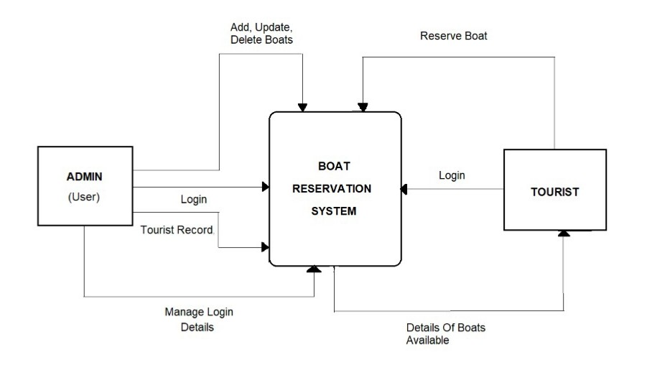

**10. Entity-Relationship Diagram**

* This document is an entity-relationship diagram, or “ERD,” for a system to manage Inventory Management System.
* An ERD is a model that identifies the concepts or entities that exist in a system and the relationships between those entities.
* An ERD is often used as a way to visualize a relational database: each entity represents a database table, and the relationship lines represent the keys in one table that point to specific records in related tables.
* ERD may also be more abstract, not necessarily capturing every table needed within a database, but serving to diagram the major concepts and relationships.
* This ERD is of the latter type, intended to present an abstract, theoretical view of the major entities and relationships needed for management of electronic resources.
* It may assist the database design process for an e-resource management system, but does not identify every table that would be necessary for an electronic resource management database.

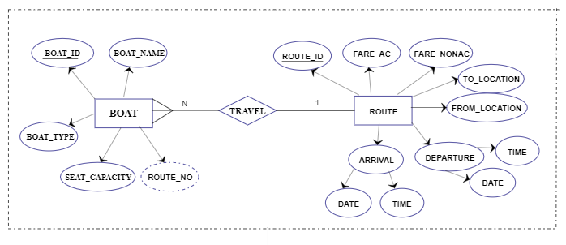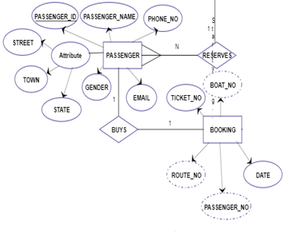

**11. USECASE DIAGRAM**

A use case diagram in the [Unified Modeling Language](http://en.wikipedia.org/wiki/Unified_Modeling_Language) (UML) is a type of behavioral diagram defined by and created from a [Use-case analysis](http://en.wikipedia.org/wiki/Use-case_analysis). Its purpose is to present a graphical overview of the functionality provided by a system in terms of [actors](http://en.wikipedia.org/wiki/Actor_(UML)), their goals (represented as [use cases](http://en.wikipedia.org/wiki/Use_case)), and any dependencies between those use cases.

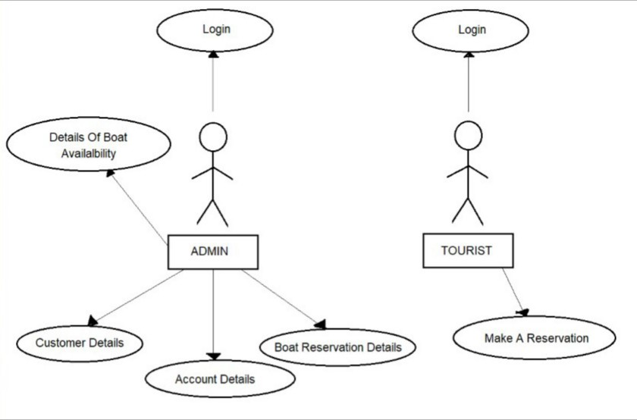

**12. PERT CHART (PROGRAM EVALUATION REVIEW TECHNIQUE)**

PERT chart is organized for events, activities or tasks. It is a scheduling device that shows graphically the order of the tasks to be performed. It enables the calculation of the critical path. The time and cost associated along a path is calculated and the path requires the greatest amount of elapsed time in critical path.

**13. GANTT CHART**

It is also known as Bar chart is used exclusively for scheduling purpose. It is a project controlling technique. It is used for scheduling. Budgeting and resourcing planning. A Gantt is a bar chart with each bar representing activity. The bars are drawn against a time line. The length of time planned for the activity. The Gantt chart in the figure shows the Gray parts is slack time that is the latest by which a task has been finished.

|  |  |  |
| --- | --- | --- |
| **AUGUST** | **SEPTEMBER** | **OCTOBER** |

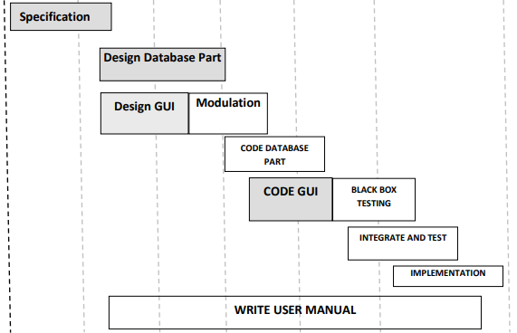

**14. SECURITY TESTING OF THE PROJECT**

Testing is vital for the success of any software. no system design is ever perfect. Testing is also carried in two phases. first phase is during the software engineering that is during the module creation. second phase is after the completion of software. This is system testing which verifies that the whole set of programs hanged together.

**14.1.1 WHITE BOX TESTING**

In this technique, the close examination of the logical parts through the software are tested by cases that exercise species sets of conditions or loops. All logical parts of the software checked once. Errors that can be corrected using this technique are typographical errors, logical expressions which should be executed once may be getting executed more than once and error resulting by using wrong controls and loops. When the box testing tests all the independent part within a module a logical decisions on their true and the false side are exercised , all loops and bounds within their operational bounds were exercised and internal data structure to ensure their validity were exercised once.

**14.1.2 BLACK BOX TESTING**

This method enables the software engineer to device sets of input techniques that fully exercise all functional requirements for a program. black box testing tests the input, the output and the external data. It checks whether the input data is correct and whether we are getting the desired output.

**14.1.3 ALPHA TESTING**

Acceptance testing is also sometimes called alpha testing. Be spoke systems are developed for a single customer. The alpha testing proceeds until the system developer and the customer agree that the provided system is an acceptable implementation of the system requirements.

**14.1.4 BETA TESTING**

On the other hand, when a system is to be marked as a software product, another process called beta testing is often conducted. During beta testing, a system is delivered among a number of potential users who agree to use it. The customers then report problems to thedevelopers. This provides the product for real use and detects errors which may not have been anticipated by the system developers.

**14.1.5 UNIT TESTING**

Each module is considered independently. It focuses on each unit of software as implemented in the source code. It is white box testing.

**14.1.6 INTEGRATION TESTING**

Integration testing aims at constructing the program structure while at the same constructing tests to uncover errors associated with interfacing the modules. Modules are integrated by using the top down approach.

**14.1.7 VALIDATION TESTING**

Validation testing was performed to ensure that all the functional and performance requirements are met.

**14.1.8 SYSTEM TESTING**

It is executing programs to check logical changes made in it with intention of finding errors. a system is tested for online response, volume of transaction, recovery from failure etc. System testing is done to ensure that the system satisfies all the user requirements.

**14.2 IMPLEMENTATION AND SOFTWARE SPECIFICATION**

**TESTINGS**

**14.2.1 DETAILED DESIGN OF IMPLEMENTATION**

This phase of the systems development life cycle refines hardware and software specifications, establishes programming plans, trains users and implements extensive testing procedures, to evaluate design and operating specifications and/or provide the basis for further modification.

**14.2.2 TECHNICAL DESIGN**

This activity builds upon specifications produced during new system design, adding detailed technical specifications and documentation.

**14.2.3 TEST SPECIFICATIONS AND PLANNING**

This activity prepares detailed test specifications for individual modules and programs, job streams, subsystems, and for the system as a whole.

**14.2.4 PROGRAMMING AND TESTING**

This activity encompasses actual development, writing, and testing of program units or modules.

**14.2.5 USER TRAINING**

This activity encompasses writing user procedure manuals, preparation of user training materials, conducting training programs, and testing procedures.

**14.2.6 ACCEPTANCE TEST**

A final procedural review to demonstrate a system and secure user approval before a system becomes operational.

**14.2.7 INSTALLATION PHASE**

In this phase the new computerized system is installed, the conversion to new procedures is fully implemented, and the potential of the new system is explored.

**14.2.8 SYSTEM INSTALLATION**

The process of starting the actual use of a system and training user personnel in its operation.

**14.2.9 REVIEW PHASE**

This phase evaluates the successes and failures during a systems development project, and to measure the results of a new Computerized Transystem in terms of benefits and savings projected at the start of the project.

**14.2.10 DEVELOPMENT RECAP**

A review of a project immediately after completion to find successes and potential problems in future work.

**14.2.11 POST-IMPLEMENTATION REVIEW**

A review, conducted after a new system has been in operation for some time, to evaluate actual system performance against original expectations and projections for cost-benefit improvements. Also identifies maintenance projects to enhance or improve the system.

**14.3 STEPS IN UNIT TESTING**

The steps involved during Unit testing are as follows:

a. Preparation of the test cases.

b. Preparation of the possible test data with all the validation checks.

c. Complete code review of the module.

d. Actual testing done manually.

e. Modifications done for the errors found during testing.

f. Prepared the test result scripts.

The unit testing done included the testing of the following items:

1. Functionality of the entire module/forms.

2. Validations for user input.

3. Checking of the Coding standards to be maintained during coding.

4. Testing the module with all the possible test data.

5. Testing of the functionality involving all type of calculations etc.

6. Commenting standard in the source files.

After completing the Unit testing of all the modules, the whole system is integrated with all its dependencies in that module. While System Integration, We integrated the modules one by one and tested the system at each step. This helped in reduction of errors at the time of the system testing.

**14.4 STEPS IN SYSTEM TESTING**

• Integration of all the modules/forms in the system.

• Preparation of the test cases.

• Preparation of the possible test data with all the validation checks.

• Actual testing done manually.

• Recording of all the reproduced errors.

• Modifications done for the errors found during testing.

• Prepared the test result scripts after rectification of the errors.

The System Testing done included the testing of the following items:

1. Functionality of the entire system as a whole.

2. User Interface of the system.

3. Testing the dependent modules together with all the possible test data scripts.

4. Verification and Validation testing.

5. Testing the reports with all its functionality.

After the completion of system testing, the next following phase was the Acceptance Testing. Clients at their end did this and accepted the system with appreciation. Thus, we reached the final phase of the project delivery.

**20.5 SPECIAL CATEGORY TEST**

There are other six tests, which fall under special category. They are described below:

**• Peak Load Test:** It determines whether the system will handle the volume of activities that occur when the system is at the peak of its processing demand. For example, test the system by activating all terminals at the same time.

**• Storage Testing:** It determines the capacity of the system to store transaction data on a disk or in other files.

**• Performance Time Testing:** it determines the length of time system used by the system to process transaction data. This test is conducted prior to implementation to determine how long it takes to get a response to an inquiry, make a backup copy of a file, or send a transmission and get a response.

**• Recovery Testing:** This testing determines the ability of user to recover data or re-start system after failure. For example, load backup copy of data and resume processing without data or integrity loss.

**• Procedure Testing:** It determines the clarity of documentation on operation and uses of system by having users do exactly what manuals request. For example, powering down system at the end of week or responding to paper-out light on printer.

**• Human Factors Testing:** It determines how users will use the system when processing data or preparing reports.

**15. SYSTEM ANALYSIS**

System analysis is a process of gathering and interpreting facts, diagnosing problems and the information about the System to recommend improvements on the system. It is a problem solving activity that requires intensive communication between the system users and system developers. System analysis or study is an important phase of any system development process. The system is studied to the minutest detail and analyzed. The system analyst plays the role of the interrogator and dwells deep into the working of the present system. The system is viewed as a whole and the input to the system are identified. The outputs from the organizations are traced to the various processes. System analysis is concerned with becoming aware of the problem, identifying the relevant and decisional variables, analyzing and synthesizing the various factors and determining an optimal or at least a satisfactory solution or program of action. A detailed study of the process must be made by various techniques like interviews, questionnaires etc. The data collected by these sources must be scrutinized to arrive to a conclusion. The conclusion is an understanding of how the system functions. This system is called the existing system. Now the existing system is subjected to close study and problem areas are identified. The designer now functions as a problem solver and tries to sort out the difficulties that the enterprise faces. The solutions are given as proposals. The proposal is then weighed with the existing system analytically and the best one is selected. The proposal is presented to the user for an endorsement by the user. The proposal is reviewed on user request and suitable changes are made. This is loop that ends as soon as the user is satisfied with proposal. Preliminary study is the process of gathering and interpreting facts, using the information for further studies on the system. Preliminary study is problem solving activity that requires intensive communication between the system users and system developers. It does various feasibility studies. In these studies a rough figure of the system activities can be obtained, from which the decision about the strategies to be followed for effective system study and analysis can be taken.

**16. RESULT**

The result of this project was a successful high-fidelity prototype of a Reservation system and scheduling application. I successfully implemented all of the above mentioned use cases, and achieved clean interfaces that further enhance the user experience.

This system is designed to provide the facility where the customer can easily reserve boats online. The user just has to register on this web portal, then the user can easily reserve boats according to their needs. While reserving boats, the user has to enter their destination point, date, and departure time. The user can also view their reservations. From Admin’s login, admin can add, view, edit, delete boats and view all user’s boat reservation. This system makes easier to the user for reserving boats online.

For more results, see video screen captures of user and admin interfaces in action.

**17. CONTRIBUTION**

The contributions of this project to my knowledge base are extensive. Before starting, I had no previous experience with web development or any of the tools used for this application.

Database Design is an invaluable aspect of the process that I mastered in the early stages of the project. Building many-to-one relationships and robust databases were required in developing this app. Familiarizing myself with SQL and database languages is also very useful going forward.

I also take away the combined understanding of PHP, MYSQL, and HTML, and how they come together to create a rich, database-backed web application.

Finally, web applications can become more than the sum of their parts with the successful integration of open source tools. Under limited time and resources, there is only so much one person can develop. However, by identifying appropriate open source projects and integrating them seamlessly, an application can become much more extensive and functional. Integrating WebCalendar, and widgets like the JavaScript date picker are perfect examples of this. If integrated poorly, these tools are obvious and detract from the user experience. Fortunately, I was able to integrate these tools well and package more than the sum of its parts.

In terms of contributions to the field, this prototype stands as a proof of concept for the idea of web-based appointment scheduling of any kind. Doctors’ offices, dentist offices, salons, boat reservation and many other industries are in great need of online, on demand scheduling. This project proves that it is very possible to build this functionality with the above-mentioned tools at very low cost. All tools used were open source.

**18. FUTURE DIRECTION**

The future enhancements can be done in this system to make it more feasible to us:-

* Multilingual support can be provided so that it can be understandable by the person of any language.
* More graphics can be added to make it more user-friendly and understandable.
* Manage & backup versions of documents online.
* We can add payments to the system.

Additionally, I would like to host the prototype online and run usability tests with surveys to gauge the effectiveness of the interface and functionality. This is a key step to perfecting the front-end interface and the functionality of the tools.

Finally, I would like to explore more dynamic, Web 2.0 tools like JavaScript, jQuery, and OpenLaszlo in more depth with the hope of making the interface richer for the user. Over the course of this project, I was able to get a small taste of these web development tools and their capabilities. They would allow me to give my application a more desktop software-feel on the web, with features like animation and drag-and drop. Unfortunately, I did not have enough time to fully explore them, and so that would be an addition improvement to consider going forward.

**19. SNAPSHOTS**

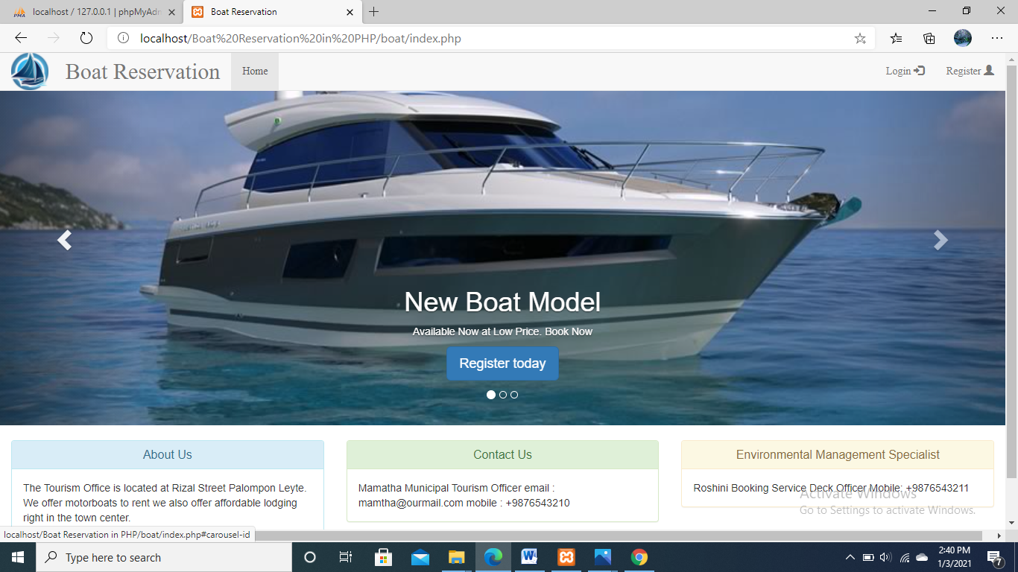**FIG : OUTPUT WINDOW FOR TOURIST**

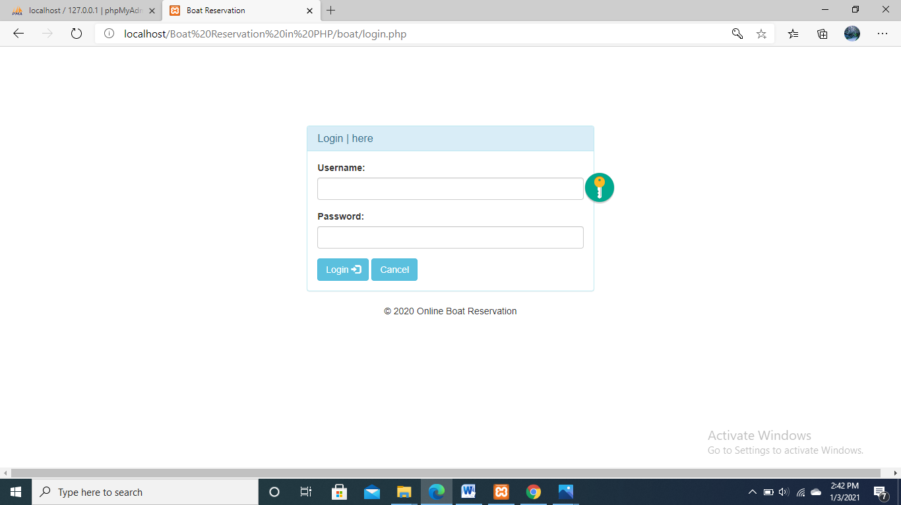

**FIG : OUTPUT WINDOW FOR ADMIN AND TOURIST LOGIN PAGE**

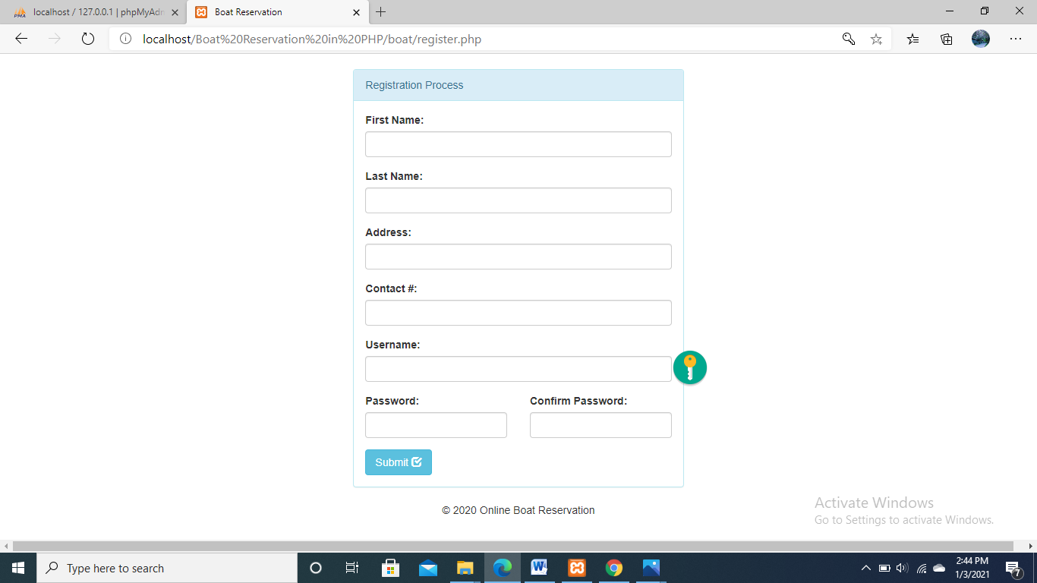

**FIG: REGISTRATION PAGE FOR TOURIST**

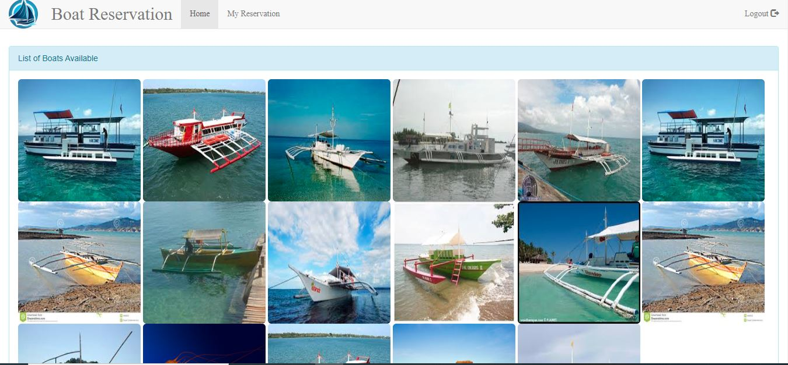

**FIG: LIST OF BOATS AVAILABLE**

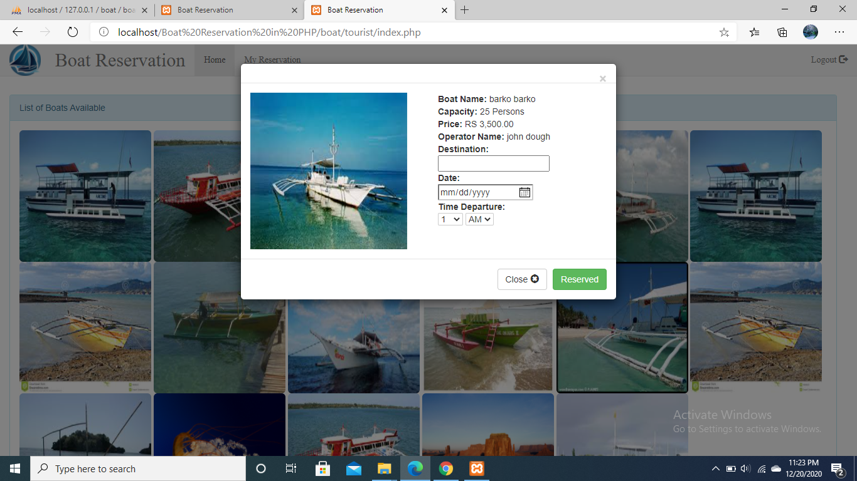

**FIG: BOAT RESERVATION PAGE**

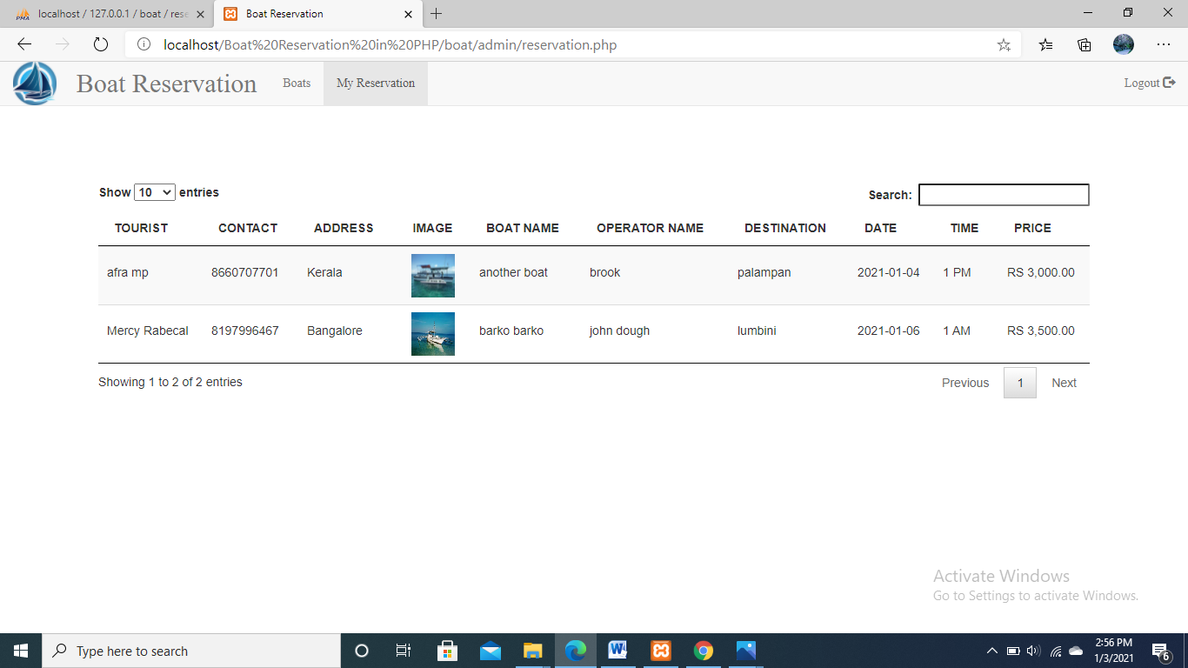

**FIG: TOURIST RESERVED BOATS**

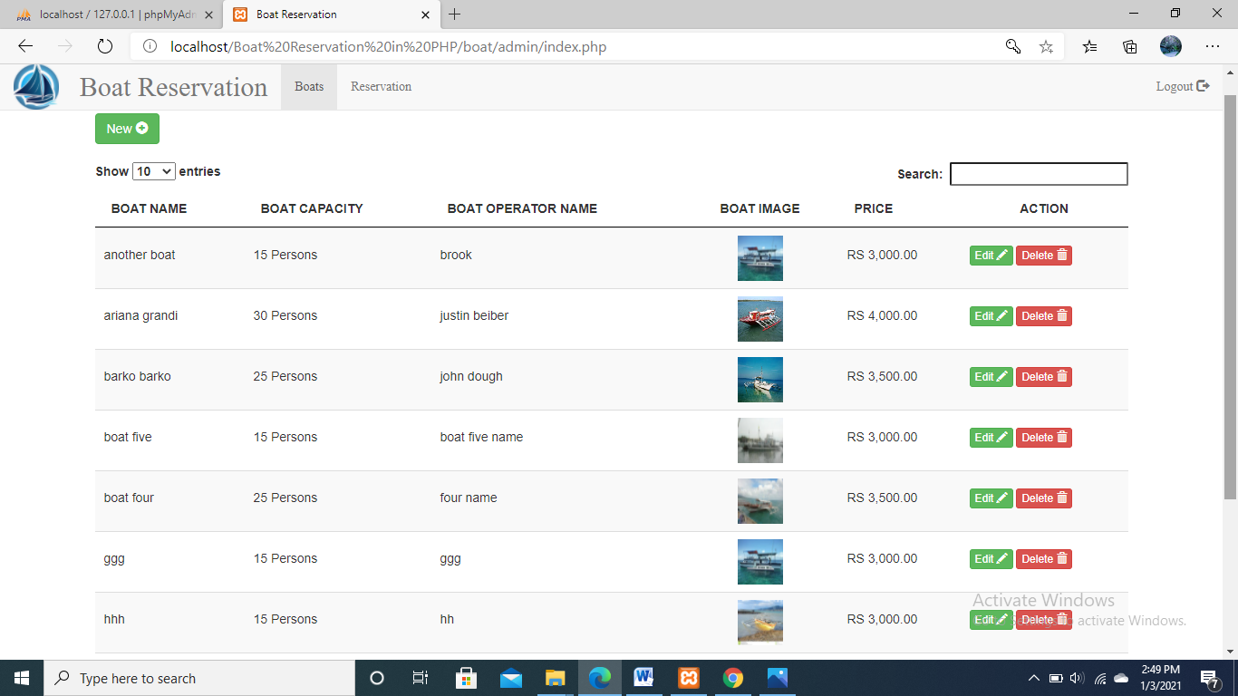

**FIG:ADMIN VIEW PAGE OF BOAT**

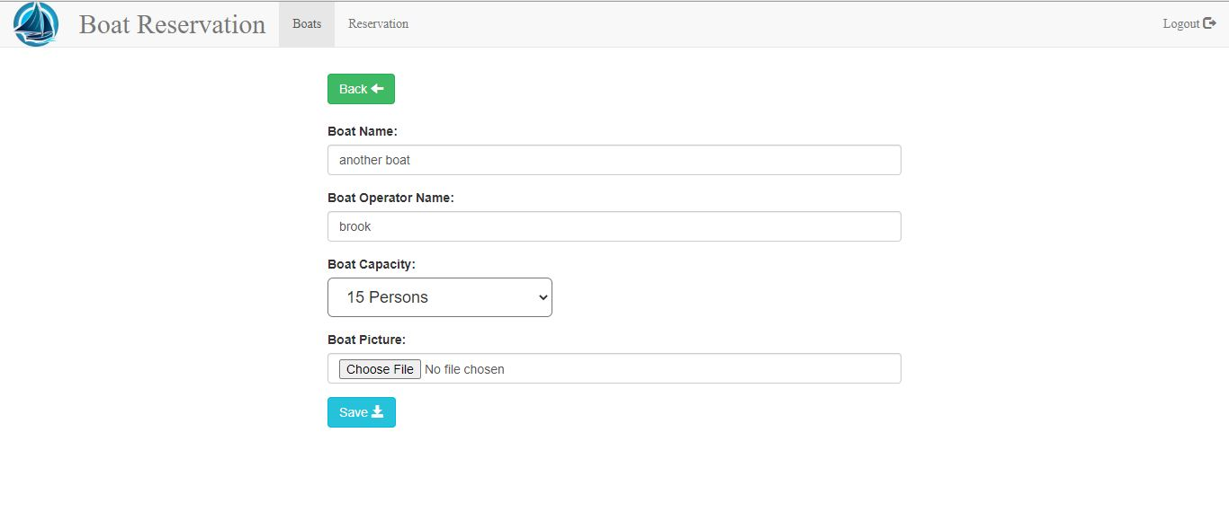

**FIG : OUTPUT WINDOW FOR ADDING BOATS**

#### 20. REFERENCES

* PHP And MySQL Web Development

By: Like Welling

PLATINUM EDITION

* PHP Solutions: Dynamic Web Design Made Easy

By: David

SECOND EDITION

* PHP For The Web: Visual Quick Start Guide

By: Larry Ullman

FOURTH EDITION

**Web references**

* www.Google.com
* www.Codeguru.com
* [www.Saveearth.org](http://www.saveearth.org/)
* [www.w3schools.com](http://www.w3schools.com)
* [www.ionic.com](http://www.ionic.com)
* [www.stackoverflow.com](http://www.stackoverflow.com)
* <https://spectrum-a6a15.firebaseapp.com/>