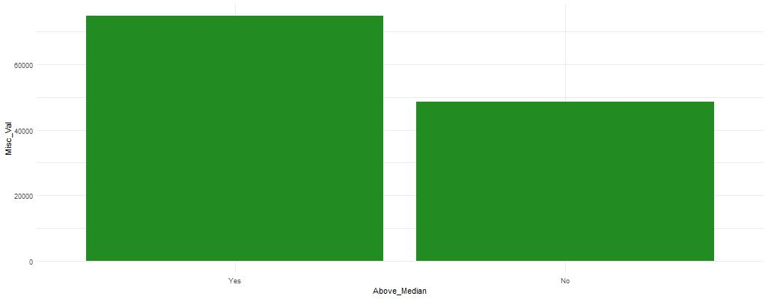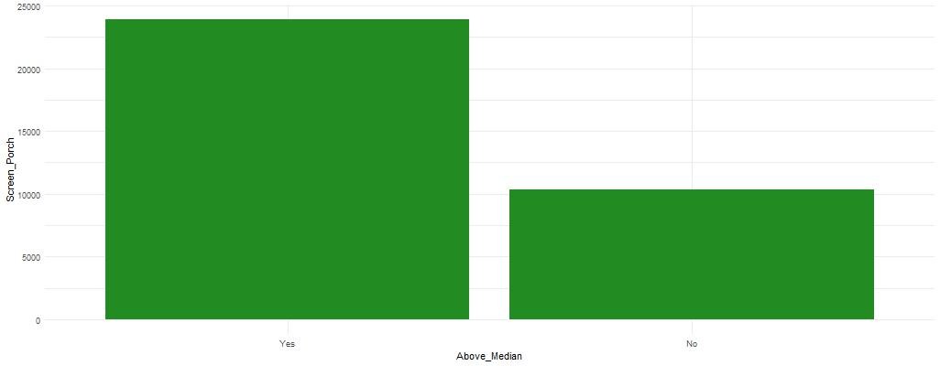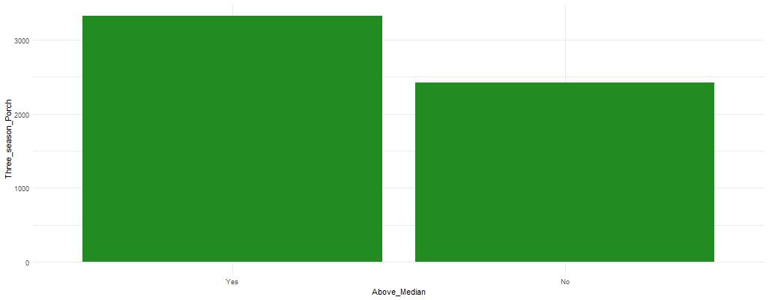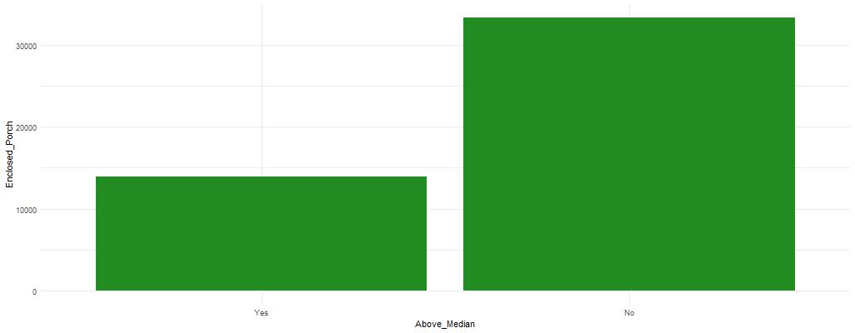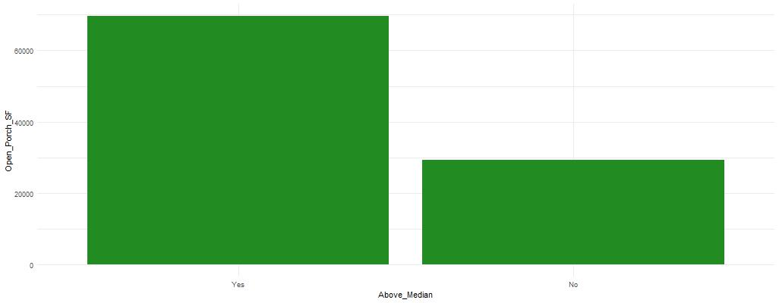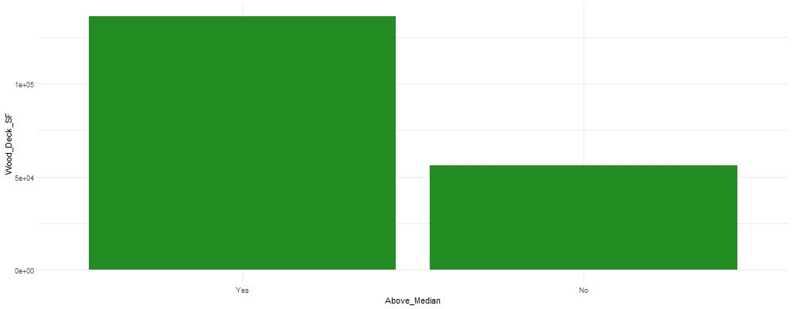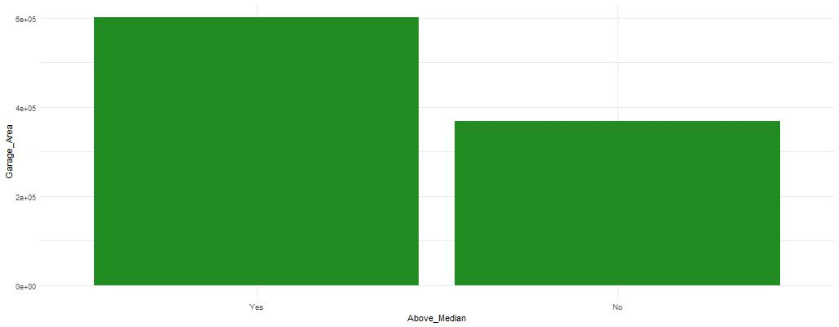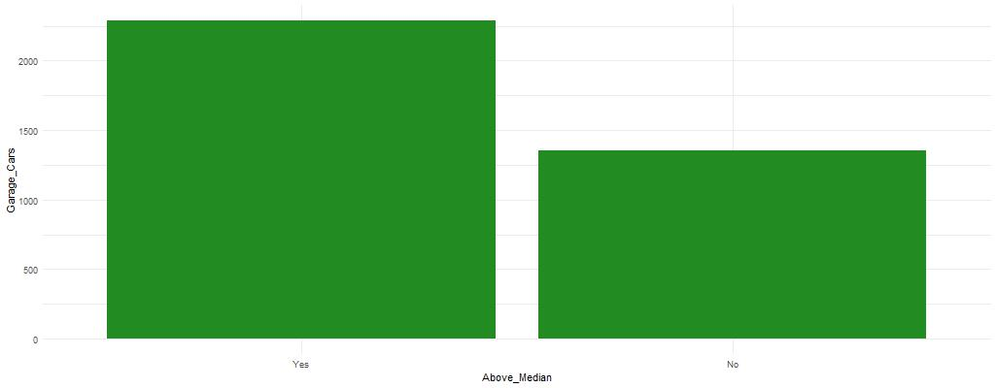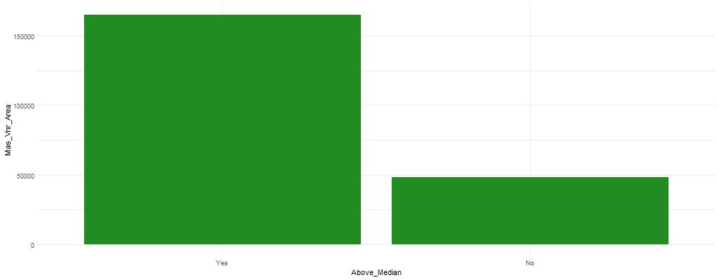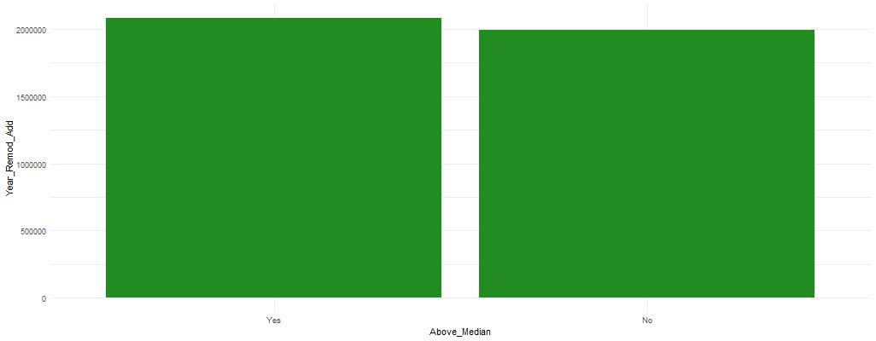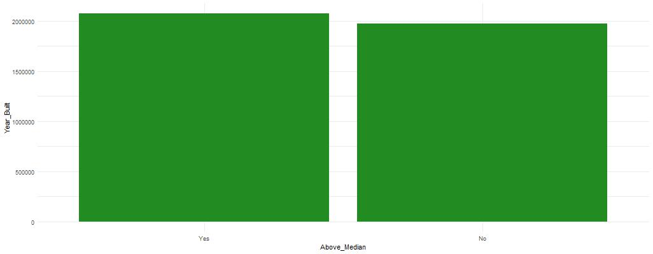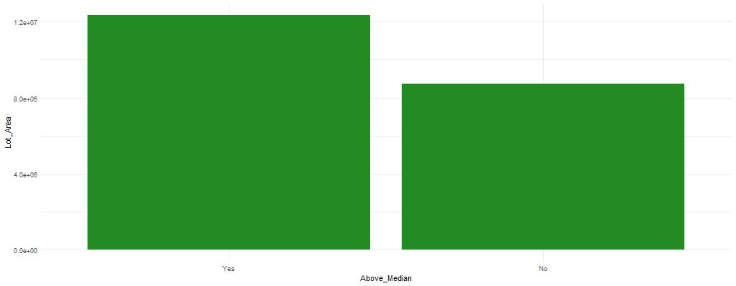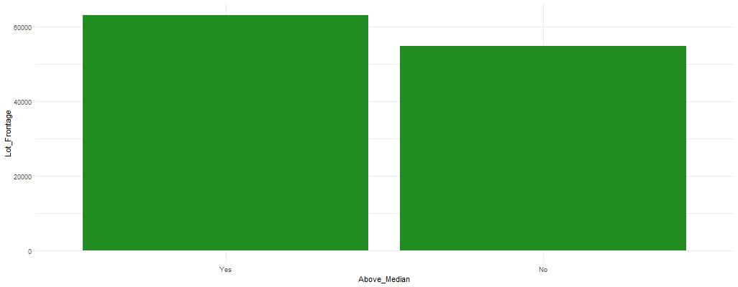

Not much difference between Yes and No

So it would probably not be a good predictor of Above_Median

Not much difference between Yes and No

So it would probably not be a good predictor of Above_Median

There is a difference between Yes and No

So, it might be a good predictor of Above_Median

Not much difference between Yes and No

So it would probably not be a good predictor of Above_Median

There is a difference between Yes and No

So, it might be a good predictor of Above_Median

There is a difference between Yes and No

So, it might be a good predictor of Above_Median

There is a difference between Yes and No

So, it might be a good predictor of Above_Median

Not much difference between Yes and No

So it would probably not be a good predictor of Above_Median

There is a difference between Yes and No

So, it might be a good predictor of Above_Median

Not much difference between Yes and No

So it would probably not be a good predictor of Above_Median

No real difference between Yes and No

So it would not be a good predictor of Above_Median

No real difference between Yes and No

So it would not be a good predictor of Above_Median

Not much difference between Yes and No

So it would probably not be a good predictor of Above_Median

No real difference between Yes and No

So it would not be a good predictor of Above_Median

Not much difference between Yes and No

So it would probably not be a good predictor of Above_Median

No real difference between Yes and No

So it would not be a good predictor of Above_Median

No real difference between Yes and No

So it would not be a good predictor of Above_Median

No real difference between Yes and No

So it would not be a good predictor of Above_Median

There is a difference between Yes and No

So, it might be a good predictor of Above_Median

Not much difference between Yes and No

So it would probably not be a good predictor of Above_Median

Not much difference between Yes and No

So it would probably not be a good predictor of Above_Median

There is a difference between Yes and No

So, it might be a good predictor of Above_Median

Not much difference between Yes and No

So it would probably not be a good predictor of Above_Median

No real difference between Yes and No

So it would not be a good predictor of Above_Median

There is a difference between Yes and No

So, it might be a good predictor of Above_Median

There is a difference between Yes and No

So, it might be a good predictor of Above_Median

Not much difference between Yes and No

So it would probably not be a good predictor of Above_Median

Not much difference between Yes and No

So it would probably not be a good predictor of Above_Median

No real difference between Yes and No

So it would not be a good predictor of Above_Median

No real difference between Yes and No

So it would not be a good predictor of Above_Median

No real difference between Yes and No

So it would not be a good predictor of Above_Median

No real difference between Yes and No

So it would not be a good predictor of Above_Median

No real difference between Yes and No

So it would not be a good predictor of Above_Median

No real difference between Yes and No

So it would not be a good predictor of Above_Median

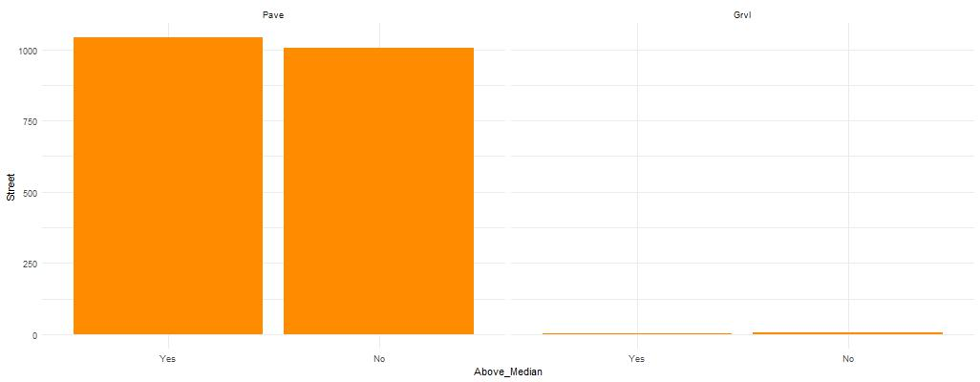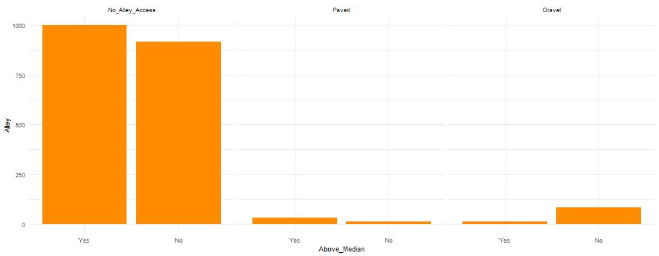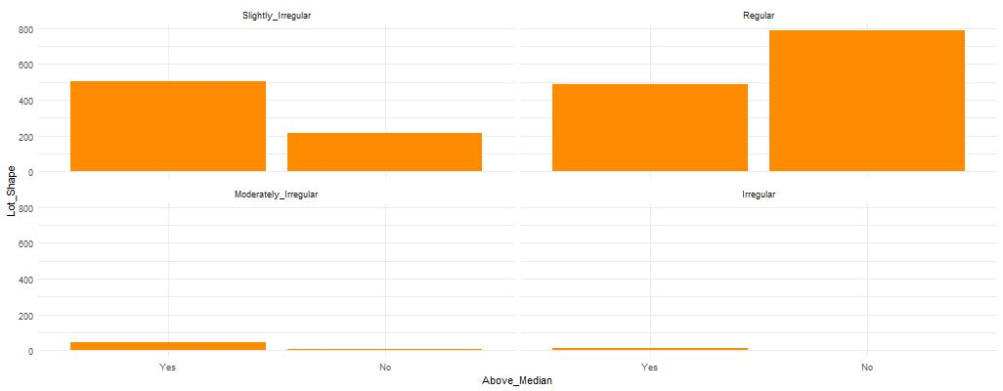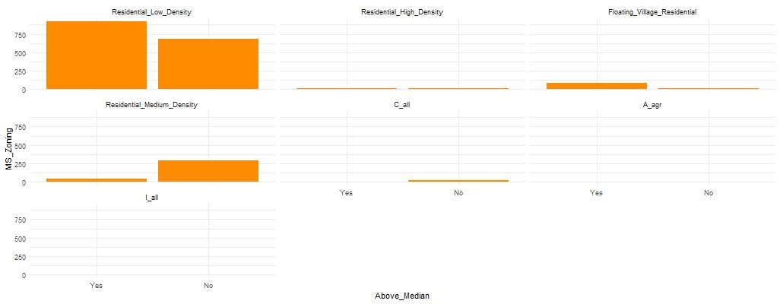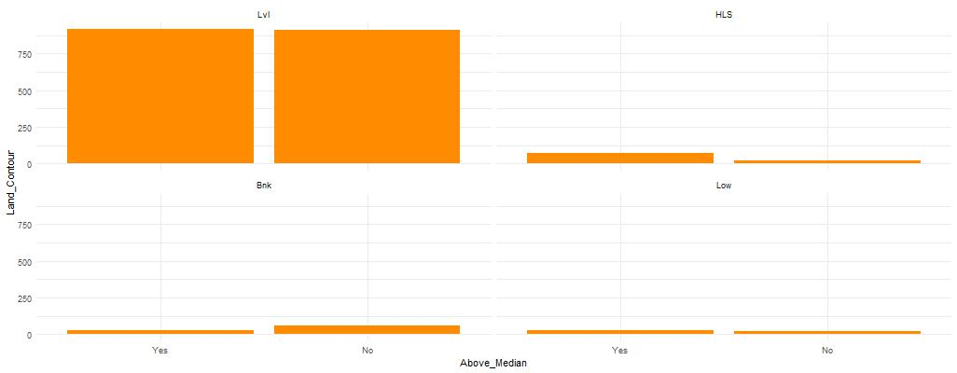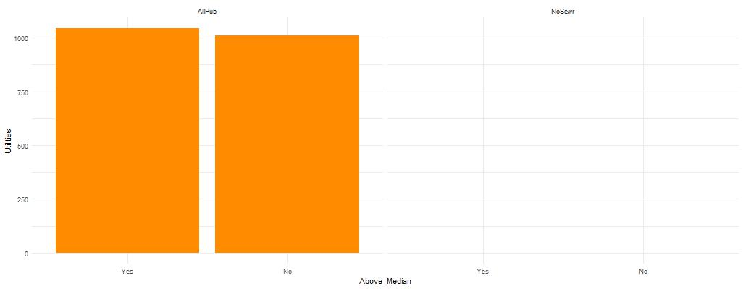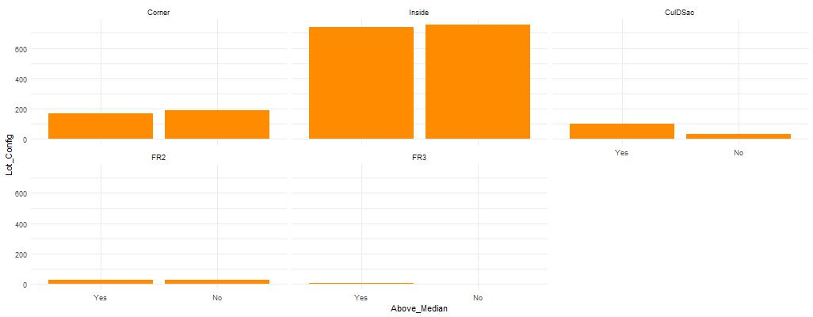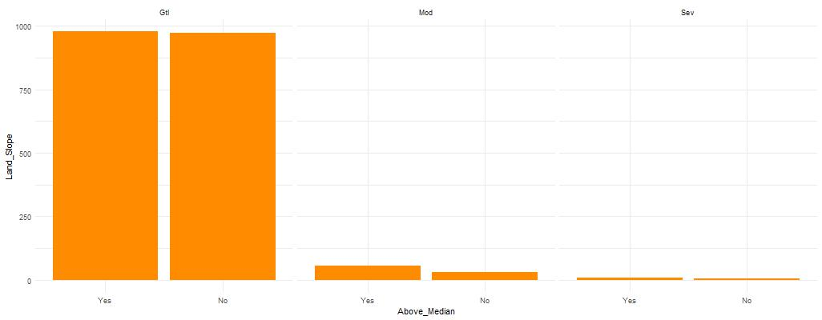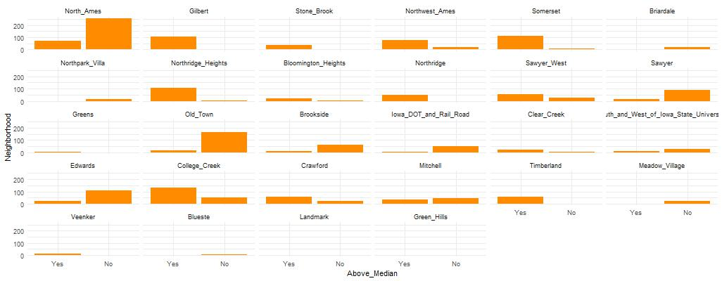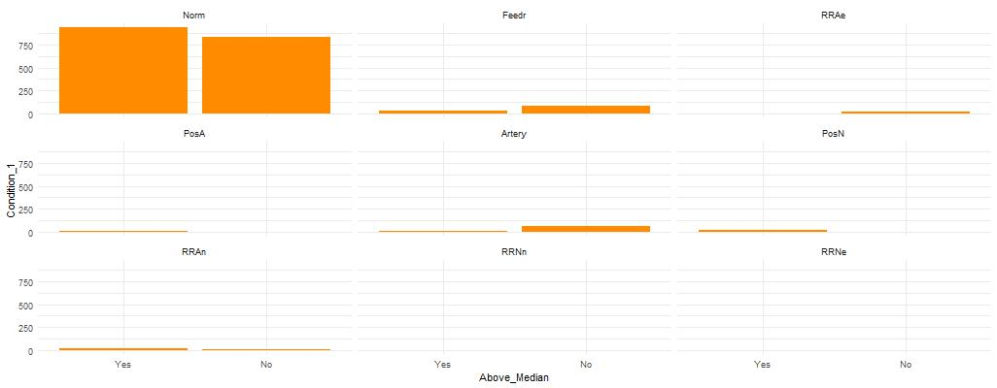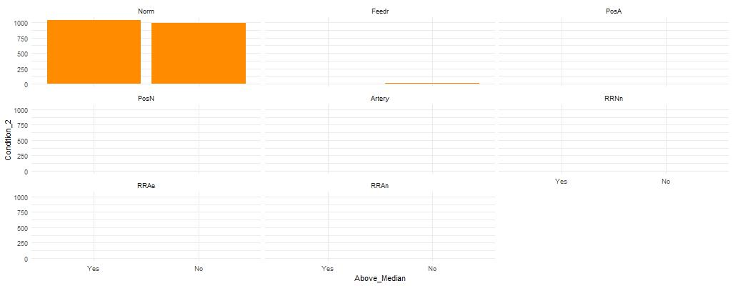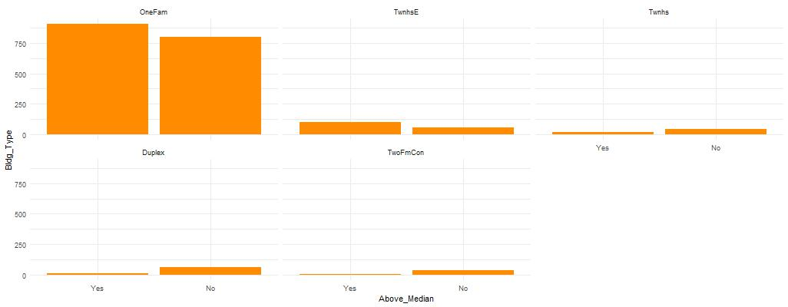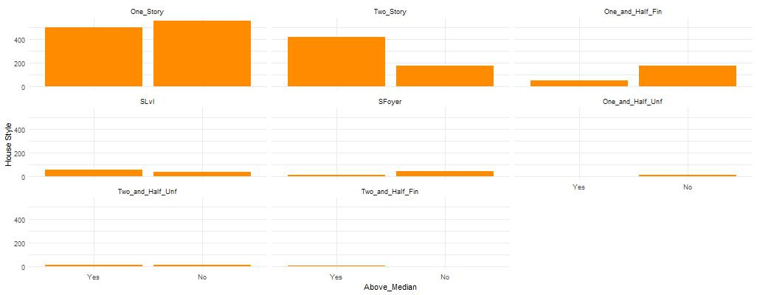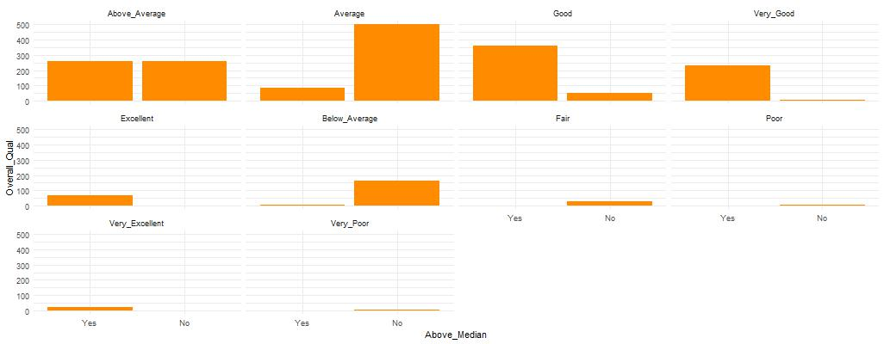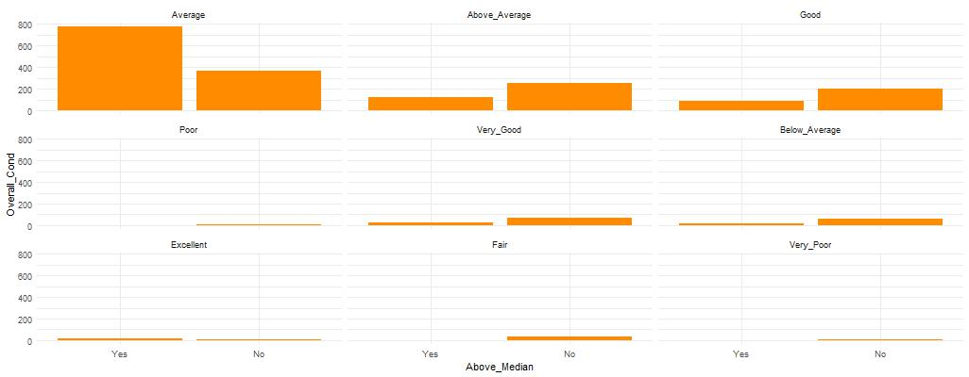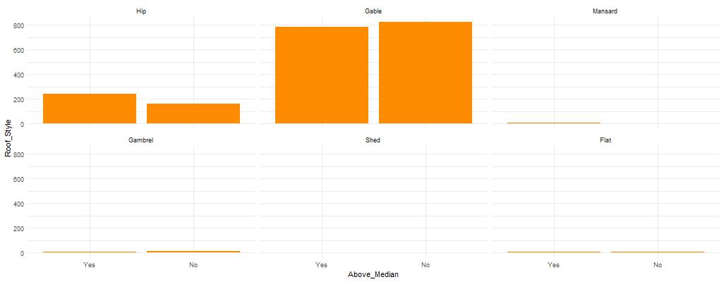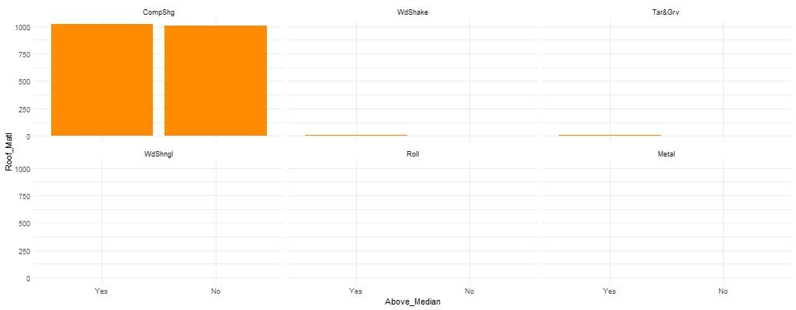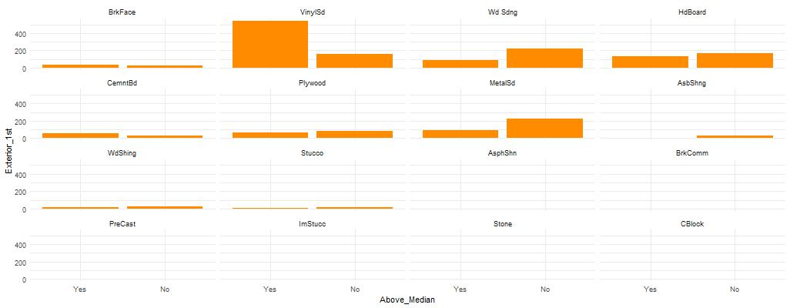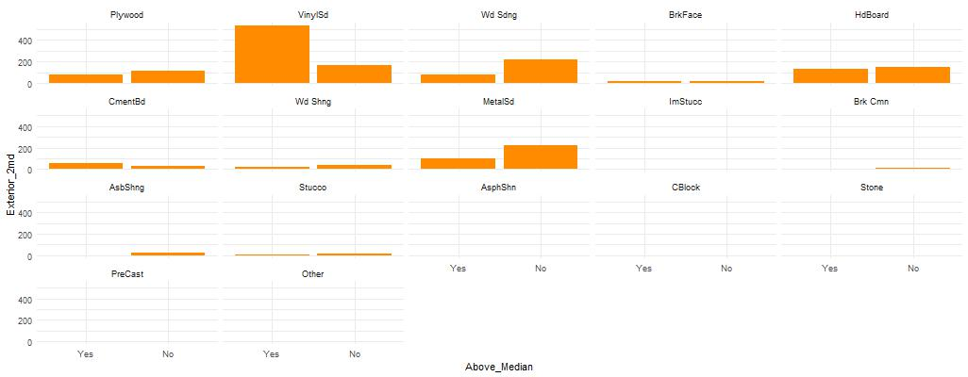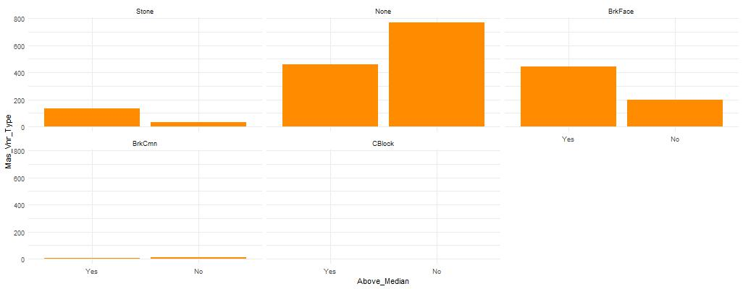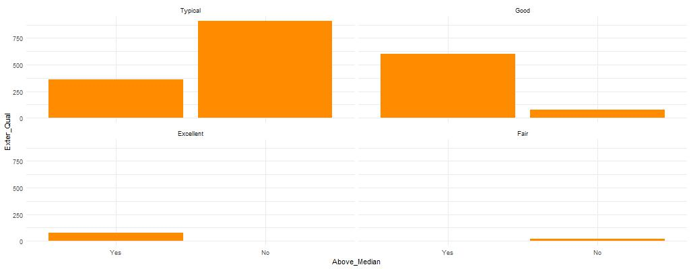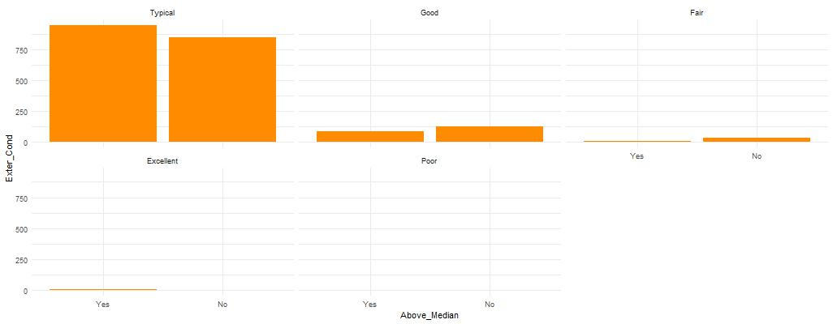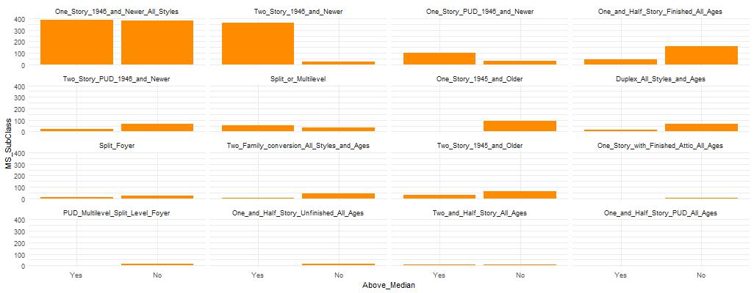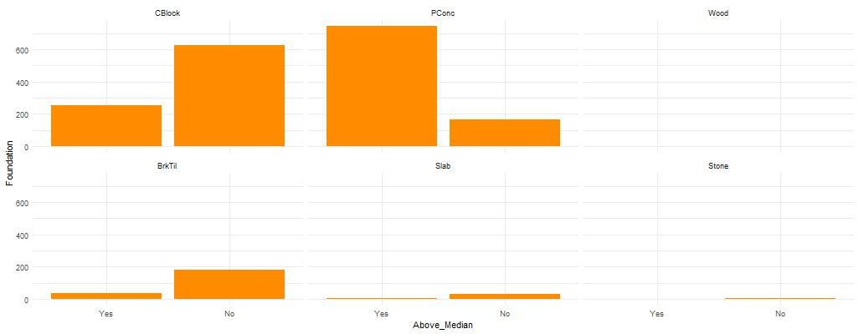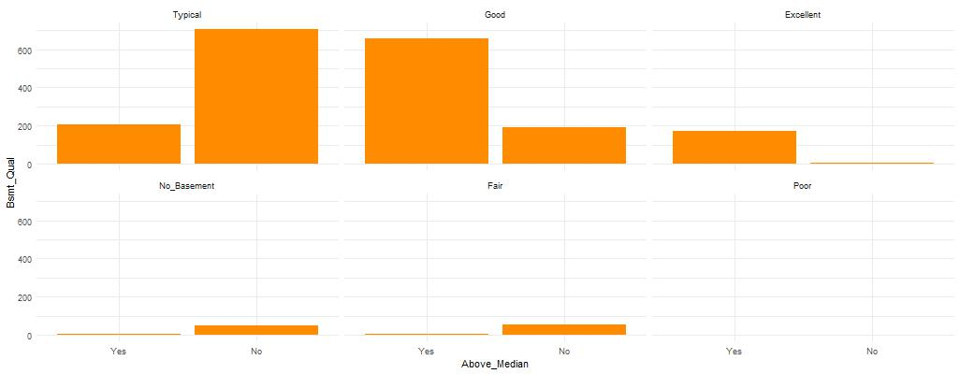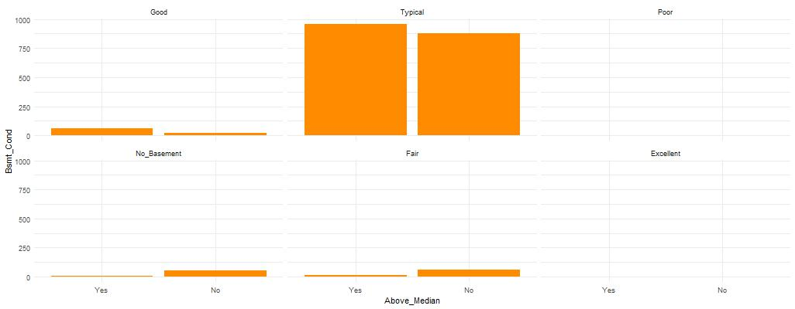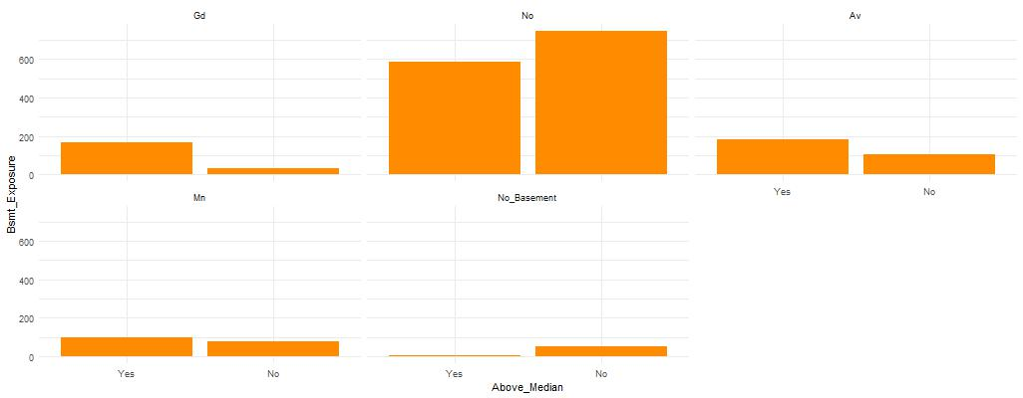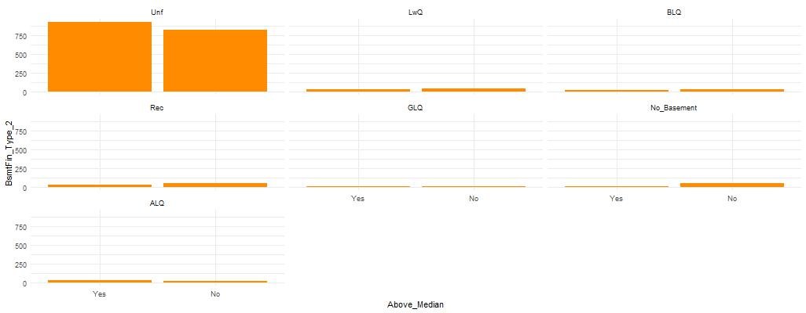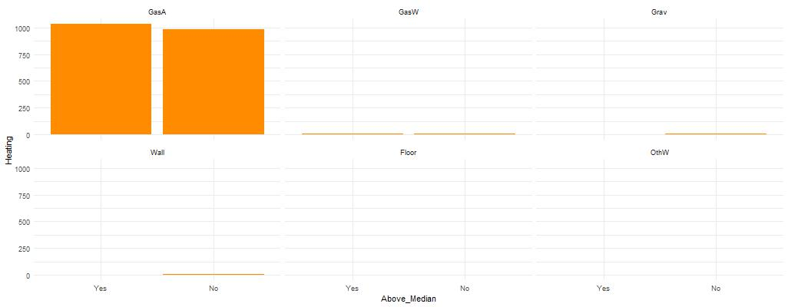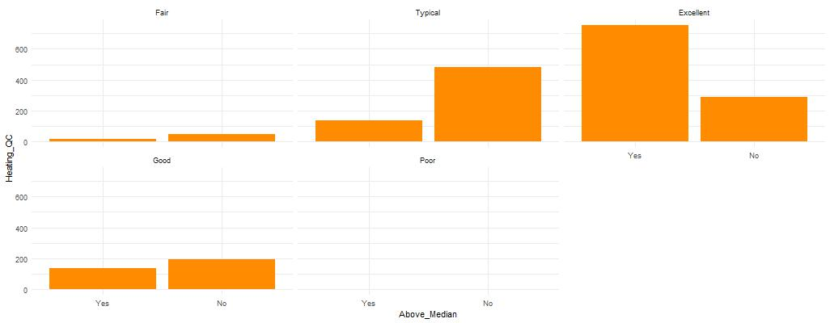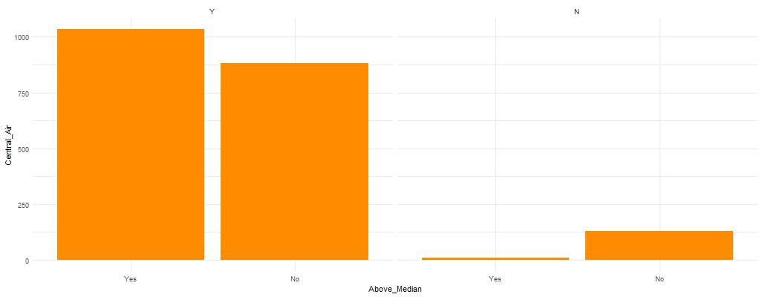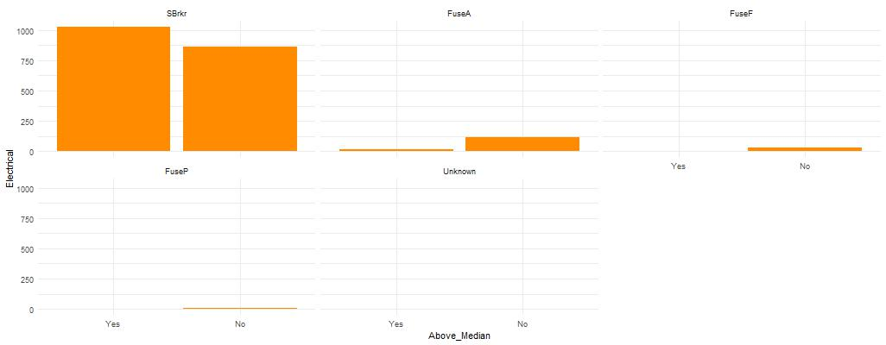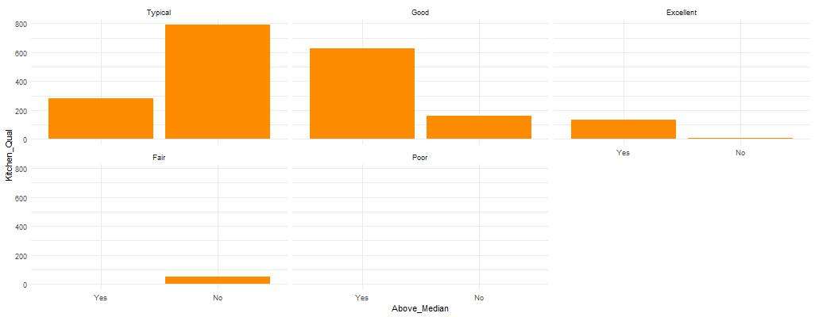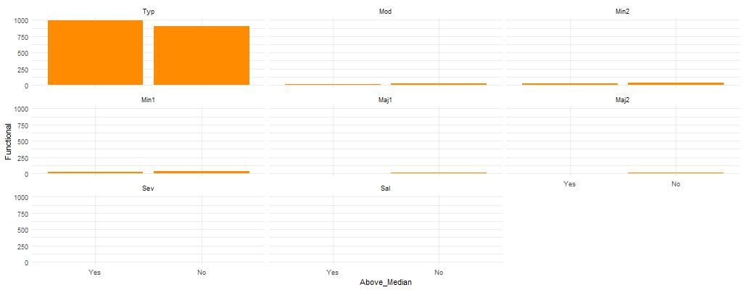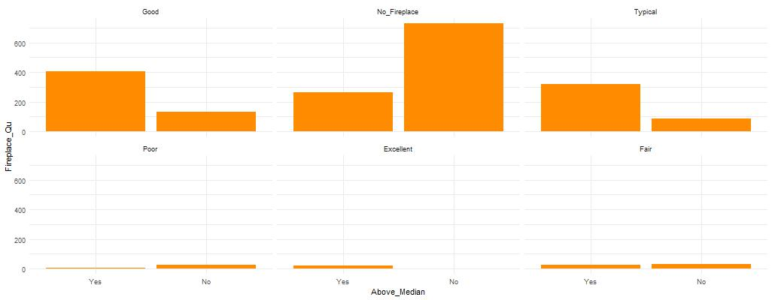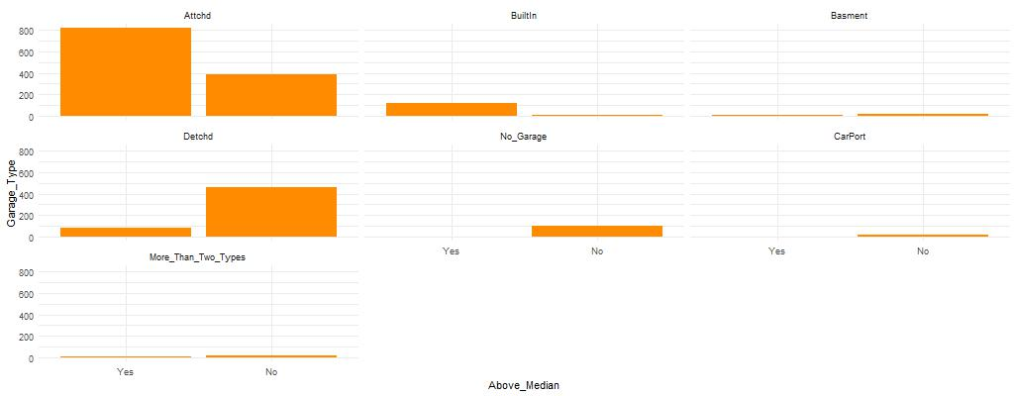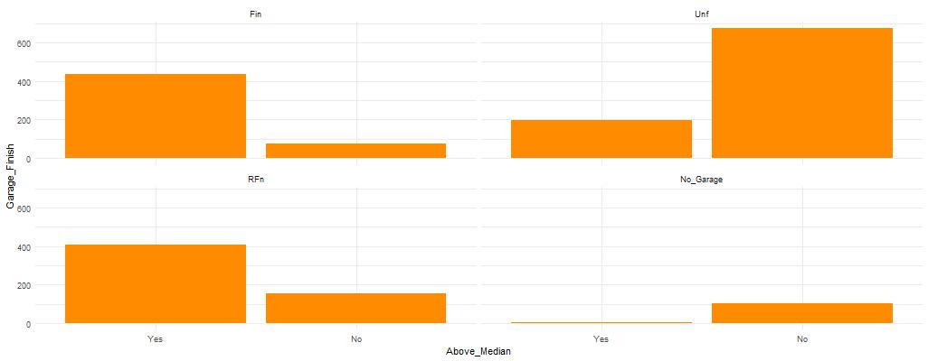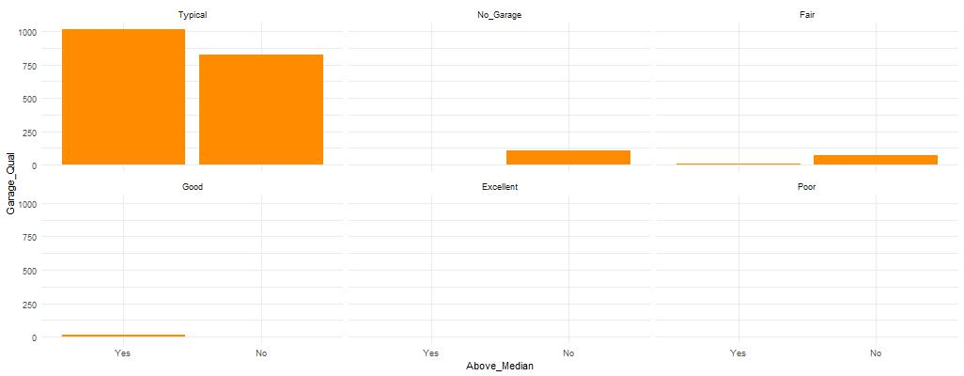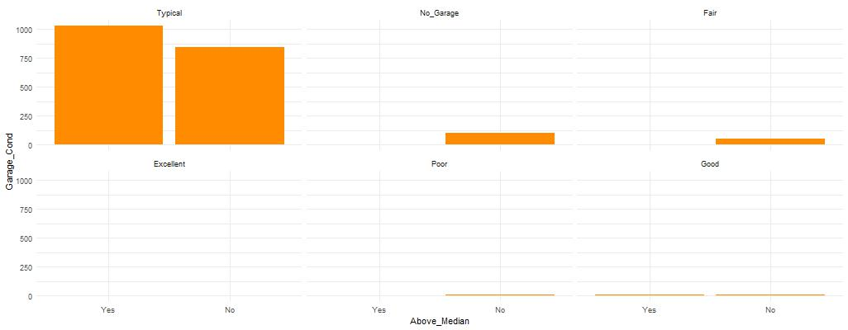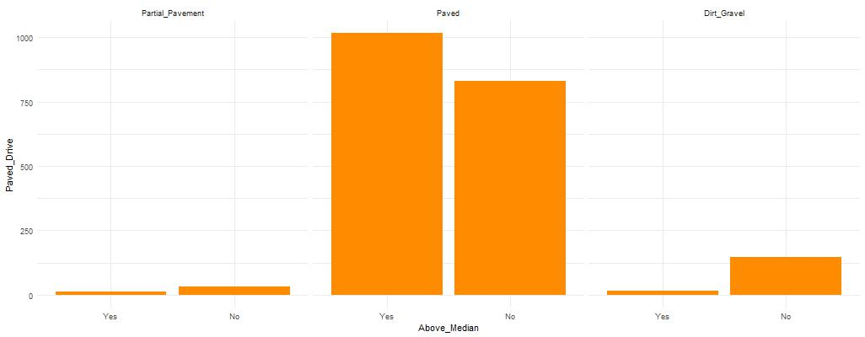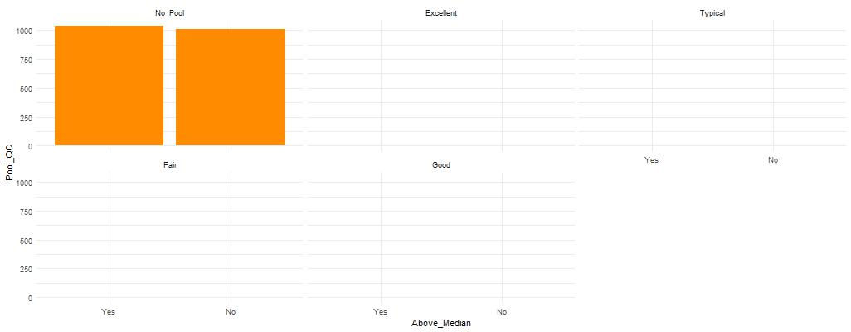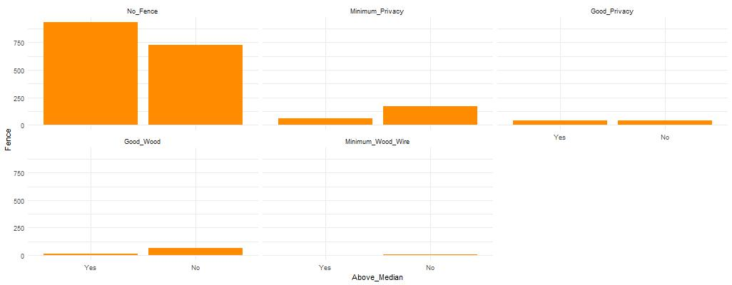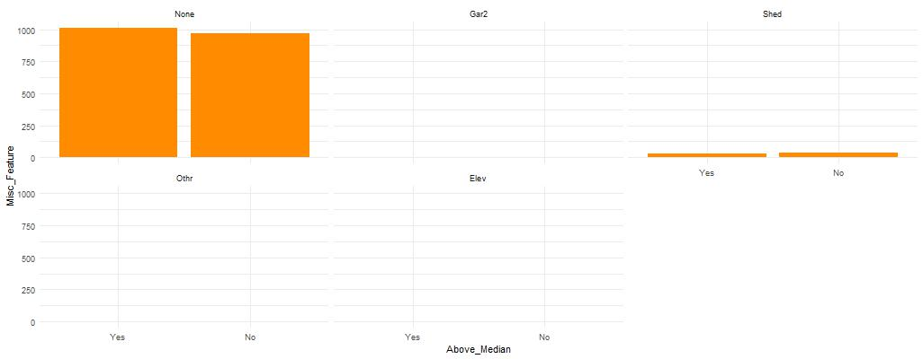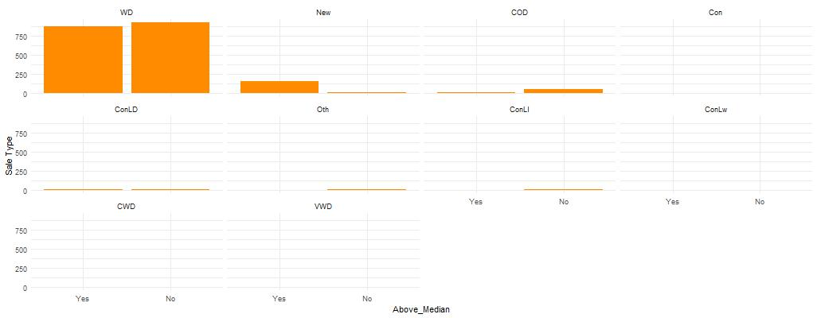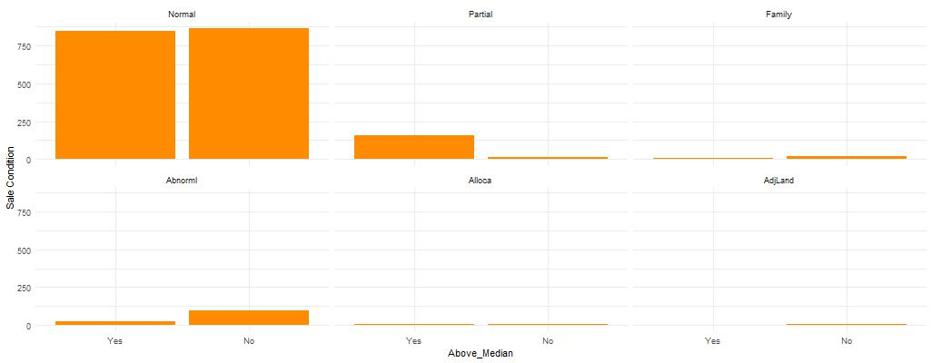

No real difference between Yes and No

So it would not be a good predictor of Above_Median

Not much difference between Yes and No

So it would probably not be a good predictor of Above_Median

There is a difference in some of the Levels between Yes and No

So, it might be a good predictor of Above_Median

Not much difference between Yes and No

So it would probably not be a good predictor of Above_Median

No real difference between Yes and No

So it would not be a good predictor of Above_Median

No real difference between Yes and No

So it would not be a good predictor of Above_Median

No real difference between Yes and No

So it would not be a good predictor of Above_Median

No real difference between Yes and No

So it would not be a good predictor of Above_Median

There is a difference in some of the Levels between Yes and No

So, it might be a good predictor of Above_Median

No real difference between Yes and No

So it would not be a good predictor of Above_Median

No real difference between Yes and No

So it would not be a good predictor of Above_Median

No real difference between Yes and No

So it would not be a good predictor of Above_Median

Not much difference between Yes and No

So it would probably not be a good predictor of Above_Median

There is a difference in some of the Levels between Yes and No

So, it might be a good predictor of Above_Median

Not much difference between Yes and No

So it would probably not be a good predictor of Above_Median

No real difference between Yes and No

So it would not be a good predictor of Above_Median

Not much difference between Yes and No

So it would probably not be a good predictor of Above_Median

Not much difference between Yes and No

So it would probably not be a good predictor of Above_Median

Not much difference between Yes and No

So it would probably not be a good predictor of Above_Median

There is a difference in some of the Levels between Yes and No

So, it might be a good predictor of Above_Median

Not much difference between Yes and No

So it would probably not be a good predictor of Above_Median

There is a difference in some of the Levels between Yes and No

So, it might be a good predictor of Above_Median

There is a difference in some of the Levels between Yes and No

So, it might be a good predictor of Above_Median

Not much difference between Yes and No

So it would probably not be a good predictor of Above_Median

There is a difference in some of the Levels between Yes and No

So, it might be a good predictor of Above_Median

Not much difference between Yes and No

So it would probably not be a good predictor of Above_Median

Not much difference between Yes and No

So it would probably not be a good predictor of Above_Median

Not much difference between Yes and No

So it would probably not be a good predictor of Above_Median

Not much difference between Yes and No

So it would probably not be a good predictor of Above_Median

Not much difference between Yes and No

So it would probably not be a good predictor of Above_Median

There is a difference in some of the Levels between Yes and No

So, it might be a good predictor of Above_Median

Not much difference between Yes and No

So it would probably not be a good predictor of Above_Median

Not much difference between Yes and No

So it would probably not be a good predictor of Above_Median

There is a difference in some of the Levels between Yes and No

So, it might be a good predictor of Above_Median.

No real difference between Yes and No

So it would not be a good predictor of Above_Median

There is a difference in some of the Levels between Yes and No

So, it might be a good predictor of Above_Median.

There is a difference in some of the Levels between Yes and No

So, it might be a good predictor of Above_Median.

There is a difference in some of the Levels between Yes and No

So, it might be a good predictor of Above_Median

No real difference between Yes and No

So it would not be a good predictor of Above_Median

No real difference between Yes and No

So it would not be a good predictor of Above_Median

No real difference between Yes and No

So it would not be a good predictor of Above_Median

No real difference between Yes and No

So it would not be a good predictor of Above_Median

No real difference between Yes and No

So it would not be a good predictor of Above_Median

No real difference between Yes and No

So it would not be a good predictor of Above_Median

No real difference between Yes and No

So it would not be a good predictor of Above_Median

No real difference between Yes and No

So it would not be a good predictor of Above_Median