Creating R Markdown Documents.Rmd

Tabitha Hagen

2022-07-15

# Module 2 - Assignment 2

## Tabitha Hagen

### Introduction to R Markdown

#### For this assignment, I will be importing a dataset into RStudio and use this dataset to run through some analysis of the data. I will start by opening a clean text file to save as a R Markdown file. This file will include a title, my name, and brief description.

##### I will use a variety of features such as:

* visual data analytic tools (graphs, measures of center measurement, comparisons, etc.)
* packages including tidyverse, ggplot2, and base R.

##### I will also be using atomic vectors which are vectors which can store only 1 type of data type (unlike the Tuple). There are 6 kinds of atomic vector:

* doubles
* integers
* characters
* logicals
* complex
* raw

##### The plot below will show a basic plot graph showing sales over the past 6 months.

# 1) Write the code to load the tidyverse package.   
 library(tidyverse)

## ── Attaching packages ─────────────────────────────────────── tidyverse 1.3.1 ──

## ✔ ggplot2 3.3.6 ✔ purrr 0.3.4  
## ✔ tibble 3.1.7 ✔ dplyr 1.0.9  
## ✔ tidyr 1.2.0 ✔ stringr 1.4.0  
## ✔ readr 2.1.2 ✔ forcats 0.5.1

## ── Conflicts ────────────────────────────────────────── tidyverse_conflicts() ──  
## ✖ dplyr::filter() masks stats::filter()  
## ✖ dplyr::lag() masks stats::lag()

# 2) Create an object called sales.   
 sales <- c(50, 150, 200, 100, 300, 250)  
# 3) Add the following values to sales (in this order): 50, 150, 200, 100,   
# 300, 250   
 sales <- c(50, 150, 200, 100, 300, 250)  
# 4) Create another object called month.   
 month <- c(1, 2, 3, 4, 5, 6)  
# 5) Add the following values to month (in this order): 1,2,3,4,5,6   
 month <- c(1, 2, 3, 4, 5, 6)  
# 6) Use the qplot function to create a scatterplot with sales on the y-axis   
# and month on the x-axis.   
 qplot(month, sales)

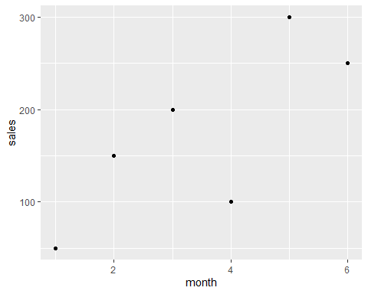

# What month had the largest sales? What was the amount?

Month 5 had the most with 300 in sales.

Month 1 had the least with only 50 in sales.