More Practice with Plots

Tabitha Hagen

2022-07-22

# Module 3 - Assignment 3

## Tabitha Hagen

### More Practice with Plots

Part 1 - Basic Plots

#### Google Sock Price Plots

The following is an analysis of Google’s stock price from October of 2019 to October of 2020. This will include a scatter, line, bar, histogram and boxplot. All the plots represent the closing price on the dates listed on the x-axis.

ggplot(data=GOOG, aes(x=Date, y=Close)) +   
 geom_point() + # Creates a Scatterplot on the graph  
 geom_smooth(method="lm", formula= "y~x" ) + # Adds a fitted line to the graph  
 labs(title = "#1-1 Date vs Close Scatterplot", # Plot Title  
 x = "Date", # x axis label  
 y = "Price at Close in US dollars ($)" # y axis label  
 )

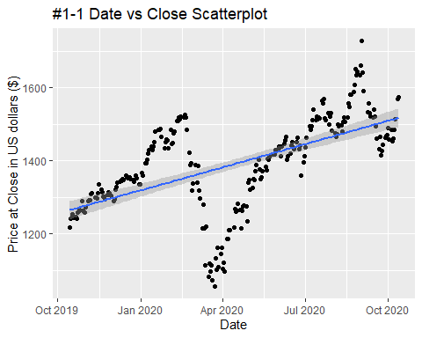

ggplot(data=GOOG, aes(x=Date, y=Close)) +   
 geom_line(aes(group=1), colour="#CC0000") + # Creates a line connecting data points  
 geom_smooth(method="lm", formula= "y~x" ) + # Adds a fitted line to the graph  
 labs(title = "#1-2 Date vs Close Line Graph", # Plot Title  
 x = "Date", # x axis label  
 y = "Price at Close in US dollars ($)" # y axis label  
 )

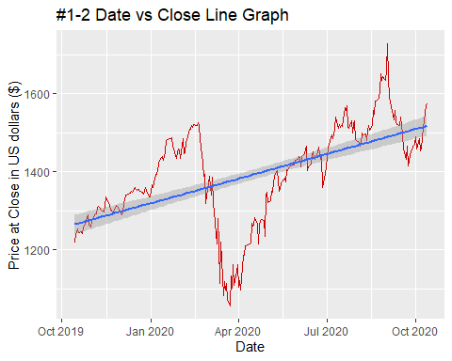

ggplot(data=GOOG, aes(x=Date, y=Close)) +   
 geom_col(aes(group=1), colour="#00abff") + # Creates a bar graph  
 geom_smooth(method="lm", formula= "y~x" ) + # Adds a fitted line to the graph  
 labs(title = "#1-3 Date vs Close Bar Graph", # Plot Title  
 x = "Date", # x axis label  
 y = "Price at Close in US dollars ($)" # y axis label  
 )

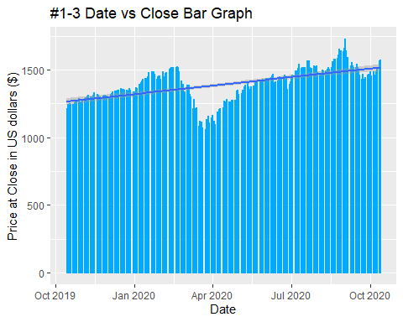

ggplot(data=GOOG, aes(x=Close)) +   
 geom_histogram(colour = 7, fill = "white", bins = 15)+ # Creates a histogram  
 labs(title = "#1-4 Close Histogram Graph", # Plot Title  
 x = "Price at Close in US dollars ($)" ) # X axis label

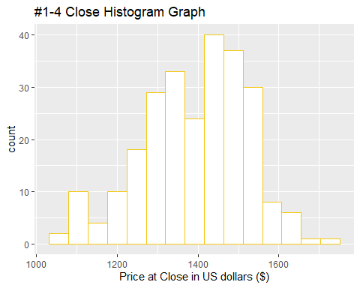

ggplot(data=GOOG, aes(x=Close)) +   
 geom_boxplot(colour = 2, fill = "yellow")+ # Creates a Boxplot  
 labs(title = "#1-5 Close Boxplot Graph", # Plot Title  
 x = "Price at Close in US dollars ($)" ) # X axis label

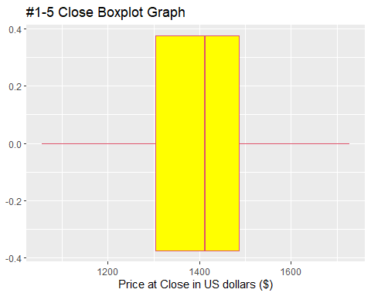

ggplot(data=GOOG, aes(x =Date, y = Close)) +  
 geom_line(colour="blue") +  
 geom_point(shape=1, colour="red")+  
 labs(title = "#1-6 Close Line Graph with Data Points", # Plot Title  
 x = "Price at Close in US dollars ($)" ) # X axis label

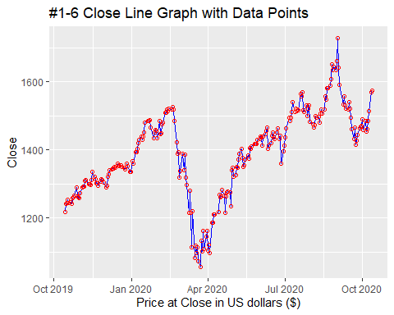

Question: You have created many different plots of the same data but some are more helpful than others. Based on the plots you created, which one do you find most useful and why? The last line graph with data points was more useful because it allowed you to see trends over time. Even the line graph with the best fit line was better than just looking at a Histogram or Box plot of one variable. The bar chart simply had too much data and needed to be grouped by week to be useful.

Part 2 - Advanced Plots

#### Google Stock Daily Price Comparisons

ggplot(data=GOOG) +  
 geom_line(aes(x=Date, y=High, colour="High")) + # Create 1st line   
 geom_line (aes(x=Date, y=Low, colour="Low")) + # Create 2nd line  
 labs(title = "#2-1 Close Line Graphs w/High and Low Data Points", # Plot Title  
 x = "Date", # x axis label  
 y = "Price at Close in US dollars ($)" # y axis label  
 )

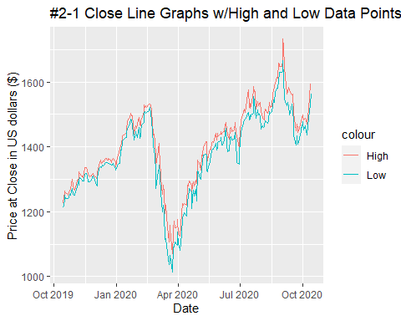

ggplot(data=GOOG) +  
 geom_line(aes(x=Date, y=Open, colour="Open")) + # Create 1st line   
 geom_line (aes(x=Date, y=Close, colour="Close")) + # Create 2nd line  
 scale_colour_manual("", values=c(Open="green",Close="red"))+ #Assign Legend Values  
 labs(title = "#2-2 Open & Close Line Graphs w/ Custom Legend", # Plot Title  
 x = "Date", # x axis label  
 y = "Price" # y axis label  
 )

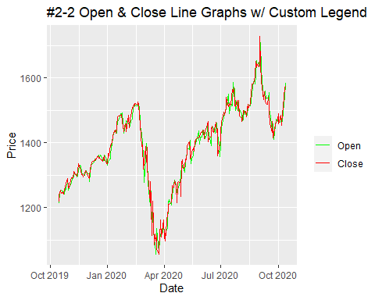

ggplot(data=GOOG, aes(x=Date, y=Close)) +  
 geom_area(color="black", fill="blue", alpha=.2) + # Create & fill area under line graph  
 labs(title = "#2-3 Date vs Close Area under the Line Graph", # Plot Title  
 x = "Date", # x axis label  
 y = "Price at Close in US dollars ($)" # y axis label  
 )

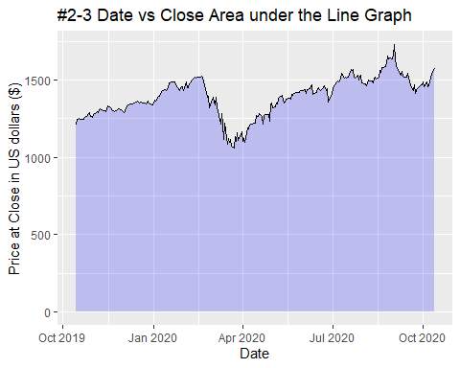

ggplot(data=GOOG, aes(x=Date, y=Open)) +  
 geom_area(color="blue", fill="green", alpha=.1) + # Create & fill area under line graph  
 labs(title = "#2-4 Date vs Open Area under the Line Graph", # Plot Title  
 x = "Date", # x axis label  
 y = "Price at Open in US dollars ($)" # y axis label  
 )

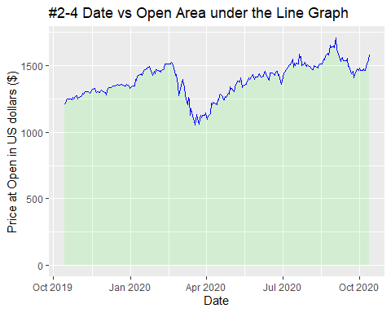

MayPrice <- subset(GOOG, Date > "2020-04-30" & Date < "2020-06-01") # Create subset of data  
ggplot(data=MayPrice, aes(x=Date, y=Close)) +  
 geom_point() + # Create a Scatterplot  
 geom_text(aes(label=round(Close)), size=3, vjust=1)+ # Label data points  
 labs(title = "#2-5 Date vs Close Scatterplot May 2020", # Plot Title  
 x = "Dates for May 2020", # x axis label  
 y = "Price at Open in US dollars ($)" # y axis label  
 )

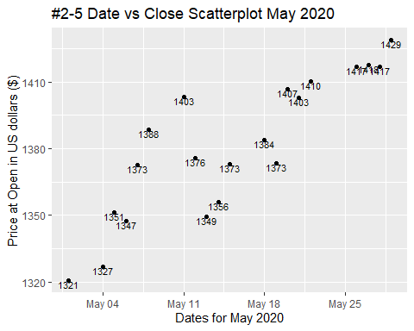

AprilPrice <- subset(GOOG, Date > "2020-03-31" & Date < "2020-05-01") # Create subset of data  
ggplot(data=MayPrice, aes(x=Date, y=Open)) +  
 geom_point(shape=1, colour="red") + # Create a Scatterplot  
 geom_text(aes(label=round(Open)),colour= "blue", size=3, vjust=1)+ # Label data points  
 labs(title = "#2-5 Date vs Open Scatterplot April 2020", # Plot Title  
 x = "Dates for April 2020", # x axis label  
 y = "Price at Open in US dollars ($)" # y axis label  
 )

