# Detecting and Removing Outliers

The following examples come from the readings assigned this week in Canvas.

## From article How to find outliers using R Programming

<https://ampersandacademy.com/tutorials/r-programming/how-to-find-outliers-using-r-programming>

sales <- c(1,2,50,45,67,200,230,55,56,49)  
boxplot(sales)

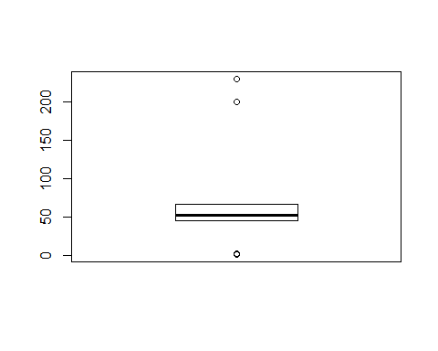

#finds outlier values  
OutlierValues <- boxplot(sales)$out



#print outliers  
OutlierValues

## [1] 1 2 200 230

which(sales %in% OutlierValues)

## [1] 1 2 6 7

#Remove Outliers  
sales[!(sales %in% OutlierValues)]

## [1] 50 45 67 55 56 49

sales <- sales[!(sales %in% OutlierValues)]  
  
boxplot(sales)

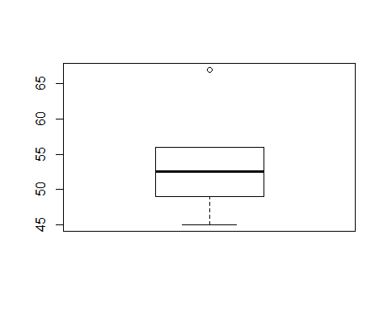

## From article: Removing Outliers - quick and dirty

<https://rpubs.com/Mentors_Ubiqum/removing_outliers>

mtcars$disp[which(mtcars$disp >420)] <- c(mtcars$disp[which(mtcars$disp >420)]*2)  
  
boxplot(mtcars$disp)

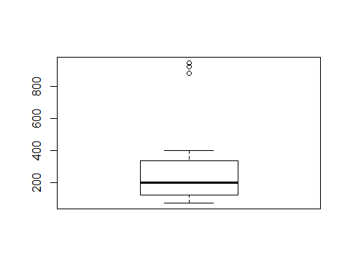

mtcars_outliers <- boxplot(mtcars$disp, plot=FALSE)$out  
  
mtcars[which(mtcars$disp %in% mtcars_outliers),]

## mpg cyl disp hp drat wt qsec vs am gear carb  
## Cadillac Fleetwood 10.4 8 944 205 2.93 5.250 17.98 0 0 3 4  
## Lincoln Continental 10.4 8 920 215 3.00 5.424 17.82 0 0 3 4  
## Chrysler Imperial 14.7 8 880 230 3.23 5.345 17.42 0 0 3 4

mtcars <- mtcars[-which(mtcars$disp %in% mtcars_outliers),]  
boxplot(mtcars$disp)

