# Introduction to tidyverse

First, we need to do is load the tidyverse package

library(tidyverse)

## Registered S3 method overwritten by 'rvest':  
## method from  
## read_xml.response xml2

## -- Attaching packages ------------------------------------------------------------- tidyverse 1.2.1 --

## v ggplot2 3.2.1 v purrr 0.3.2   
## v tibble 2.1.1 v dplyr 0.8.0.1  
## v tidyr 0.8.3 v stringr 1.4.0   
## v readr 1.3.1 v forcats 0.4.0

## Warning: package 'ggplot2' was built under R version 3.6.2

## -- Conflicts ---------------------------------------------------------------- tidyverse_conflicts() --  
## x dplyr::filter() masks stats::filter()  
## x dplyr::lag() masks stats::lag()

head(mpg)

## # A tibble: 6 x 11  
## manufacturer model displ year cyl trans drv cty hwy fl class  
## <chr> <chr> <dbl> <int> <int> <chr> <chr> <int> <int> <chr> <chr>  
## 1 audi a4 1.8 1999 4 auto(~ f 18 29 p comp~  
## 2 audi a4 1.8 1999 4 manua~ f 21 29 p comp~  
## 3 audi a4 2 2008 4 manua~ f 20 31 p comp~  
## 4 audi a4 2 2008 4 auto(~ f 21 30 p comp~  
## 5 audi a4 2.8 1999 6 auto(~ f 16 26 p comp~  
## 6 audi a4 2.8 1999 6 manua~ f 18 26 p comp~

For ggplot, we are going to use mpg to create a simple scatterplot of displacement by hwy. There are actually multiple ways to write this code. The first example below is how the book presents the code (notice the placement of the “+” sign):

ggplot(data=mpg, aes(x=displ,y=hwy)) +  
 geom_point()

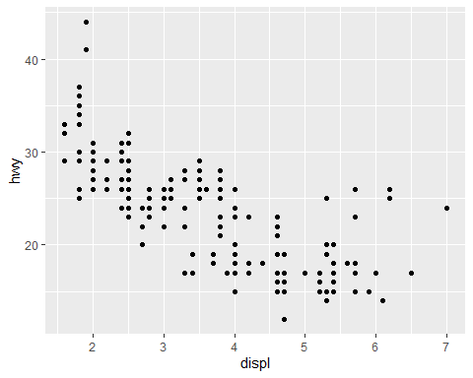

ggplot(mpg) +  
 geom_point(aes(displ,hwy))



ggplot(data=mpg, aes(x=displ,y=hwy,color=class)) +  
 geom_point()

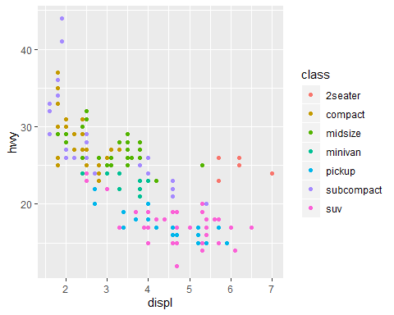

ggplot(data=mpg, aes(x=displ, y=hwy, color=manufacturer)) +  
 geom_point()

