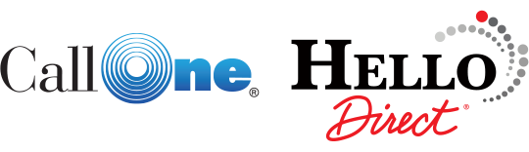
VNOC OPERATIONS
Architecture, Workflow, and Tooling Proposal

PREPARED FOR
Call One, Inc. AV Division Leadership
PREPARED BY
Alex Zawadzki
DATE
May 2026

Executive Summary
Call One supports a growing fleet of unified communications and AV endpoints across customer sites nationwide. As the AV Division scales beyond installation into long-term managed services, the operational model needs a Video Network Operations Center, or VNOC, that can monitor, triage, and resolve issues without forcing technicians to swivel between half a dozen vendor consoles.
This proposal outlines a VNOC built around a single principle: every alert, ticket, and remote control action lives in one custom dashboard. Manufacturer platforms feed in by API. ServiceNow handles the ticket lifecycle. Utelogy handles cross-vendor AV control. Call One technicians work from one screen, with one workflow, and one source of truth.

Why this matters
- Customers expect proactive support. They are paying for outcomes, not reactive break-fix calls.
- Vendor dashboards are siloed. Poly Lens, Yealink YMCS, Neat Pulse, Logitech Sync, and Cisco Control Hub each tell part of the story. None of them tell the whole story.
- Mean time to resolution is the metric customers grade us on. Tab-switching adds minutes to every incident. Across thousands of incidents per year, that is real money.
- The VNOC is also a sales asset. Demonstrating a live, branded operations dashboard during enterprise pursuits closes deals the demo room cannot.

What this document covers
- Architecture for the Call One VNOC, including how manufacturer platforms, ServiceNow, and Utelogy integrate.
- A visual mockup of the unified dashboard showing the layout, panels, and data each role needs at a glance.
- The standard service workflow that every VNOC technician will follow when an alert arrives.
- Tooling reference and onboarding checklist for the operations team.
- A phased implementation roadmap with rough milestones.

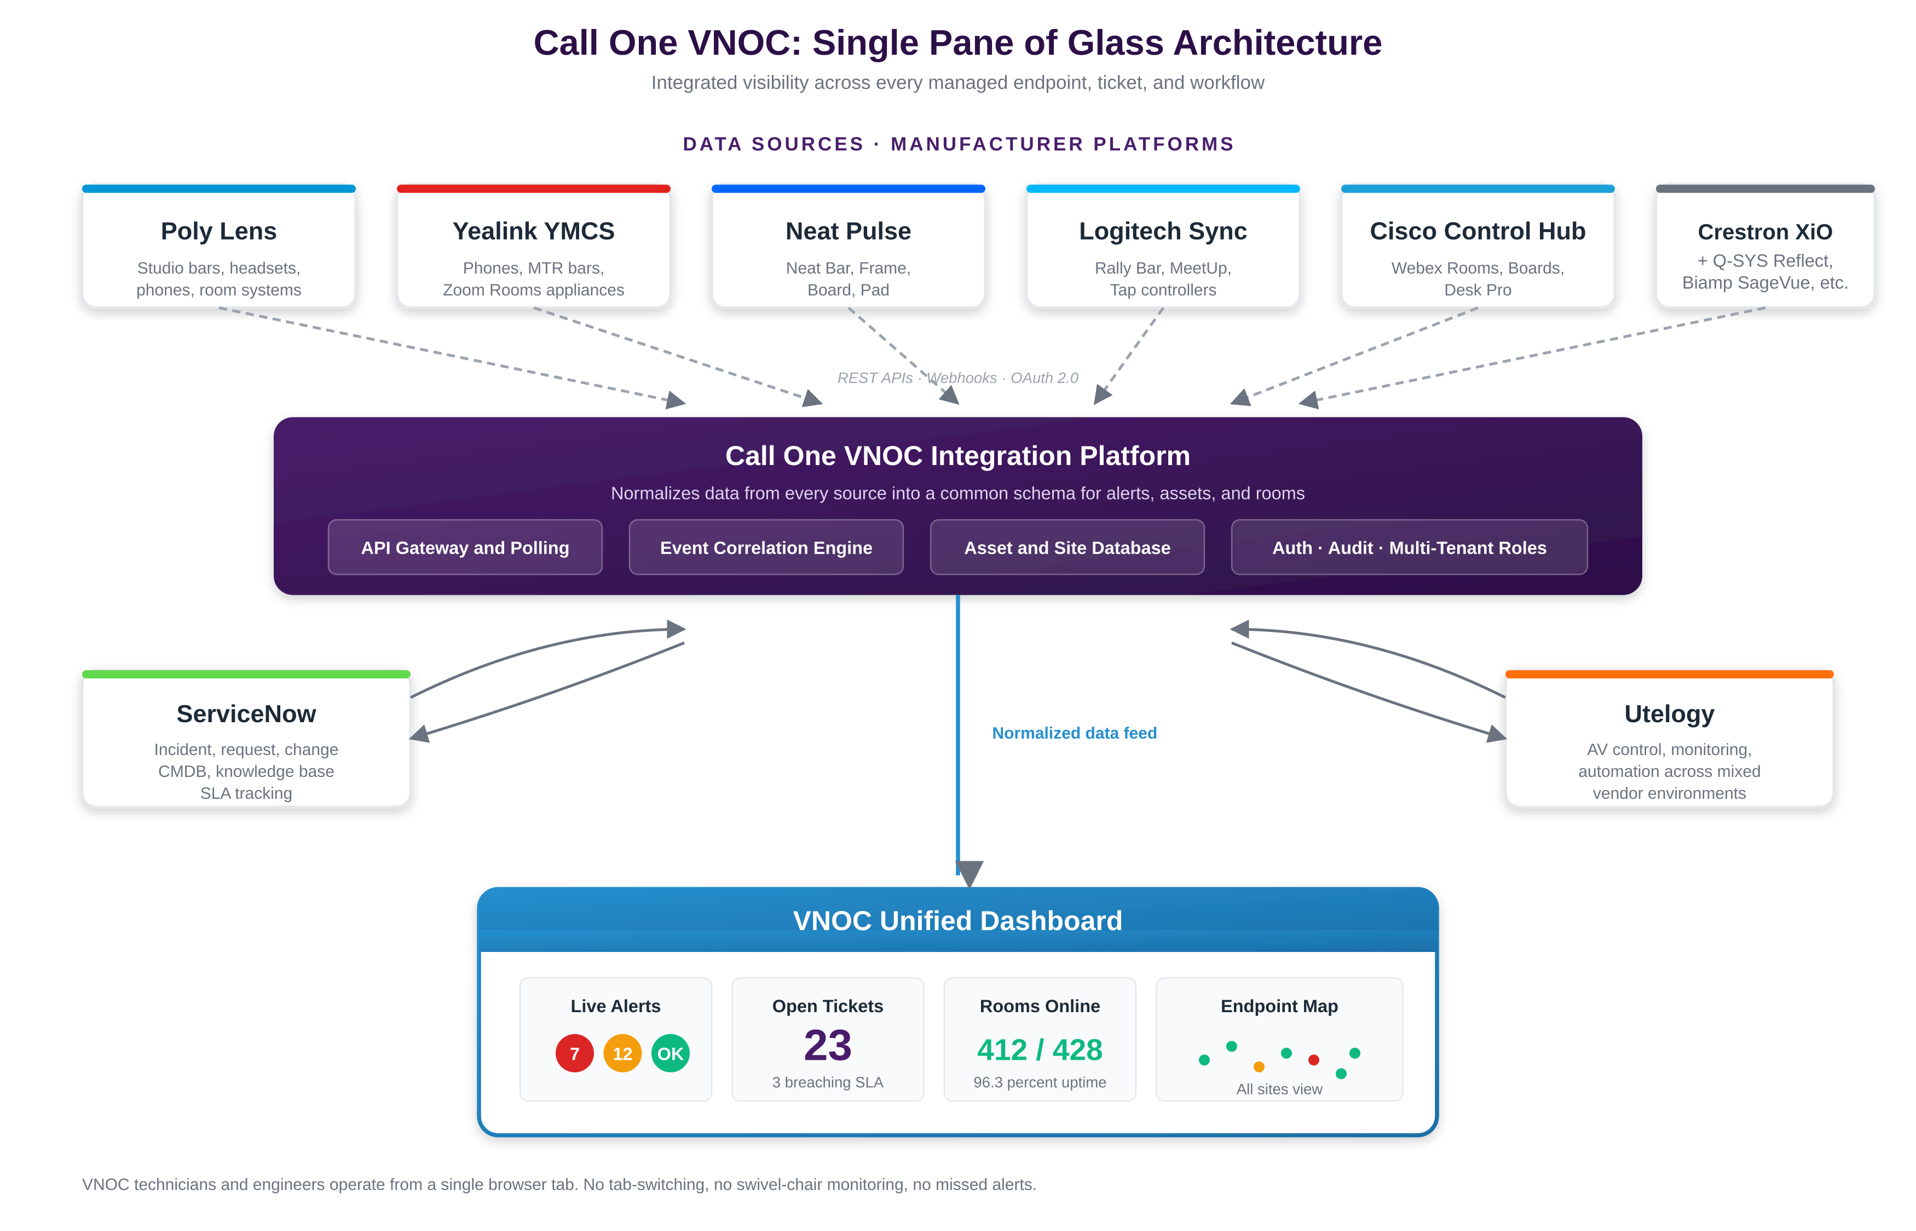
Figure 1. Single-pane-of-glass architecture for the Call One VNOC.

VNOC Architecture
The architecture is intentionally simple at the edges and unified at the core. Every manufacturer platform exposes its data through documented APIs. Call One does not need to replace any of them. Instead, the VNOC integration platform pulls from each, normalizes the data, and pushes it into one operational view.
See Figure 1 for the full single-pane-of-glass architecture, including data sources, the integration platform, and how ServiceNow and Utelogy integrate.

Three layers, one experience

Layer 1: Data sources
Manufacturer cloud platforms remain the source of truth for their own devices. The VNOC reads from them, never replaces them. Initial integration scope:
- Poly Lens for HP Poly endpoints including Studio bars, headsets, and phones.
- Yealink Management Cloud Service (YMCS) for Yealink phones, MTR appliances, and Zoom Rooms hardware.
- Neat Pulse for Neat Bar, Frame, Board, and Pad.
- Logitech Sync for Rally Bar, MeetUp, Tap, and CollabOS appliances.
- Cisco Control Hub for Webex Rooms, Boards, and Desk Pro.
- Crestron XiO Cloud, Q-SYS Reflect, and Biamp SageVue as second-wave additions.

Layer 2: Integration platform
This is the engine that makes the dashboard possible. It performs four jobs:
- Ingestion: API gateway that receives webhooks and polls platforms that do not push events.
- Correlation: groups duplicate alerts, suppresses flapping, and links related events into a single incident.
- Asset and site database: the customer, site, room, and device hierarchy that ties every alert and ticket to a real-world location.
- Authentication, audit, and tenancy: role-based access so technicians only see customers they support, and every action is logged.

Layer 3: Operations layer
ServiceNow handles ticket lifecycle, SLAs, knowledge management, and the Configuration Management Database (CMDB). Utelogy handles real-time AV control and remote remediation across mixed-vendor rooms. Both are bidirectionally integrated with the VNOC dashboard so technicians never leave the unified view.

Why this architecture wins
- No rip and replace. Every manufacturer platform stays. The VNOC layers on top.
- Vendor-agnostic. New platforms (whatever the next big AV cloud turns out to be) plug in by API, not by replacing the dashboard.
- Defensible. Customers can see the integration story in a single page. Competitors selling raw Poly Lens or vanilla ServiceNow cannot match it.

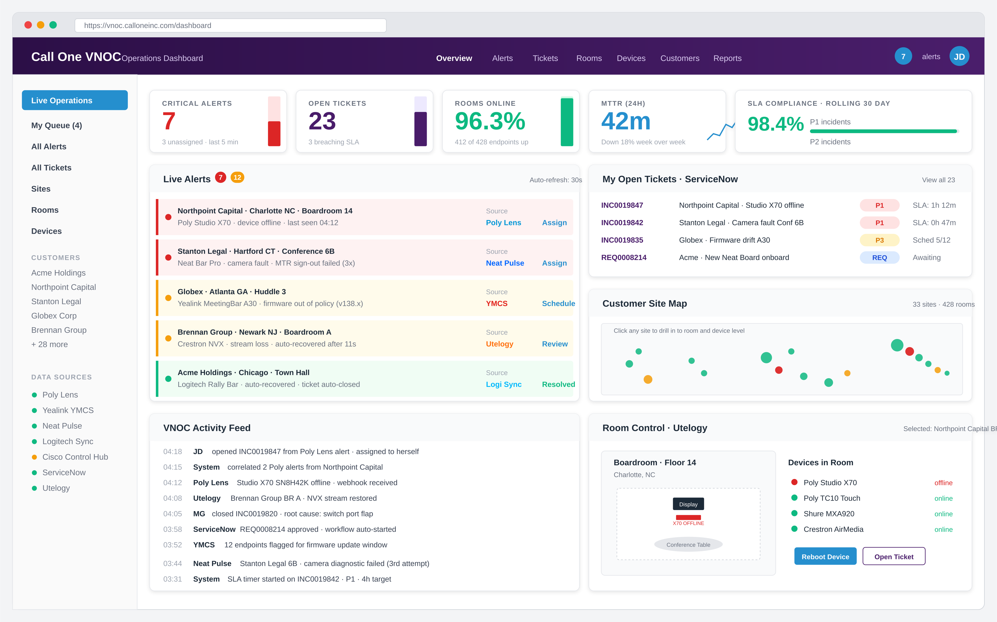
Figure 2. VNOC unified dashboard mockup. All data flows in from the integration layer.

The Single Pane of Glass
The dashboard is the product. Everything else is plumbing. The mockup shows the operational view a VNOC technician sees the moment they sign in.
See Figure 2 for the full VNOC unified dashboard mockup, including the KPI strip, live alerts, ticket queue, site map, activity feed, and Utelogy room control panel.

Panel-by-panel walkthrough

KPI strip (top)
Five tiles give the room-temperature read on the operation: critical alerts, open tickets, percentage of rooms online, mean time to resolution over the last 24 hours, and rolling 30-day SLA compliance. These are the numbers leadership wants to see at any moment, and the only ones a tech needs to glance at to know whether the day is calm or on fire.

Live alerts feed
Every active alert from every integrated platform, ranked by severity. Each row shows the customer, site, room, device, and source platform. The colored left border encodes severity (red P1, amber P2, green resolved or auto-recovered). One click takes the technician straight into the alert detail and ticket creation flow.

My open tickets
ServiceNow tickets assigned to the signed-in technician, with priority badge and SLA countdown. P1 incidents that are at risk surface in red so they cannot be missed. Clicking a row opens the ServiceNow ticket inside the dashboard frame, no separate tab required.

Customer site map
Geographic view of every managed site with a health dot. Useful for at-a-glance regional pattern recognition (a sudden cluster of red dots in one metro almost always signals a carrier or platform-side issue, not customer hardware).

Activity feed
Chronological log of everything the VNOC and the integrated systems are doing: alerts received, tickets opened, technicians taking action, automation triggering, SLAs starting or stopping. This is the audit trail for every action the VNOC takes.

Room control panel
Powered by Utelogy. When a tech selects a room, they get the as-built layout, every device in that room with live status, and one-click remote actions (reboot, restart stream, push config). This is where the dashboard moves from monitoring to action.

Roles and views
The dashboard is role-aware. Three primary personas:
Role | Default landing view | Primary metrics
Tier 1 Technician | My Queue (assigned tickets) plus All Alerts feed | Tickets in queue, SLA countdowns, alert acknowledgment time
Tier 2 Engineer | All Tickets, escalations, customer-specific drill-downs | MTTR, root cause categories, customer health trends
VNOC Manager | Executive overview with KPI strip and rolling SLA report | Compliance, technician utilization, customer-by-customer health scoring

Platform Integrations
Each integrated platform contributes a slice of the operational picture. The table below summarizes the API capability, what data the VNOC pulls, and what actions the dashboard can push back to the platform.
Platform | Data ingested | Actions available from VNOC | API method
Poly Lens | Device health, firmware, call quality, peripheral status, room state | Reboot, firmware push, config update, factory reset | REST + webhooks
Yealink YMCS | Device inventory, firmware version, registration state, alarms | Reboot, firmware push, template apply, line config | REST
Neat Pulse | Endpoint status, AV peripheral health, room occupancy, sign-in events | Reboot, firmware management, room reset | REST + webhooks
Logitech Sync | Device telemetry, room insights, peripheral connectivity | Reboot, firmware push, RoomMate / CollabOS config | REST + webhooks
Cisco Control Hub | Endpoint health, call quality, registration, RoomOS telemetry | Reboot, RoomOS push, deployment template apply | REST + xAPI
ServiceNow | Ticket lifecycle, SLA timers, CMDB records, knowledge articles | Create, update, assign, close incidents and requests | Table API + Flow Designer
Utelogy | Real-time AV system state, signal flow, control system telemetry | Source switching, mute, recall presets, reboot AV systems | REST

Why ServiceNow and Utelogy together
These two platforms answer different questions, and the VNOC needs both. ServiceNow answers "what work is open and who owns it." Utelogy answers "what is the AV system actually doing right now and how do I fix it." Without both, technicians end up with either tickets they cannot act on or actions they cannot track. With both, every alert becomes a tracked, resolvable, auditable piece of work.

Build versus buy
The integration platform is the only custom build. Every other component (manufacturer platforms, ServiceNow, Utelogy) is licensed off the shelf. The custom dashboard is what turns Call One's VNOC into a Call One product, not a generic reseller offering.

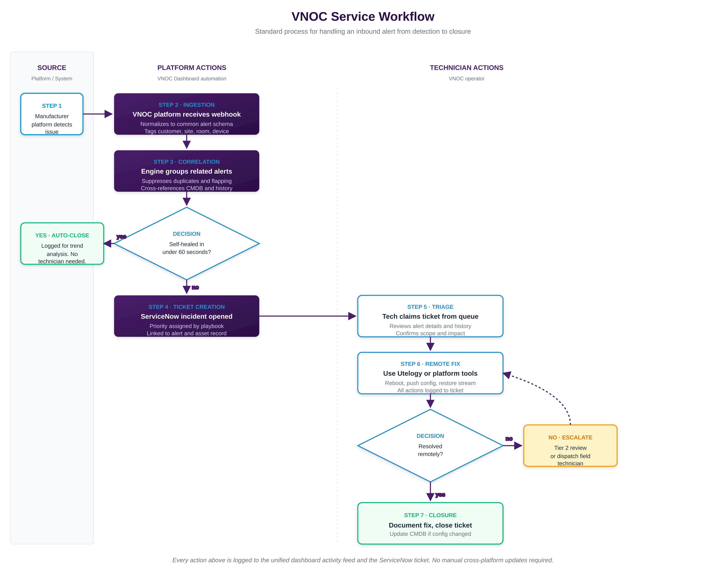
Figure 3. End-to-end VNOC service workflow.

Service Workflow
Every alert that enters the VNOC follows the same path. The workflow below is the canonical process every technician learns on day one.
See Figure 3 for the end-to-end VNOC service workflow, broken into platform automation and technician actions.

Step-by-step

Step 1. Detection
A manufacturer platform detects an issue. This could be a Poly Studio X70 going offline, a Neat Bar reporting a camera fault, or a Yealink endpoint failing to register. Detection happens at the platform layer, exactly where it should.

Step 2. Ingestion
The VNOC integration platform receives a webhook (or, for platforms without push, polls the API on a tight interval). The raw alert is normalized into a common schema with consistent fields: customer, site, room, device, severity, source, timestamp, and raw payload. This normalization is what makes the rest of the workflow possible.

Step 3. Correlation
The correlation engine asks three questions. Is this a duplicate of an alert we already have open? Is this a flapping device that resolved within seconds and needs to be suppressed? Is this part of a larger pattern (multiple devices in one room, or one site, all going down at once)? The answers determine whether to suppress, group, or surface the alert.

Decision: did the system self-heal?
If the device recovers within 60 seconds and the issue does not recur within the suppression window, the alert is auto-closed and logged for trend analysis. No technician time is consumed. If the issue persists, the workflow continues.

Step 4. Ticket creation
A ServiceNow incident is opened automatically. Priority is assigned by playbook (P1 for production-impacting issues during business hours at executive sites, P3 for non-impacting firmware drift, etc.). The ticket is linked to the alert, the asset record, and the customer. SLA timers start at this moment.

Step 5. Triage
A Tier 1 technician claims the ticket from their queue. They review the alert detail, the device history, and any related alerts the correlation engine has grouped. They confirm scope and impact, set the customer expectation in the ticket, and decide on the remediation path.

Step 6. Remote remediation
The technician acts from inside the dashboard. Most issues resolve here: a device reboot, a firmware push, a config restore, a Utelogy preset recall. Every action is logged automatically to the ServiceNow ticket. There is no manual ticket update step.

Decision: did the remote fix resolve it?
If yes, the workflow proceeds to closure. If no, the technician escalates: Tier 2 review for engineering-level issues, or field dispatch for hardware that needs hands-on attention. Escalations follow a documented playbook so the customer experience is consistent regardless of who is on shift.

Step 7. Closure
The technician documents the root cause and resolution in the ticket. If a configuration changed, the CMDB is updated. The ticket closes. The activity is captured in the customer health record for trend analysis. The workflow ends.

Workflow guardrails
- Every step is logged. There is no manual cross-platform updating. The technician works in one tool and the system handles the rest.
- SLA timers are visible at every stage. Tickets approaching breach surface to the manager view automatically.
- Escalation criteria are documented and enforced by the platform. A Tier 1 technician cannot accidentally sit on a P1 issue past the threshold.
- Customers see consistent ticket cadence regardless of which technician handles the work.

Tooling Reference and Onboarding
VNOC technicians need a short, repeatable mental model of which tool does what. The following reference is the basis for new-hire training and day-to-day operational documentation.

Tool-by-tool quick reference
Tool | Use it for | Do not use it for
VNOC Dashboard | Default view. Alerts, tickets, room status, customer health. | Direct device-level configuration changes.
ServiceNow | Authoritative ticket and SLA system. Customer notes. CMDB. | Real-time alert monitoring. (Use the dashboard.)
Utelogy | Cross-vendor AV system control. Signal flow troubleshooting. | Endpoint firmware or cloud account changes.
Manufacturer platforms | Deep device diagnostics, firmware management, account-level config. | Day-to-day monitoring. The VNOC pulls what you need.

New technician onboarding checklist
- Provisioned in ServiceNow with the appropriate role and assigned to the VNOC group.
- Provisioned in the VNOC dashboard with role-based access scoped to assigned customers.
- Read-only access (initially) to each manufacturer platform for shadowing and learning.
- Utelogy operator account with read-write to assigned customer environments.
- Completed walkthrough of the service workflow (Figure 3) with a senior technician.
- Shadowed three live tickets end-to-end before taking the queue solo.
- Reviewed escalation playbook and runbook library.

Implementation Roadmap
Standing up the VNOC is staged across four phases. Each phase delivers a usable capability before the next begins, so Call One starts seeing operational benefit early instead of waiting for a big-bang launch.
Phase | Milestone | Scope | Target
1 | Foundation | ServiceNow VNOC instance configured. Asset and site database stood up. Initial customer onboarding playbook drafted. | Weeks 1 to 6
2 | First integrations | Poly Lens, Yealink YMCS, and ServiceNow live in the dashboard. Live alerts feed and ticket panel functional. | Weeks 6 to 12
3 | Full integration | Neat Pulse, Logitech Sync, Cisco Control Hub, and Utelogy added. Room control panel live. Pilot customer migrated. | Weeks 12 to 20
4 | Production rollout | All managed customers migrated. Tier 1 / Tier 2 staffing trained. Customer-facing reporting portal launched. | Weeks 20 to 32

Decisions that need to land early
- Hosting model. Cloud-hosted (likely Azure given the existing tech stack) versus on-premise. Cloud is recommended.
- ServiceNow instance. Net-new tenant or shared with existing IT operations? Net-new is cleaner for managed services scoping.
- Utelogy licensing model. Per-room versus enterprise. Volume across the customer base will determine which is cheaper.
- VNOC staffing target. The dashboard makes one technician roughly 2 to 3 times more productive than the current siloed approach. Initial hire of one Tier 1 plus one shared Tier 2 covers the first 50 customers comfortably.

Next Steps
This document is the framework, not the final spec. Three near-term actions move it forward:
- Stakeholder review. Walk through this proposal with AV Division leadership and the IT operations team. Capture changes.
- Vendor scoping. Get formal pricing from ServiceNow, Utelogy, and the integration platform build (whether that is internal development or a partner engagement).
- Pilot customer selection. Identify one or two customers willing to be on the leading edge of the new operational model. Their feedback shapes Phase 3.
Once those three pieces are in place, Phase 1 can start within the same quarter.
One dashboard. One workflow. One source of truth. That is the Call One VNOC.
Prepared by
Alex Zawadzki
Call One, Inc.
alexz@calloneonline.com

