# Prerequisites for starting the training JAVA Challenge

1. Trainee completed the course ‘Java Basics’
2. Trainee brings a laptop with the following installed: JDK11, IntelliJ, and the exercises

# Software

Installation Location

Create a java directory on the C drive: C:\Java

JDK 11

This is the Java Development Kit, which is necessary to be able to develop Java applications on your local machine.

The JDK may be downloaded here: <https://www.oracle.com/technetwork/java/javase/downloads/index.html>

Download the Java SE 11.0.x Oracle JDK installer. Choose the windows-x64_bin.zip. Extract the contents of the zip file to C:\Java

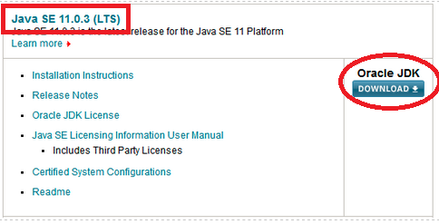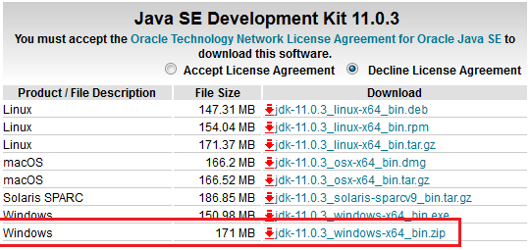

A directory called jdk-11.0.3 (or similar) will appear. Rename this directory to jdk-11

IntelliJ IDEA Community

May be downloaded here: <https://www.jetbrains.com/idea/download/> (Be sure to select the Community edition and just download the .exe file). IntelliJ is one of the most popular development environments for Java applications. It serves the developer all kinds of features to make a developer’s life easier.

The Community edition is free of charge and serves more than enough features to follow this course.

Some screenshots with notable settings during installation are mentioned below. If no screenshot is provided, just continue with the default and/or ‘most logical’ settings.

Select the options as specified and continue:

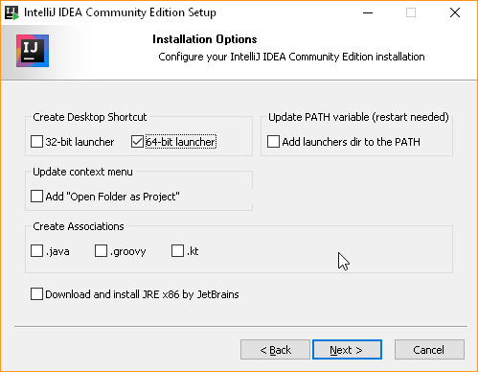

After the installation finishes, check “Run IntelliJ IDEA Community Edition” and click “Finish”:

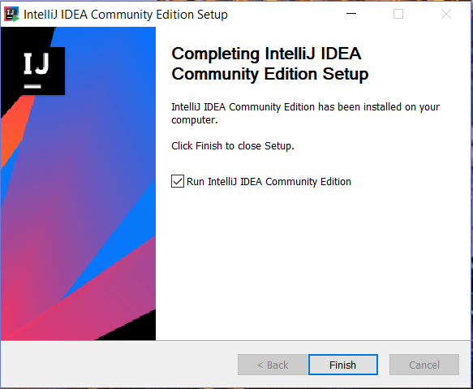

Use the default IntelliJ settings:

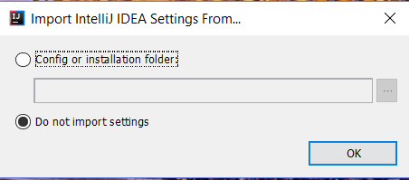

Select the UI theme of your liking and click “Skip Remaining and Set Defaults” on the bottom left: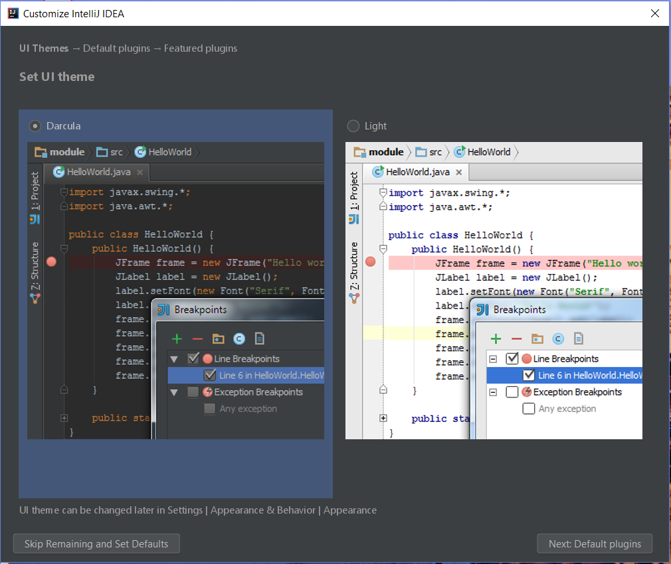

After this screen, just keep IntelliJ open and continue with the following paragraph.

Practice project

Several practice projects have been created for this training. The project needed for the first day will have been send to you via e-mail.

Extract the contents of the zip file to C:\Java, a directory called exercise_day1 will appear.

At the welcome screen of IntelliJ, select “Open”: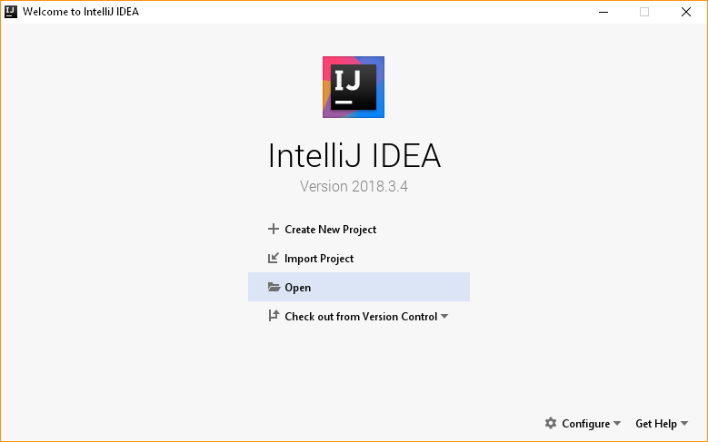

In the dialog that appears, select C:\Java\exercise_day1 and continue. IntelliJ will now open the practice project and there’s just one step left before you’re ready to start with the training.

Go to *File > Project Structure*. In the window that appears, go to *Project Settings > Project*, and click *New > JDK* under *Project SDK*:

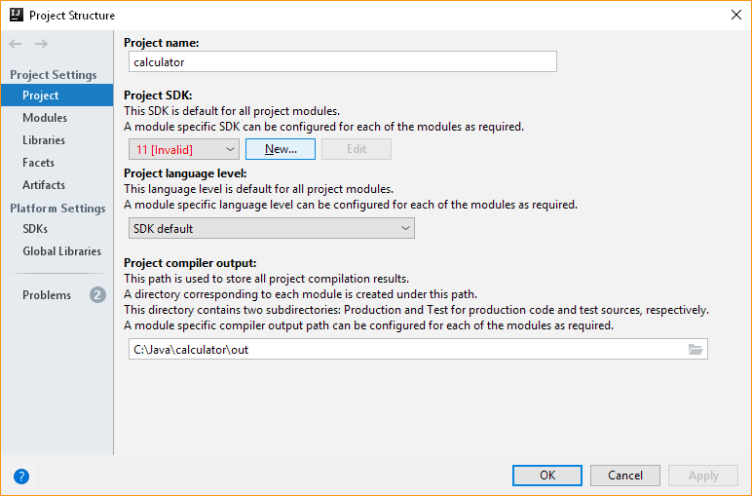

In the dialog that appears, select C:\Java\jdk-11 and continue. Click OK to finalize the changes. IntelliJ will now configure the project to work with JDK 11.

Running the practice project

To test if everything was installed correctly run the hello world application.

Find the main class of exercise 0 and open it.

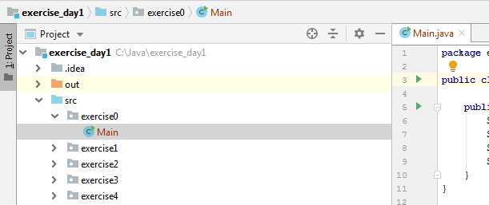

Click on a green triangle and choose the option “Run ‘Main.main()’”

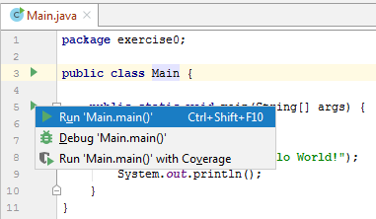

The result should be as followed:

