Meresa Gebrewahd

Lab 4 Parts A&B sequence diagram

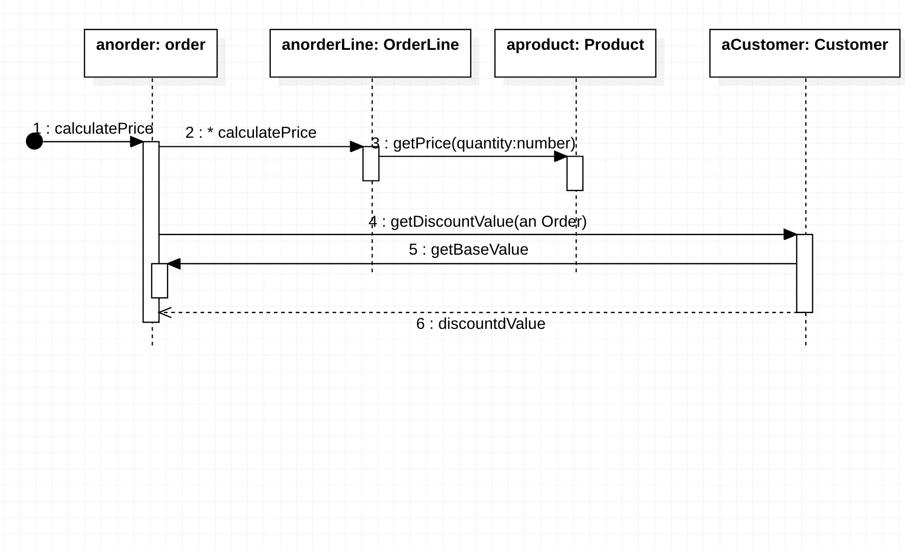

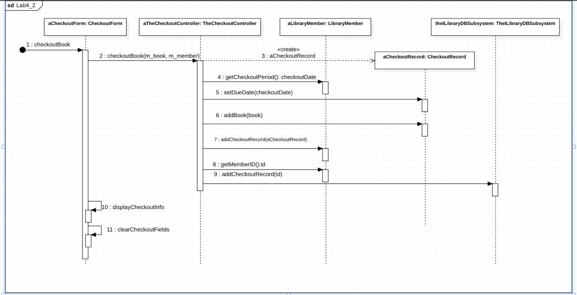

Lab 4 Parts C sequence diagram

