**Quiz:**

A PL/SQL block must consist of the following three sections:

• A Declarative section, which begins with the keyword

DECLARE and ends when the executable section starts.

• An Executable section, which begins with the keyword

BEGIN and ends with END.

• An Exception handling section, which begins with the

keyword EXCEPTION and is nested within the executable section.

**Answer: False**

**Practice 1.**

In this practice, you navigate to the SQL Developer home page and browse helpful information on the tool.

1.1) Access the SQL Developer home page.

1. a) Access the online SQL Developer Home Page, which is available at:

2. <http://www.oracle.com/technology/products/database/sql_developer/index.html>

3. b) Bookmark the page for easier access in future.

**Practice 2.**

1.1) Start SQL Developer.

2.2) Create a database connection by using the following information (Hint: Select the Save Password check box):

a) Connection Name: MyConnection

b) Username: hr

c) Password: hr

d) Hostname: localhost

e) Port: 1521

f) SID: orcl

3) Test the new connection. If the Status is Success, connect to the database using this

new connection.

a) In the Database Connection window, click the Test button.

Note: The connection status appears in the lower-left corner of the window.

b) If the status is Success, click the Connect button.

4) Browse the structure of the EMPLOYEES table and display its data.

a) Expand the MyConnection connection by clicking the plus symbol next to it.

b) Expand the Tables icon by clicking the plus symbol next to it.

c) Display the structure of the EMPLOYEES ̃ table.

5) Use the EMPLOYEES tab to view data in the EMPLOYEES table.

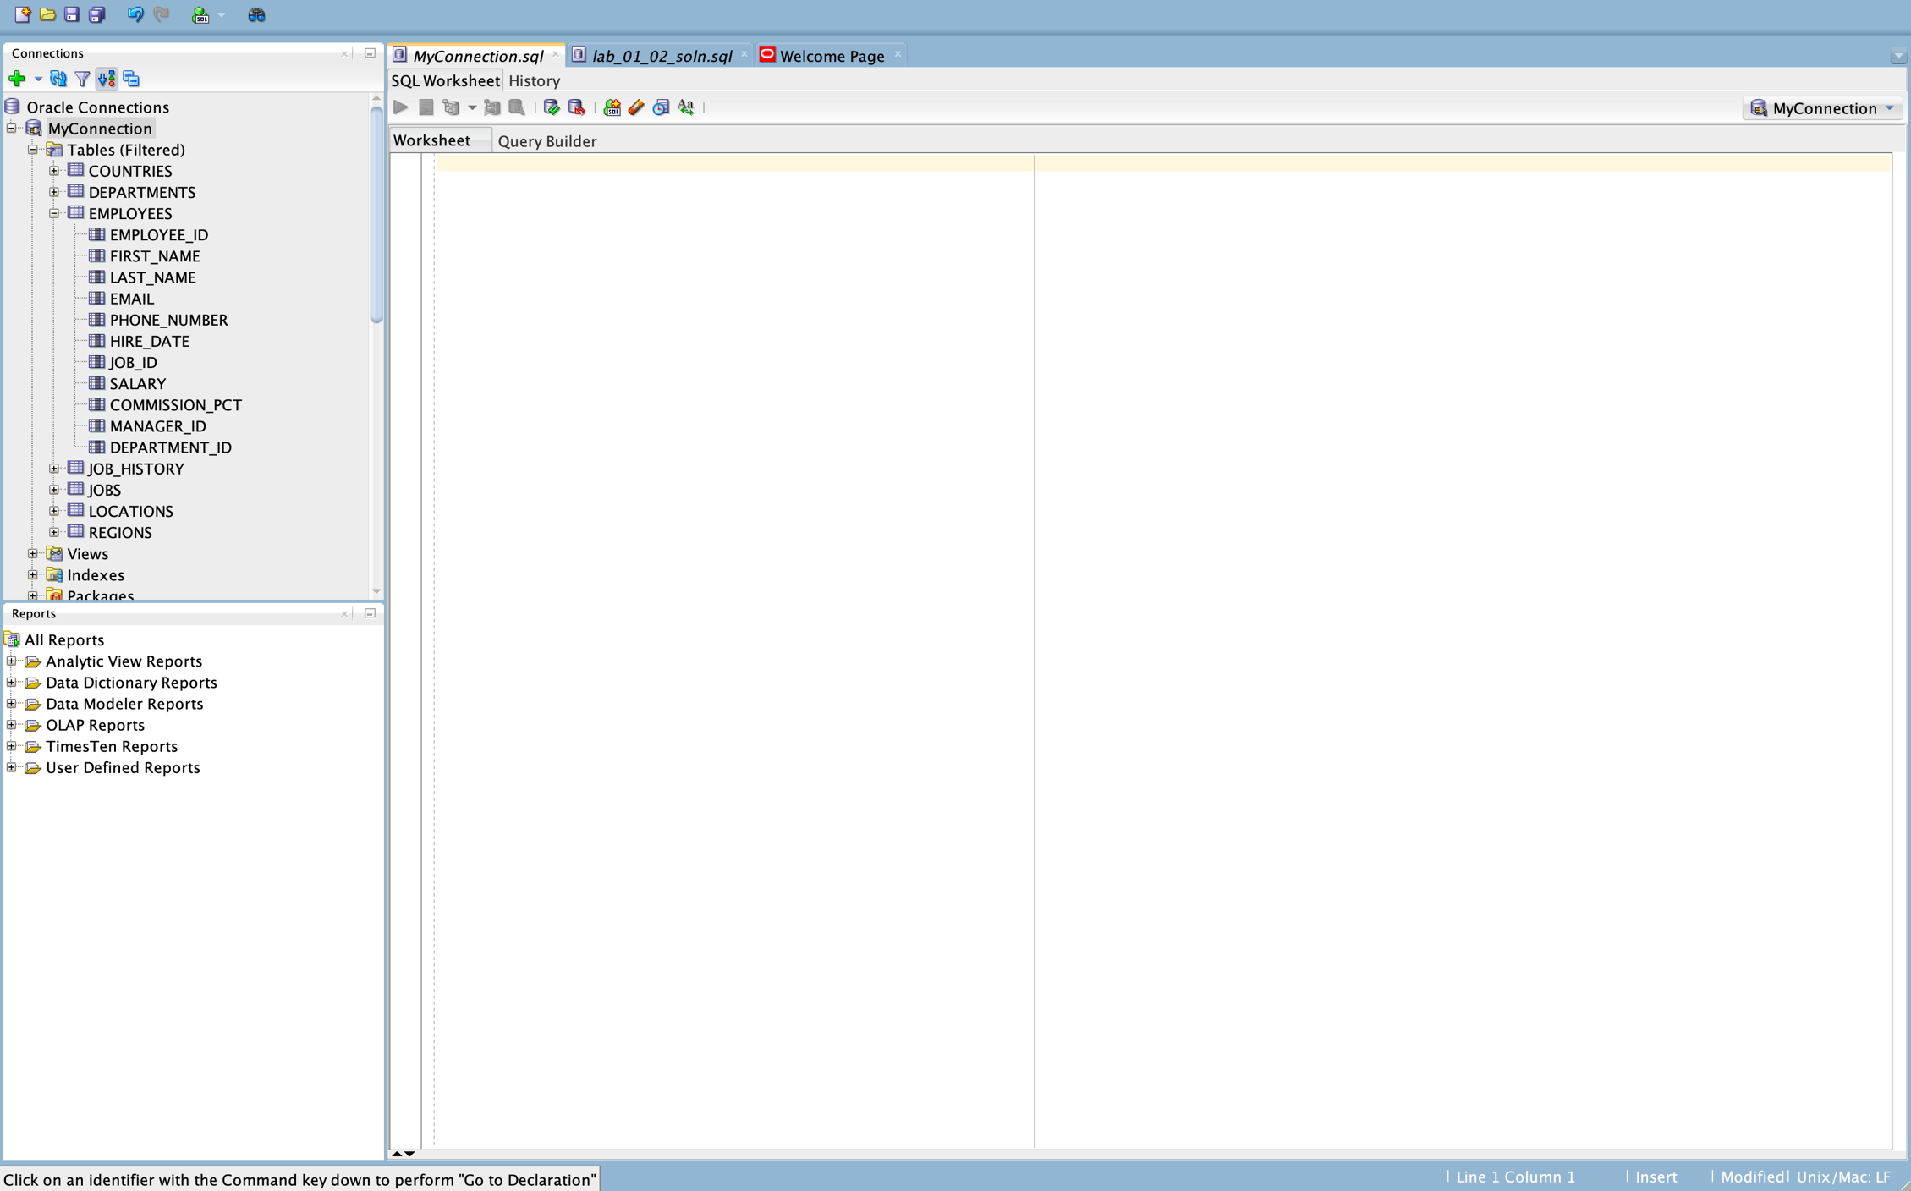

6) Use the SQL Worksheet to select the last names and salaries of all employees whose annual salary is greater than $10,000. Use both the Execute Statement (F9) and the Run Script (F5) icons to execute the SELECT statement. Review the results of both methods of executing the SELECT statements on the appropriate tabs.

Note: Take a few minutes to familiarize yourself with the data, or consult Appendix B, which provides the description and data for all the tables in the HR schema that you will use in this course.

**SELECT last_name, salary FROM employees**

**WHERE salary > 10000;**

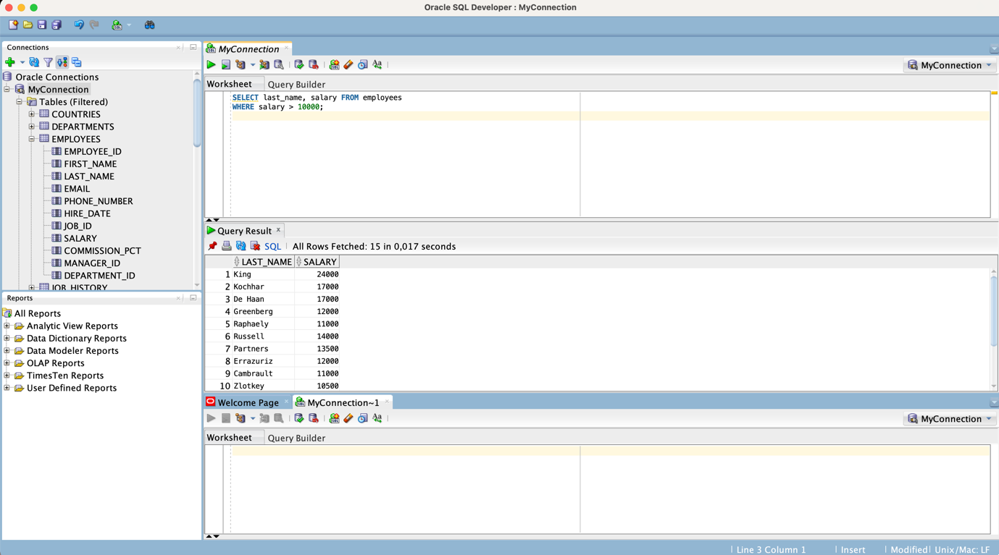

*Figure 1. Output of execute statement*

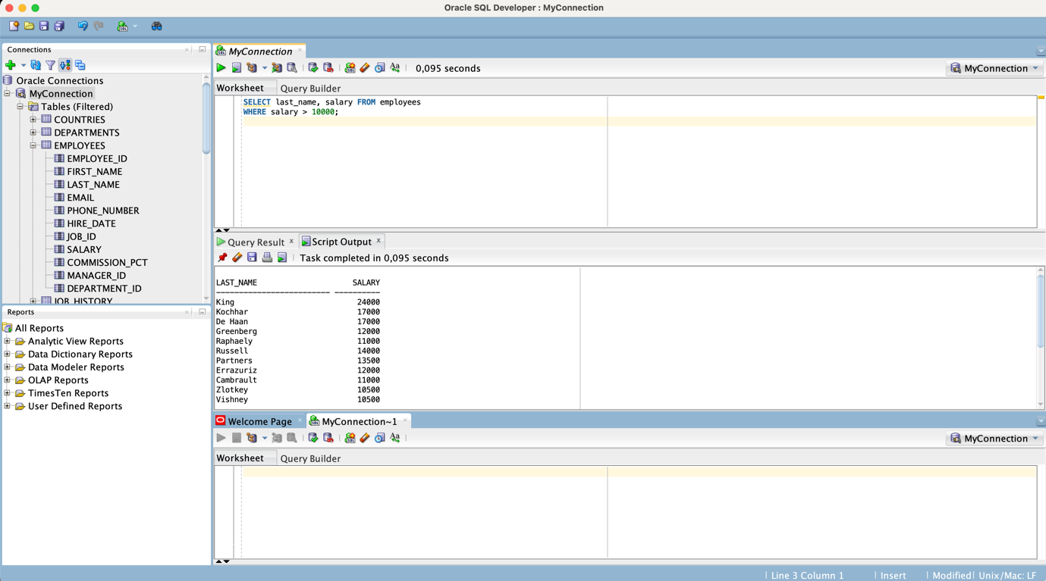

*Figure 2. Output of the script*

7) From the SQL Developer menu, select Tools > Preferences. The Preferences window appears.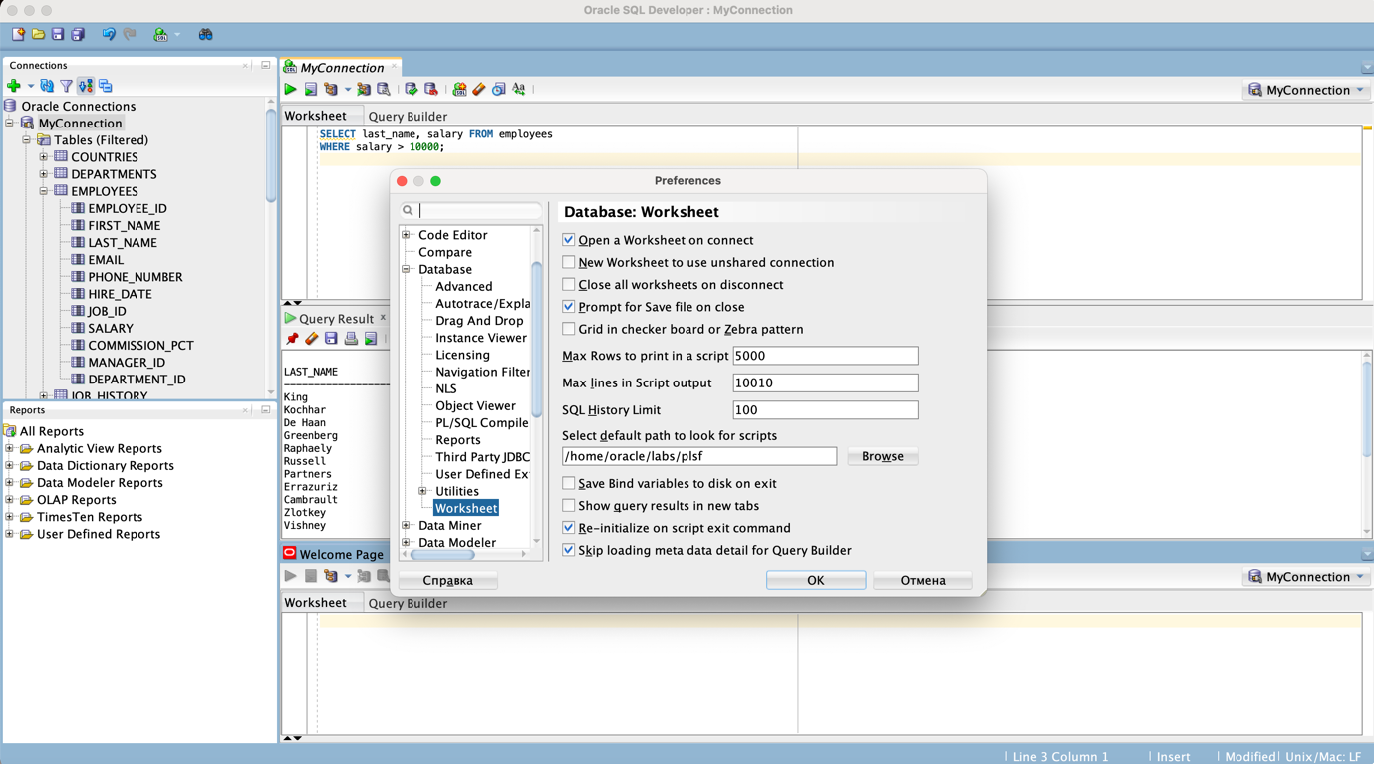

8) Select Database > Worksheet Parameters. In the ”Select default path to look for scripts” text box, use the Browse button to select the /home/oracle/labs/plsf folder. This folder contains the code example scripts, lab scripts, and practice solution scripts that are used in this course. Then, in the Preferences window, click OK to save the Worksheet Parameter setting.

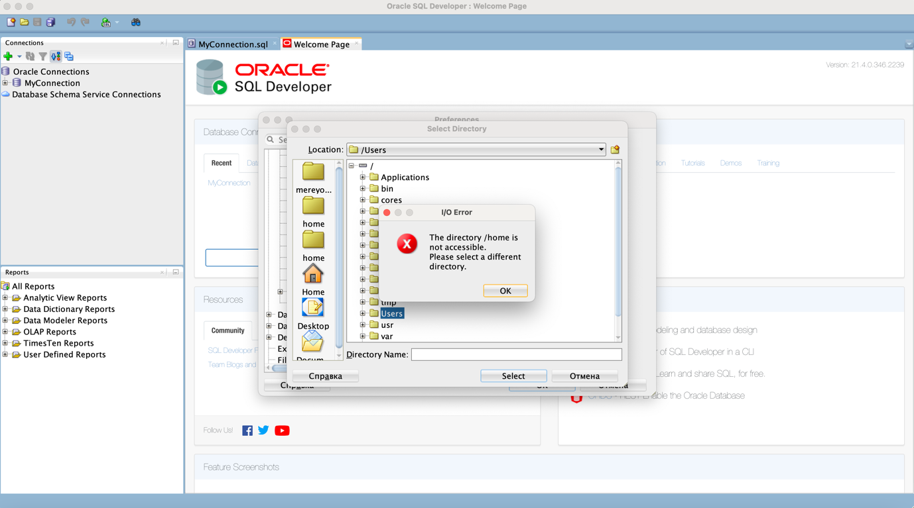

**Practice 3.**

1) Which of the following PL/SQL block execute successfully?

**Answer: none of them**

2) Create and execute a simple anonymous block that outputs "Hello World". Execute and save this script as lab_01_02_soln.sql

**SET SERVEROUTPUT ON**

**BEGIN**

**DBMS_OUTPUT.PUT_LINE('Hello World');**

**END;**

