**Quiz**

The %TYPE attribute:

1. Is used to declare a variable according to a database column definition

2. Is used to declare a variable according to a collection of columns in a database table or view

3. Is used to declare a variable according to the definition of another declared variable

4. Is prefixed with the database table and column name or the name of the declared variable

**Answer: 1, 3, 4**

**Practice 2: Declaring PL/SQL Variables**

In this practice, you declare PL/SQL variables.

1)  Identify valid and invalid identifiers:

a) today – Valid

b) last_name – Valid

c) today’s_date – Invalid, character «’» cannot be used

d) Number_of_days_in_February_this_year – Invalid, very long identifier

e) Isleap$year – Valid

f) #number – Invalid, cannot start with character

g) NUMBER# – Valid

h) number1to7 – Valid

2)  Identify valid and invalid variable declaration and initialization:

a) number_of_copies PLS_INTEGER; – Valid

b) PRINTER_NAME constant VARCHAR2 (10); – Invalid, constant identifier must be initialized during declaration

c) deliver_to VARCHAR2 (10):= Johnson; – Invalid, string literal must be quoted

d) By_when DATE:=CURRENT_DATE+1; – Valid

3) Examine the following anonymous block, and then select a statement from the following that is true.

a)  The block executes successfully and prints “fernandez.”

b)  The block produces an error because the fname variable is used without initializing.

c)  The block executes successfully and prints “null fernandez.”

d)  The block produces an error because you cannot use the DEFAULT keyword to initialize a variable of type VARCHAR2.

e)  The block produces an error because the v_fname variable is not declared.

**Answer: A**

**Practice 2: Declaring PL/SQL Variables (continued)**

4)  Modify an existing anonymous block and save it as a new script.

a)  Open the lab_01_02_soln.sql script, which you created in Practice 1.

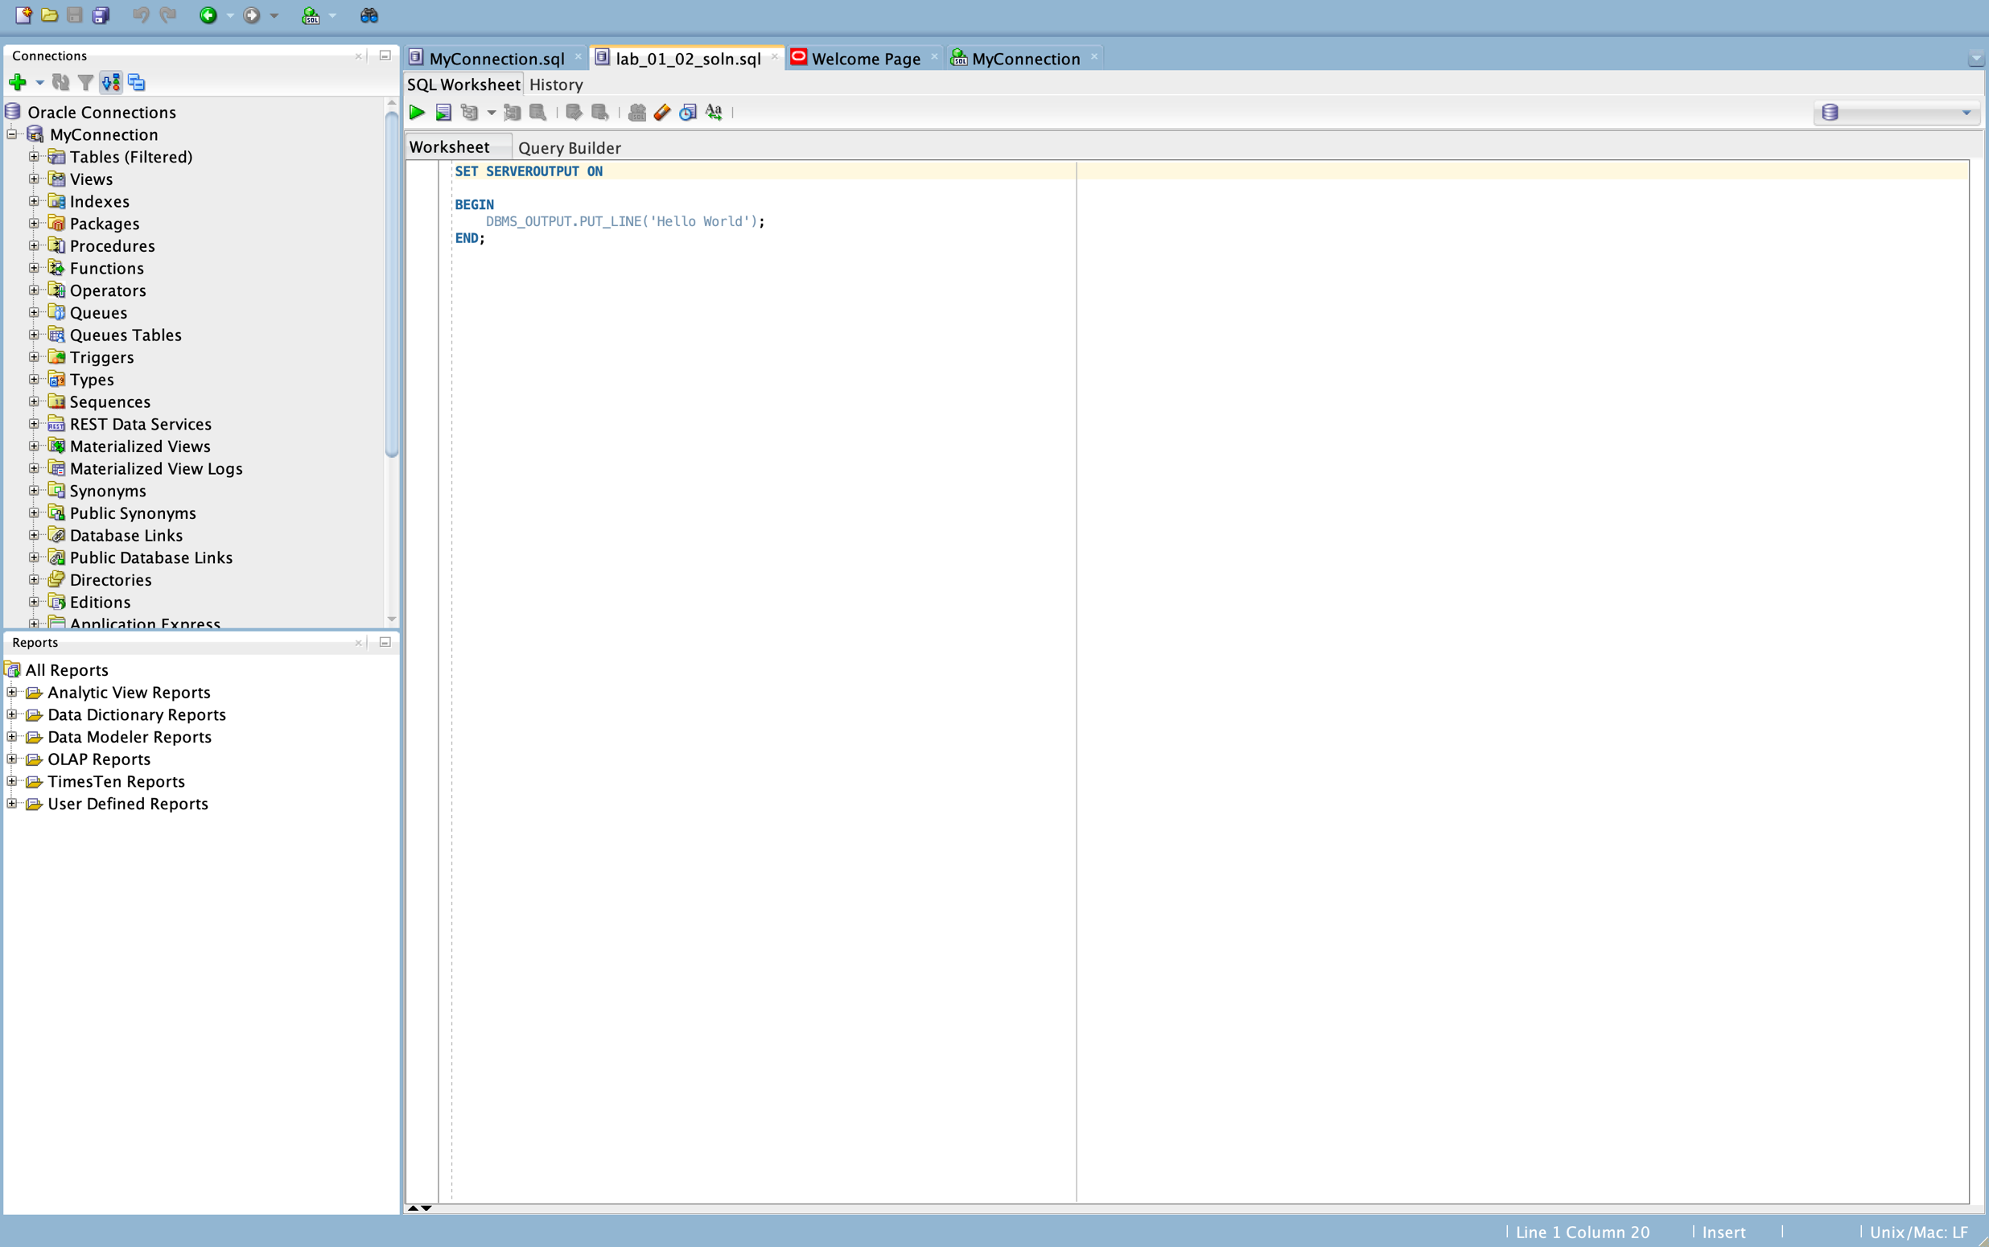

**Picture 1. Open lab_01_02_soln.ql**

b)  In this PL/SQL block, declare the following variables:

1. v_today of type DATE. Initialize today with SYSDATE.

2. v_tomorrow of type today. Use the %TYPE attribute to declare this

variable.

**SET SERVEROUTPUT ON  
  
DECLARE   
 v_today DATE := SYSDATE;  
 v_tomorrow v_today%TYPE;  
BEGIN  
 DBMS_OUTPUT.PUT_LINE('Hello World');  
END;**

c) In the executable section:

1. Initialize the v_tomorrow variable with an expression, which calculates tomorrow’s date (add one to the value in today)

2. Print the value of v_today and tomorrow after printing “Hello World”

**SET SERVEROUTPUT ON  
  
DECLARE  
 v_today DATE := SYSDATE;  
 v_tomorrow v_today%TYPE;  
BEGIN  
 v_tomorrow := v_today + 1;  
 DBMS_OUTPUT.PUT_LINE('Hello World');  
 DBMS_OUTPUT.PUT_LINE('Today''s date: ' || v_today);  
 DBMS_OUTPUT.PUT_LINE('Tomorrow''s date: ' || v_tomorrow);  
END;**

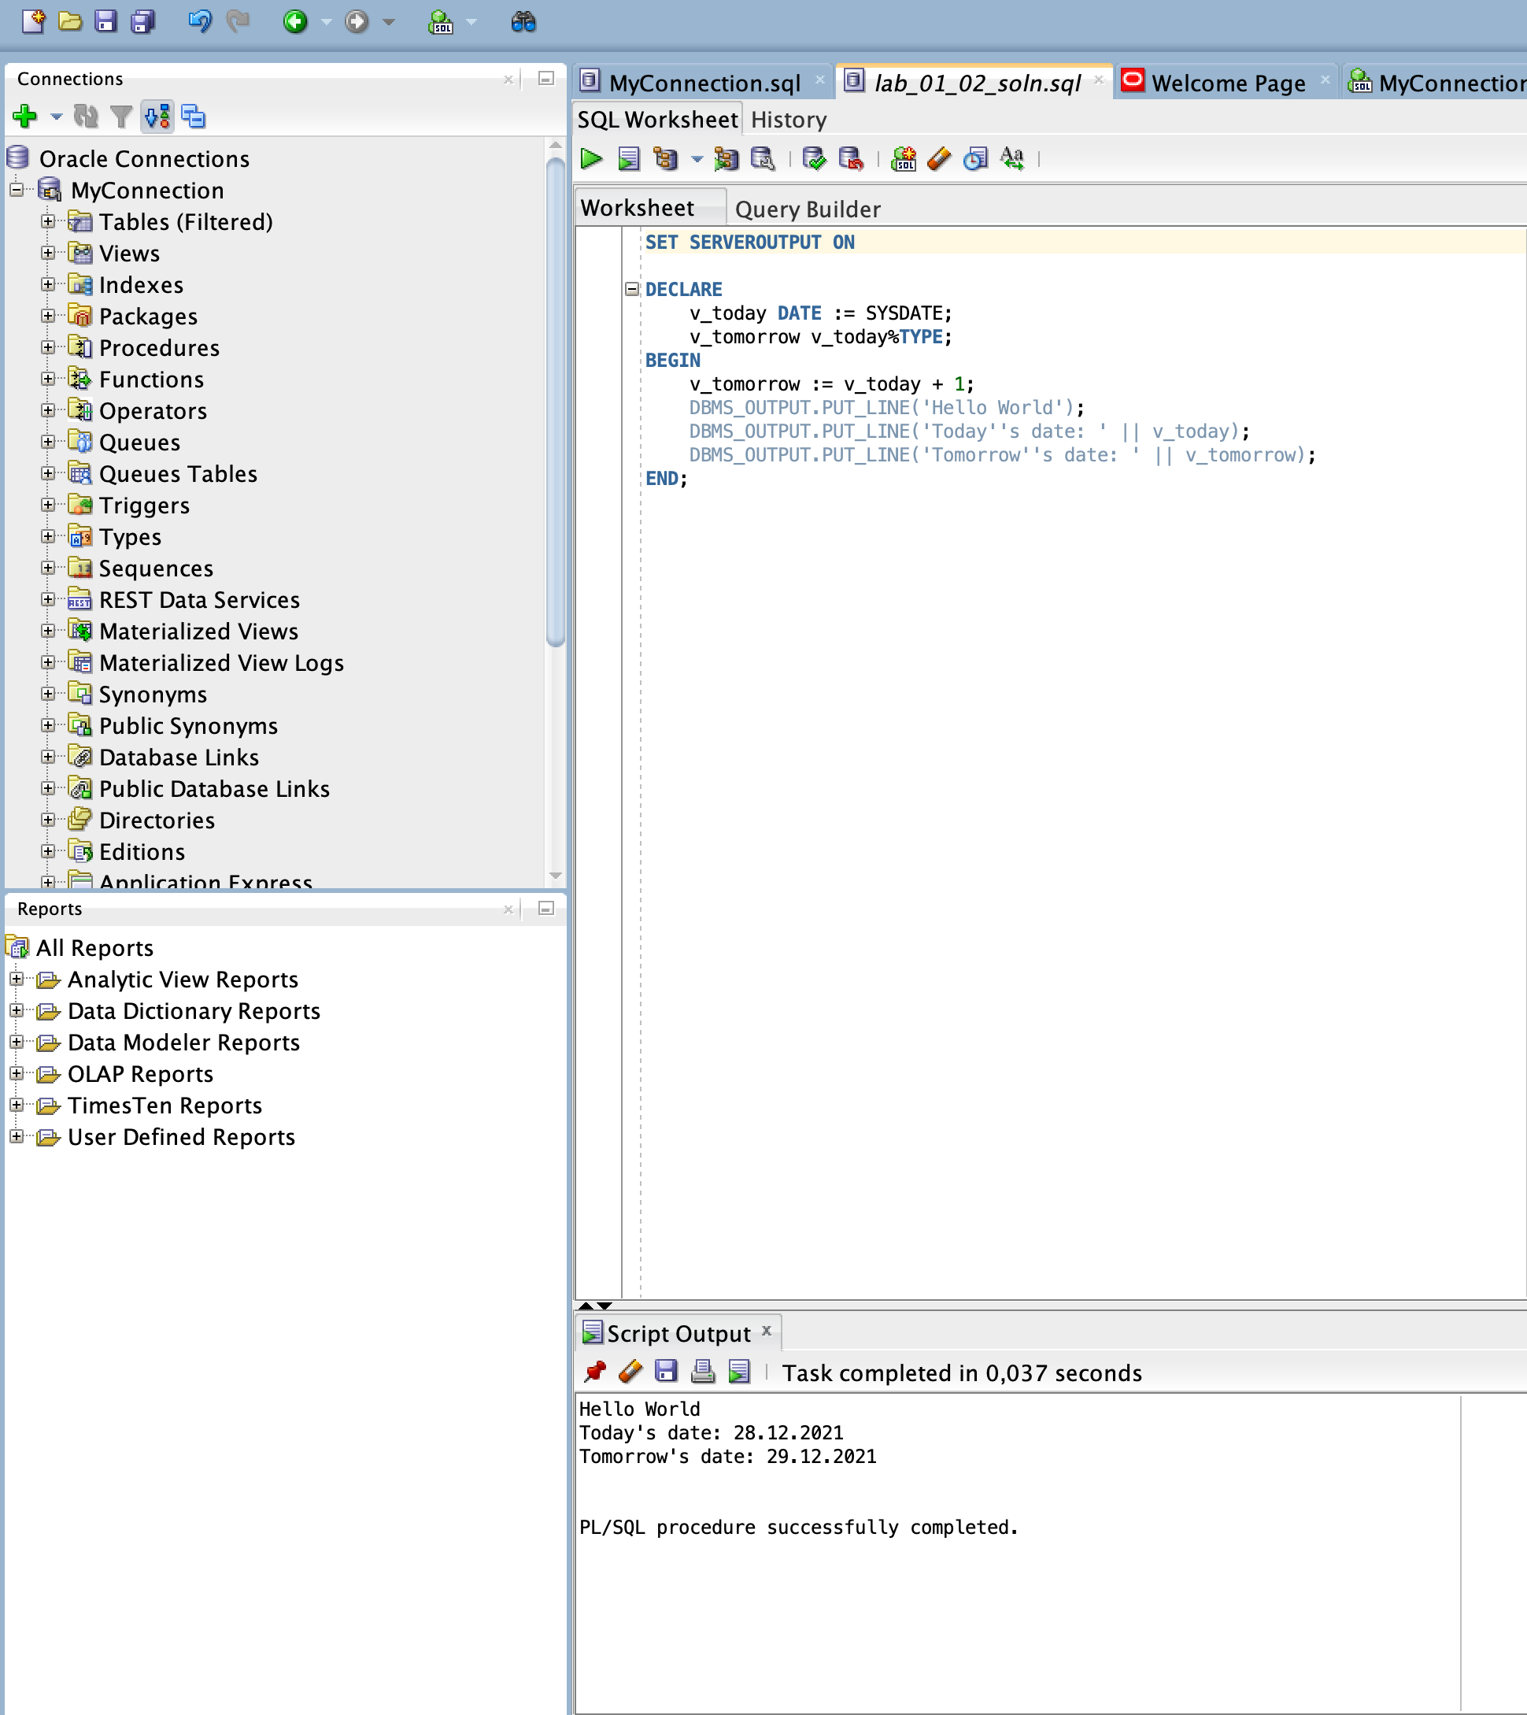

d)  Save your script as lab_02_04_soln.sql, and then execute.

The sample output is as follows (the values of v_today and v_tomorrow will be different to reflect your current today’s and tomorrow’s date):

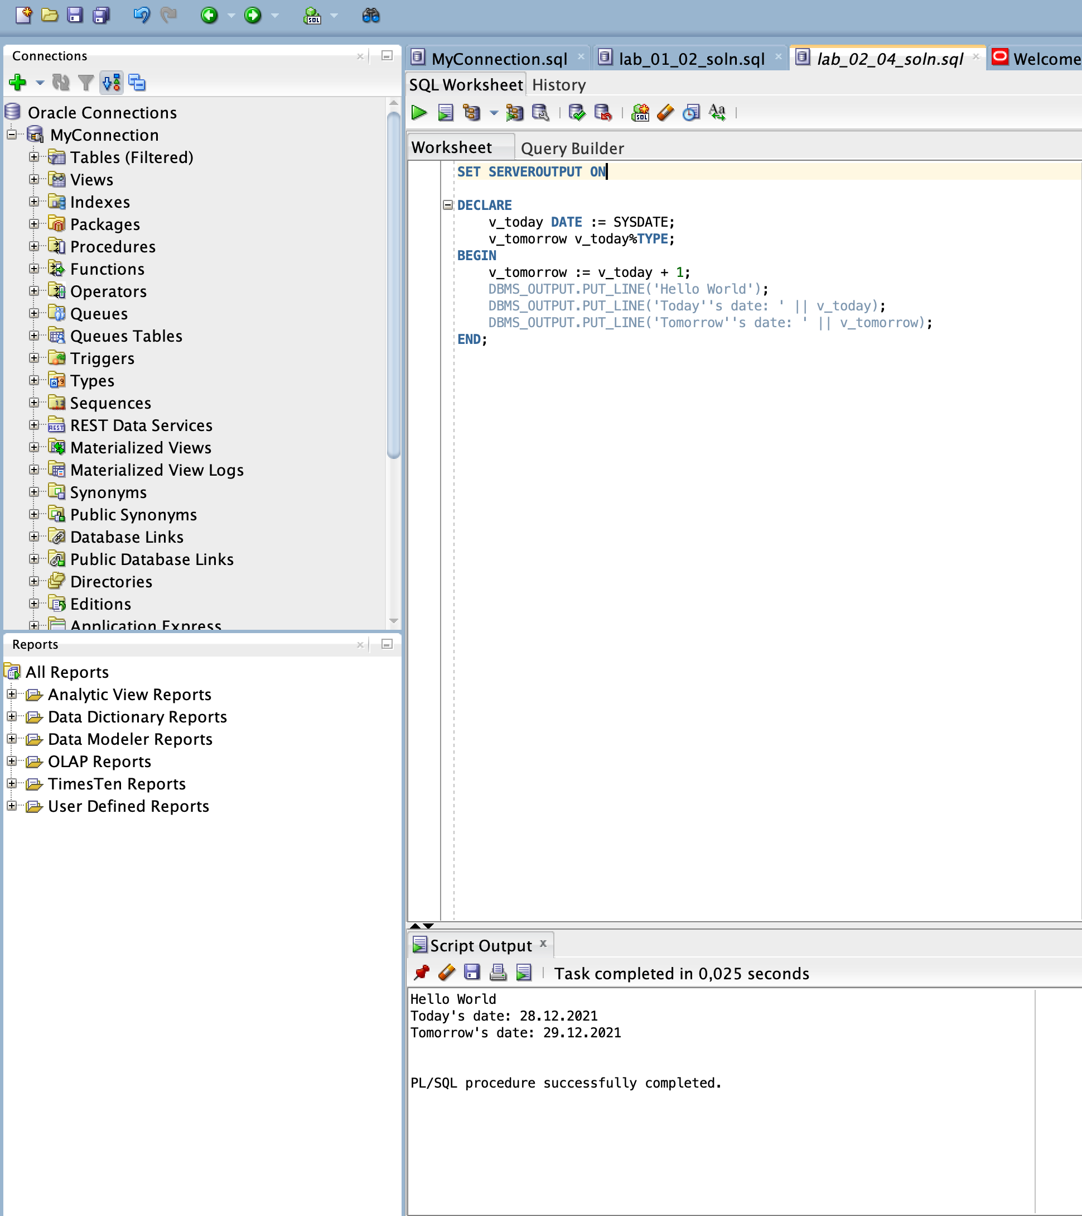

5) Edit the lab_02_04_soln.sql script.

a) Add code to create two bind variables, named b_basic_percent and b_pf_percent. Both bind variables are of type NUMBER.

**SET SERVEROUTPUT ON  
  
VARIABLE b_basic_percent NUMBER;  
VARIABLE b_pf_percent NUMBER;  
  
DECLARE  
 v_today DATE := SYSDATE;  
 v_tomorrow v_today%TYPE;  
BEGIN  
 v_tomorrow := v_today + 1;  
 DBMS_OUTPUT.PUT_LINE('Hello World');  
 DBMS_OUTPUT.PUT_LINE('Today''s date: ' || v_today);  
 DBMS_OUTPUT.PUT_LINE('Tomorrow''s date: ' || v_tomorrow);  
END;**

b)  In the executable section of the PL/SQL block, assign the values 45 and 12 to b_basic_percent and b_pf_percent, respectively.

**SET SERVEROUTPUT ON  
  
VARIABLE b_basic_percent NUMBER;  
VARIABLE b_pf_percent NUMBER;  
  
DECLARE   
 v_today DATE := SYSDATE;  
 v_tomorrow v_today%TYPE;  
BEGIN  
 v_tomorrow := v_today + 1;  
   
 :b_basic_percent := 45;  
 :b_pf_percent := 12;  
   
 DBMS_OUTPUT.PUT_LINE('Hello World');  
 DBMS_OUTPUT.PUT_LINE('Today''s date: ' || v_today);  
 DBMS_OUTPUT.PUT_LINE('Tomorrow''s date: ' || v_tomorrow);  
END;**

c)  Terminate the PL/SQL block with “/” and display the value of the bind variables by using the PRINT command.

**SET SERVEROUTPUT ON  
  
VARIABLE b_basic_percent NUMBER;  
VARIABLE b_pf_percent NUMBER;  
  
DECLARE   
 v_today DATE := SYSDATE;  
 v_tomorrow v_today%TYPE;  
BEGIN  
 v_tomorrow := v_today + 1;  
   
 :b_basic_percent := 45;  
 :b_pf_percent := 12;  
   
 DBMS_OUTPUT.PUT_LINE('Hello World');  
 DBMS_OUTPUT.PUT_LINE('Today''s date: ' || v_today);  
 DBMS_OUTPUT.PUT_LINE('Tomorrow''s date: ' || v_tomorrow);  
END;  
/  
PRINT b_basic_percent;  
PRINT b_pf_percent;**

d)  Execute and save your script as lab_02_05_soln.sql. The sample output is as follows:

