**Quiz**

When using the SELECT statement in PL/SQL, the INTO clause is required and queries can return one or more row.

1. True

2. False

**Answer: False, queries must return only one row**

**Practice 4: Interacting with the Oracle Server**

**In this practice, you use PL/SQL code to interact with the Oracle Server.**

1) Create a PL/SQL block that selects the maximum department ID in the departments table and stores it in the v_max_deptno variable. Display the maximum department ID.

a) Declare a variable v_max_deptno of type NUMBER in the declarative section.

**DECLARE**

**v_max_deptno NUMBER;**

b) Start the executable section with the BEGIN keyword and include a SELECT statement to retrieve the maximum department_id from the departments table.

**DECLARE**

**v_max_deptno NUMBER;**

**BEGIN**

**SELECT MAX(department_id) INTO v_max_deptno**

**FROM departments;**

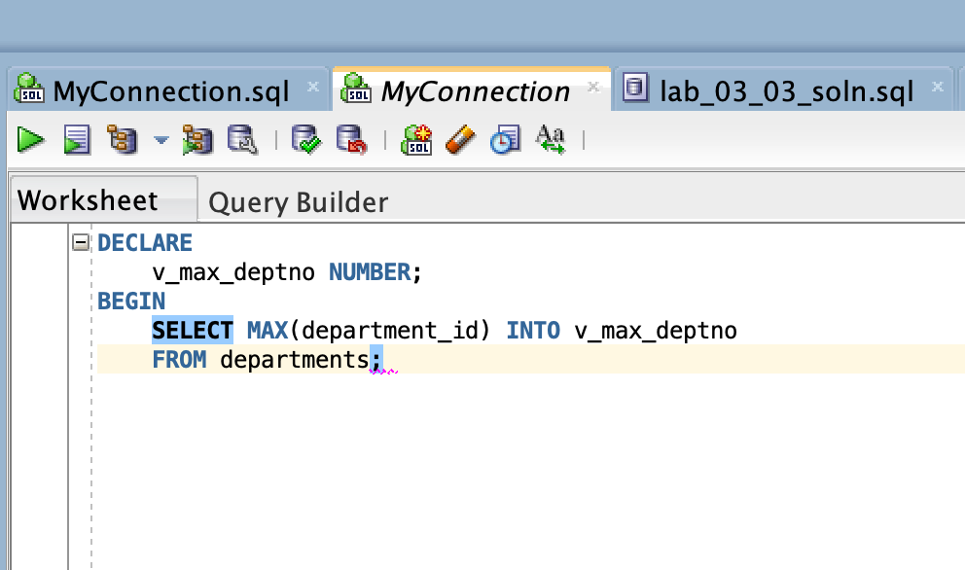

c) Display v_max_deptno and end the executable block.

**SET SERVEROUTPUT ON**

**DECLARE**

**v_max_deptno NUMBER;**

**BEGIN**

**SELECT MAX(department_id) INTO v_max_deptno**

**FROM departments;**

**DBMS_OUTPUT.PUT_LINE('The maximum department_id: ' || v_max_deptno);**

**END;**

d) Execute and save your script as lab_04_01_soln.sql. The sample output is as follows:

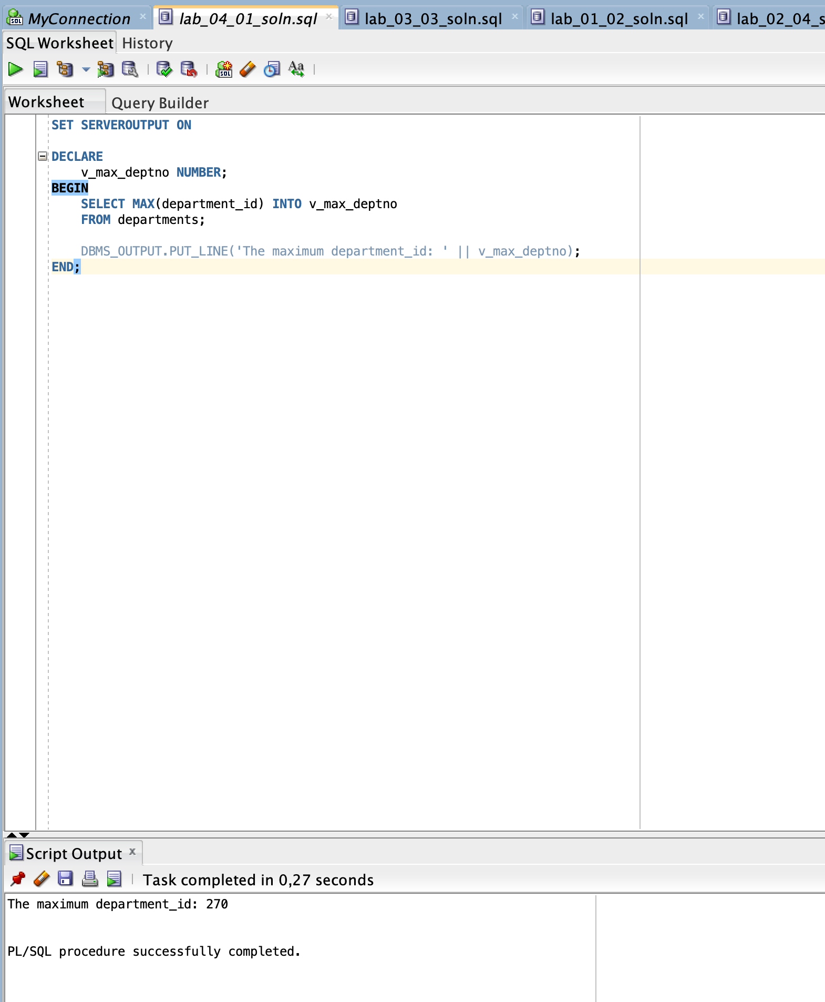

2) Modify the PL/SQL block that you created in step 1 to insert a new department into the departments table.

a) Load the lab_04_01_soln.sql script. Declare two variables: v_dept_name of type departments.department_name and v_dept_id of type NUMBER

Assign 'Education' to v_dept_name in the declarative section.

**DECLARE**

**v_max_deptno NUMBER;**

**v_dept_name departments.department_name%TYPE := 'Education';**

**v_dept_id NUMBER;**

b) You have already retrieved the current maximum department number from the departments table. Add 10 to it and assign the result v_dept_id.

**v_dept_id := v_max_deptno + 10;**

c) Include an INSERT statement to insert data into the department_name, department_id, and location_id columns of the departments table. Use values in dept_name and dept_id for department_name and department_id, respectively, and use NULL for location_id.

**INSERT INTO departments (department_name, department_id, location_id)**

**VALUES (v_dept_name, v_dept_id, NULL);**

d) Use the SQL attribute SQL%ROWCOUNT to display the number of rows that are affected.

**DBMS_OUTPUT.PUT_LINE('Number of rows that are affected: ' || SQL%ROWCOUNT);**

e) Execute a SELECT statement to check whether the new department is inserted. You can terminate the PL/SQL block with "/" and include the SELECT statement in your script.

**/**

**SELECT*FROM departments WHERE department_id = 280;**

f) Execute and save your script as lab_04_02_soln.sql.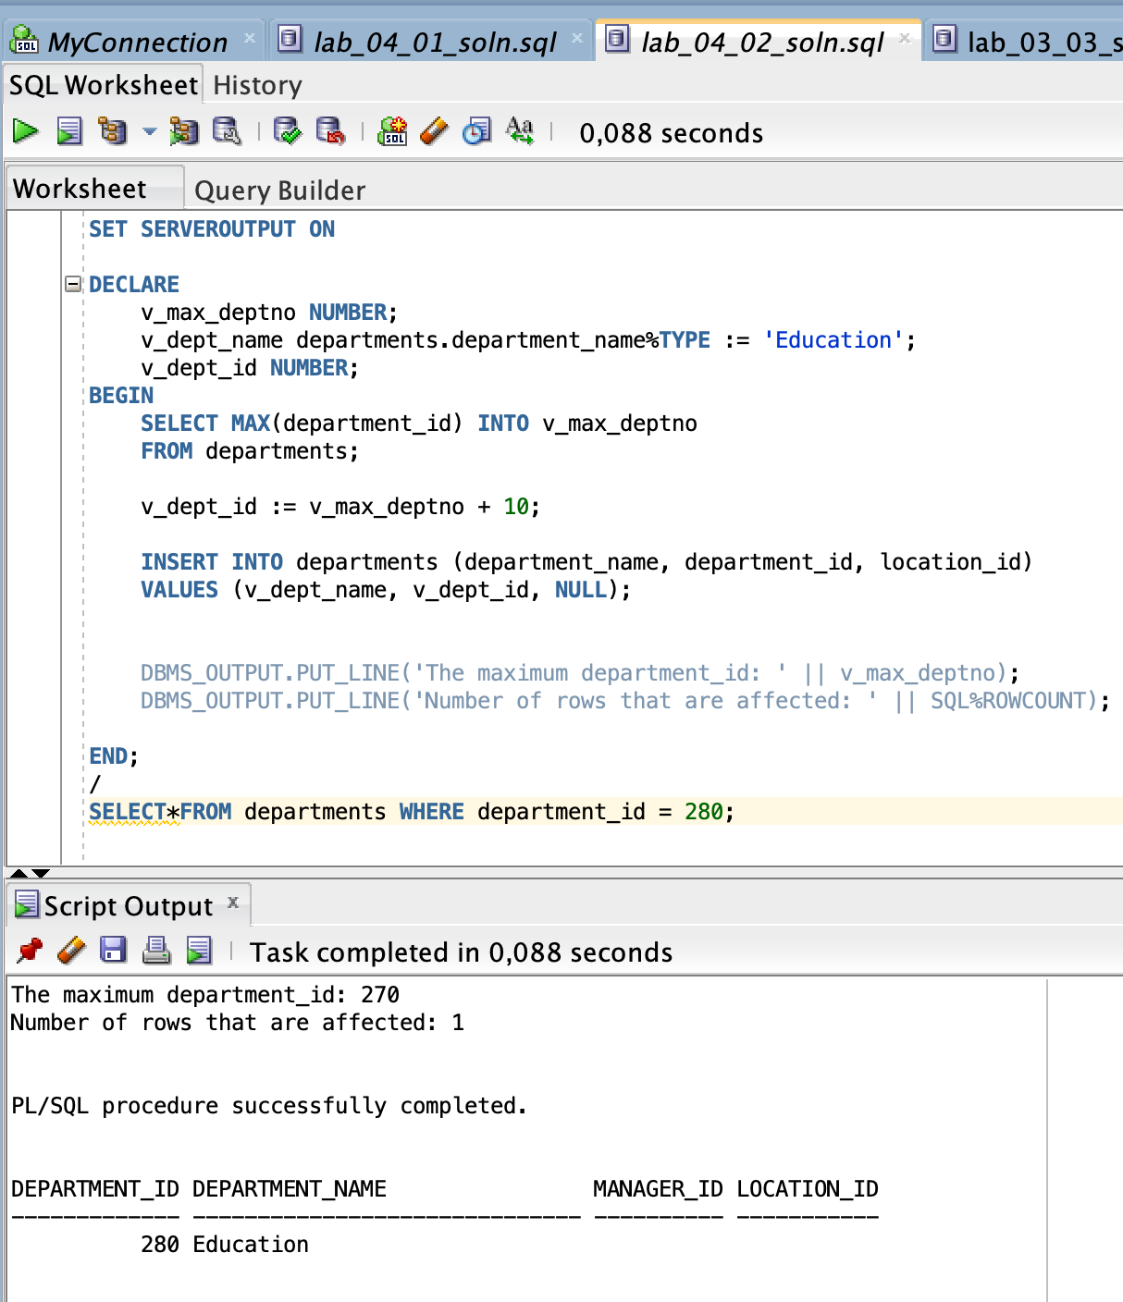

3) In step 2, you set location_id to NULL. Create a PL/SQL block that updates the location_id to 3000 for the new department.

Note: If you successfully completed step 2, continue with step 3a. If not, first execute the solution script /soln/sol_04_02.sql.

a) Start the executable block with the BEGIN keyword. Include the UPDATE statement to set the location_id to 3000 for the new department (dept_id=280).

**BEGIN**

**UPDATE departments SET location_id = 3000**

**WHERE department_id = 280;**

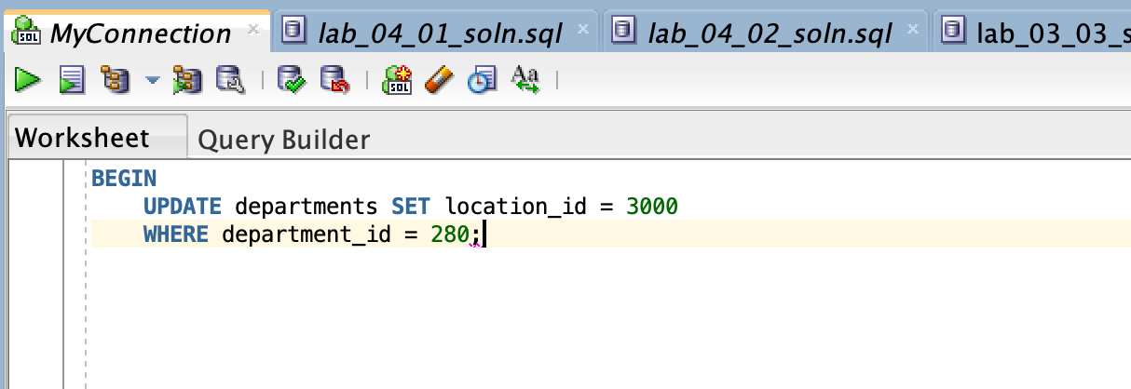

b) End the executable block with the END keyword. Terminate the PL/SQL block with "/" and include a SELECT statement to display the department that you updated.

**END;**

**/**

**SELECT*FROM departments WHERE department_id = 280;**

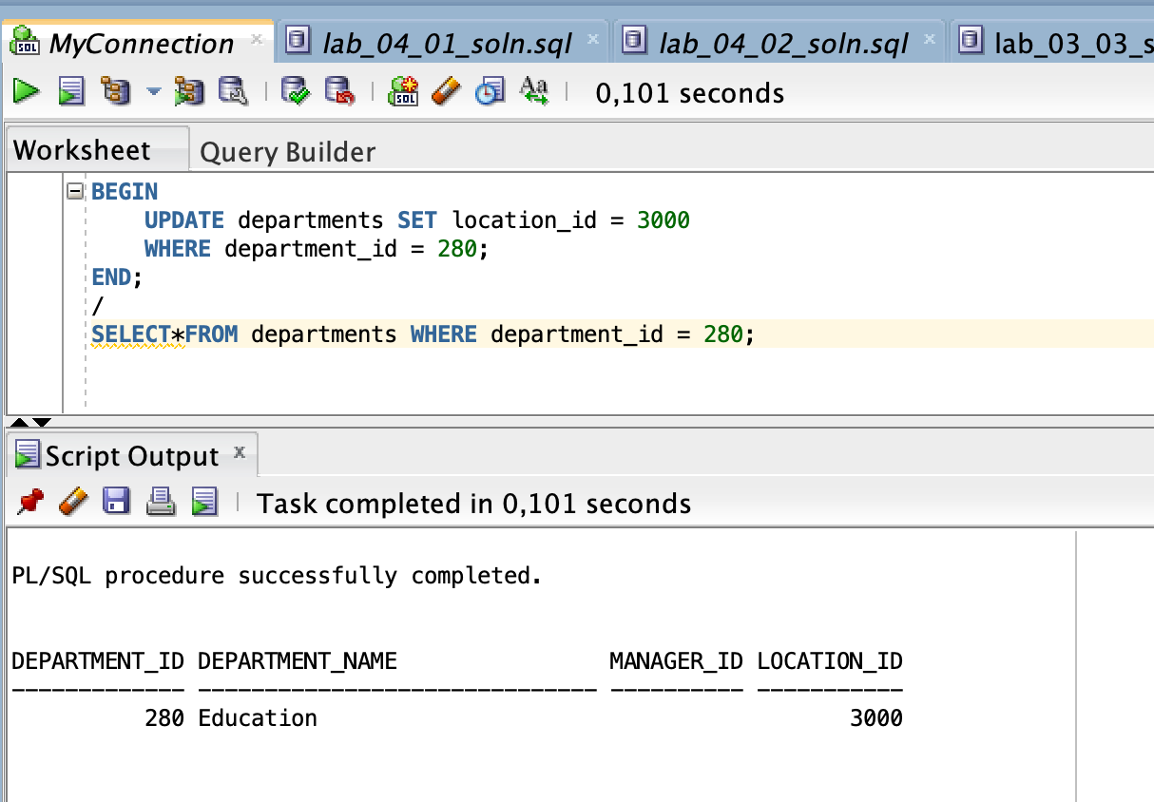

c) Include a DELETE statement to delete the department that you added.

**DELETE FROM departments WHERE department_id = 280;**

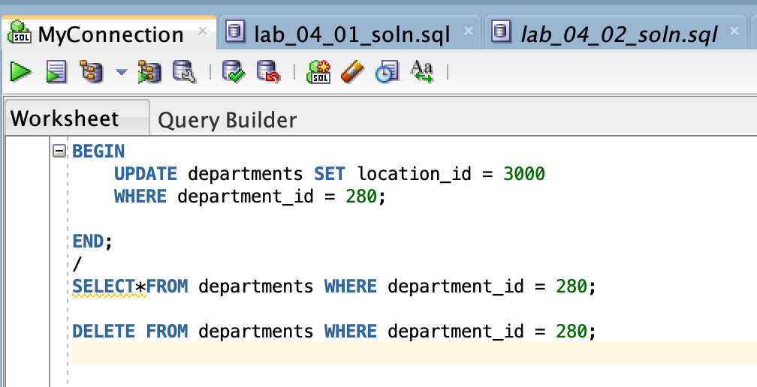

d) Execute and save your script as lab_04_03_soln.sql.

