**Quiz**

There are three types of loops: basic, FOR, and WHILE.

1. True  
2. False

**Answer: True**

**Practice 5: Writing Control Structures**

**In this practice, you create PL/SQL blocks that incorporate loops and conditional control structures. This practice tests your understanding of various IS statements and LOOP constructs.**

1)  Execute the command in the lab_05_01.sql file to create the messages table. Write a PL/SQL block to insert numbers into the messages table.

**CREATE TABLE messages (**

**results VARCHAR2(50)**

**);**

a)  Insert the numbers 1 through 10, excluding 6 and 8.

**BEGIN**

**FOR i IN 1..10 LOOP**

**IF i = 6 OR i = 8 THEN**

**CONTINUE;**

**ELSE**

**INSERT INTO messages(results)**

**VALUES(i);**

**END IF;**

**END LOOP;**

**END;**

**/**

b)  Commit before the end of the block.

**BEGIN**

**FOR i IN 1..10 LOOP**

**IF i = 6 OR i = 8 THEN**

**CONTINUE;**

**ELSE**

**INSERT INTO messages(results)**

**VALUES(i);**

**END IF;**

**END LOOP;**

**COMMIT;**

**END;**

**/**

c)  Execute a SELECT statement to verify that your PL/SQL block worked.

Result: You should see the following output:

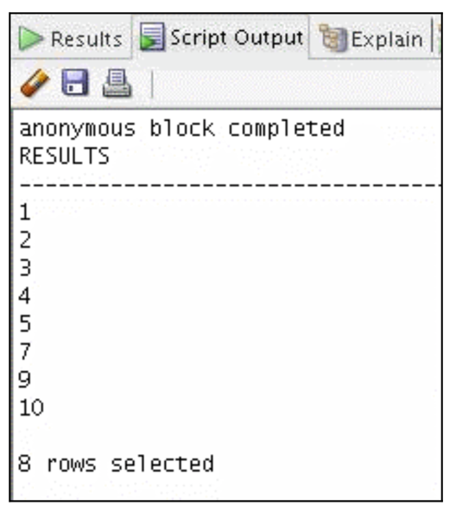

2)  Execute the lab_05_02.sql script. This script creates an emp table that is a replica of the employees table. It alters the emp table to add a new column, stars, of VARCHAR2 data type and size 50. Create a PL/SQL block that inserts an asterisk in the starts column for every $1000 of an employee’s salary. Save your script as lab_05_02_soln.sql.

**CREATE TABLE emp AS SELECT*FROM employees;**

**ALTER TABLE emp ADD stars VARCHAR2(50);**

a)  In the declarative section of the block, declare a variable v_empno of type emp.employee_id and initialize it to 176. Declare a variable v_asterisk of type emp.stars and initialize it to NULL. Create a variable v_sal of type emp.salary.

**DECLARE**

**v_empno emp.employee_id%TYPE := 176;**

**v_asterisk emp.stars%TYPE := NULL;**

**v_sal emp.salary%TYPE;**

b)  In the executable section, write logic to append an asterisk (*) to the string for every $1,000 of the salary. For example, if the employee earns $8,000, the string of asterisks should contain eight asterisks. If the employee earns $12,500, the string of asterisks should contain 13 asterisks.

**BEGIN**

**SELECT salary**

**INTO v_sal**

**FROM emp WHERE employee_id = v_empno;**

**FOR i IN 1..v_sal/1000 LOOP**

**v_asterisk := v_asterisk || '*';**

**END LOOP;**

c) Update the stars column for the employee with the string of asterisks. Commit before the end of the block.

**UPDATE emp SET stars = v_asterisk**

**WHERE employee_id = v_empno;**

**COMMIT;**

**END;**

d)  Display the row from the emp table to verify whether your PL/SQL block has executed successfully.

**SELECT employee_id, salary, stars**

**FROM emp**

**WHERE employee_id = 176;**

e)  Execute and save your script as lab_05_02_soln.sql. The output is as follows:

