**Quiz**

Identify situations in which you can use the %ROWTYPE attribute.

1. When you are not sure about the structure of the underlying database table

2. When you want to retrieve an entire row from a table

3. When you want to declare a variable according to another previously declared variable or database column

**Answer: 1, 2**

**Practice 6: Working with Composite Data Types**

1)  Write a PL/SQL block to print information about a given country.

a)  Declare a PL/SQL record based on the structure of the countries table.

b)  Declare a variable v_countryid. Assign CA to v_countryid.

c)  In the declarative section, use the %ROWTYPE attribute and declare the v_country_record variable of type countries.

d)  In the executable section, get all the information from the countries table by using v_countryid. Display selected information about the country. The sample output is as follows:

**SET SERVEROUTPUT ON**

**DECLARE**

**v_countryid VARCHAR2(30) := 'CA';**

**v_country_record countries%ROWTYPE;**

**BEGIN**

**SELECT * INTO v_country_record**

**FROM countries WHERE country_id = v_countryid;**

**DBMS_OUTPUT.PUT_LINE('Country Id: ' || v_country_record.country_id ||**

**' Country name: ' || v_country_record.country_name ||**

**' Region: ' || v_country_record.region_id);**

**END;**

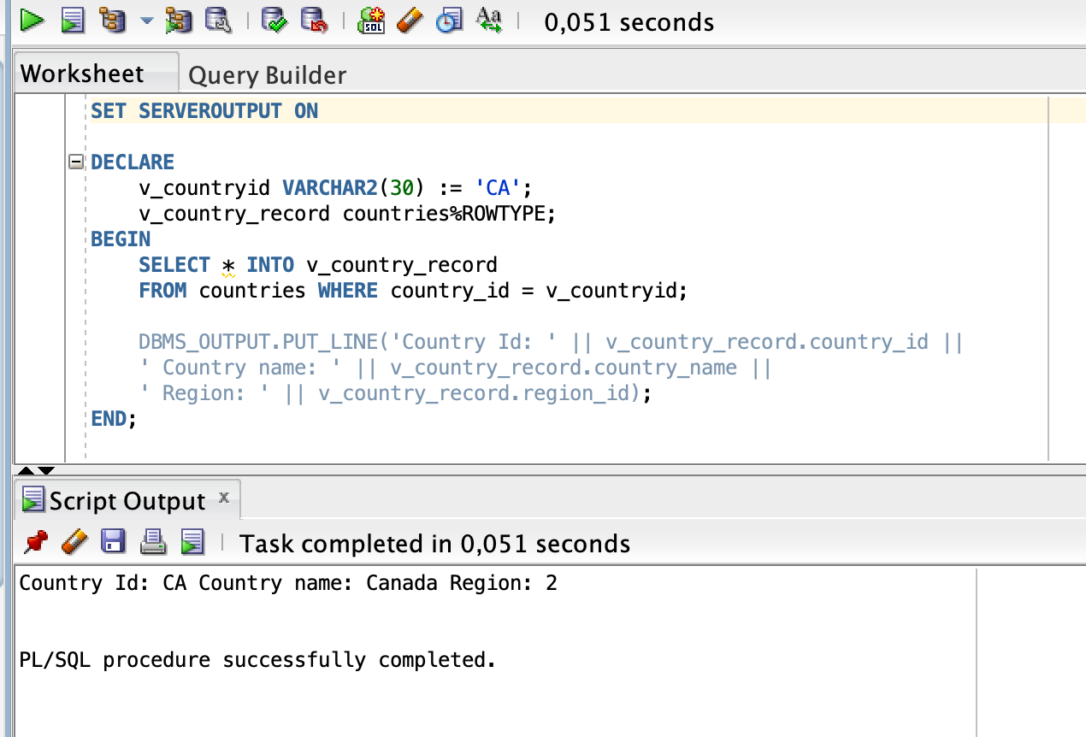

e)  You may want to execute and test the PL/SQL block for countries with the IDs DE, UK, and US.

**SET SERVEROUTPUT ON**

**DECLARE**

**v_countryid VARCHAR2(30) := 'CA';**

**v_country_record countries%ROWTYPE;**

**BEGIN**

**FOR v_country_record IN**

**(SELECT * FROM countries WHERE country_id IN ('DE', 'UK', 'US'))**

**LOOP**

**DBMS_OUTPUT.PUT_LINE('Country Id: ' || v_country_record.country_id ||**

**' Country name: ' || v_country_record.country_name ||**

**' Region: ' || v_country_record.region_id);**

**END LOOP;**

**END;**

2)  Create a PL/SQL block to retrieve the names of some departments from the departments table and print each department name on the screen, incorporating an associative array. Save the script as lab_06_02_soln.sql.

a)  Declare an INDEX BY table dept_table_type of type departments.department_name. Declare a variable my_dept_table of type dept_table_type to temporarily store the names of the departments.

**DECLARE**

**TYPE dept_table_type IS TABLE OF**

**departments.department_name%TYPE**

**INDEX BY PLS_INTEGER;**

**my_dept_table dept_table_type;**

b)  Declare two variables: f_loop_count and v_deptno of type NUMBER. Assign 10 to f_loop_count and 0 to v_deptno.

**f_loop_count NUMBER := 10;**

**v_deptno NUMBER := 0;**

c)  Using a loop, retrieve the names of 10 departments and store the names in the associative array. Start with department_id 10. Increase v_deptno by 10 for every loop iteration. The following table shows the department_id for which you should retrieve the department_name.

**BEGIN**

**FOR i IN 1..f_loop_count LOOP**

**v_deptno := v_deptno + 10;**

**SELECT department_name**

**INTO my_dept_table(i)**

**FROM departments WHERE department_id = v_deptno;**

**END LOOP;**

d) Using another loop, retrieve the department names from the associative array and display them.

**FOR i IN 1..f_loop_count LOOP**

**DBMS_OUTPUT.PUT_LINE(my_dept_table(i));**

**END LOOP;**

e)  Execute and save your script as lab_06_02_soln.sql. The output is as follows:

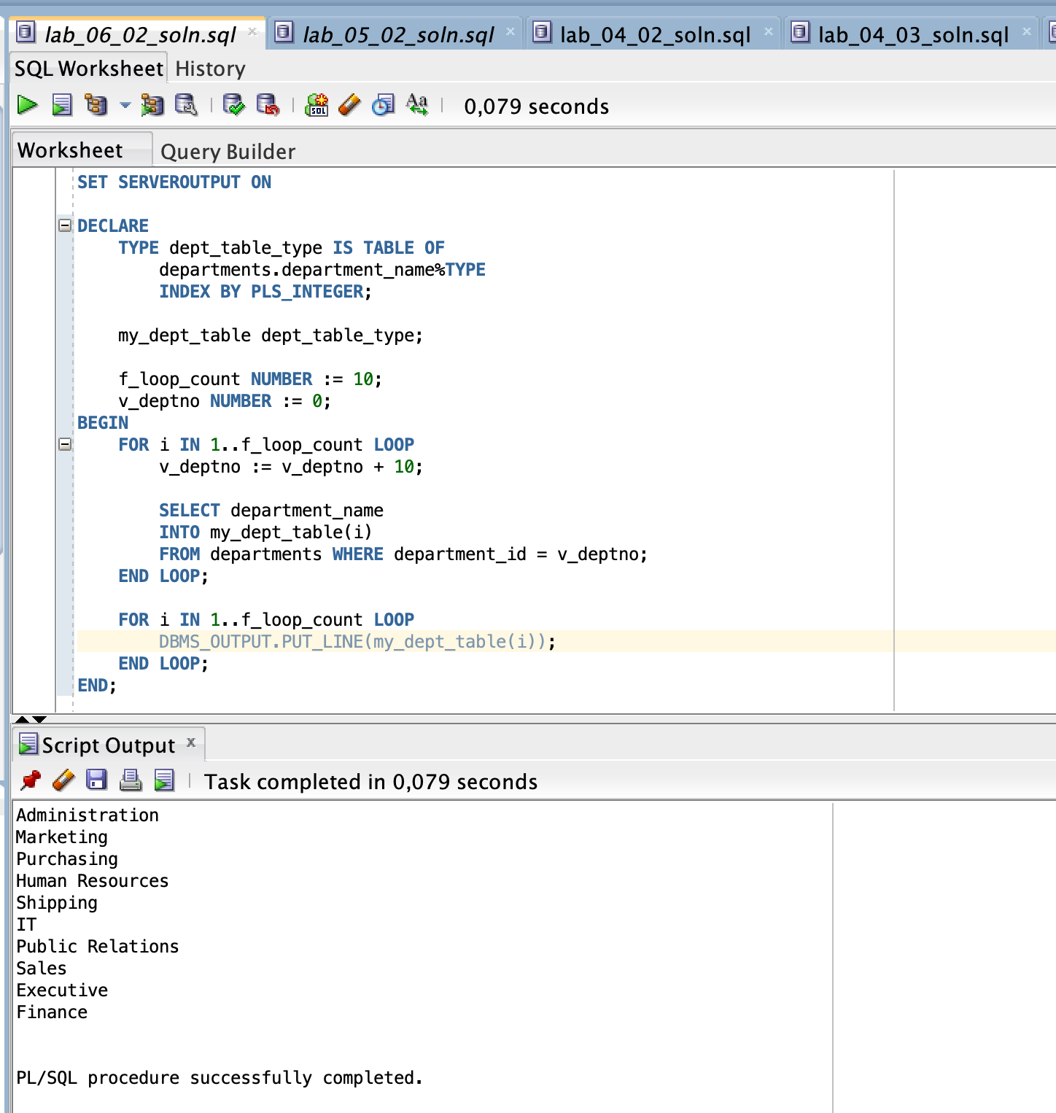

3) Modify the block that you created in Practice 2 to retrieve all information about each department from the departments table and display the information. Use an associative array with the INDEX BY table of records method.

a)  Load the lab_06_02_soln.sql script.

b)  You have declared the associative array to be of type departments.department_name. Modify the declaration of the associative array to temporarily store the number, name, and location of all the departments. Use the %ROWTYPE attribute.

**DECLARE**

**TYPE dept_table_type IS TABLE OF**

**departments%ROWTYPE**

**INDEX BY PLS_INTEGER;**

c)  Modify the SELECT statement to retrieve all department information currently in the departments table and store it in the associative array.

**SELECT * INTO my_dept_table(i)**

**FROM departments WHERE department_id = v_deptno;**

d)  Using another loop, retrieve the department information from the associative array and display the information.

**FOR i IN 1..f_loop_count LOOP**

**DBMS_OUTPUT.PUT_LINE(**

**'Department Number: ' || my_dept_table(i).department_id ||**

**' Department Name: ' || my_dept_table(i).department_name ||**

**' Manager Id: ' || my_dept_table(i).manager_id ||**

**' Location Id: ' || my_dept_table(i).location_id);**

**END LOOP;**

The sample output is as follows:

