
CubeMapGen v1.4
A Cubemap Filtering and Mipchain Generation Tool

GPG Developer Tools
gputools.support@amd.com

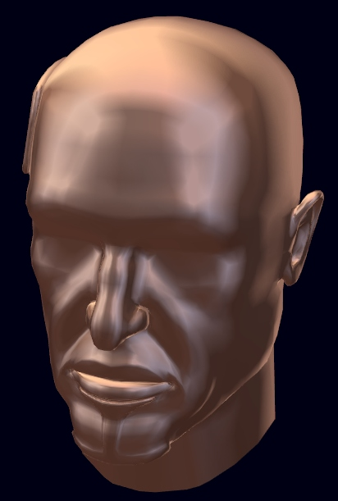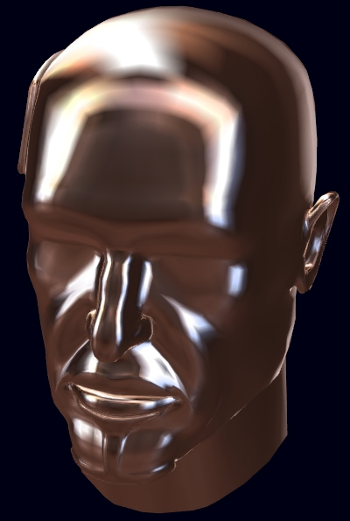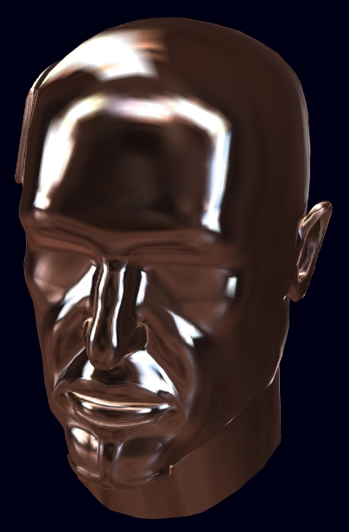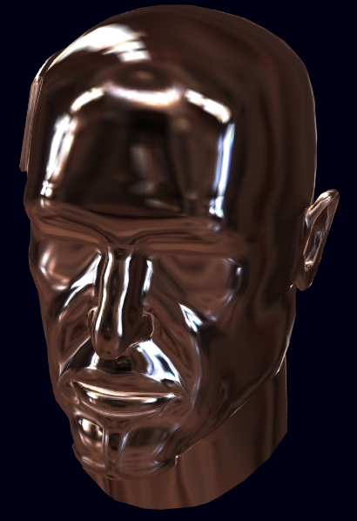
4x4
8x8
16x16
32x32
A visualization of low resolution cubemap miplevels generated using the CubeMapGen tool.

© 2006–2011 Advanced Micro Devices, Inc. All rights reserved.

The contents of this document are provided in connection with Advanced Micro Devices, Inc. (“AMD”) products. AMD makes no representations or warranties with respect to the accuracy or completeness of the contents of this publication and reserves the right to make changes to specifications and product descriptions at any time without notice. The information contained herein may be of a preliminary or advance nature and is subject to change without notice. No license, whether express, implied, arising by estoppel or otherwise, to any intellectual property rights is granted by this publication. Except as set forth in AMD’s Standard Terms and Conditions of Sale, AMD assumes no liability whatsoever, and disclaims any express or implied warranty, relating to its products including, but not limited to, the implied warranty of merchantability, fitness for a particular purpose, or infringement of any intellectual property right.

AMD’s products are not designed, intended, authorized or warranted for use as components in systems intended for surgical implant into the body, or in other applications intended to support or sustain life, or in any other application in which the failure of AMD’s product could create a situation where personal injury, death, or severe property or environmental damage may occur. AMD reserves the right to discontinue or make changes to its products at any time without notice.
Synopsis:

Despite the fact that cube maps are defined on the spherical domain, standard cubemap mipchain generation techniques perform filtering independently on each cube face. The main problem with this approach is that no information is propagated across edges, thus creating undesirable discontinuities along the cube face edges. A limitation of nearly all cube mapping hardware which makes the seam problem substantially worse is the fact that the bilinear texel filtering is not able to fetch across cube faces thus producing a hard seam artifact in addition to introducing aliasing artifacts. These two compounding problems limit the usefulness of cubemapping.

Our pre-processing approach alleviates this problem using two techniques. The first, angular extent filtering, defines each tap’s filter kernel using an angular extent around the center tap as opposed to a fixed per-face pixel-based extent. The advantages of angular extent filtering are that the filtering kernels used for all taps have a constant solid angle as well as have the ability to pull texels from multiple faces. In addition to this, the filtering takes into account the solid angle subtended by each tap in the filter. Also, by varying the angular extent of the filter used to generate the base mip-level, pre-convolved reflections for a variety of materials can be precomputed.

The second technique, edge seam fixup, uses a per mip-level seam averaging and smoothing algorithm in order to effectively hide the seam artifacts. This enables the lower-resolution cubemap miplevels (even 2x2 and 4x4) to be directly used for tarnished metal shaders, matte surfaces shaders, and even for diffuse lighting. In addition to this, by providing good quality cubemaps throughout the mipchain, miplevel selection via the texCUBEbias, and texCUBELOD instructions can be used for selective blurring.

CubeMapGen is a tool for importing, filtering, visualizing, and exporting cubemaps, its list of features include:

Cubemap Filtering and MipChain Generation: Angular extent filtering and edge seam fixup provides new high quality filtering results for prefiltered environment mapping, and cubemap mipchain generation.

Interactive Cubemap Assembly: Cubemaps can be assembled from separate face images that can be loaded into each cubemap face and interactively flipped vertically, horizontally, and diagonally in order to align the faces.

Cubemap Import: Import entire cube maps from HDRShop vertical cross cubemap images, DirectX .dds cubemap files, and separate image files

Cubemap Export: Export cubemap with mipchain to single .dds file, cube cross images for each mip level, or a collection of separate images for each cubemap face for each mip level. Also supported is a specialized DXT compressor which allows for the creation of seamless DXT compressed cubemaps.

Command Line Interface: Allows you to use CubeMapGen as a command line tool for processing cubemaps in scripts and batch files.

HDR Image Support: All filtering is performed in high dynamic range.

HDRShop v1.0 plugin functionality: CubeMapGen also functions as an HDRShop plugin that provides the filtering functionality of CubeMapGen to HDRShop.

Revisions for Version 1.4:

* Prepare source code for public release
* Added Visual Studio 2008 solution and project files
* DXT support removed due to licensing restrictions
* The project files now reference the DXSDK_DIR environment variable, so the Microsoft DirectX SDK must be installed or the environment variable defined.

Revisions for Version 1.3:

* Removed 1k x 1k texture limit

Revisions for Version 1.2:

* Updated user interface
* Removed unsupported use of shader model 1.1; now uses 2.0
* Updated icons

Revisions for Version 1.1:

* Added -consoleErrorOutput option to command line, to output messages to the
command line instead of using message boxes.
* Fixed –importCubeDDS -importCubeCross command line options.
* Added 24-bit bitmap support to complement existing 32-bit bitmap support.
* CubeMapGen now generates exit codes that reflect whether or not the application
terminated normally, or because of an error. See section “Exit Codes for Command
Line Mode” for more information.
* Added button to reset input cubemap to default color cube.
* Added “CenterBB” checkbox to resize and re-center current object based on bounding
box.

Requirements:

-A graphics card capable of pixel shader model 2.0 for interactive mode.
-DirectX 9.0c (and the DXSDK_DIR environment variable is defined)
-At least 128MB of RAM.

Angular Extent Filtering:

In order to efficiently process all the texels within an angular domain, we use a few different lookup tables to expedite the computation. The key idea to process each texel within the filter extent exactly once in a reasonably quick way. Processing each tap only once is particularly important for HDR imagery, where a single bright pixel value can dominate a region.

To filter cubemaps in this way, we first generate a normalizer/solid angle lookup cube map same size as cubemap once per mip-level. This is used to quickly lookup the associated direction vector and solid angle for any given texel in the cubemap.

Then per output cube-map sample, bounding box regions for the angular kernel extent are computed for each of the cube faces. Within each bounding box regions the filter weights are computed per-tap via a dot product between the normalizer cube map lookup for that texel. The dot product is used as a fast test to see whether or not the given tap is within the angular extent of the kernel.

Certain filter types take into account the angle between the current tap vector, and the center tap vector to derive the per tap weights. The result of the dot product is used to index into a lookup table to compute the tap weight in order to implement these filters efficiently.

The four filtering techniques provided are Disc, Cone, Cosine, and Angular Gaussian.

Disc filtering does not take into account the angle between with the center tap vector and the current tap vector for determining per-tap weights. This option tends to make bright points in the input cube map into circular disks in the output. “Disc” fitering can be thought of as providing the largest amount of blurring for a given angle.

Cone filtering uses per-texel weights that fall off linearly with respect to the angle between the center tap and current tap vector. Note that the weights fall off to zero at the outside edge of the angular extent of the filter.

Cosine filtering weights each tap by cosine of the angle between the center tap vector and the current tap vector. The main purpose of this is to incorporate the hemisphere cosine term when integrating over the entire hemisphere (e.g. a 180 degree angular extent)

Angular Gaussian filtering uses per-texel weights with a Gaussian falloff with respect to the angle between the center tap vector and the current tap vector. Note that this filter is defined in such as way that the outside edge of the angular extent region is exactly 3 standard deviations away from the center.

Edge Fixup Methods for Cubemaps:

The basic idea behind edge fixup is to average cubemap edge texels across edges, and hide the effect of the averaging by adjusting intensity values within the edge fixup width from the edge. There are a few ways which CubeMapGen uses to adjust the intensity values in the fixup region.

The Pull methods adjust the texel intensity values in the edge fixup region by a fraction of the amount the edge pixels were adjusted by during the average. This fraction either falls off linearly (PullLinear), or cubically (PullHermite) to zero as the distance from the edge increases. These methods tend to maintain high frequency information within the fixup region.

The Avg methods perform a weighted average of the texel intensity values in the edge fixup region with the averaged edge values. The weight either falls off linearly (AvgLinear), or cubically (AvgHermite) to zero as the distance from the edge increases.
These methods hide the edge fixup artifacts more, but tend to smooth over high frequency detail in the edge regions more than the Pull methods. These methods work well in the case when the source images used to construct the cubemap have different intensities or exposure levels.

Usage Recommendations

If large filtering angles are required (>15 degrees), and time is of the essence, first produce a low-resolution output cubemap (64 x 64 or less) using small filtering angles, Angular Gaussian filtering and no edge fixup and save it out to disk. After this use the low resolution cubemap as input to generate the highly filtered version. Note that with large filtering angles, most of the high frequency information will be lost, so generating them from a decimated version of the original cubemap will produce near identical results. When generating a highly filtered low resolution cubemap, it is recommended that the Angular Gaussian filter be used, unless the desired result is to produce a diffuse lighting cubemap. For that case, using the Cosine filtering technique with a 180 degree filtering angle for the base mip-level is recommended.

Interactive Application UI Element Descriptions:

Load Basemap: Loads a basemap used for rendering. (default basemap is all white)
The basemap is modulated with the current cubemap format

Load Object: Loads an object in .obj or .x format to use when displaying the cubemap.

Sphere: Sets the current object to the default sphere shape.

Load CubeMap (.dds): Loads an entire cubemap (with mipchain) stored in a .dds file.

ColorCube: Resets the current input cube map to the default color cubemap.

Load Cube Cross: Loads a cubemap stored in a HDRShop compatible cube cross layout image file.

Save CubeMap (.dds): Saves all faces of the output cubemap to a single .dds file

Save CubeMap to Images: Saves cubemap as a series of face images to multiple image files. The string “_c##” is appended to the prefix where ## is the index 00-05 of the cube face being written. The supported file formats are .hdr, .pfm, .bmp, .jpg, .dib, and .dds.

Save Cube Cross: Saves all faces of the cube map to a vertical cubecross image.
The supported file formats are .hdr, .pfm, .bmp, .jpg, .dib, and .dds.

Save Mipchain: This checkbox specifies whether or not to save out the mipchain when saving the cubemaps. When this box is not checked, only the base miplevel is saved.
When saving cubemaps to images or cubecrosses, the miplevels are saved to separate files. When saving out the miplevels, the string “_m##” is appended to the prefix where ## denotes the current miplevel.

Export Image Layout: Selects which API standard to use when writing out cube faces to images. The D3D layout allows for the images to be loaded into the D3D layout cubemap directly. The OpenGL layout is identical to the D3D layout, except for the fact that the images are flipped horizontally.

Select Cube Face: Selects the cube map face to manipulate/load individual images into.
The hotkeys 1, 2, 3, 4, 5, and 6 can also be used to select the current face quickly.

Load CubeMap Face: Loads an image into the selected cubemap face. The image size must be a power of 2 and the image must be square. The hotkey for this command is ‘F’

Flip Face Diagonal: Flips the current cubemap face across its diagonal. This effectively swaps its 2D u and v axes. This is useful for manually assembling cubemaps from a set of 6 disjoint images in which the relative orientations to one another are unknown. The hotkey for this command is ‘D’.

Flip Face Horizontal: Flips the current cubemap face horizontally. This is useful for manually assembling cubemaps from a set of 6 disjoint images in which the relative orientations to one another are unknown. The hotkey for this command is ‘H’.

Flip Face Vertical: Flips the current cubemap face vertically. This is useful for manually assembling cubemaps from a set of 6 disjoint images in which the relative orientations to one another are unknown. The hotkey for this command is ‘V’.

Display CubeMap: Selects which cubemap to display, the input or the output cubemap.
The hotkeys ‘I’ and ‘O’ can also be used select the input and output cubemaps.

Select Miplevel: Selecting this checkbox allows an individual miplevel to be displayed for user inspection. The slider selects the miplevel to display.

MipClamp: Selecting this checkbox turns on miplevel clamping via the MaxMipLOD sampler state, in order to show the effect of using lower miplevels as prefiltered versions of the environment to emulate the effect of more matte surfaces.
Note that in this mode, the select miplevel slider selects the highest resolution miplevel to use.

Alpha: Checkbox to enable rendering using the alpha channel of the current cubemap as a grayscale value.

CenterBB: Checkbox to enable resizing and centering of the current object based on its bounding box size and center axis. This is useful for viewing objects which are not centered at the origin, or objects that are tiny or huge.

Skybox: Toggles the skybox mode. The skybox can be very useful to determine where the light is coming from when visualizing highly processed cubemaps.

FOV: Adjusts the field of view of the camera from 20 degrees to 160 degrees. Adjusting field of view can be useful for inspecting a model closeup without introducing geometric distortion.

Render Mode: (SurfNorm, Reflect Per-Vertex, Reflect Per-Pixel or MipAlphaLOD) Selects rendering method to use to display this cubemap. Selecting SurfNorm uses the interpolated surface normal to index into the cubemap. This mode is most useful for cubemaps which encode the effects of a diffuse lighting environment. Selecting Reflect Per-Vertex or Reflect Per-Pixel uses the per-vertex or per-pixel reflection vector to index into the cubemap. This mode is most useful for reflective, glossy, or shiny surfaces. Selecting MipAlphaLOD uses a shader that performs selective blurring per-pixel based on the alpha of the basemap. The alpha of the basemap can be thought of as a roughness map, and the selective blurring is performed by clamping the miplevel via the texCUBEbias instruction. Note that this shader requires the a cubemap filtered using the Pack Mip Level Into Alpha option turned on, and the cubemap size to be at least 256x256. The modes Reflect Per-Pixel and MipAlphaLOD require pixel shader model 2.0.

Input Intensity Clamp: This is specifies the highest allowable intensity level in the input cubemap. Any intensities greater than this value get clamped to this value. This feature can be useful to fix the problematic cases with HDR imagery when there are an extremely bright spots in the image that overpower the lower miplevels. Many times this is the case of manually authored HDR imagery where the lights that are added to the scene are too bright. In these cases, when the cubemap is used as an environment map the edges of the object are overly bright due to the overpowered miplevels. To fix this use the input intensity clamp to limit the maximum input intensity to prevent these regions from overpowering the lower mip levels.

Input Degamma: This is used to specify the gamma of the input cubemap, in order to convert the pixel values into linear intensity space (gamma = 1 .0) prior to filtering.

Filter Type: (Disc, Cone, Cosine or Gaussian) Selects filtering method used to filter the cubemap. See section, About Angular Extent Filtering for more information.

Base Filter Angle: This is the angle in degrees of the angular extent used to generate the base miplevel (miplevel 0) of the output mipchain from the input mipchain. Setting this to zero specifies point sampling nearest.

If the output and input cube map sizes are the same, and the sole purpose is to generate a mipchain for antialiasing, setting this option to zero effectively replicates the input cubemap baselevel as the output cubemap baselevel.

When the input and output cubemap sizes are different sizes, setting the base filter angle to the average angular extent of a texel in the output cube maps base level works well.
Some recommended sizes are:

Output Cube Map Size: | Base Filter Angle:
8 | 11.25
16 | 5.63
32 | 2.81
64 | 1.40
128 | 0.703
256 | 0.352
512 | 0.175
1024 | 0.087
2048 | 0.044
4096 | 0.022

Another use for the base filter angle switch is to prefilter a environment cubemap to simulate reflections from more diffuse or matte surfaces.

Mip Initial Filter Angle: This specifies the filtering angle used to generate the first miplevel down from the base miplevel. If CubeMapGen is used solely for antialiasing, using a value from the above table based on the size of the first miplevel down from the base level will provide good results.

Mip Filter Angle Scale: This specifies a scale factor to apply to the mip initial filtering angle for generating subsequent miplevels. Because mip-level down is a factor of two that its previous (parent) miplevel, this slider has a default value of 2.0, which works well for purposes of mipmapping for antialiasing. For shaders that use the miplevel in order to
select an angular filtering extent, this slider allows you to specify additional blurring than ordinarily would be performed for the lower miplevels.

Edge Fixup: (Checkbox and Slider) The edge fixup checkbox allows you to enable edge fixup and specify the edge fixup width in texels. The basic idea behind edge fixup is to average cubemap edge texels across edges, and hide the effect of the averging by adjusting intensity values within the edge fixup width from the edge. See section Edge Fixup Methods for Cubemaps for more detail.

Edge Fixup Method: ( Pull Linear, Pull Hermite, Avg Linear, or Avg Hermite) This allows you to choose the method used for edge fixup. See section Edge Fixup Methods for Cubemaps for more detail.

Output Cube Size: This sets the output cubemap size.

Pack Miplevel in Alpha: This checkbox enables packing the miplevel of the cubemap in the alpha channel after filtering. The miplevel is packed as using the formula
(16.0f*(mipLevel/255.0f)). This ensures that the encoding of each miplevel has an exact representation when packed into an 8-bit or 16-bit texture. The miplevel can subsequently be used in ps.2.0 shaders such as the shader used for the MipAlphaLOD rendering mode.

Use Solid Angle Weighting: This checkbox specifies whether or not to use weight each texel in the cubemap by its solid angle in addition to any other weighting applied by filtering kernels. By default this should be on, seeing as the filters are angular extent based rather than texel based.

Filter Cubemap: If Auto Refresh is unchecked, this button will manually begin cube map filtering using the current settings, and copies the results to the output cubemap. By default, Auto Refresh is checked, so pressing this button is unnecessary. Note that the filtering operation can take a very long time with large filtering angles, so it is wise to begin experimentation with small filtering angles. Also the filtering operations run in a separate thread (two separate threads) from the main application. Because of this, the filtering progress will be displayed if the Show Progress checkbox is selected; otherwise, the display will only be updated after the filtering process is completed.

Output Cube Format: This sets the output cubemap pixel format for viewing and saving. CubeMapGen internally stores the current filtering result, so this option can be changed post filtering without having to refilter the cubemap.

8-bit RGB R8G8B8 8-bit unsigned fixed point [0.0 -1.0] range

8-bit RGBA A8R8G8B8 8-bit unsigned fixed point [0.0 -1.0] range

16-bit RGBA A16B16G16R16 16-bit unsigned fixed point [0.0 -1.0] range

float16RGBA A16B16G16R16F 16-bit floating point s10e5
(sign bit, 5-bit exponent, 10-bit mantissa)

float32RGBA A32B32G32R32F 32-bit floating point s23e8
(sign bit, 8-bit exponent, 23-bit mantissa)

Note that certain filetypes have their own supported internal formats, and the data will get converted from the output cubemap format into the format during save. The implicit pixel formats of the supported filetypes are:

.dds No implicit format, encodes data using current output cubemap format
.jpg 8-bit RGB
.bmp 8-bit RGB or 8-bit RGBA
.png 8-bit RGBA or 16-bit RGBA
.pfm float32 RG BA
.hdr float32 RG BA

Output Intensity Scaling: This specifies a global intensity scale value applied to the output cube map immediately after filtering. This option can be changed post filtering without having to refilter the cubemap in order to adjust the output before saving the results to disk. Press Refresh Output Cubemap to visualize the results.

Output Gamma: This is the gamma to apply to the output cubemap as the final step before copying to the output cubemap. This option can be changed post filtering without having to refilter the cubemap in order to adjust the output before saving the results to disk. Press Refresh Output Cubemap to visualize the results.

Periodic Refresh of Filtering Results: Selecting this option allows for the cubemap to be updated periodically while the filtering operation is running in a separate thread. The filtering results update roughly every 5 seconds. Note that this option can slow down the filtering, so only select it when needed. When this option is selected it is useful to set the select mip level checkbox in order to visualize only the miplevel being updated.

Refresh Output Cubemap: Refreshes the output cubemap, press this to visualize the current progress of the filtering, using the current settings.

Command Line Options:

CubeMapGen can be also be run in command line mode and takes a list of command line options. Here is a list of the command line options:

OPTIONS:
--help
Displays HDRShop plugin compatible help screen for specifying options to HDR shop.

-help
Displays full list of command line options.

-importCubeDDS:[string]
Loads input cubemap from a .dds file.

-importCubeCross:[string]
Loads input cubemap from a cube cross.

-importFaceXPos:[string=xpos.dds]
Load image into the X positive cube map face of the input cubemap.

-importFaceXNeg:[string=xneg.dds]
Load image into the X negative cube map face of the input cubemap.

-importFaceYPos:[string=ypos.dds]
Load image into the Y positive cube map face of the input cubemap.

-importFaceYNeg:[string=yneg.dds]
Load image into the Y negative cube map face of the input cubemap.

-importFaceZPos:[string=zpos.dds]
Load image into the Z positive cube map face of the input cubemap.

-importFaceZNeg:[string=zneg.dds]
Load image into the Z negative cube map face of the input cubemap.

-flipFaceXPos:{H|V|D|HV|HD|VD|HVD}
Flip X positive cubemap face {V}ertically, {H}orizontally, and/or {D}iagonally

-flipFaceXNeg:{H|V|D|HV|HD|VD|HVD}
Flip X negative cubemap face {V}ertically, {H}orizontally, and/or {D}iagonally

-flipFaceYPos:{H|V|D|HV|HD|VD|HVD}
Flip Y positive cubemap face {V}ertically, {H}orizontally, and/or {D}iagonally

-flipFaceYNeg:{H|V|D|HV|HD|VD|HVD}
Flip Y negative cubemap face {V}ertically, {H}orizontally, and/or {D}iagonally

-flipFaceZPos:{H|V|D|HV|HD|VD|HVD}
Flip Z positive cubemap face {V}ertically, {H}orizontally, and/or {D}iagonally

-flipFaceZNeg:{H|V|D|HV|HD|VD|HVD}
Flip Z negative cubemap face {V}ertically, {H}orizontally, and/or {D}iagonally

-exportFacePrefix:[string=CubeFace]
Filename prefix for series of face images. Use -exportCubeFaces
to export the faces after specifying this option.

-exportCrossPrefix:[string=CubeCross]
Filename prefix for cubecross image(s). Use -exportCubeCross
to export the cross image after specifying this option.

-exportFilename:[string=Cube.dds]
Filename for saving entire mipchain to a single .dds file. Use
-exportCubeDDS to export the cubemap after specifying this option.

-exportFormat:{BMP|JPG|PNG|DDS|DIB|HDR|PFM}
Image format used when exporting cubemap to face images or cross images.

-exportMipChain
Flag to export entire mipchain when exporting cubemap.

-exportCubeFaces
Export cube map as a series of face images.

-exportCubeCross
Export all cube map faces in an HDRShop cube cross layout.

-exportCubeDDS
Export all cube map faces within a single .dds file.

-baseFilterAngle:[float=0.0]
Initial filtering angle for base level of cubemap.

-initialMipFilterAngle:[float=0.2]
Filtering angle to generate second mip-level of cubemap.

-perLevelMipFilterScale:[float=2.0]
Filtering angle scale to generate sucessive cubemap miplevels.

-filterTech:{Disc|Cone|Cosine|AngularGaussian}
Technique used for filtering.

-edgeFixupTech: {None|LinearPull|HermitePull|LinearAverage|HermiteAverage}
Technique used for cubemap edge fixup.

-edgeFixupWidth:[int=1]
Width in texels for edge fixup. (0 = no edge fixup)

-solidAngleWeighting
Use each texels solid angle to weight taps in the filtering kernel.

-writeMipLevelIntoAlpha Encode the miplevel in the alpha channel of the output cubemap.

-importDegamma:[float=1.0]
Degamma to apply to input cubemap prior to filtering.

-importMaxClamp:[float=10e30]
Value to clamp input intensity values to prior to filtering.

-exportScaleFactor:[float=1.0]
Scale factor to apply to intensity values after filtering prior to export gamma.

-exportGamma:[float=1.0]
Gamma to apply to filtered and intensity scaled cubemap prior to export.

-exportSize:[int=128]
Used to specify the size of the output cubemap.

-exportPixelFormat:
{A32B32G32R32F|A8R8G8B8|R8G8B8|A16B16G16R16|A16B16G16R16F}
Output pixel encoding for (.DDS files)

-exportCubeDDS
Export cube map w/ mipchain within a single .dds file.

-exportCubeFaces
Export cube map w/ mipchain as a series of face images.

-numFilterThreads:{1|2}
Set number of filtering threads 1 or 2. Using 2 filtering threads is only beneficial on a dual CPU machine. The default is 1 filtering thread.

-forceRefRast
Force software rasterization for hardware which is not ps.2.0 shader capable.

-consoleErrorOutput
Output all error messages to the console instead of using a message box.

-exit
Close CubeMapGen window after processing.

Exit Codes for Command Line Mode:

CubeMapGen now returns an error code that reflects the current condition of the program when it exits. Here are the codes:

0 - No errors occurred at all.
-1 - A non-fatal error occurred (e.g. a file was unable to be loaded, or a format was
not supported.)
-15 - The application terminated with a fatal error. (e.g. out of memory, etc.).

CubeMapGen HDRShop v1.0 Plugin Instructions:

In order to use CubeMapGen as an HDRShop v1.0 plugin copy the CubeMapGen.exe file in the plugins directory under the HDRShop directory. Just run HDRShop and select the rescan for plugins option to get CubeMapGen as an option under plugins. The plugin assumes that the input image is in the cubemap vertical cross format.

There is a known HDRShop issue where if the filtering takes too long, HDRShop will overwrite the filtering results. In this case, the message box pops up a warning stating that ''The plugin does not exit when queried for parameters.'' If this happens do not click the OK button until the filtering is complete. After this CubeMapGen will write out a backup file cube cross image that contains the filtering results. This file will be named “HDRShopBackupCross.pfm”. This file can be loaded back into HDRShop once the filtering is complete.

HDRShop is available at:
http://www.ict.usc.edu/graphics/HDRShop/

Other Sources of Cubemap Imagery

In addition to the cubemaps provided in the zipfile with this application, you can find some excellent cubemaps online:

USC Light Probe Image Gallery:
http://athens.ict.usc.edu/Probes/

Codemonsters Cubemap Repository:
http://www.codemonsters.de/html/textures_cubemaps.html

