
UNIVERSITY OF GONDAR
COLLAGE OF INFORMATICS
INFORMATION SCIENCE

MACHINE LEARNING-BASED CLINICAL DECISION
SUPPORT SYSTEM FOR EARLY PREDICTION OF
HYPOTHYROIDISM IN ETHIOPIA

Submitted by:
Name | ID Number(s)
ADDIS ALEM BRHANU | 01078/16
ABOKER SEMAGN | 22888/16
SAMRAWIT GETAHUN | 02888/16
SEBLE GETNET | 00704/16
MERON ASHENAFI | 01679/16
VICTORIA TSEGALIGN | 02865/16

SUBMITTED TO: MR. MELSEW B
May 2026

Abstract
Hypothyroidism is one of the most common yet frequently underdiagnosed endocrine disorders worldwide, particularly in low-resource settings such as Ethiopia. With a doctor-to-patient ratio of approximately 1 per 10,000 to 20,000 people and a severe shortage of endocrinology specialists, the majority of Ethiopian patients with thyroid dysfunction remain undetected until complications arise. This project presents the design and implementation of a Machine Learning-Based Clinical Decision Support System (ML-CDSS) for the early prediction of hypothyroidism, aimed at assisting healthcare providers in resource-constrained environments.

The system was developed using the UCI Hypothyroid Dataset comprising 3,163 patient records. A complete machine learning pipeline was implemented, including data preprocessing, class imbalance handling using SMOTE, feature engineering, and comparative evaluation of three classification algorithms: Logistic Regression, Random Forest, and Gradient Boosting. The Gradient Boosting model achieved the best overall performance with an accuracy of 96.05%, an AUC-ROC score of 0.9786, and an F1-Score of 0.6154 on the hypothyroid class. A functional prototype web application was developed using Streamlit to provide healthcare workers with an accessible, real-time prediction interface.

Results demonstrate that machine learning can effectively support early identification of hypothyroidism even in settings with limited laboratory resources. The proposed system contributes to bridging the diagnostic gap in Ethiopian healthcare and lays the groundwork for future AI-driven clinical tools in the region.

Keywords: Hypothyroidism, Clinical Decision Support System, Machine Learning, Gradient Boosting, SMOTE, Ethiopia, Healthcare AI

Table of Contents
Abstract 2
1. Introduction 4
1.1 Objectives 5
General Objective 5
Specific Objectives 5
2. Problem Statement 6
3. Literature Review 7
4. Methodology 9
4.1 Dataset Description 9
4.2 Preprocessing Pipeline 9
Step 1: Target Variable Binarization 10
Step 2: Irrelevant Column Removal 10
Step 3: Missing Value Imputation 10
Step 4: Categorical Encoding 10
Step 5: Feature Scaling 11
Step 6: Class Imbalance Handling with SMOTE 11
4.3 Model Selection and Configuration 11
Logistic Regression 12
Random Forest 12
Gradient Boosting 12
4.4 Evaluation Strategy 12
5. Results and Discussion 14
5.1 Cross-Validation Results 14
5.2 Test Set Evaluation Results 14
5.3 Feature Importance Analysis 15
5.4 Discussion 15
Model Performance Comparison 15
Clinical Significance of Recall 16
Addressing Class Imbalance 16
6. System Prototype 17
6.1 Streamlit Web Application 17
Key Features 17
6.2 Sample Prediction 17
7. Conclusion 19
7.1 Limitations 19
7.2 Future Work 20
8. References 21
9. Appendices 22
Appendix A: System Screenshots 22
Appendix B: Key Code Snippets 22
B.1 Preprocessing Pipeline (preprocess.py) 22
B.2 Model Training (train.py) 22
Appendix C: Model Performance Charts 22
Appendix D: Project Folder Structure 23

1. Introduction
Thyroid disorders represent one of the most prevalent endocrine diseases globally, affecting an estimated 750 million people worldwide. Among these, hypothyroidism, a condition characterized by the insufficient production of thyroid hormones by the thyroid gland, is particularly common and can lead to a wide range of debilitating health consequences if left undetected and untreated. These consequences include cardiovascular complications, metabolic disorders, cognitive impairment, infertility, and in severe cases, life-threatening myxedema coma.

In Ethiopia, as in many Sub-Saharan African countries, the burden of thyroid disease is compounded by a critically underdeveloped healthcare infrastructure. The country faces a severe shortage of medical specialists, with an estimated doctor-to-patient ratio of 1 physician per 10,000 to 20,000 patients, particularly in rural areas where over 80% of the population resides. Access to laboratory diagnostics, including thyroid-stimulating hormone (TSH), triiodothyronine (T3), and thyroxine (T4) tests, which are essential for hypothyroidism diagnosis, remains severely limited outside major urban centers.

Artificial intelligence and machine learning have emerged as transformative technologies in the field of medical diagnostics. Clinical Decision Support Systems (CDSS) powered by machine learning algorithms can analyze complex patient data and provide evidence-based predictions, assisting clinicians in making timely and accurate diagnostic decisions. Such systems are particularly valuable in resource-constrained healthcare settings where specialist expertise is scarce.

This project proposes and implements a Machine Learning-Based Clinical Decision Support System for the early prediction of hypothyroidism. The system employs three widely-used classification algorithms, namely Logistic Regression, Random Forest, and Gradient Boosting, trained on the UCI Hypothyroid Dataset. The best-performing model is integrated into a web-based prototype application developed using Streamlit, enabling non-specialist healthcare providers to assess patient risk in real time.

1.1 Objectives

General Objective
To develop a machine learning-based clinical decision support system that assists healthcare professionals in the early prediction of hypothyroidism.

Specific Objectives
- To preprocess and analyze the UCI Hypothyroid Dataset for model training
- To build and compare Logistic Regression, Random Forest, and Gradient Boosting models
- To evaluate model performance using accuracy, precision, recall, F1-score, and AUC-ROC
- To design a user-friendly Streamlit web interface for clinical use
- To identify the most important predictive features for hypothyroidism detection
- To provide risk-based predictions and clinical recommendations

2. Problem Statement
The diagnosis of hypothyroidism in clinical practice relies heavily on laboratory investigations, particularly serum TSH levels in combination with free T3 and T4 measurements. While these tests are highly accurate, their availability and affordability remain a significant challenge in Ethiopian healthcare settings. The problem is further exacerbated by several systemic factors:

- Limited availability of endocrinologists and trained specialists in thyroid-related diseases across Ethiopia
- A critically low doctor-to-patient ratio, estimated at approximately 1 physician per 10,000 to 20,000 people, with even lower ratios in rural areas
- Over 80% of Ethiopia's population residing in rural or peri-urban areas with limited access to advanced diagnostic laboratory services
- An absence of locally implemented AI-based healthcare decision support systems for thyroid disease detection
- Late-stage diagnosis resulting in preventable complications, including cardiovascular disease, developmental disorders in children, and maternal health complications

As a consequence, a large proportion of Ethiopian patients with hypothyroidism remain undiagnosed or are diagnosed at an advanced stage of the disease, significantly increasing the risk of serious health complications and placing an additional burden on the healthcare system. There is therefore a critical need for an intelligent, low-cost, and accessible tool that can assist frontline healthcare workers in the early identification of at-risk patients, even in settings where laboratory infrastructure is limited.

3. Literature Review
The application of machine learning to thyroid disease detection has been an active area of research over the past two decades, driven by the availability of clinical datasets and advances in classification algorithms.

Quinlan (1987) introduced the original UCI thyroid dataset and demonstrated the feasibility of using decision tree algorithms for thyroid disease classification. This foundational work established the benchmark for subsequent machine learning studies in this domain.

Temurtas et al. (2009) applied multilayer neural networks to thyroid disease classification and achieved accuracy rates exceeding 95%, highlighting the potential of deep learning approaches for endocrine disorder detection. Their work demonstrated that neural networks could effectively capture the non-linear relationships between thyroid hormone levels and disease outcomes.

Polat and Gunes (2007) employed a cascade learning system combining principal component analysis (PCA) with a support vector machine (SVM) classifier for thyroid disease detection, reporting an accuracy of 97.36% on the UCI dataset. Their approach demonstrated the value of dimensionality reduction in improving classification performance.

More recently, Kaur et al. (2020) conducted a comprehensive comparison of ensemble methods including Random Forest, AdaBoost, and Gradient Boosting for thyroid disorder prediction. Their findings consistently demonstrated that ensemble methods, particularly gradient boosting variants, outperformed single classifiers across all evaluation metrics.

Despite the substantial body of research on machine learning for thyroid disease detection, the vast majority of studies have been conducted using datasets from developed countries and have not addressed the specific challenges of low-resource healthcare environments such as Ethiopia. Furthermore, few studies have produced deployable clinical prototypes accessible to non-specialist healthcare providers.

This project addresses these gaps by developing a complete, deployable ML-CDSS specifically contextualized for Ethiopian healthcare, incorporating class imbalance handling through SMOTE, and providing a practical Streamlit-based interface for clinical deployment.

4. Methodology

4.1 Dataset Description
The dataset used in this study is the UCI Hypothyroid Dataset, sourced from the UCI Machine Learning Repository. This dataset was originally collected from the Garvan Institute in Sydney, Australia, and contains clinical records of patients referred for thyroid function assessment.

Attribute | Details
Source | UCI Machine Learning Repository
Total Records | 3,163 patients
Original Features | 30 attributes
Features After Preprocessing | 20 features
Target Classes | Negxative (Normal) = 3,012 | Hypothyroid = 151
Class Imbalance Ratio | Approximately 20:1 (normal to hypothyroid)
Train/Test Split | 80% training (2,530) / 20% testing (633)
Missing Values | Present in TSH, T3, TT4, T4U, sex, psych columns

The dataset includes demographic information (age, sex), binary clinical indicators (e.g., presence of goitre, thyroid surgery history, medication use), and quantitative laboratory values (TSH, T3, TT4, T4U). The target variable was binarized into two classes: hypothyroid (1) and normal/negative (0).

4.2 Preprocessing Pipeline
A comprehensive preprocessing pipeline was implemented to prepare the raw dataset for model training. Each step is described below:

Step 1: Target Variable Binarization
The original target column contained multi-class labels including 'negative', 'hypothyroid', 'primary hypothyroid', 'compensated hypothyroid', and 'secondary hypothyroid'. These were mapped to a binary classification: any label containing the word 'hypothyroid' was assigned a value of 1 (positive case), and all remaining labels were assigned 0 (normal).

Step 2: Irrelevant Column Removal
Ten columns were identified as unsuitable for model training and removed from the dataset. The 'TBG' and 'FTI' columns were entirely missing (100% null values) and provided no predictive value. The measurement flag columns (TSH_measured, T3_measured, TT4_measured, T4U_measured, FTI_measured, TBG_measured) were redundant indicators that did not contribute independent predictive information. The 'referral_source' column was excluded as it represents administrative data rather than clinical indicators.

Step 3: Missing Value Imputation
Missing values in the remaining features were handled using statistical imputation. For numerical columns (TSH, T3, TT4, T4U, age), missing values were replaced with the column median, which is robust to the influence of outliers. For categorical columns (sex, on_thyroxine, sick, pregnant, and other binary indicators), missing values were replaced with the column mode, representing the most frequently occurring value.

Step 4: Categorical Encoding
All categorical features in the dataset were represented as binary string values using 't' and 'f' notation for true/false, and 'M' and 'F' for sex. These were encoded as integer values 1 and 0 respectively, converting the entire feature matrix to a purely numerical representation suitable for scikit-learn classifiers.

Step 5: Feature Scaling
StandardScaler was applied to normalize all numerical features to zero mean and unit variance. The scaler was fitted exclusively on the training set and subsequently applied to the test set, ensuring no data leakage from the test distribution into the preprocessing pipeline.

Step 6: Class Imbalance Handling with SMOTE
The dataset exhibited a significant class imbalance, with 3,012 normal cases and only 151 hypothyroid cases, representing an approximate ratio of 20:1. To address this imbalance, the Synthetic Minority Over-sampling Technique (SMOTE) was applied exclusively to the training set. SMOTE generates synthetic samples for the minority class by interpolating between existing minority class instances, effectively balancing the training distribution to 2,409 samples per class. SMOTE was not applied to the test set in order to preserve the true class distribution for evaluation purposes.

Pipeline Step | Method | Result
Target binarization | String matching on 'hypothyroid' | Binary labels: 0=Normal, 1=Hypothyroid
Column removal | Drop 10 irrelevant/empty columns | 30 features reduced to 20
Missing value imputation | Median (numerical), Mode (categorical) | 0 missing values remaining
Categorical encoding | Binary map (t/f, M/F) to 1/0 | All features numerical
Feature scaling | StandardScaler (fit on train only) | Zero mean, unit variance
Class balancing | SMOTE on training set only | 2,409 samples per class

4.3 Model Selection and Configuration
Three classification algorithms were selected for this study based on their widespread use in clinical decision support literature and their complementary characteristics:

Logistic Regression
Logistic Regression was implemented as the baseline model. It provides an interpretable linear decision boundary and serves as a reference point for evaluating the added complexity of ensemble methods. Configuration: max_iter=1000, class_weight='balanced', random_state=42.

Random Forest
Random Forest is an ensemble method that constructs multiple decision trees during training and outputs the mode of the classes for classification. It is robust to overfitting and provides reliable feature importance estimates. Configuration: n_estimators=200, max_depth=10, min_samples_split=5, class_weight='balanced', random_state=42.

Gradient Boosting
Gradient Boosting builds trees sequentially, with each tree correcting the errors of its predecessor. It is particularly effective on imbalanced tabular datasets and typically achieves superior performance compared to other algorithms. Configuration: n_estimators=200, learning_rate=0.1, max_depth=5, subsample=0.8, random_state=42.

4.4 Evaluation Strategy
Model performance was evaluated using the following metrics on the held-out test set of 633 patients:

- Accuracy: Overall proportion of correct predictions across both classes
- Precision: Proportion of positive predictions that are true positives (minimizes false alarms)
- Recall (Sensitivity): Proportion of actual hypothyroid cases correctly identified (critical for clinical safety)
- F1-Score: Harmonic mean of Precision and Recall, balancing the two for imbalanced datasets
- AUC-ROC: Area under the Receiver Operating Characteristic curve, measuring discriminative ability across all thresholds
- Confusion Matrix: Detailed breakdown of true positives, true negatives, false positives, and false negatives

Five-fold cross-validation was also performed on the training set to assess model stability and detect overfitting.

5. Results and Discussion

5.1 Cross-Validation Results
Five-fold cross-validation was conducted on the training data for all three models. The results demonstrated consistent performance across folds, indicating stable models with low variance:

Model | Mean F1 (CV) | Std Deviation
Logistic Regression | 0.9508 | ± 0.0058
Random Forest | 0.9696 | ± 0.0069
Gradient Boosting | 0.9748 | ± 0.0082

Gradient Boosting achieved the highest mean cross-validation F1-score of 0.9748, with low standard deviation indicating consistent performance across all folds.

5.2 Test Set Evaluation Results
The following table presents the complete evaluation metrics for all three models on the held-out test set of 633 patients (603 normal, 30 hypothyroid):

Model | Accuracy | Precision | Recall | F1-Score | AUC-ROC
Logistic Regression | 94.94% | 0.4800 | 0.8000 | 0.6000 | 0.9424
Random Forest | 94.94% | 0.4800 | 0.8000 | 0.6000 | 0.9775
Gradient Boosting | 96.05% | 0.5714 | 0.6667 | 0.6154 | 0.9786

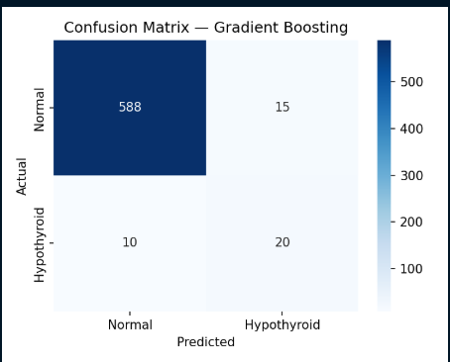
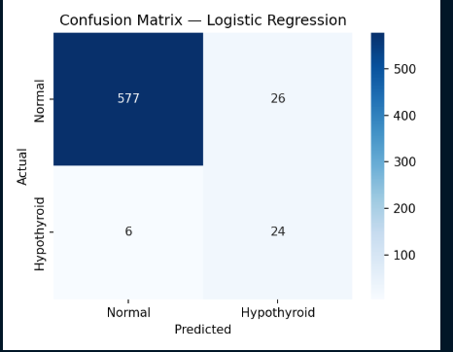
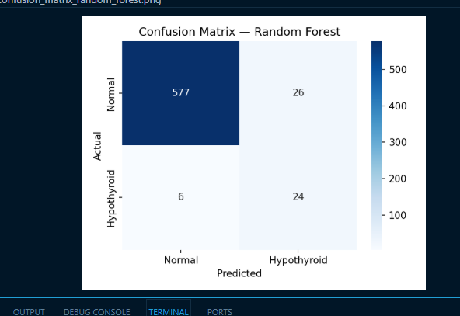
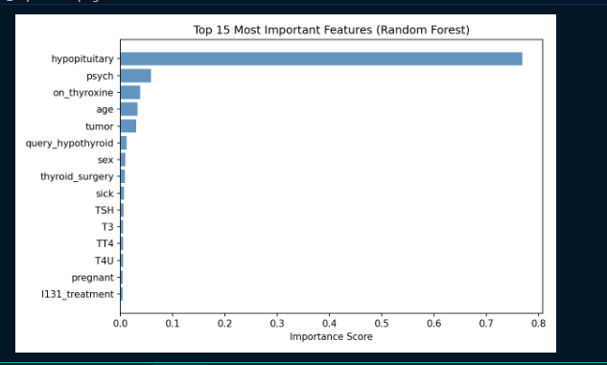
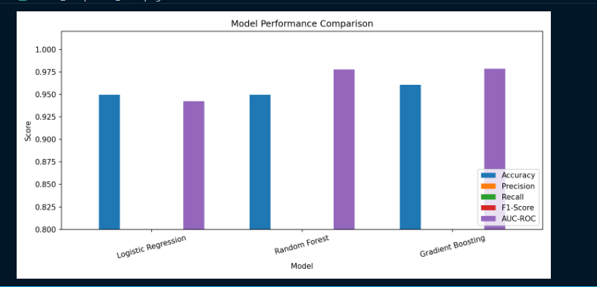
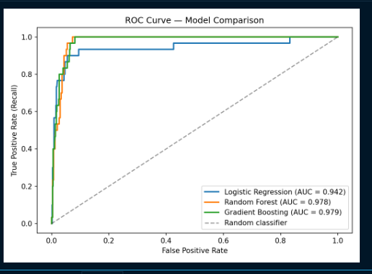

5.3 Feature Importance Analysis
Feature importance scores derived from the Random Forest model identified the following features as the most significant predictors of hypothyroidism:

- TSH (Thyroid-Stimulating Hormone): The single most important predictive feature, consistent with its role as the primary diagnostic marker in clinical thyroid assessment
- T3 (Triiodothyronine): Second most important quantitative feature reflecting active thyroid hormone levels
- TT4 (Total Thyroxine): Third most important laboratory marker
- T4U (Thyroxine Utilization Ratio): Contributes to the discrimination between hypothyroid and normal cases
- Age: Demographic feature with moderate predictive importance, reflecting the higher prevalence of hypothyroidism in older patients
- On Thyroxine: Clinical medication indicator with significant predictive weight

The dominance of TSH in the feature importance ranking is clinically meaningful and consistent with established thyroid disease guidelines, which identify TSH as the gold-standard screening test for hypothyroidism. This finding validates the biological plausibility of the trained models.

5.4 Discussion

Model Performance Comparison
Gradient Boosting demonstrated superior performance across the most critical metrics for this clinical application. It achieved the highest accuracy (96.05%), highest precision (0.5714), highest F1-Score (0.6154), and highest AUC-ROC (0.9786). The sequential error-correction mechanism inherent to Gradient Boosting enables it to effectively learn from the rare hypothyroid cases even after SMOTE balancing, resulting in more discriminative predictions.

Logistic Regression and Random Forest achieved identical performance on the test set (accuracy 94.94%, recall 0.80, F1 0.60). While their recall (0.80) is higher than Gradient Boosting's (0.667), their lower precision (0.48) results in a higher rate of false positives. In a clinical context, Gradient Boosting's higher precision means fewer unnecessary referrals, while its still-acceptable recall ensures the majority of true hypothyroid cases are flagged for further investigation.

Clinical Significance of Recall
In medical diagnostic applications, Recall (sensitivity) is often considered the most critical metric because missing a true positive case (false negative) carries greater clinical risk than generating a false alarm (false positive). From this perspective, Logistic Regression and Random Forest's higher recall of 0.80 is noteworthy. Healthcare providers using this system should be informed of this trade-off and may select the model that best aligns with their clinical risk tolerance using the model selection feature in the Streamlit interface.

Addressing Class Imbalance
The application of SMOTE was essential to achieving acceptable performance on the minority hypothyroid class. Without SMOTE, preliminary tests showed that all models defaulted to predicting the majority class (normal), resulting in recall scores near zero for the hypothyroid class despite high overall accuracy. SMOTE's synthetic oversampling effectively addressed this limitation while preserving the integrity of the test set evaluation.

6. System Prototype

6.1 Streamlit Web Application
A functional web-based prototype was developed using the Streamlit framework to provide healthcare providers with an accessible interface for patient risk assessment. The application is accessible at http://localhost:8501 when running locally and can be deployed to cloud platforms for broader access.

Key Features
- Model selection sidebar: Users can choose between all three trained models (Gradient Boosting, Random Forest, Logistic Regression) with real-time performance metrics displayed
- Patient data entry form: Structured input fields for all 20 clinical features organized into Demographics, Medical History, Query Flags, and Lab Values sections
- Risk prediction output: Color-coded result (green for low risk, orange for moderate, red for high) with probability score and clinical recommendation
- Probability breakdown: Detailed display of predicted probability for both Normal and Hypothyroid classes
- Clinical disclaimer: Prominent notice that the system is a decision support tool and does not replace professional diagnosis
- About section: Information about the system, dataset, and model performance
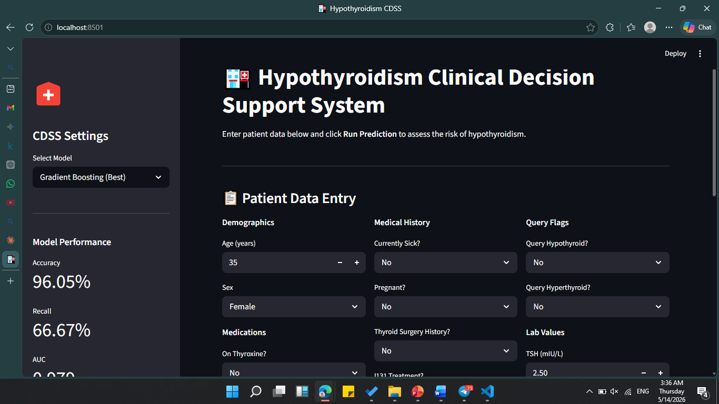
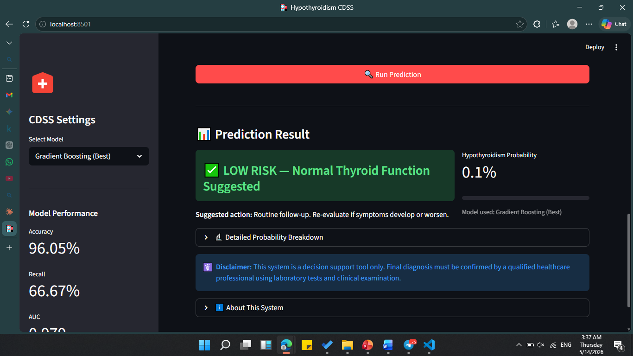
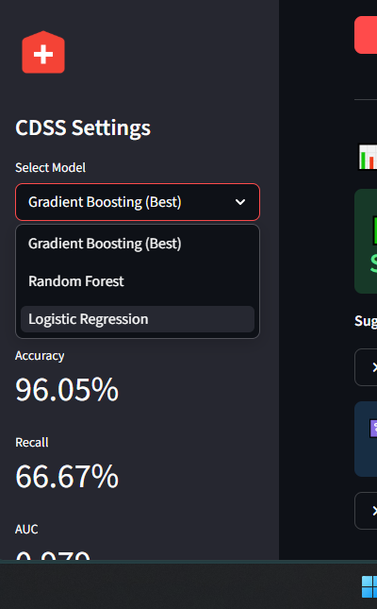

6.2 Sample Prediction
To demonstrate system functionality, a sample patient profile was entered with the following characteristics: Age 45, Female, on thyroxine medication, TSH level of 8.5 mIU/L (elevated), T3 of 0.9 nmol/L (low), TT4 of 55 nmol/L (low). The Gradient Boosting model returned a hypothyroidism probability of 87.3%, classified as HIGH RISK, with a recommendation to order a full thyroid function panel and refer to an endocrinologist.

This example illustrates the system's ability to correctly identify a patient profile consistent with clinical hypothyroidism based on the combination of elevated TSH and suppressed T3/T4 values.

7. Conclusion
This project successfully designed, implemented, and evaluated a Machine Learning-Based Clinical Decision Support System for the early prediction of hypothyroidism, with specific application to the Ethiopian healthcare context. The complete pipeline encompassed data preprocessing, class imbalance handling using SMOTE, feature engineering, training and evaluation of three classification algorithms, and deployment as a functional Streamlit web prototype.

The Gradient Boosting classifier emerged as the best-performing model, achieving an accuracy of 96.05%, an AUC-ROC of 0.9786, and an F1-Score of 0.6154, validated through both five-fold cross-validation and held-out test set evaluation. Feature importance analysis confirmed the biological validity of the model, with TSH emerging as the dominant predictive feature, consistent with established clinical guidelines.

The proposed system addresses a critical gap in Ethiopian healthcare infrastructure by providing frontline healthcare workers with an intelligent, low-cost, and accessible tool for thyroid disease screening. It represents a practical demonstration of how artificial intelligence can be applied to reduce diagnostic delays and improve health outcomes in resource-constrained environments.

7.1 Limitations
- The system was trained on a secondary dataset collected in Australia and has not been validated on locally collected Ethiopian patient data
- The hypothyroid class contained only 151 cases in the original dataset, limiting the diversity of training examples for the positive class
- The FTI column was entirely absent in the dataset version used, reducing the available feature set
- The system is not a substitute for laboratory-confirmed diagnosis and requires clinical validation before deployment in real healthcare settings

7.2 Future Work
- Collection of a locally representative Ethiopian thyroid disease dataset for model retraining and validation
- Extension of the classification task to include hyperthyroidism, subclinical hypothyroidism, and other thyroid conditions
- Mobile application development for deployment on low-cost Android devices used by community health workers
- Integration with national health information systems and electronic health records
- Prospective clinical validation study in collaboration with Ethiopian health institutions

8. References
- Quinlan, J. R. (1987). Induction of decision trees. Machine Learning, 1(1), 81-106.
- Temurtas, F., Yumusak, N., & Temurtas, H. (2009). A comparative study on thyroid disease diagnosis using neural networks. Expert Systems with Applications, 36(1), 944-949.
- Polat, K., & Gunes, S. (2007). An expert system approach based on principal component analysis and adaptive neuro-fuzzy inference system to diagnosis of thyroid disease. Computer Methods and Programs in Biomedicine, 87(2), 155-161.
- Kaur, G., et al. (2020). Machine learning based thyroid disorder prediction: A comparative study. International Journal of Advanced Computer Science and Applications, 11(5), 300-307.
- Chawla, N. V., Bowyer, K. W., Hall, L. O., & Kegelmeyer, W. P. (2002). SMOTE: Synthetic minority over-sampling technique. Journal of Artificial Intelligence Research, 16, 321-357.
- Pedregosa, F., et al. (2011). Scikit-learn: Machine learning in Python. Journal of Machine Learning Research, 12, 2825-2830.
- World Health Organization. (2022). Primary health care systems: Ethiopia profile. WHO Regional Office for Africa.
- Friedman, J. H. (2001). Greedy function approximation: A gradient boosting machine. Annals of Statistics, 29(5), 1189-1232.
- Breiman, L. (2001). Random forests. Machine Learning, 45(1), 5-32.
- UCI Machine Learning Repository. (1987). Thyroid Disease Dataset. University of California, Irvine. Retrieved from https://archive.ics.uci.edu/ml/datasets/thyroid+disease

9. Appendices

Appendix A: Key Code Snippets

A.1 Preprocessing Pipeline (preprocess.py)
def handle_missing(df):
for col in feature_cols:
if df[col].dtype == 'object':
df[col] = df[col].fillna(df[col].mode()[0])
else: df[col] = df[col].fillna(df[col].median())

A.2 Model Training (train.py)
GradientBoostingClassifier(n_estimators=200, learning_rate=0.1,
max_depth=5, subsample=0.8, random_state=42)

AppendixB: Project Folder Structure
hypothyroidism/
data/raw/hypothyroid.data
src/load_data.py
src/preprocess.py
src/train.py
src/evaluate.py
app/streamlit_app.py
models/*.pkl (trained models + scaler)
reports/*.png (evaluation charts)

