**Figure 1. MaAsLin2 results showing significant species drivers between pre-contact vs post-contact (based on CLR transformed data) – github?**

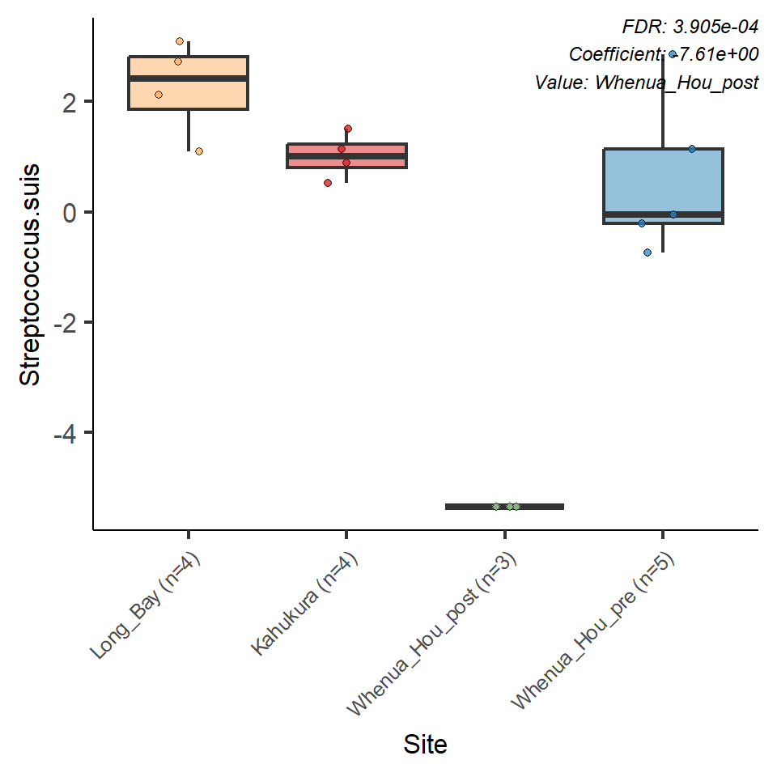

**Figure 1. Figure 1 continued**

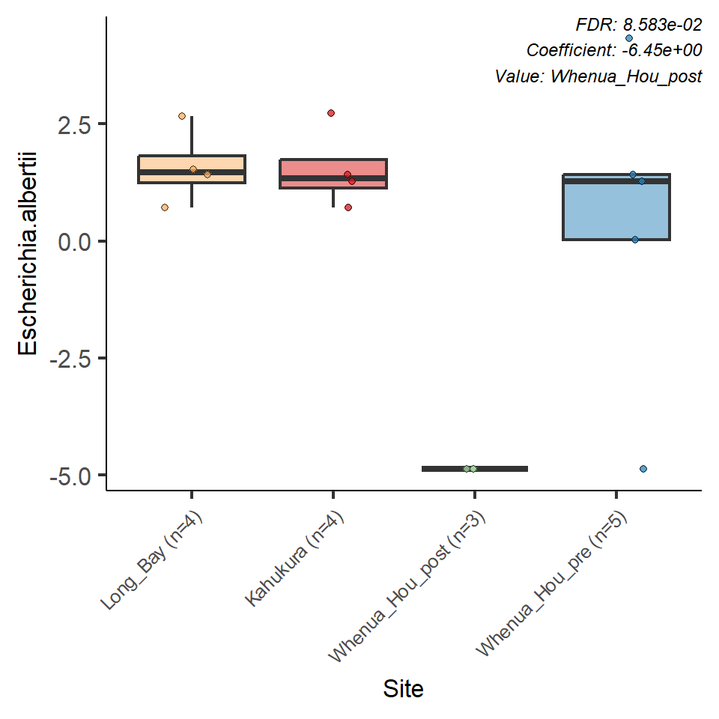

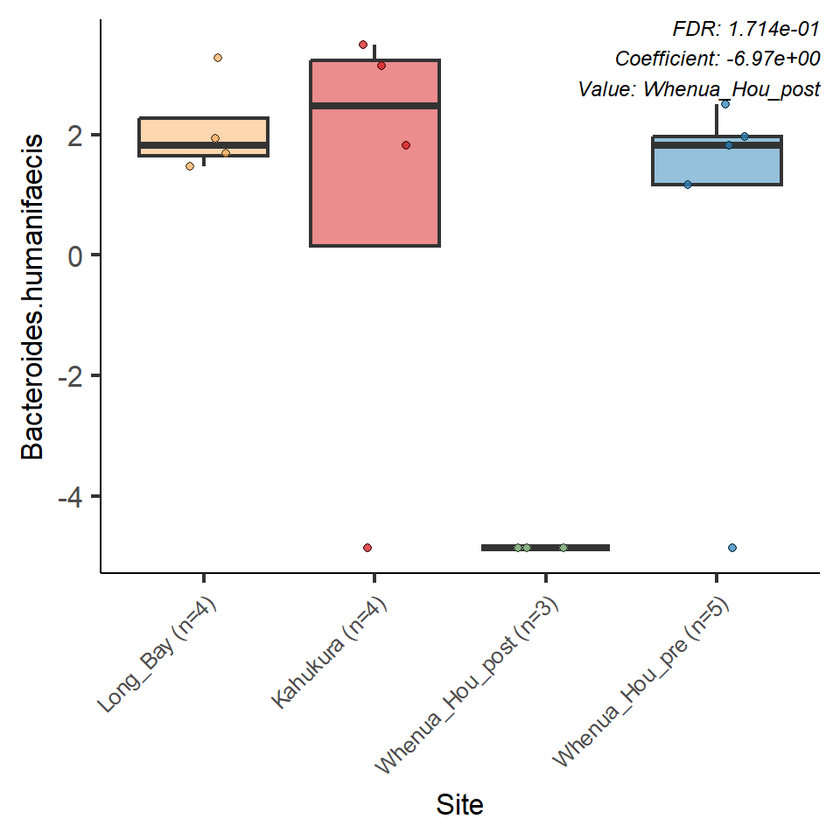

**Figure 1. Figure 1 continued**

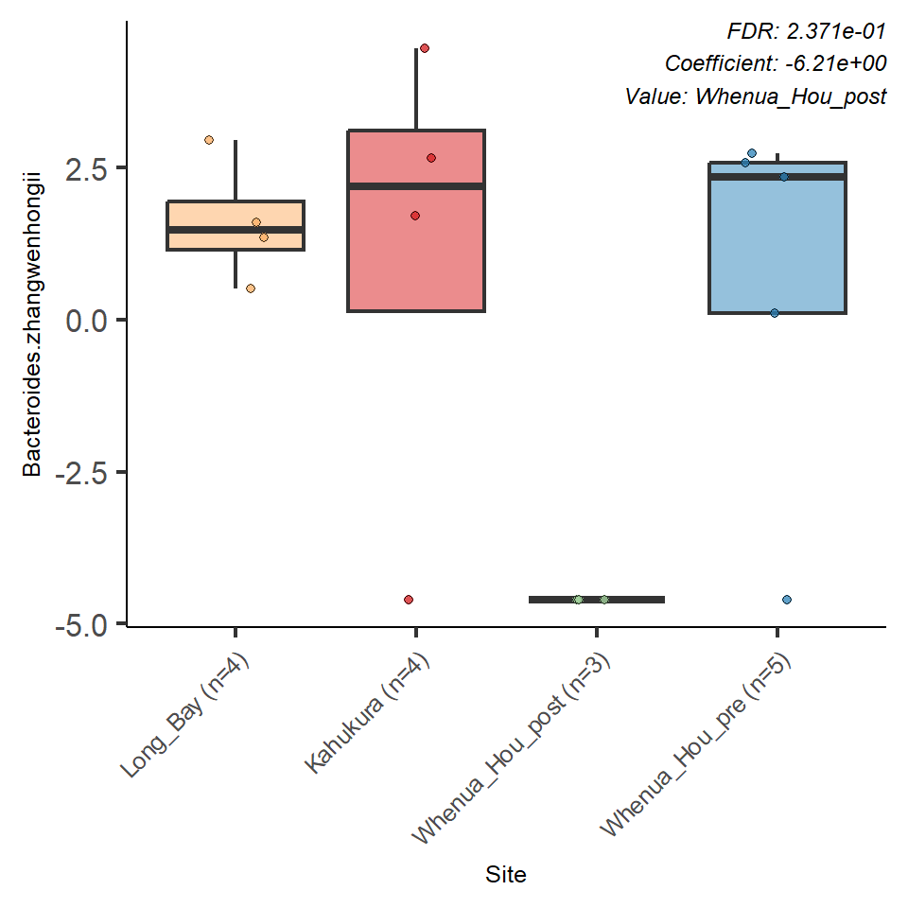

**Figure 1. Figure 1 continued**

**Figure 1. Figure 1 continued**

