**Figure 1. MaAsLin2 results showing boxplots of shared contaminant species (based on CLR transformed data)**

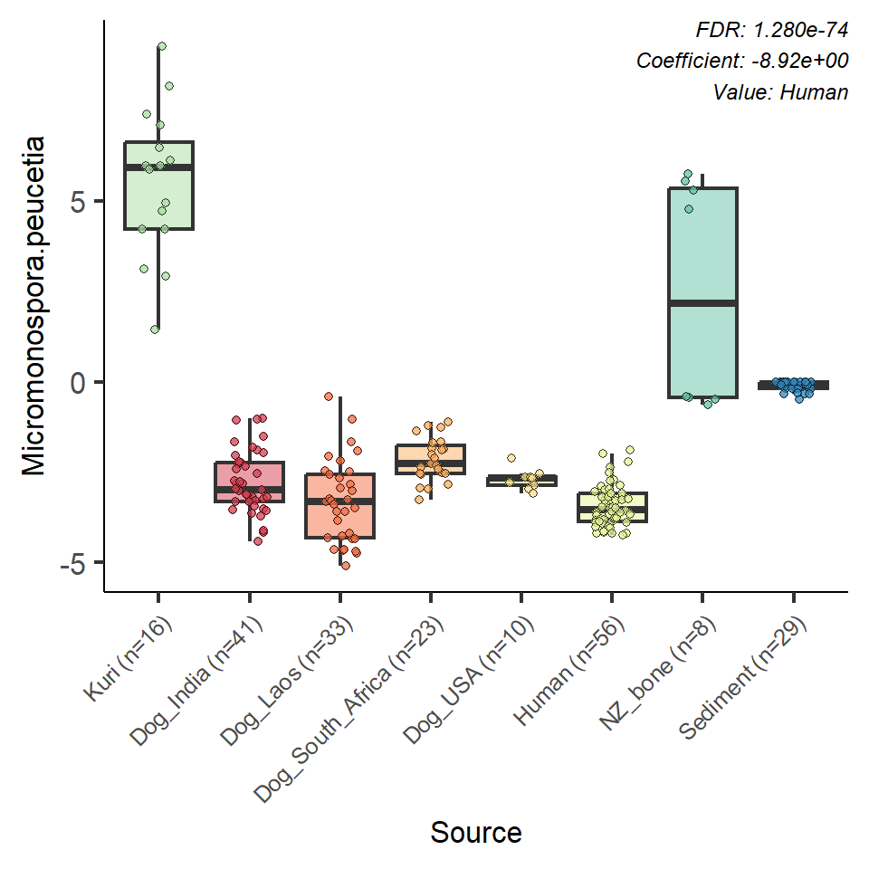

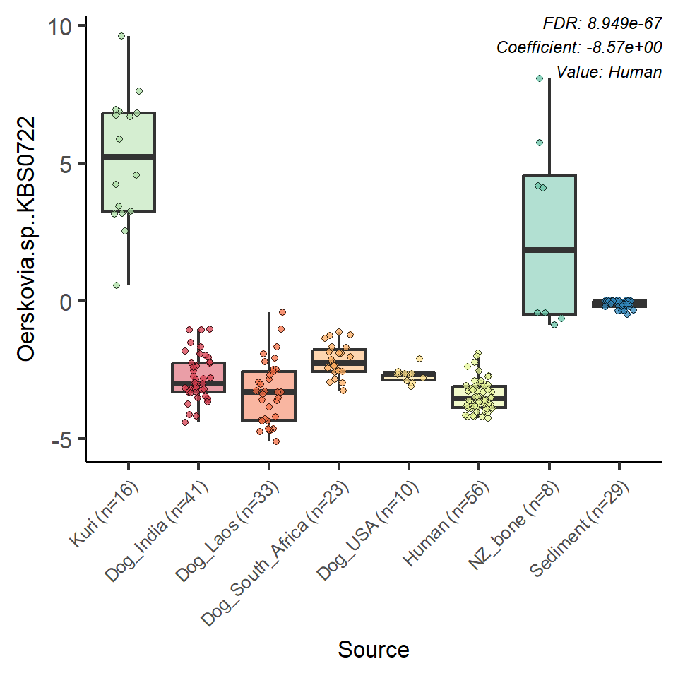

**Figure 1. continued**

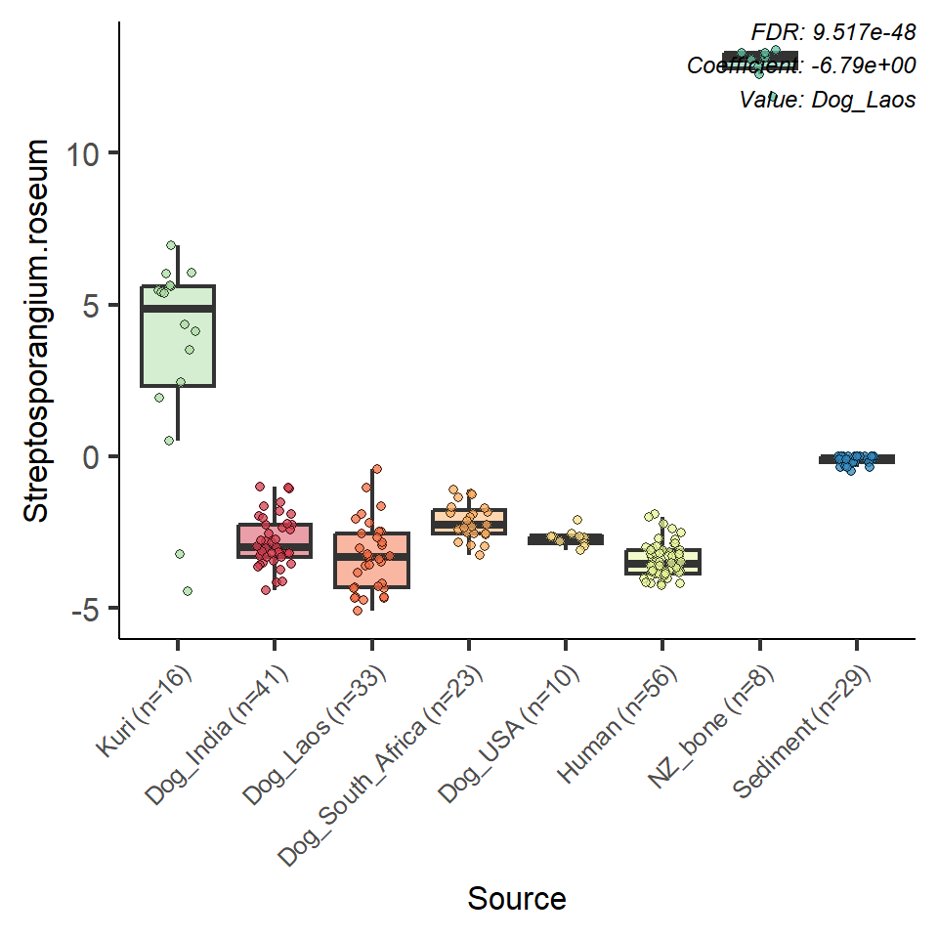

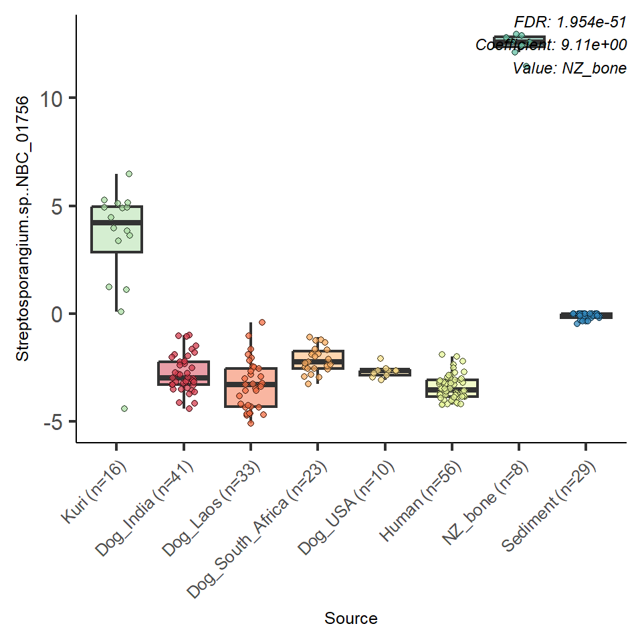

**Figure 1. continued**

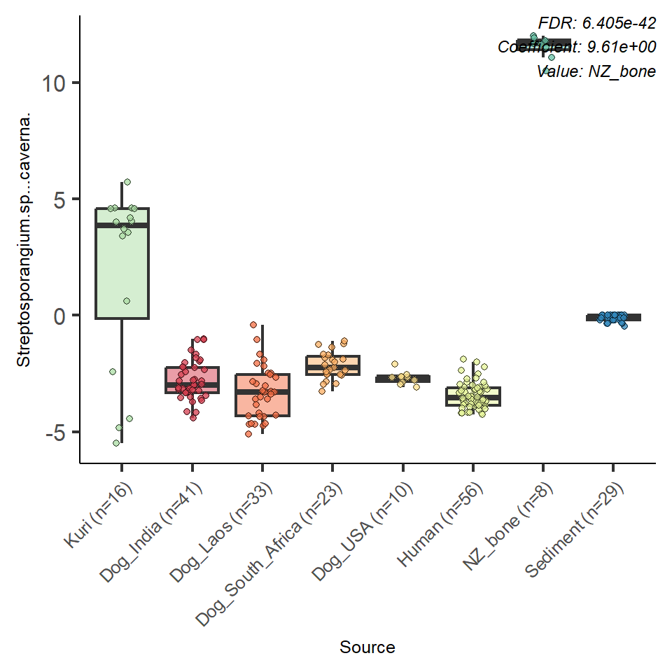

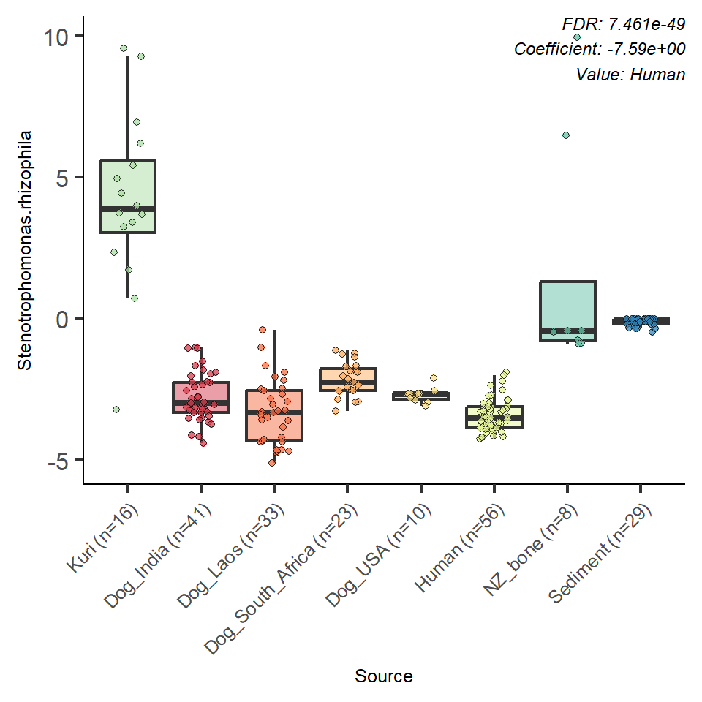

**Figure 1. continued**

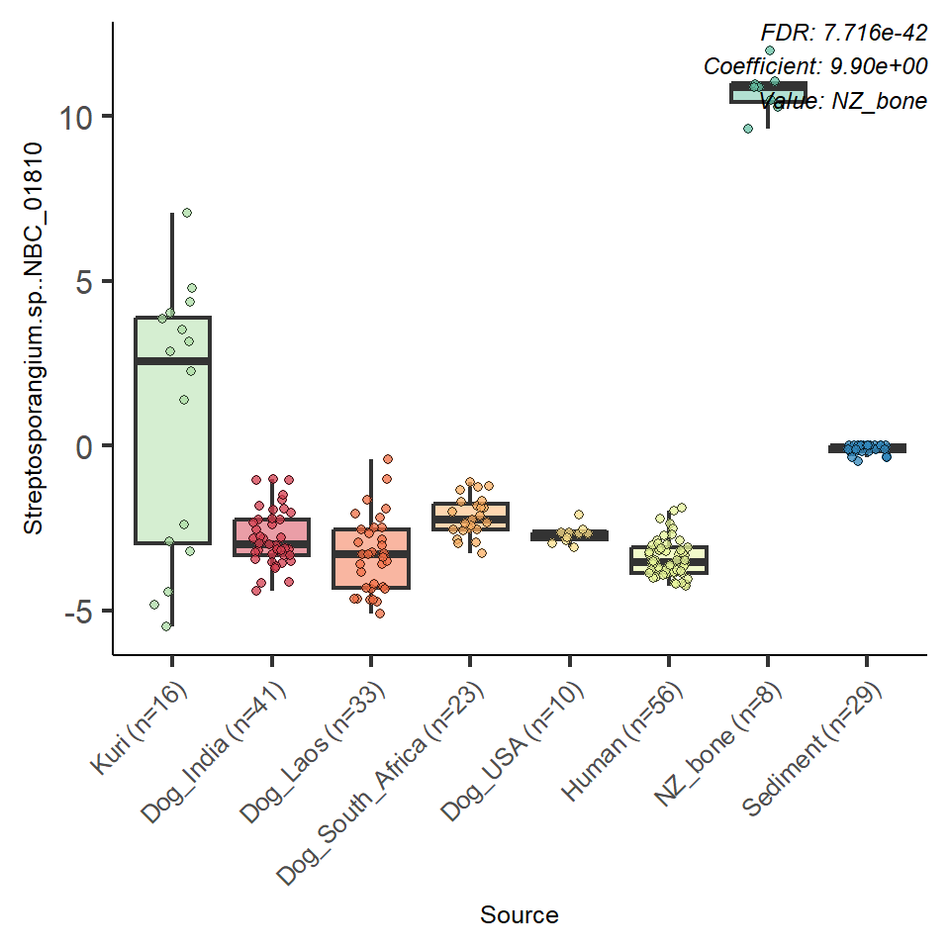

**Figure 2. MaAsLin2 results showing boxplots of shared microbiome species (based on CLR transformed data)**

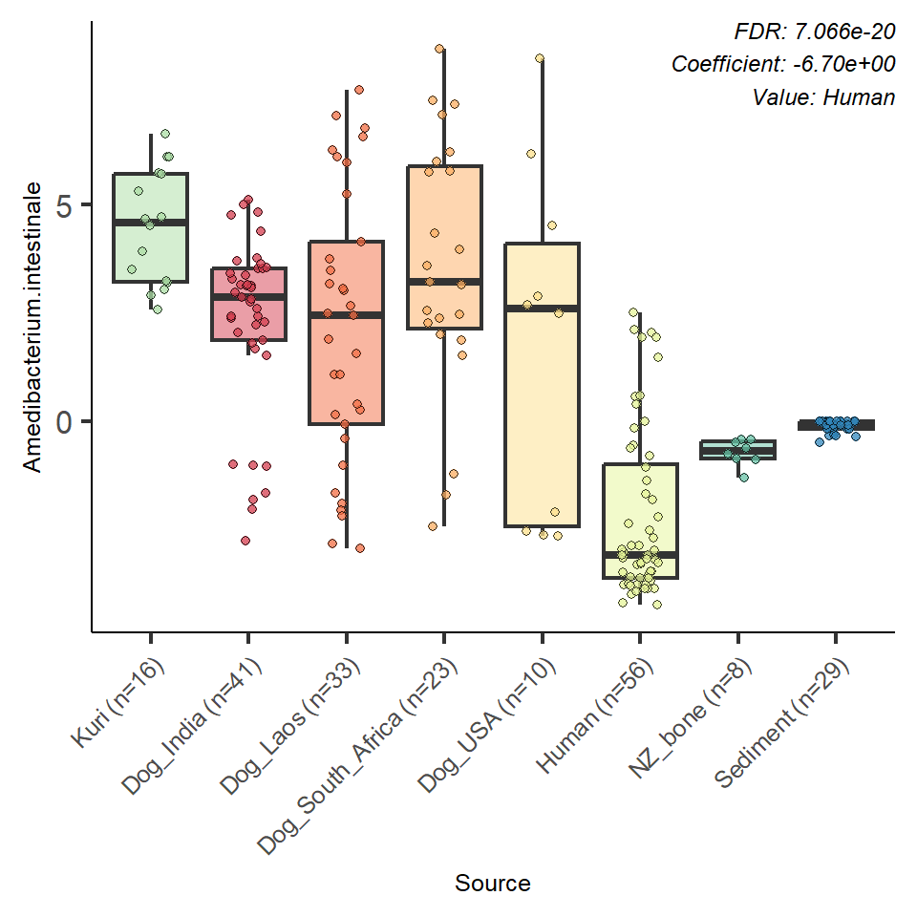

**Figure 2. Continued**

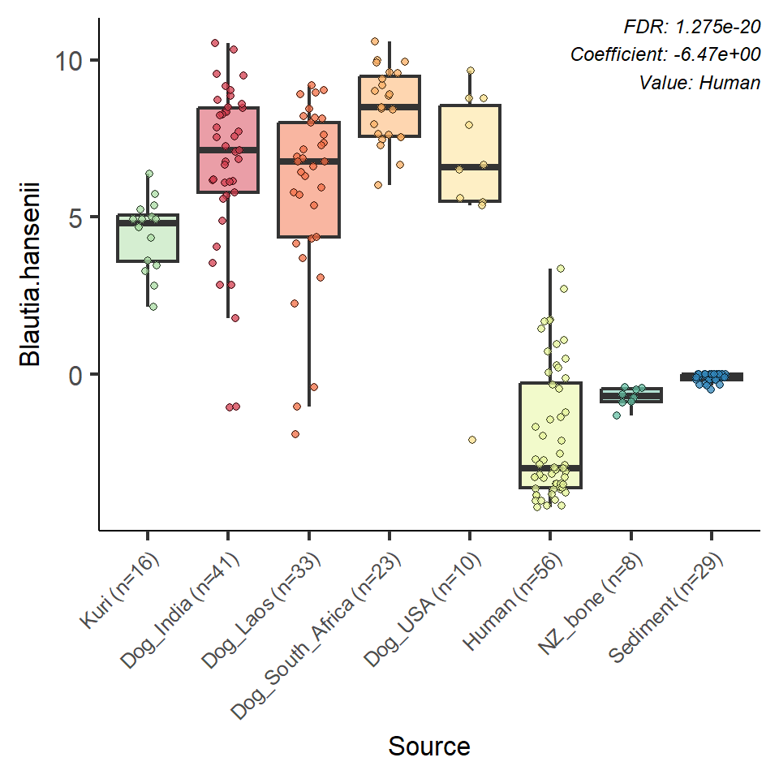

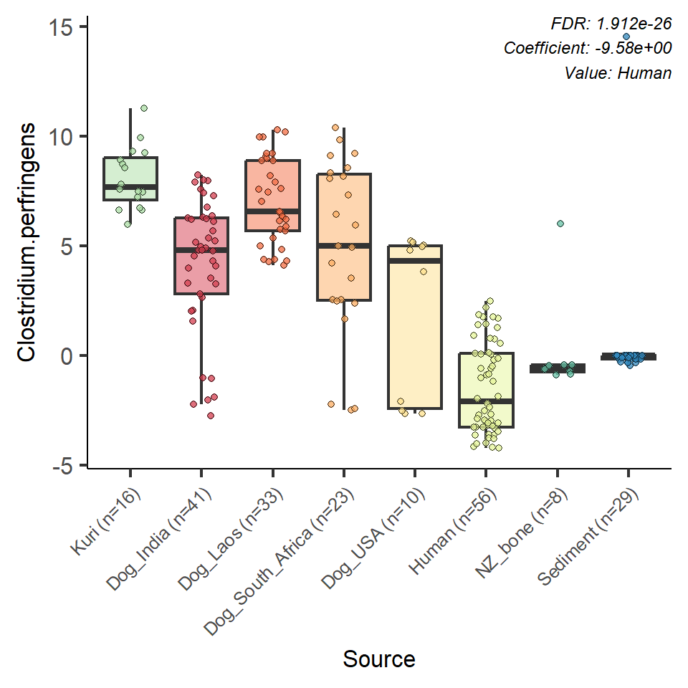

**Figure 2. Continued**

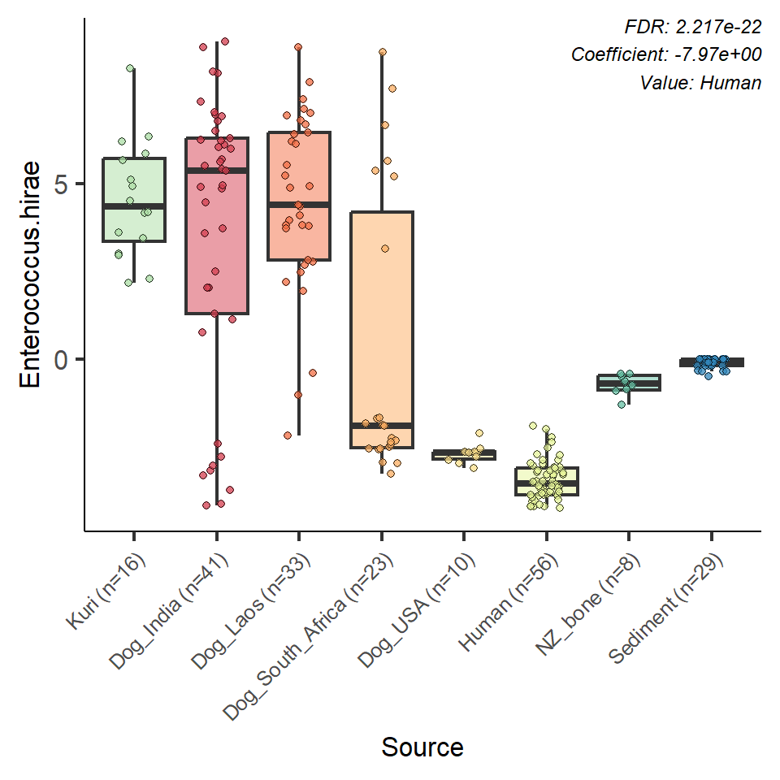

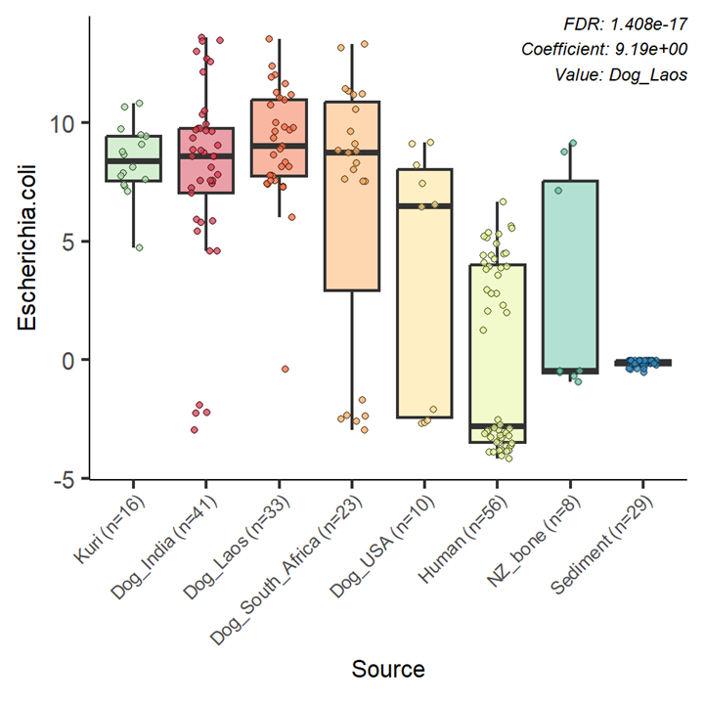

**Figure 2. Continued**

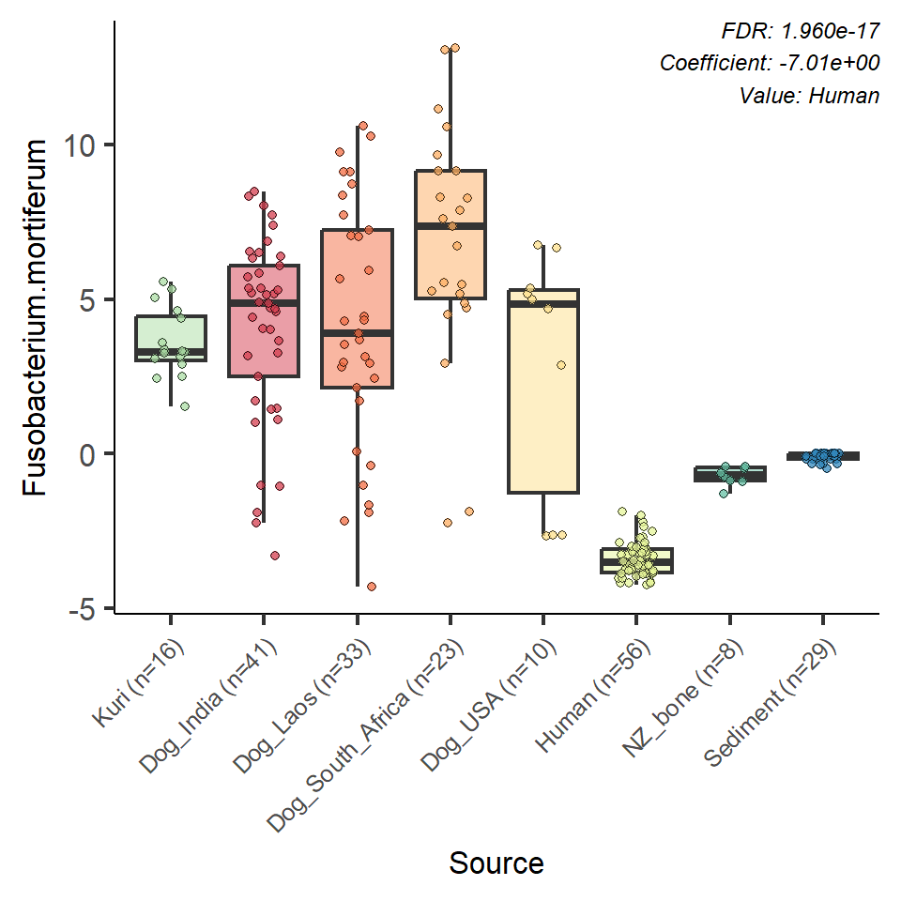

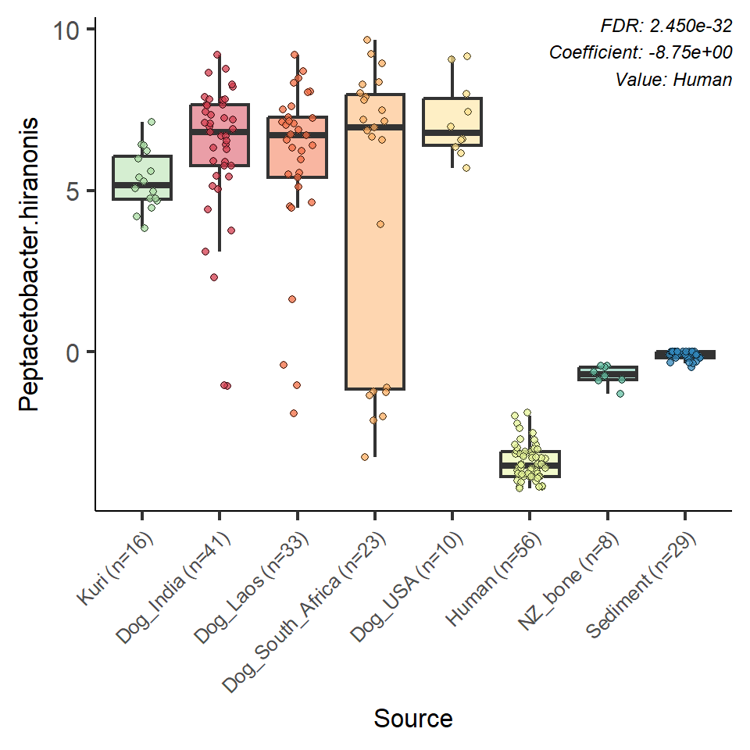

**Figure 3. MaAsLin2 results showing boxplots of species common in palaeofaecal species, but rare in other sources (based on CLR transformed data)**

**Figure 3. Continued**

**Figure 3. Continued**

