Directshow Editing Services SlideshowVB Sample Application

Description:
The Dexter Slideshow Sample Application is a GUI-based tool used to create multimedia slideshows, save them to XTL files, or render them to .AVI files.

Path
Source: (SDK root)\Samples\Multimedia\VBSamples\DirectShow\Editing\SlideshowVB

User Guide
This sample application demonstrates the following tasks using Microsoft Visual Basic:

- Using the MediaDet object to obtain a poster frame for each source clip.
- Exporting a timeline using the XTL File format.
- Exporting a timeline using the AVI File format.
- Loading media clips from the following file formats: .avi;.mov;.mpg;.mpeg;bmp;.jpg;.jpeg;.gif

When the application is first started, you should see the user interface displayed below.
The UI is subdivided into the following parts:

- The Microsoft SourceClip Control (VB UserControl contained in the sample application)
- A textbox & combobox to input the clip time (in seconds) and default transition, respectively.
- Common buttons for each of the given operations.

  - Play Renders the current slideshow
  - Write XTL Exports the slideshow using the XTL File Format
  - Write AVI Exports the slideshow using the AVI File Format
  - Exit Ends the sample application

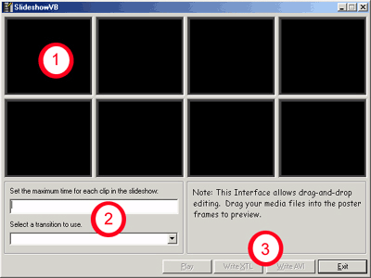

Once the application is loaded, you can begin inserting media into the cells. Starting in the upper left hand cell, work your way across the app by dragging and dropping video files into each of the cells.

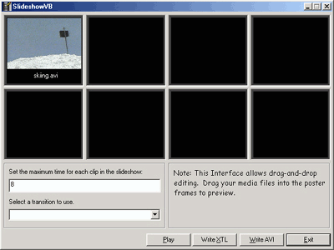

Next you can assign the length of the clip (dry time) and the transition to be used between each clip. These times are then used for all the clips in the slideshow. Transition times between the clips are fixed at 2 seconds. Therefore, a dry time of 3 seconds plus the 2-second transition will result in a 5 second playback time. When all the clips are in place and the clip length and transitions have been assigned, you can preview your slideshow by clicking on ‘Play’, by exporting it to an XML file format by clicking ‘Write XTL’, or by rendering the slideshow to an AVI file by clicking on the ‘Write AVI file’ command button.

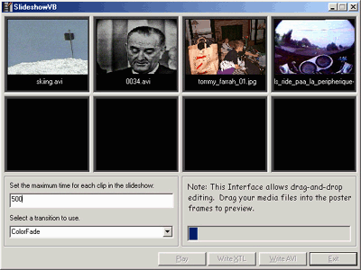

When writing a new AVI file, a progress bar will appear to indicate the percentage written to disk. Large files may take several minutes to render. Note that the AVI file will be written to disk in uncompressed AVI format, so the files will be large. You can compress the resultant AVI file with the codec of your choice, using a third-party video editing application.

