Overview Of Slope Rendering in Meridian 59
by Colin Andrews March 26, 1997
The capability to render sloped floors and ceilings has been added to the rendering engine for the “Konima’s Island” a.k.a. “Warriors Island” release of Meridian 59. The following is an overview of the approach taken to handling such regions and their adjoining walls within the context of the current 3D rendering engine. You need to be familiar with the basics of how the engine functions to understand the modifications described here. This document does not cover the math behind perspective correct texture mapping necessary to texture the sloped regions. Please see the other articles supplied with this document for an explanation of this technique. There is also a very good series of articles by Chris Hecker in Game Developer Magazine about this technique. This discussion is only meant to supplement the inline documentation in the relevant source code.

Sloped Surfaces
Sectors with sloped floors or ceilings have associated with them a plane in 3D space described by the four coefficients of the plane equation in the form:
Ax + By + Cz + D = 0
The utility functions GetFloorHeight and GetCeilingHeight each check to see if there is a plane equation for the floor or ceiling of the input sector as appropriate. If there is a plane associated with the sector these routines calculate the height at the input x & y by plugging them into the plane equation. Otherwise, they simply return the height stored for the whole sector.
The WalkLeaf procedure in the file drawbsp.c is the routine that handles creating draw items for floors and ceilings. The routine divides the screen area of the current leaf of the bsp into draw items corresponding to the regions below each side of the polygon bounding the leaf. The routine calls GetFloorHeight or GetCeilingHeight as appropriate to determine the correct height at each point of the polygon for sloped or normal regions. When the region is sloped, the draw items created are of type DrawSlopedFloorType or DrawSlopedCeilingType. The routine doDrawSloped handles texturing cones of this type.
Associated with the plane equation for each slope is information describing the orientation of the texture to be applied to the surface. At each frame this information needs to be combined with the current viewing parameters to generate the values that describe how screen space maps to texture space. Refer to the documentation on perspective correct texture mapping for an explanation of this process. Currently, the mapping values are set up for all sloped floors and ceilings in the current map for every frame, regardless of whether the floors or ceilings are visible. This is done at the beginning of the DrawBSP routine by calling SetMappingValues for every sloped floor or ceiling referred to in the sector array. The doDrawSloped routine uses this information to texture all of the draw items corresponding to each sloped surface.

Sloped Walls
Since the vertical extents of walls are defined by the ceiling and floor heights of the sectors adjacent to the wall, sloped floors and ceilings created wall that are trapezoidal or triangular in world space rather than rectangular, as is the case for walls that adjoin normal flat sectors. The code handles this by storing two sets of heights for each wall record. Where previously the wall record only needed to store the heights separating the rectangular upper, normal, and lower wall segments, the record now has these heights for each of the x y endpoints of the wall. WalkWall uses these heights to calculate the shape of the wall when projected on the screen and create the draw item for texturing them.
For normal rectangular walls, the vertical texture offsets are measured from the bottom of the wall when the texture mapping is set to “bottom up” and from the top of the wall when set to “top down”. Walls adjoining sloped regions can have angled tops or bottoms. For walls with sloped bottoms, the origin for “bottom up” texture offsets is chosen as the nearest multiple of FINENESS (1024) below the lowest endpoint of the bottom of the wall. For walls with sloped tops, the origin for “top down” texture offsets is chosen as the nearest multiple of FINENESS (1024) above the highest endpoint of the top of the wall. This is to enable automatic alignment of tiled textures on adjacent sloped walls.
Bowties are walls on the boundary between a sloped sector and another sloped or normal sector. They have the property that at one endpoint the sector in front of the wall is higher than the one behind, and at the other end of the wall, the sector behind is higher than the one in front. So, it looks something like this if your are looking at it from in front:
What the user should see when looking at one of these walls depends on which side of the wall the user is standing. The sector on the side of the wall closer to the user always covers everything from one of the diagonals down (for lower walls, up for upper walls) so all that needs to be drawn is the part of the bowtie that extends above the nearer sector:
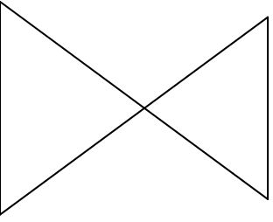
Which part of the bowtie shape gets drawn depends on which side of wall the user is on. From the other side of the above example, the other point of the bowtie would extend above the nearer sector. Which point of the bowtie gets drawn also depends on which sector is higher at each endpoint of the wall. In the above example, the closer sector is above at the left endpoint of the wall. If the sector behind the wall is above at the left endpoint, then it would look like this:
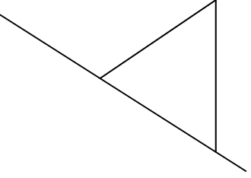
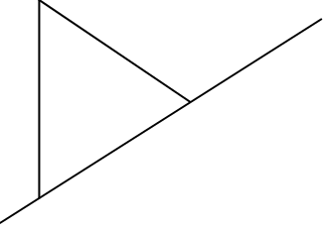
There are four cases that need to be handled by the wall rendering code:
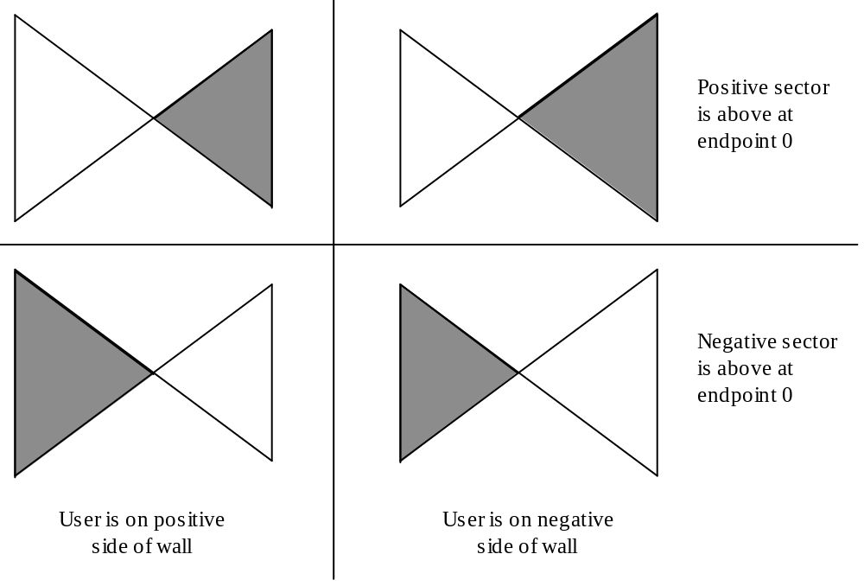
In the figure above, the top row shows how bowties should be drawn when the positive sector is above at the first endpoint. The lower row shows how bowties should be drawn when the negative sector is on top at the first endpoint. The left column shows the bowties when the user is on the positive side of the wall and the right column shows the view from the negative side. The part of the bowtie that is shaded gray is the part that needs to get filled by the wall rendering code.
Bowties in the upper or lower walls are identified by SetWallHeights. It is assumed that bowtied normal walls cannot (or should not) exist. The height values for the WallData struct are filled in as they be would for a normal wall. Flag bits are set in the wall struct indicating that the above and or below wall is bowtied and whether each has the positive sector on top at the first endpoint.
When WalkWall sees that a wall is flagged as bowtie, it modifies the z values at either endpoint so that the wall has the proper shape for the side facing the user according to which sector is above at the first endpoint.

Further work
There are a number of reasonable modifications to the current state of the code (3-26-97) that time has not allowed me to make or it has not been clear that these modifications are necessary. Most of these modifications would be for performance optimization of slope handling. The engineering staff may want to consider implementing these modifications at some point.

Affine Step Size
The texture mapping of sloped surfaces only calculates the perspective correct texture coordinates at certain intervals along a row. Currently the size of the interval is fixed at 24 pixels. In between these pixels the texture coordinates are linearly interpolated. This is done for performance reasons, because calculating the correct value at every pixel would too slow. When this value is larger, the render goes faster but the quality of the perspective correct texture mapping will go down.
The size of this parameter (SLOPE_TEXTURE_STEP in drawbsp.c) may need to be fiddled with quite a bit to get the best balance between quality and speed. Another way to proceed is to change this parameter to a variable that the user can modify in the settings dialog. This would allow users to choose a setting that works for their tastes and for their machine.

Store Heights of Polygon Points
Right now, WalkLeaf recalculates the floor height of each vertex of the polygon associated with a leaf of the bsp tree even though these values never change. If performance becomes an issue, the heights should be stored in an array corresponding to the array of vertex coordinates for leaves with sloped floors or ceilings. This is a classic time vs. space trade off. You might determine at a later point that the improved performance is worth the extra ram.

Only Set Up Mapping for Visible Sectors
Currently, the texture mapping parameters are calculated for all sloped regions in the current map for every frame. The calculations required are non-trivial and may bog down slower machines, especially for maps with lots of sloped sectors. It would be a simple modification to call SetMappingValues only for the sectors that are actually drawn in the current frame.
If a scheme like this is adopted, some further modification could reduce the amount of memory used to store texture mapping parameters for sloped regions. The SlopeData structure contains quite a bit of storage that is only used for per frame scratch values. These values could be moved to a separate structure. The program could then allocate a pool of these records that is smaller than the total number of slopes in the level. Visible slopes would take records from the pool for use during rendering and return them to the pool after the frame is completely drawn.

Texture Alignment on Sloped Walls
The default alignment for texturing walls whose tops or bottoms are sloped was designed to ease the alignment of tiled textures on adjacent sloped walls. This will make it more difficult for level designers to align a texture with the top or bottom of the wall. It may be desirable to change the code which chooses the texture origins of sloped walls in DoDrawWall. Choosing the minimum height of the lower endpoints for “bottom up” alignment and the maximum of the upper endpoints for “top down” alignment will cause textures to automatically align to the top or bottom of the sloped wall. This will, however, come at the expense of the ease of alignment of tiled textures across adjacent sloped walls.

